

**LUK EDUCATION MANAGEMENT SYSTEM (LUKEMS)**

**Software Requirement Specification**

– Danang, June 2025 –

**Table of Contents**

**I. Project Report 5**

1. Status Report 5

2. Team Involvements 5

3. Issues/Suggestions 5

4. Record of Changes 5

**II. Software Requirement Specification 7**

1. Product Overview 7

2. User Requirements 7

2.1 Actors 7

2.2 Use Cases 8

3. Functional Requirements 19

3.1 System Functional Overview 19

3.2 UC-01-Login 34

3.3 UC-02-Logout 37

3.4 UC-03-View and Update Profile 39

3.5 UC-04-List report on learning outcomes 42

3.6 UC-05-View statistics, score all accounts 46

3.7 UC-06-View activity history all accounts 49

3.8 UC-07-Grade submissions: daily vlog / check1 / check2 / essay 53

3.9 UC-08-Send feedback on grades: vlog / check1 / check2 / essay 57

3.10 UC-09-Download student submissions 61

3.11 UC-10-List learning materials 65

3.12 UC-11-Add Learning Materials 69

3.13 UC-12-Update Learning Materials 72

3.14 UC-13-Delete Learning Materials 76

3.15 UC-14-List Quiz 79

3.16 UC-15-Create Quiz 83

3.17 UC-16-Update Quiz 87

3.18 UC-17-Delete Quiz 90

3.19 UC-18-Personal Schedule for Coach 94

3.20 UC-19-Notify New Content 97

3.21 UC-20 View all account student 100

3.22 UC-21 View all account Ted Team 103

3.23 UC-22 View all account Coach 107

3.24 UC-23 View all account Admin 110

3.25 UC-24 Add account student 114

3.26 UC-25 Add account Ted Team 117

3.27 UC-26 Add account Coach 119

3.28 UC-27 Add account Admin 121

3.29 UC-28 Import Excel file for accounts 123

3.30 UC-29 Lock or unlock account 127

3.31 UC-30 View detailed account 130

3.32 UC-31 Search class 133

3.33-UC-32 List Class 136

3.34 UC-33 Add class 138

3.35 UC-34 Update class 141

3.36 UC-35 Delete class 144

3.37 UC-36 View detailed class 147

3.38 UC-37 Import student to class by excel file 150

3.39 UC-38 Add student to class 153

3.40 UC-39 Change student in class 156

3.41 UC-40 Delete student from class 159

3.42UC-41 Search shift 162

3.43UC-42 List shift 165

3.44 UC-43 Add shift 168

3.45 UC-44 Shift approval 171

3.46 UC-45 Update timetable 174

3.47 UC-46 Delete timetable 177

3.48 UC-47 Create form email 180

3.49 UC-48 Send Email Notify 183

3.50 UC-49 View statistics for all accounts 186

3.51 UC-50 View scores for all accounts 190

3.52 UC-51 View progress for all accounts 193

3.53 UC-52 View performance for all account 196

3.54 UC-53 View activity history for all accounts 199

3.55 UC-54 View learning calendar 202

3.56 UC-55 View quizzes 206

3.57 UC-56 View News 208

3.58 UC-57 View videos 210

3.59 UC-58 Do quiz 212

3.60 UC-59 Write News 214

3.61 UC-60 Submit Video/Vlog 216

3.62 UC-61 Academic progress 217

3.63 UC-61.1 View exercises history 220

3.64 UC-61.1.1 View result each quiz screen. 221

3.65 UC-61.2 View average score 223

3.66 UC-62 View leaderboard 225

3.67 UC-63 View notifications 226

3.68 UC-64 View course feedback 228

3.68 UC-65 Do feedback 230

3.69 UC-66 View learning materials 232

3.70 UC-67 View personal schedule 234

3.71 UC-68 Register work schedule 236

3.72 UC-69 Cancel register work schedule 240

3.73 UC-70 Checkin self 242

3.74 UC-71 View assignment progress of students 244

3.75 UC-72 Send reminder 247

3.76 UC-73 View class list 249

3.77 UC-74 Check student 251

3.78 UC-75 Update class note 254

3.79 UC-76 View quiz status 256

3.80 UC-77 Submit report 258

4. Non-Functional Requirements 261

4.1 External Interfaces 261

4.2 Quality Attributes 261

5. Requirement Appendix 262

5.1 Business Rules 262

5.2 Common Requirements 269

5.3 Application Messages List 269

5.4 Other Requirements… 280

**Table of Figure**

Figure 01 - Context Diagram 9

Figure 02 - User Case Overview 10

Figure 03 - User Case for Student 12

Figure 04 - User Case for Ted Team 12

Figure 05 - User Case for Coach 13

Figure 06 - User Case for Admin 14

Figure 07 - Screens Flow for Student 21

Figure 08 - Screens Flow for Coach 22

Figure 09 - Screens Flow for Admin 22

Figure 10 - Screens Flow for TedTeam 23

Figure 11 - Entity Relationship Diagram 34

Figure 12 - Login 39

Figure 13 - Logout 42

Figure 14 - View and Update Profile 45

Figure 15 - List report on learning outcomes 47

Figure 16 - View statistics, score all account 51

Figure 17 - View activity history all accounts 54

Figure 18 - Grade submissions 58

Figure 19 - Grade submissions 58

Figure 20 - Send Feedback 62

Figure 21 - Download students submissions 66

Figure 22 - List learning material 70

Figure 23 - Add learning material 74

Figure 24 - Update learning material 77

Figure 25 - Delete learning material 81

Figure 26 - List Quiz 85

Figure 27 - Create Quiz 88

Figure 28 - Update Quiz 92

Figure 29 - Delete Quiz 95

Figure 30 - Personal Schedule for Coach 98

Figure 31 - Notify new content 102

Figure 32 - View all account Student 105

Figure 33 - View all account Ted Team 109

Figure 34 - View all account Coach 113

Figure 35 - View all account Admin 117

Figure 36 - Add account student 121

Figure 37 - Add account Ted Team 124

Figure 38 - Add account Coach 127

Figure 39 - Add account Admin 130

Figure 40 - Import Excel file for accounts 133

Figure 41 - Lock or unlock account 137

Figure 42 - View detailed account 141

Figure 43 - Search class 145

Figure 44 - List class 149

Figure 45 - Add class 153

Figure 46 - Update class 157

Figure 47 - Delete class 161

Figure 48 - View detailed class 165

Figure 49 - Import student to class by Excel file 169

Figure 50 - Add student to class 174

Figure 51 - Change student in class 178

Figure 52 - Delete student from class 183

Figure 53.1 - List shift by day 191

Figure 53.2 - List shift by week 191

Figure 53.3 - List shift by month 191

Figure 54 - Add shift 195

Figure 55 - Shift approval 200

Figure 56 - Update timetable 204

Figure 57 - Delete timetable 209

Figure 58 - Create form email 213

Figure 59 - View statistics for all accounts 221

Figure 60 - View scores for all accounts 226

Figure 61 - View progress for all accounts 230

Figure 62 - View performance for all accounts 235

Figure 63 - View activity history for all accounts 240

Figure 64 - View learning calendar 243

Figure 65 - View quizzes 246

Figure 66 - View News 249

Figure 67 - View videos 252

Figure 68.1 - Do quiz 255

Figure 68.2 - Do quiz 255

Figure 69 - Write News 259

Figure 70.1 - Submit video 262

Figure 70.2 - Submit video 263

Figure 71 - View academic progress 267

Figure 72 - View exercises history 271

Figure 73.1 - View result each quiz 276

Figure 73.2 - View result each quiz 276

Figure 74 - View average score 280

Figure 75 - View Leader board 285

Figure 76 - View notifications 290

Figure 77 - View feedback 292

Figure 78 - Do feedback 294

Figure 79 - View Learning Materials 298

Figure 80 - View personal schedule 300

Figure 81 - Register work schedule 303

Figure 82 - Cancel register wo schedule 306

Figure 83 - View assignment progress of students 310

Figure 84 - Send reminder 313

Figure 85 - View classlist 317

Figure 86 - Check attendance students 321

Figure 87 - Update class note 324

Figure 88 - View quiz 327

Figure 89 - Submit report 332

# I. Project Report

## 1. Status Report

* Project in development phase. Core functionalities for all four user roles (Student, TT, Coach, Admin) have been defined.
* Technical stack: Web application architecture. Frontend and backend development ongoing.

## 2. Team Involvements

| Bùi Thị Tuyết Nhi | DE180868 |
| --- | --- |
| Lê Thị Kim Anh | DE180827 |
| Hoàng Công Bình | DE180906 |
| Trần Tuấn Anh | DE180904 |
| Lê Đức Anh Phương | DE180914 |

## 3. Issues/Suggestions

* Custom grading workflows for vlog submissions need clarity.
* Integrating video upload and processing requires robust file handling.

## 4. Record of Changes

| **Date** | **A* M, D** | **In charge** | **Change Description** |
| --- | --- | --- | --- |
| 21/5/2025 | A | NhiBTT | Write status report, team involvement |
| 22/5/2025 | A | NhiBTT | Write use case description and use case diagram |
| 23/5/2025 | A | NhiBTT | Write screen flow description |
| 24/5/2025 | A | NhiBTT | Write UC description for student role |
| 22/5/2025 | A | PhuongLDA | Write UC for Login, Logout, Profile |
| 22/5/2025 | A | BinhHC | Write UC for Admin account management |
| 22/5/2025 | A | AnhTT | Write UC for Coach functionalities |
| 28/5/2025 | M | AnhTT | Update UC-06 View activity history all accounts |
| 31/5/2025 | A | AnhTT | Add UC-07 Grade submissions |
| 02/6/2025 | A | AnhTT | Add UC-08 Send feedback on grades |
| 05/6/2025 | M | AnhTT | Modify UC-09 Download student submissions |
| 09/6/2025 | A | AnhTT | Add UC-11 Add learning materials |
| 12/6/2025 | M | AnhTT | Modify UC-12 Update learning materials |
| 15/6/2025 | A | AnhTT | Add UC-13 Delete learning materials |

*A - Added M - Modified D - Deleted

# II. Software Requirement Specification

## 1. Product Overview

LUKEMS is a learning management platform tailored for English education at LUK Global. It enables Students, Ted Team (TT), Coaches, and Admins to interact with the system in a structured and role-specific manner. The system aims to automate class management, facilitate learning activities, and enhance communication within the learning environment.

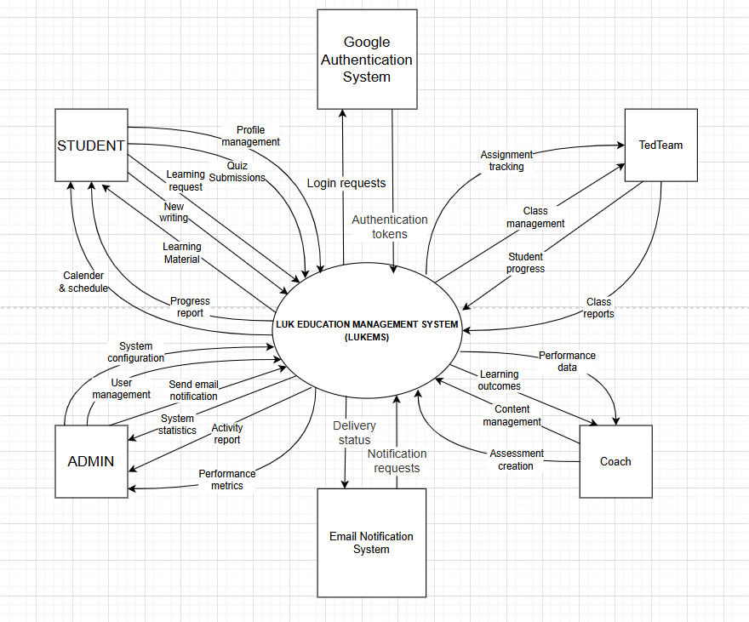

###### *Figure 01 - Context Diagram*

## 2. User Requirements

### 2.1 Actors

| **#** | **Actor** | **Description** |
| --- | --- | --- |
| 1 | Student | Learner who performs learning activities: quizzes, vlogs, profile updates, learning academic statistics, leaderboard,... |
| 2 | Ted Team | Working register, managing attendance of students,... |
| 3 | Coach | Teacher managing quizzes, grading, and materials,... |
| 4 | Admin | Manages users, schedules, classes, notifications, and reporting,... |

### 2.2 Use Cases

#### 2.2.1 Diagram(s)

##### 2.2.1.1 User Case Overview

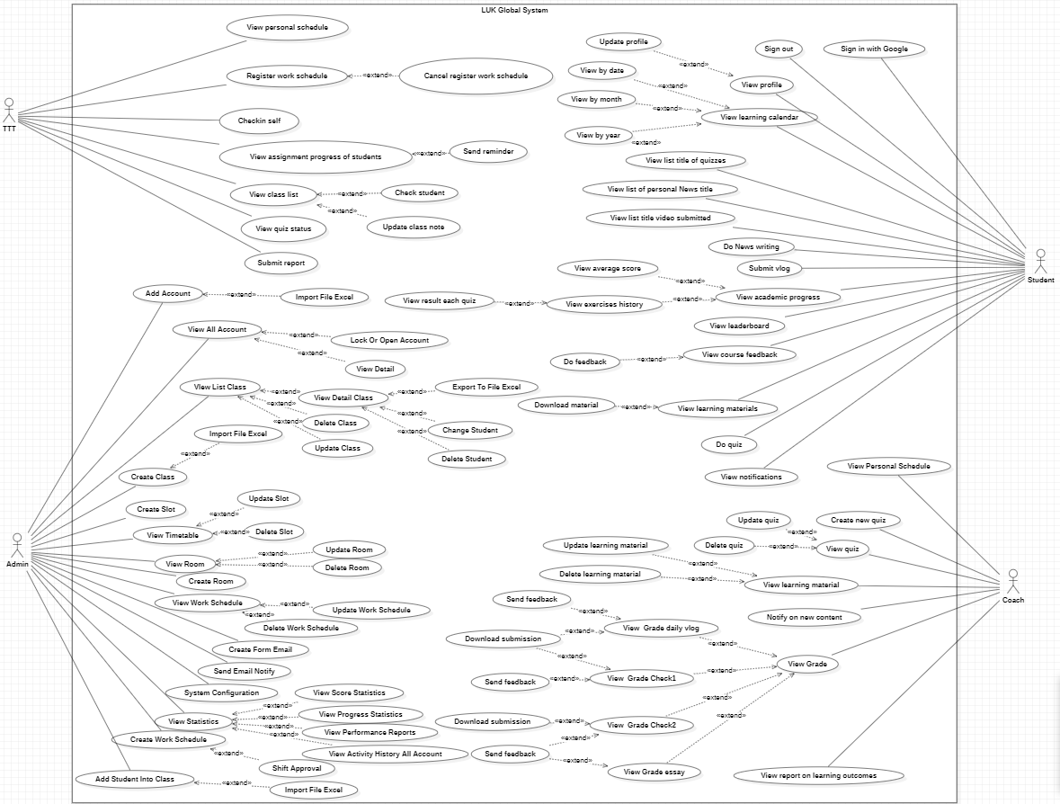

###### *Figure 02 - User Case Overview*

##### 2.2.1.2 User Case for Student

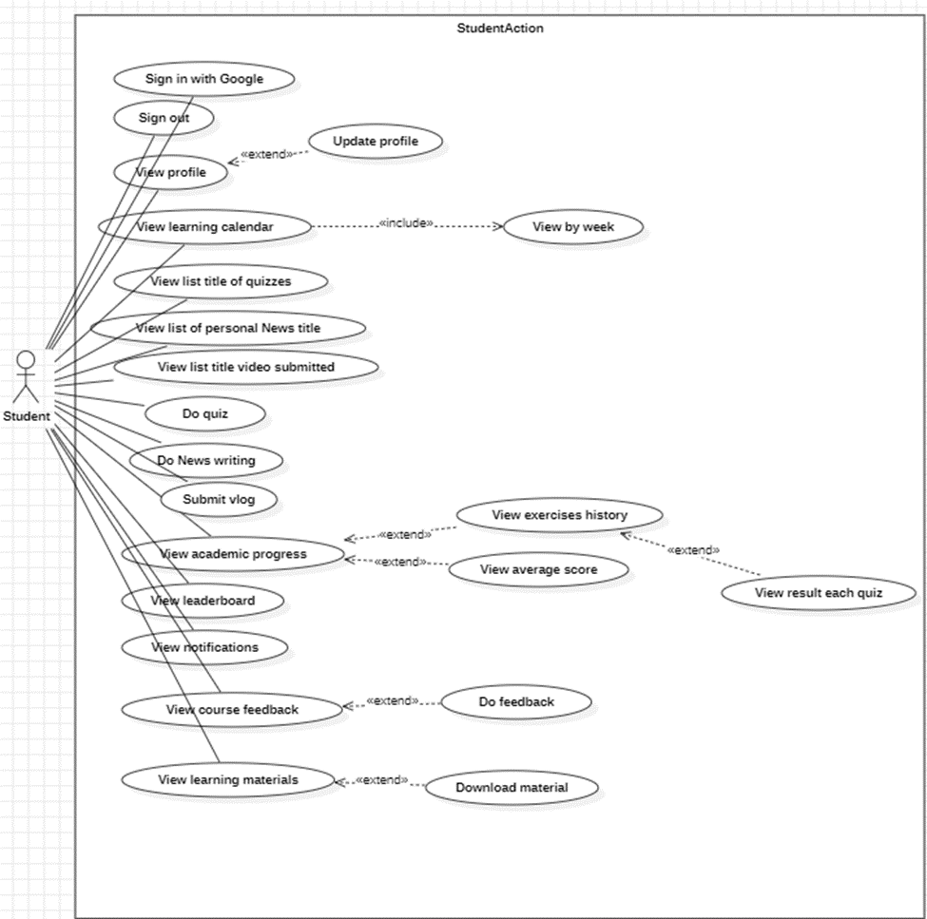

###### *Figure 03 - User Case for Student*

##### 2.2.1.3 User Case for Ted Team

###### *Figure 04 - User Case for Ted Team*

##### 2.2.1.4 User Case for Coach

###### *Figure 05 - User Case for Coach*

##### 2.2.1.5 User Case for Admin

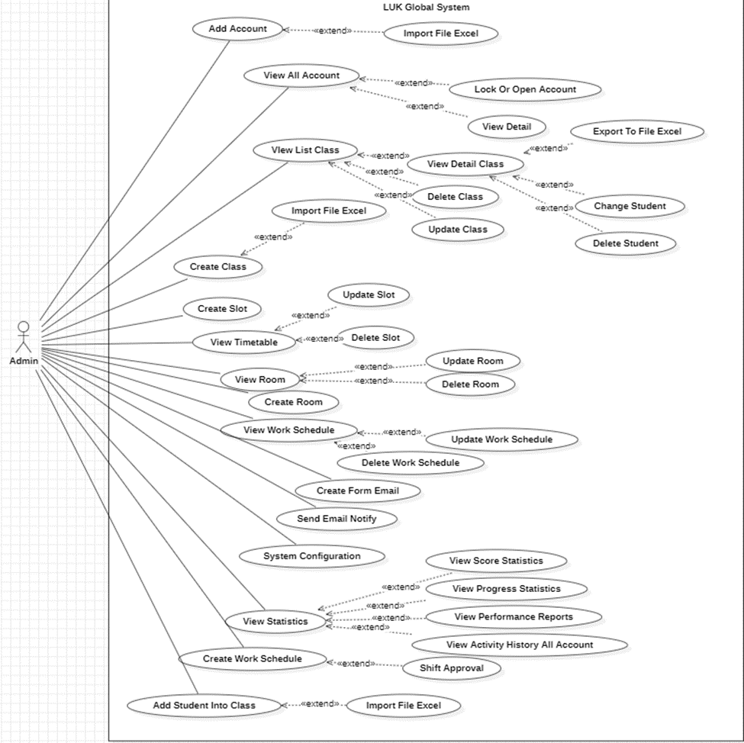

###### *Figure 06 - User Case for Admin*

#### 2.2.2 Descriptions

| **ID** | **Use Case** | **Actors** | **Use Case Description** |
| --- | --- | --- | --- |
| UC-1 | Sign in with Google | All | Access the account using the provided Gmail account |
| UC-2 | Sign out with Google | All | Log out when not in use |
| UC-3 | View and Update profile | All | View and update personal information in the profile anytime |
| UC-4 | List report on learning outcomes | Coach | View a report summarizing learning performance across all students |
| UC-5 | View statistics, score all accounts | Coach | View scores, ranking, and progress of all students |
| UC-6 | View activity history all accounts | Coach | See login, task, and page view history for student accounts |
| UC-7 | Grade submissions (vlog, etc.) | Coach | Grade student submissions for vlog, check-in, or essays |
| UC-8 | Send feedback on grades | Coach | Send written feedback after grading |
| UC-9 | Download student submissions | Coach | Download uploaded assignments from students |
| UC-10 | List learning materials | Coach | View available learning materials for assigned classes |
| UC-11 | Add learning materials | Coach | Upload or link new learning content (PDFs, videos, links) |
| UC-12 | Update learning materials | Coach | Edit metadata or files of existing materials |
| UC-13 | Delete learning materials | Coach | Permanently remove learning materials |
| UC-14 | List quiz | Coach | View list of quizzes organized by subject or module |
| UC-15 | Create quiz | Coach | Create a new quiz with title, questions, time, and subject |
| UC-16 | Update quiz | Coach | Modify title, questions, or subject of an existing quiz |
| UC-17 | Delete quiz | Coach | Remove a quiz if allowed by system policy |
| UC-18 | List personal schedule for coach | Coach | View upcoming class and event schedule by date |
| UC-19 | Notify new content | Coach | Trigger or auto-send notifications for new materials/quizzes |
| UC-20 | View all account student | Admin | Display a list of all student accounts in the system |
| UC-21 | View all accounts Ted Team | Admin | Display a list of all Ted Team member accounts in the system |
| UC-22 | View all accounts coach | Admin | Display a list of all coach accounts in the system |
| UC-23 | View all accounts admin | Admin | Display a list of all admin accounts in the system |
| UC-24 | Add account student | Admin | Add a new student account by providing the required user details |
| UC-25 | Add account Ted Team | Admin | Add a new Ted Team account by entering the required information |
| UC-26 | Add account coach | Admin | Add a new coach account to the system with appropriate details |
| UC-27 | Add account admin | Admin | Add a new admin account to the system with appropriate details |
| UC-28 | Import Excel file for accounts | Admin | Import a list of accounts into the system using an Excel file |
| UC-29 | Lock or unlock account | Admin | Lock or unlock a specific user account to restrict or restore access |
| UC-30 | View detailed account | Admin | Display detailed information about a selected user account |
| UC-31 | Search class | Admin | Search for classes by entering keywords or filter criteria |
| UC-32 | List class | Admin | Display a list of all classes available in the system |
| UC-33 | Add class | Admin | Create and add a new class by entering its details |
| UC-34 | Update class | Admin | Modify the details of an existing class |
| UC-35 | Delete class | Admin | Remove an existing class from the system |
| UC-36 | View detailed class | Admin | Display detailed information about a selected class |
| UC-37 | Import student to class by Excel file | Admin | Import a list of students into a class from an Excel file |
| UC-38 | Add student to class | Admin | Add a student to a specific class manually |
| UC-39 | Change student in class | Admin | Transfer or change the assigned class of a student |
| UC-40 | Delete student from class | Admin | Remove a student from a specific class |
| UC-41 | Search shift | Admin | Search for shifts using specific keywords or filters |
| UC-42 | List shift | Admin | Display all scheduled shifts in the system |
| UC-43 | Add shift | Admin | Add a new shift to the system by specifying details |
| UC-44 | Shift approval | Admin | Approve a proposed or newly added shift |
| UC-45 | Update timetable | Admin | Edit or update the timetable of a class or student |
| UC-46 | Delete timetable | Admin | Delete an existing timetable entry from the system |
| UC-47 | Create form email | Admin | Create a custom email template for notifications |
| UC-48 | Send email notify | Admin | Send email notifications to users |
| UC-49 | View statistics for all accounts | Admin | Display overall statistics for all user accounts |
| UC-50 | View scores for all accounts | Admin | Display the scores or grades of all users |
| UC-51 | View progress for all accounts | Admin | Show the learning progress of all users |
| UC-52 | View performance for all accounts | Admin | Display performance evaluation data for all users |
| UC-53 | View activity history for all accounts | Admin | View a history log of user activities |
| UC-54 | View learning calendar | Student | View their learning schedule |
| UC-54.1 | View by week | Student | View calendar week-by-week |
| UC-55 | View quizzes | Student | View the list of available quizzes |
| UC-56 | View News | Student | View personal news titles |
| UC-57 | View videos | Student | View submitted video |
| UC-58 | Do quiz | Student | Take a quiz |
| UC-59 | Write News | Student | Write a News |
| UC-60 | Submit Video/Vlog | Student | Submit a vlog for review |
| UC-61 | Academic progress | Student | View their academic progress |
| UC-61.1 | View exercises history | Student | View history of completed exercises. |
| UC-61.1.2 | View result each quiz | Student | View result of each quiz |
| UC-61.2 | View average score | Student | View average scores across quizzes, News, videos |
| UC-62 | View leaderboard | Student | View the leaderboard standings |
| UC-63 | View notifications | Student | View system notifications |
| UC-64 | View course feedback | Student | View feedback received for the course/coach/ted team |
| UC-65 | Do feedback | Student | Give a feedback on the course/coach/ted team |
| UC-66 | View learning materials | Student | View learning materials for each study day |
| UC-66.1 | Download material | Student | Downloads the learning material for prepare learning |
| UC-67 | View personal schedule | Ted Team | View the user's own work schedule |
| UC-68 | Register work schedule | Ted Team | Register the available working schedule |
| UC-69 | Cancel register work schedule | Ted Team | Cancel a previously registered work schedule |
| UC-70 | Checkin self | Ted Team | Perform self check-in for attendance |
| UC-71 | View assignment progress of students | Ted Team | View progress status of students' assignments |
| UC-72 | Send reminder | Ted Team | Send reminder to students regarding assignment progress |
| UC-73 | View class list | Ted Team | View the list of students in the assigned classes |
| UC-74 | Check student | Ted Team | Check student details in class |
| UC-75 | Update class note | Ted Team | Update class notes for the students |
| UC-76 | View quiz status | Ted Team | View students' status on quizzes |
| UC-77 | Submit report | Ted Team | Submit report about class or teaching activity |

## 3. Functional Requirements

### 3.1 System Functional Overview

#### 3.1.1 Screens Flow

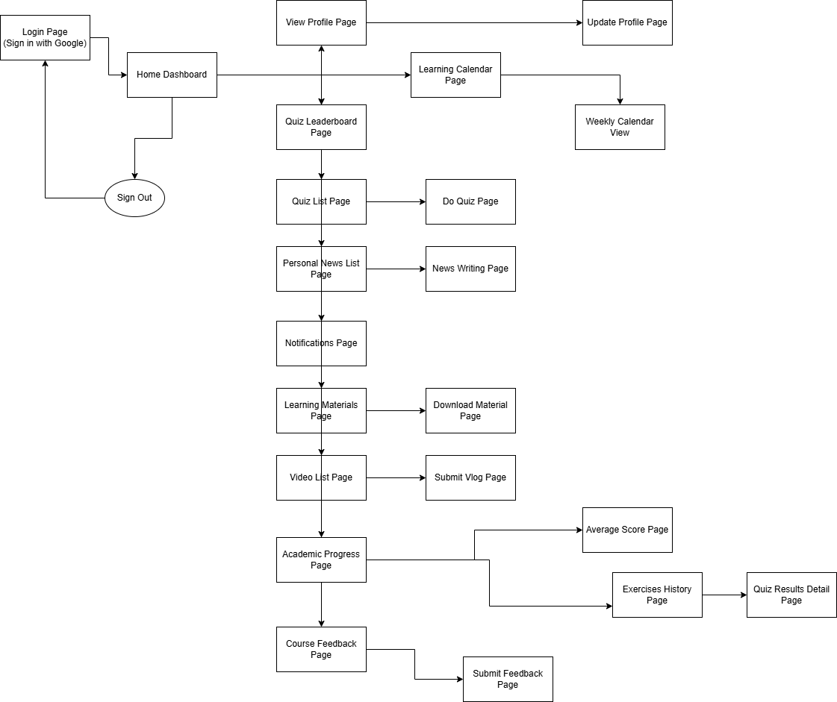

###### *Figure 07 - Screens Flow for Student*

#### 

###### *Figure 08 - Screens Flow for Coach*

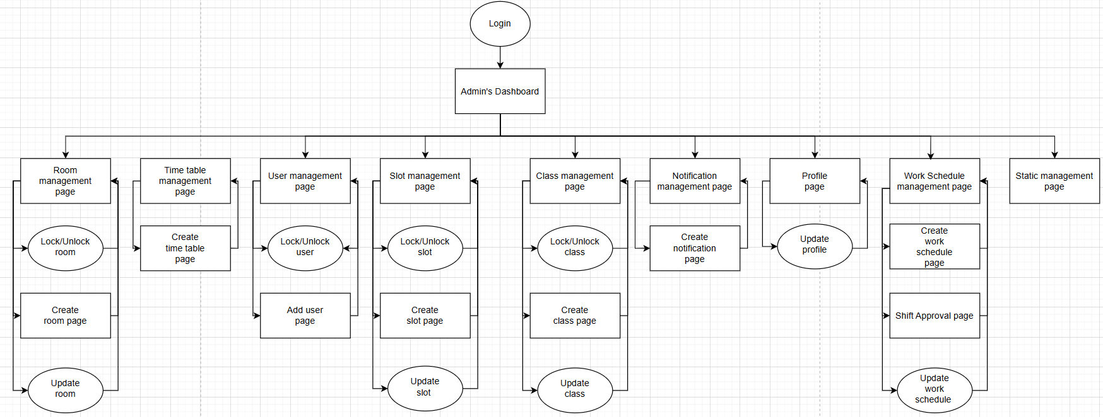

###### *Figure 09 - Screens Flow for Admin*

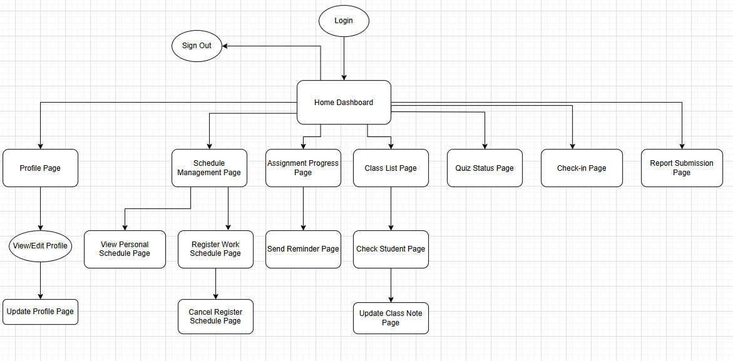

###### *Figure 10 - Screens Flow for TedTeam*

#### 3.1.2 Screen Descriptions

| **#** | **Feature** | **Screen** | **Description** |
| --- | --- | --- | --- |
| 1 | Login with Google | Login page | Authenticate user using Google account to access the system |
| 2 | Dash board of student | Home dashboard | Main navigation hub linking to all major pages and features. |
| 3 | View profile | View profile page | Displays user profile and allows updating personal information. |
| 4 | Update Profile | Update Profile page | Edit and update user account details such as name or email. |
| 5 | View learning calendar | Learning Calendar Page | Displays upcoming lessons, deadlines, and activities. |
| 6 | View by Week | Learning Calendar Page | View the learning calendar filtered by week. |
| 7 | View list quizzes | Quizzes Page | List all available quizzes for the student. |
| 8 | Do quiz | Do Quiz page | Start and complete quizzes provided. |
| 9 | View list News | News list page | Display all title News submitted. |
| 10 | News writing | News writing page | Form for enter information and submit News |
| 11 | View list of video | Video list page | Display all title and video submitted. |
| 12 | View leaderboard | Leaderboard page | Display leaderboard of student |
| 13 | View notification | Notification page | Display all notifications from system |
| 14 | View learning material | Learning material page | View all material system provided |
| 15 | View academic progress | Academic progress page | View statistic of learning journey |
| 16 | View average score | Average score page | View average score of individual |
| 17 | View exercise history | Exercise history page | Display all activities student do in this system like quiz, News, video submitted |
| 18 | View quiz result | Quiz result page | Display result of each quiz |
| 19 | View course feedback | Course feedback page | View all feedback of students in system |
| 20 | Do feedback | Submit feedback page | Display form to enter information of feedback |
| 21 | View personal schedule | View Personal Schedule Page | Display the user's registered work schedule |
| 22 | Register work schedule | Register Work Schedule Page | Allow user to register a work schedule |
| 23 | Cancel registered schedule | Cancel Register Schedule Page | Cancel or delete previously registered work schedule. |
| 24 | View assignment progress | Assignment Progress Page | Display the progress of students on their assigned tasks |
| 25 | Send reminder | Send Reminder Page | Allow user to send reminders to students regarding assignments |
| 26 | View class list | Class List Page | Display list of students in a class. |
| 27 | Check student | Check Student Page | View detailed student information such as attendance or performance |
| 28 | Update class notes | Update Class Note Page | Update and manage class notes related to the student. |
| 29 | View quiz status | Quiz Status Page | Show students' progress or status on quizzes |
| 30 | Check-in | Check-in Page | Allow user to perform self check-in |
| 31 | Submit report | Report Submission Page | Allow user to submit teaching or activity reports |
| 32 | List report on learning outcomes | List report on learning outcomes page | Allows Coaches to view a list of learning outcome reports for all students, including progress, task completion, and evaluation comments. |
| 33 | View activity history all accounts | Activity history page | View activity history of all student accounts including login times, task actions, and timestamps. |
| 34 | View ranking overview | Statistics and scores page | Display student ranking by score |
| 35 | View top/high/low scores | Statistics and scores page | Display highest, lowest, and top performer scores. |
| 36 | Filter statistics by class/contest | Statistics and scores page | Filter ranking and statistics by class or contest. |
| 37 | Select task to grade | Grade submissions page | Select a task type (vlog, Check1, Check2, essay) to grade. |
| 38 | View submissions list | Grade submissions page | View list of student submissions for selected task. |
| 39 | Enter and save grade | Grade submissions page | Enter grade and save it to the system. |
| 40 | View graded submissions list | Send feedback page | View list of graded submissions eligible for feedback. |
| 41 | Enter feedback | Send feedback page | Type and submit written feedback for graded submissions. |
| 42 | Select task type to download | Download submissions page | Select task type (vlog, Check1, Check2, essay) to view submissions. |
| 43 | View submission list | Download submissions page | View list of student submissions for selected task. |
| 44 | Download submission file | Download submissions page | Download a specific student’s submission file. |
| 45 | View List learning materials | Learning materials page | View and filter all learning materials for classes (PDFs, videos, slides, links). |
| 46 | Add Learning Material | Add Learning Material | Allows coach to upload or link new learning materials. |
| 47 | Update Learning Material | Update Learning Material | Enables editing or replacing existing learning materials. |
| 48 | Delete Learning Material | Delete Learning Material | Allows deletion of learning materials with confirmation. |
| 49 | List Quiz | Quiz List | Shows all quizzes assigned to coach’s classes with filters. |
| 50 | Create Quiz | Create Quiz | Provides form to create new quizzes with title, subject, and questions. |
| 51 | Update Quiz | Update Quiz | Allows updating quiz details and questions. |
| 52 | Delete Quiz | Delete Quiz | Enables quiz deletion with confirmation and updates the list. |
| 53 | Personal Schedule | Personal Schedule | Displays coach’s schedule including classes and events with date filters. |
| 54 | Notify New Content | Notify New Content | Lets coach send notifications for new content; system can auto-notify. |
| 55 | View Student Accounts | User Management - Student | Admin views, searches, filters, and manages all student accounts. |
| 56 | View Ted Team Accounts | User Management - Ted Team | Admin views, searches, filters, and manages all Ted Team accounts. |
| 57 | View Coach Accounts | User Management - Coach | Admin views, searches, filters, and manages all Coach accounts. |
| 58 | View Admin Accounts | User Management - Admin | Admin views, searches, filters, and manages all Admin accounts. |
| 59 | Add Student Account | Add New Student Account | Admin adds a new student account by entering required details. |
| 60 | Add Ted Team Account | Add New Ted Team Account | Admin adds a new Ted Team account by entering required details. |
| 61 | Add account Coach | Add New Coach Account Page | Admin adds a new Coach account by entering email and status. |
| 62 | Add account Admin | Add New Admin Account Page | Admin adds a new Admin account by entering email and status. |
| 63 | Import Excel file for accounts | Import Excel | Admin imports user accounts from an Excel file into the system. |
| 64 | Lock or unlock account | User Management | Admin locks or unlocks user account access. |
| 65 | View detailed account | Account Detail View | Admin views detailed information of a specific user account. |
| 66 | Search class | Class Management | Admin searches for classes by keyword. |
| 67 | List class | Class Management | Admin views a list of all classes with key information. |
| 68 | Add class | Add Class Form | Admin creates a new class by entering class information. |
| 69 | Update class | Edit Class | Admin updates an existing class’s name or status. |
| 70 | Delete class | Class Management | Admin deletes an existing class after confirmation. |
| 71 | View detailed class | Class Detail View | Admin views detailed information about a specific class. |
| 72 | Import student to class by Excel file | Import Student List | Admin imports student list into class by uploading Excel file. |
| 73 | Add student to class | Add Student to Class | Admin manually adds a student to an existing class. |
| 74 | Change student in class | Change Student Form | Admin replaces a student in a class with another student. |
| 75 | Delete student from class | Class Detail – Student List | Admin removes a student from the class after confirmation. |
| 76 | Search shift | Shift Management | Admin searches for shifts using filters or keywords. |
| 77 | List shift | Shift Management | Admin views a list of all shifts with basic shift details. |
| 78 | Add shift | Shift Management | Admin adds a new shift by specifying class, date, and time via the Add Shift form. |
| 79 | Shift approval | Shift Management | Admin approves pending shifts to activate them in the system. |
| 80 | Update timetable | Time Table Management | Admin edits timetable entries (class, date, time, coach) and saves updates. |
| 81 | Delete timetable | Time Table Management | Admin deletes a timetable entry after confirmation. |
| 82 | Create form email | Email Template Management | Admin creates and saves new email templates for notifications like shift assignments, approvals, or timetable changes. |
| 83 | Send Email Notify | Send Email Notify Page | Admin sends email notifications to selected users using templates or custom content. |
| 84 | View statistics for all accounts | View Account Statistics Page | Admin views summarized stats of all accounts including activity, registration, shifts, and progress. |
| 85 | View scores for all accounts | View Score Page | Admin views detailed learning scores and performance metrics for all users. |
| 86 | View progress for all accounts | View Progress Page | Admin monitors progress of all users including shift participation, tasks, milestones, attendance. |
| 87 | View performance for all accounts | View Performance Page | Admin views consolidated performance overview: attendance, evaluations, task efficiency, engagement. |
| 88 | View activity history for all accounts | View Activity History Page | Admin monitors user activity logs including logins, actions, timestamps, and system interactions. |

#### 3.1.3 Screen Authorization

| **Screen** | **Coach** | **Student** | **Ted Team** | **Admin** |
| --- | --- | --- | --- | --- |
| Login page | X | X | X | X |
| View profile page | X | X | X | X |
| Update Profile page | X | X | X | X |
| Learning Calendar Page |  | X |  |  |
| Quizzes Page |  | X |  |  |
| Do Quiz page |  | X |  |  |
| News list page |  | X |  |  |
| News writing page |  | X |  |  |
| Video list page |  | X |  |  |
| Leaderboard page |  | X |  |  |
| Notification page |  | X |  |  |
| Learning material page |  | X |  |  |
| Academic progress page |  | X |  |  |
| Academic progress page |  | X |  |  |
| Average score page |  | X |  |  |
| Exercise history page |  | X |  |  |
| Quiz result page |  | X |  |  |
| Course feedback page |  | X |  |  |
| Submit feedback page |  | X |  |  |
| Send Feedback | X |  |  |  |
| Statistics Overview | X |  |  |  |
| Activity Logs | X |  |  |  |
| List report o learning outcomes | X |  |  |  |
| View statistics, score all accounts | X |  |  |  |
| View activity history all accounts | X |  |  |  |
| View Learning Materials | X |  |  |  |
| Create Learning Materials | X |  |  |  |
| Update Learning Materials | X |  |  |  |
| Delete Learning Materials | X |  |  |  |
| View Quiz | X |  |  |  |
| Create Quiz | X |  |  |  |
| Update Quiz | X |  |  |  |
| Delete Quiz | X |  |  |  |
| Personal Schedule | X |  |  |  |
| Grade Submissions | X |  |  |  |
| Room management page |  |  |  | X |
| Create room page |  |  |  | X |
| Time table management page |  |  |  | X |
| Create time table page |  |  |  | X |
| User management page |  |  |  | X |
| Add user page |  |  |  | X |
| Slot management page |  |  |  | X |
| Create slot page |  |  |  | X |
| Class management page |  |  |  | X |
| Create class page |  |  |  | X |
| Notification management page |  |  |  | X |
| Create notification page |  |  |  | X |
| Work Schedule management page |  |  |  | X |
| Create work schedule page |  |  |  | X |
| Shift Approval page |  |  |  | X |
| Static management page |  |  |  | X |

#### 3.1.4 Non-Screen Functions

| **#** | **Feature** | **System Function** | **Description** |
| --- | --- | --- | --- |
| 1 | Notification | Auto Notify New Content | System automatically sends notification to students when new materials/quizzes are added. (UC-19) |
| 2 | Notification | Scheduled Reminder | System automatically sends reminders to students about pending assignments (UC-72). Runs via batch/cron job daily. |
| 3 | User Management | Import Accounts from Excel | API or background job processes bulk import of user accounts from Excel files. (UC-27, UC-36) |
| 4 | Reporting | Batch Generate Learning Reports | Scheduled batch job that generates learning outcome reports per class or contest for coaches/admin. |
| 5 | Activity Logging | System Activity Logger | Background service that logs user activities (login, submissions, page visits) for UC-06. |
| 6 | File Processing | Video Upload & Processing | Service handles uploading, transcoding, and storing videos submitted by students (UC-60). |
| 7 | Backup | Database Backup Job | Scheduled batch job to perform daily backup of database to ensure data integrity and recovery. |
| 8 | Email | Send Email Notifications | API or service that sends templated email notifications (UC-47, UC-19). |

#### 3.1.5 Entity Relationship Diagram

###### *Figure 11 - Entity Relationship Diagram*

**Entities Description**

| **#** | **Entity** | **Description** |
| --- | --- | --- |
| 1 | Users | Stores user information including roles (Student, Coach, TedTeam, Admin). Acts as the base entity for other tables. |
| 2 | Classes | Manages class details. References Users for the coach responsible for the class. |
| 3 | ClassCalendar | Defines schedules for classes. References Classes, Rooms, and Slots for full scheduling information. |
| 4 | ClassScores | Records scores of users in classes. References both Users and Classes. |
| 5 | Assignments | Stores assignment tasks per class. References Classes and the assigning User (e.g., Coach or TedTeam). |
| 6 | AssignmentSubmissions | Stores submissions of assignments. References Assignments and the submitting User. |
| 7 | Quizzes | Defines quizzes assigned to a class. References Classes and the creator User. |
| 8 | Questions | Stores individual questions belonging to quizzes. References Quizzes. |
| 9 | QuizSubmissions | Stores attempts made by users for quizzes. References Quizzes and Users. |
| 10 | QuestionSubmissions | Stores per-question answers in a quiz attempt. References QuizSubmissions and Questions. |
| 11 | Documents | Stores learning resources (PDFs, videos, links). May reference Classes or be general-purpose. |
| 12 | Notifications | Contains system-generated notifications. Typically references Users as recipients. |
| 13 | Feedback | Stores feedback given to or from users. References Users and possibly Classes or Assignments. |
| 14 | Attendance | Tracks attendance per user per class session. References Users and ClassCalendar. |
| 15 | Rooms | Stores room information used in scheduling. Referenced by ClassCalendar. |
| 16 | Slots | Defines time slots (e.g., morning, afternoon). Referenced by ClassCalendar. |
| 17 | RequestSchedule | Allows users to register preferred working schedules. References Users. |
| 18 | News | Stores news articles created by users. References the submitting User. |

### 3.3 UC-01-Login

| **Use Case ID** | **UC-01** | **Use Case Name** | **Sign in with Google** |
| --- | --- | --- | --- |
| Created By | PhuongLDA | Date Created | 22 May 2025 |
| Primary Actor | All | Secondary Actor | — |
| Description | To access the account, simply log in using the provided Gmail address. Enter the email and password, and follow any verification steps if required. Once signed in, you’ll be directed to your inbox or account dashboard. Make sure you're on a secure connection, and contact support if you run into any issues. | | |
| Trigger | User chooses to sign in with Google account. | | |
| Pre-conditions | User must have an existing Google account. | | |
| Post-conditions | User is authenticated and logged into the system. | | |
| Basic flow | 1. User clicks “Sign in with Google”.  2. System redirects to Google OAuth.  3. User enters credentials and consents.  4. System verifies credentials.  5. User is logged in and redirected to homepage. | | |
| Alternative flow | 1. User cancels Google sign-in → system shows login cancelled message.  2. Google authentication fails → system shows error and prompts retry.Please try again later.” (M0602) | | |
| Exception | Google OAuth service unavailable or times out → System displays: MSG048  Invalid or misconfigured OAuth client → System displays: MSG0489  User’s Google account is suspended or disabled → System displays: MSG050  Network issue during authentication → System displays: *MSG051*  Google token verification fails → System displays: MSG052  Unexpected server-side error during login → System displays: MSG053 | | |
| Business rules | BR-154, BR-155, BR-156, BR-157 | | |

| **Screen** | | Menu page,Login | | | | |
| --- | --- | --- | --- | --- | --- | --- |
| **Description** | | To access the account, simply log in using the provided Gmail address. Enter the email and password, and follow any verification steps if required. Once signed in, you’ll be directed to your inbox or account dashboard. Make sure you're on a secure connection, and contact support if you run into any issues. | | | | |
| **Screen Access** | | At homepage, click to button in dashboard | | | | |
| Screen Content | | | | | | |
| **Item** | | **Type** | **Data** | | **Description** | |
| Sign in button | | Button | “Sign in with Google” | | Button to start Google sign-in | |
| Google login popup | | Popup form | Email, Password | | Google login interface | |
| Error message area | | Text | Error text | | Displays error message when sign-in fails | |
| Loading spinner | | Animation | - | | Shows while sign-in process is ongoing | |
| Screen Actions | | | | | | |
| **Action Name** | **Description** | | | **Success** | | **Failure** |
| Click “Sign in with Google” | User clicks the Google sign-in button | | | Google OAuth window opens | | - |
| Enter credentials | User enters email and password | | | System authenticates successfully | | Authentication error displayed |
| Authenticate user | System verifies login information | | | Sign-in success, redirect to dashboard | | Sign-in error displayed |

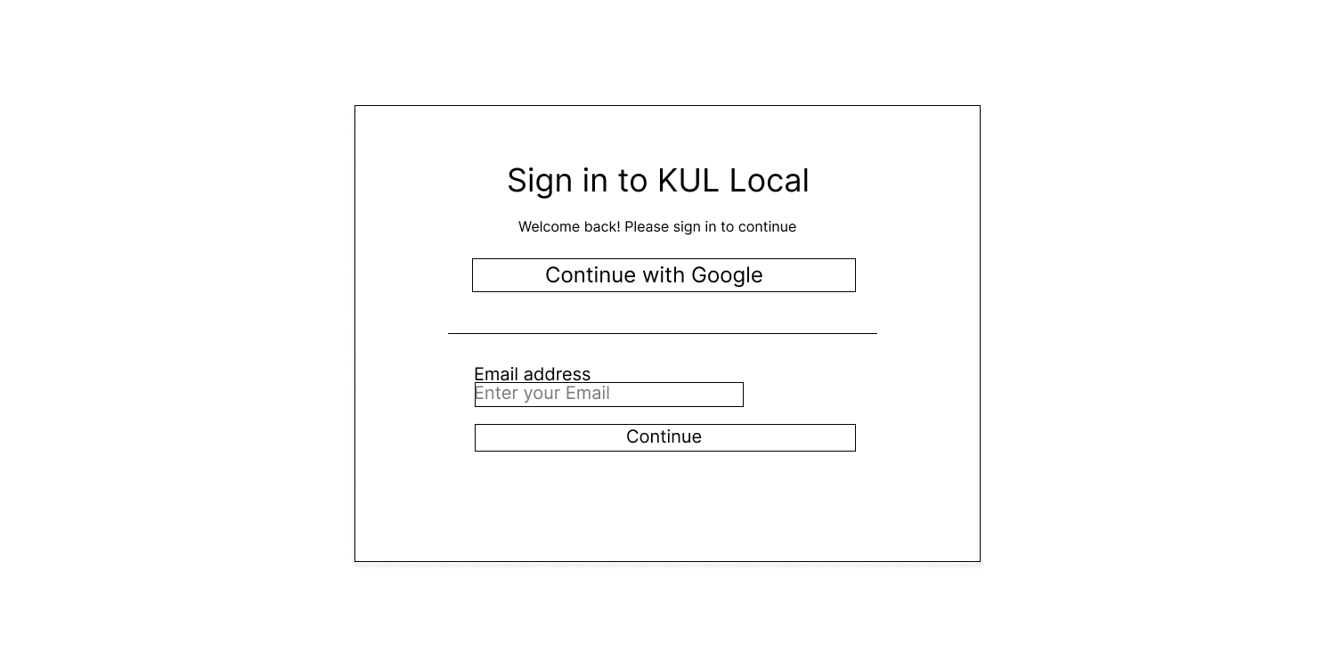

###### *Figure 12 - Login*

### 3.3 UC-02-Logout

| **Use Case ID** | **UC-01** | **Use Case Name** | **Sign out with Google** |
| --- | --- | --- | --- |
| Created By | PhuongLDA | Date Created | 22 May 2025 |
| Primary Actor | All | Secondary Actor | — |
| Description | For security purposes, please make sure to log out of your account when it is not in use. This helps prevent unauthorized access and protects your personal and organizational data, especially when using shared or public devices. | | |
| Trigger | User chooses to sign out. | | |
| Pre-conditions | | User is currently logged in. | | --- |      |  | | --- | | | |
| Post-conditions | User session is terminated and logged out. | | |
| Basic flow | 1. User clicks “Sign out”.  2. System terminates session.  3. User redirected to login page. | | |
| Alternative flow | 1. Sign out fails due to network error → system shows error and retries. | | |
| Exception | Network error during sign out → System displays: MSG054  Server error while terminating session → System displays: MSG055  Session already expired or invalid → System displays: MSG056 | | |
| Business rules | BR-158, BR-159, BR-160, BR-161 | | |

| **Screen** | | Menu page, Sign out with Google | | | | |
| --- | --- | --- | --- | --- | --- | --- |
| **Description** | | For security purposes, please make sure to log out of your account when it is not in use. This helps prevent unauthorized access and protects your personal and organizational data, especially when using shared or public devices. | | | | |
| **Screen Access** | | At homepage, click to button in dashboard | | | | |
| Screen Content | | | | | | |
| **Item** | | **Type** | **Data** | | **Description** | |
| Sign out button | | Button | “Sign Out” | | Button to sign out of the account | |
| Confirmation dialog | | Dialog | “Are you sure?” | | Confirmation dialog (if any) | |
| Message area | | Text | Success/Error text | | Displays success or error messages | |
| Loading spinner | | Animation | - | | Shows while sign-in process is ongoing | |
| Screen Actions | | | | | | |
| **Action Name** | **Description** | | | **Success** | | **Failure** |
| Click “Sign Out” | User clicks the sign-out button | | | Session ends, redirect to login page | | Sign-out error displayed |
| Confirm sign out | User confirms sign out (if prompted) | | | Sign-out successful | | Sign-out cancelled |

### 

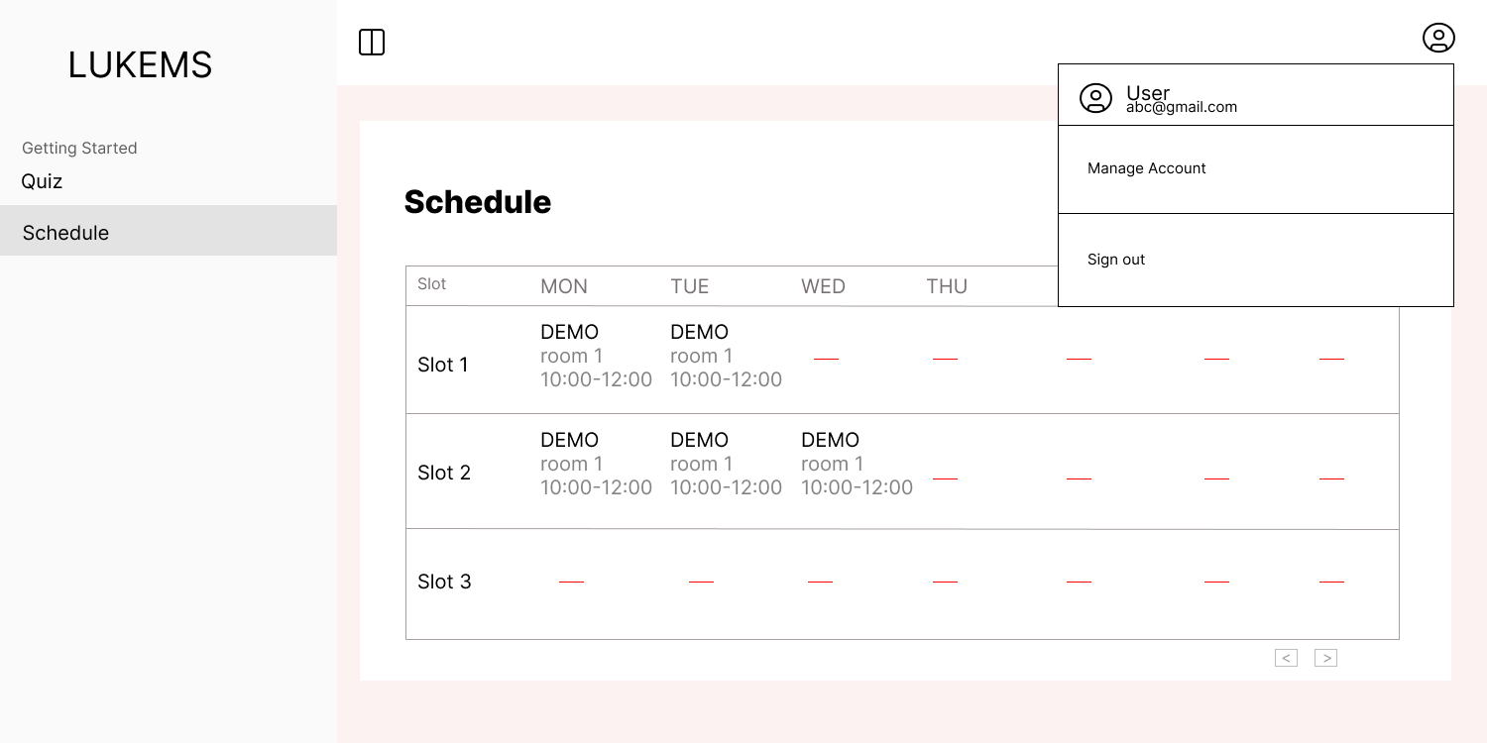

###### *Figure 13 - Logout*

### 3.4 UC-03-View and Update Profile

| **Use Case ID** | **UC-01** | **Use Case Name** | **View and Update Profile** |
| --- | --- | --- | --- |
| Created By | PhuongLDA | Date Created | 22 May 2025 |
| Primary Actor | All | Secondary Actor | — |
| Description | View and update personal information in the profile anytime, such as name, date of birth, address, etc. | | |
| Trigger | User chooses to view or update profile. | | |
| Pre-conditions | | User is currently logged in. | | --- |      |  | | --- | | | |
| Post-conditions | User’s profile information is updated and saved. | | |
| Basic flow | 1. User opens profile page.  2. User views current info.  3. User edits fields.  4. User saves changes.  5. System validates and updates profile.  6. Confirmation shown to user. | | |
| Alternative flow | 1. Validation error → system shows error messages and prompts correction. | | |
| Exception | Session expired or user not authenticated → System displays: MSG057  Server error during profile update → System displays: MSG058  Profile update failed due to database issue → System displays: MSG059 | | |
| Business rules | BR-162, BR-163, BR-164, BR-165 | | |

| **Screen** | | Menu page, View and Update Profile | | | | |
| --- | --- | --- | --- | --- | --- | --- |
| **Description** | | View and update personal information in the profile anytime, such as name, date of birth, address, etc. | | | | |
| **Screen Access** | | At homepage, click to button in dashboard | | | | |
| Screen Content | | | | | | |
| **Item** | | **Type** | **Data** | | **Description** | |
| Profile form fields | | Form | Name, Date of Birth, Address, Email, Phone | | Personal information fields | |
| Edit button | | Button | “Edit” | | Enables editing of profile information | |
| Save button | | Button | “Save” | | Saves changes | |
| Cancel button | | Button | “Cancel” | | Cancels changes | |
| Screen Actions | | | | | | |
| **Action Name** | **Description** | | | **Success** | | **Failure** |
| Click “Edit” | User enables edit mode | | | Fields become editable | | - |
| Update profile info | User modifies profile information | | | Input accepted | | Validation errors displayed |
| Click “Save” | User saves changes | | | Information saved successfully | | Save error displayed |
| Click “Cancel” | User cancels changes | | | Returns to view-only mode | | - |

### 

###### *Figure 14 - View And Update Profile*

### 

### 3.5 UC-04-List report on learning outcomes

#### 

#### 

| **Use Case ID** | **UC04** | **Use Case Name** | **List report on learning outcomes** |
| --- | --- | --- | --- |
| Created By | AnhTT | Date Created | 22 May 2025 |
| Primary Actor | Coach | Secondary Actor | – |
| Description | Allows Coaches to view a list of learning outcome reports for all students, including progress, task completion, and evaluation comments. | | |
| Priority | Must have | | |
| Trigger | Coach selects the “Learning Outcomes Report” option from the system menu. | | |
| Pre-conditions | Coach is logged into the system.  Coach has the “Coach” role assigned. | | |
| Post-conditions | The system displays the requested learning outcomes report. | | |
| Basic flow | 1. Coach selects learning outcomes report.  2. System displays overview info, average scores, and total students.  3. Coach views detailed reports by contest or class. | | |
| Alternative flow | Alternative flow 1: Validation error → system shows error messages and prompts correction. | | |
| Exception | Session expired or user not authenticated → System displays: MSG057  Server error during data loading → System displays: MSG055  Failed to load academic progress data → System displays: MSG027  Failed to load quiz results → System displays: MSG029  Failed to load average score data → System displays: MSG030  Failed to load leaderboard data → System displays: MSG031 | | |
| Business rules | BR-01,BR-02,BR-03 | | |

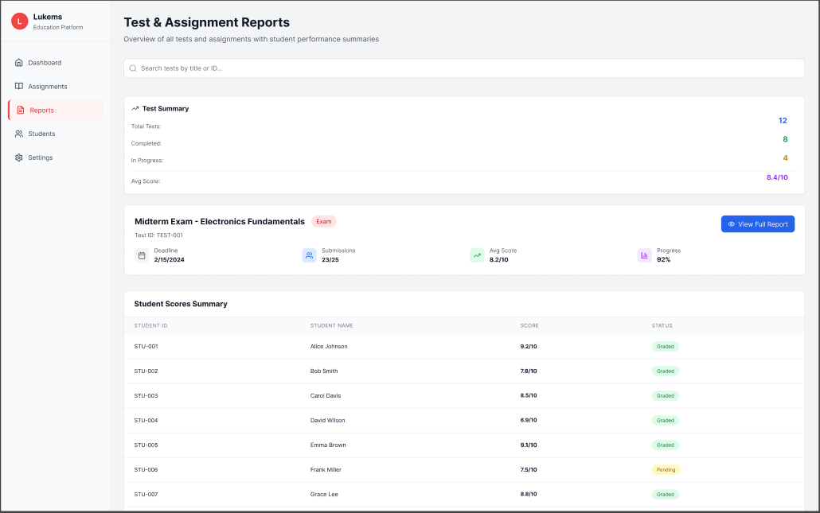

###### *Figure 15 - List report on learning outcomes*

| **Screen** | | Menu page, View List report on tests and assignments | | | | |
| --- | --- | --- | --- | --- | --- | --- |
| **Description** | | List report on all tests and assignments with student performance summaries | | | | |
| **Screen Access** | | At homepage, click the “Reports” button in the dashboard menu | | | | |
| **Screen Content** | | | | | | |
| **Item** | | **Type** | **Data** | | **Description** | |
| Test Summary | | Text |  | | Displays overall summary metrics for all tests and assignments | |
| Total Tests | | Text/Number | Calculated total | | Shows total number of created tests | |
| Completed Tests | | Text/Number | Calculated total | | Shows number of tests that are completed | |
| Tests In Progress | | Text/Number | Calculated total | | Shows number of tests still in progress | |
| Average Score | | Text/Number | Average of scores | | Shows average performance score across all tests | |
| Test Details | | Text |  | | Displays specific test information | |
| Test Title | | Text | Test name | | Displays the title of the selected test | |
| Test ID | | Text | Unique identifier | | Unique ID code of the test | |
| Deadline | | Date | Due date | | Submission deadline for the test | |
| Submissions | | Text/Number | Submission count | | Number of students who submitted the test | |
| Test Average Score | | Text/Number | Average score | | Average score for the test | |
| Test Progress | | Text/Number | Percentage | | Completion progress of the test | |
| Student Scores Summary | | Table | Student scores | | Displays individual student scores and grading status | |
| Student ID | | Text | Unique student ID | | ID assigned to each student | |
| Student Name | | Text | Student names | | Names of students who submitted | |
| Score | | Text/Number | Student score | | Score of each student | |
| Status | | Text | Grading status | | Graded or Pending status | |
| Screen Actions | | | | | | |
| **Action Name** | **Description** | | | **Success** | | **Failure** |
| View overview | View overall test and assignment summary | | | Overview displayed successfully | | Error loading overview data |
| View full report | View detailed report of a selected test | | | Detailed report displayed successfully | | Error loading detailed report |
| View student scores | View list of individual student scores | | | Student scores displayed successfully | | Error loading student scores |

### 

### 3.6 UC-05-View statistics, score all accounts

#### 

| **Use Case ID** | **UC-05** | **Use Case Name** | **View statistics, score all account** |
| --- | --- | --- | --- |
| Created By | AnhTT | Date Created | 24 May 2025 |
| Primary Actor | Coach | Secondary Actor | – |
| Description | Allows coaches to see an overview of students' scores, progress, and learning status | | |
| Priority | Must have | | |
| Trigger | The coach selects the “Statistics Learning Outcomes” option from the system menu | | |
| Pre-conditions | Coach is logged into the system | | |
| Post-conditions | The system displays the statistics and scores for all accounts | | |
| Basic flow | 1. Coach selects the Statistics Learning Outcomes option  2. System displays ranking overview and statistics  3. Coach filters data as needed | | |
| Alternative flow | Alternative flow 1: Filter validation error → system shows error messages and prompts correction. | | |
| Exception | Session expired or user not authenticated → System displays: MSG057  Server error during data loading → System displays: MSG055  Failed to load academic progress data → System displays: MSG027  Failed to load average score data → System displays: MSG030  Failed to load leaderboard data → System displays: MSG031  Failed to load score distribution chart → System displays: MSG060  Failed to load assignment completion status chart → System displays: MSG061 | | |
| Business rules | BR-04, BR-02, BR-03 | | |

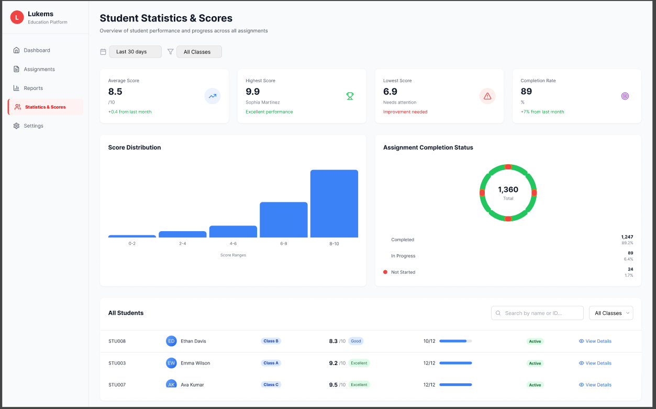

###### *Figure 16 -View statistics, score all account*

| **Screen** | | Menu page, View statistics, score all account | | | | |
| --- | --- | --- | --- | --- | --- | --- |
| **Description** | | Allows coaches to see an overview of students' scores, progress, and learning status | | | | |
| **Screen Access** | | At homepage, click to button in dashboard | | | | |
| **Screen Content** | | | | | | |
| **Item** | | **Type** | **Data** | | **Description** | |
| Average Score | | Number | Average score | | Displays the average score across all students | |
| Highest Score | | Number | Top score | | Displays the highest score among all students | |
| Lowest Score | | Number | Lowest score | | Displays the lowest score among all students | |
| Completion Rate | | Number | Percentage | | Shows the percentage of assignments completed | |
| Score Distribution | | Bar chart | Score ranges | | Visualizes how scores are distributed in predefined ranges | |
| Assignment Completion Status | | Doughnut chart | Completion counts | | Shows counts and percentages of completed, in progress, and not started assignments | |
| All Students | | Table | Student list with scores | | Displays all students with their scores, class, status, and progress | |
| Filter by date/class | | Filter | Date range / Class list | | Enables filtering data by date range or class selection | |
| Screen Actions | | | | | | |
| **Action Name** | **Description** | | | **Success** | | **Failure** |
| View overview | View average, highest, and lowest scores overview | | | Overview displayed successfully | | Error loading overview data |
| View score distribution | Show score distribution chart | | | Score distribution displayed successfully | | Error loading score distribution |
| View assignment status | Display assignment completion status | | | Assignment status displayed successfully | | Error loading assignment status |
| View student list | View full list of student scores and statuses | | | Student list displayed successfully | | Error loading student list |

### 3.7 UC-06-View activity history all accounts

| **Use Case ID** | **UC-06** | **Use Case Name** | **View activity history all accounts** |
| --- | --- | --- | --- |
| Created By | AnhTT | Date Created | 28 May 2025 |
| Primary Actor | Coach | Secondary Actor | – |
| Description | Allows coaches to view the activity history of all student accounts in the system. The history includes login times, task submissions, accessed modules, and timestamps for each action. | | |
| Priority | Must have | | |
| Trigger | The coach selects the “Activity History” option from the system menu | | |
| Pre-conditions | Coach is logged into the system | | |
| Post-conditions | The system displays the activity history of all student accounts | | |
| Basic flow | 1. Coach selects the Activity History option  2. System displays activity log table  3. Coach filters data as needed | | |
| Alternative flow | Alternative flow : Filter validation error → system shows error messages and prompts correction: MSG02, MSG08 | | |
| Exception | Session expired or user not authenticated → System displays: MSG057  Server error during data loading → System displays: MSG055  Failed to load exercise history → System displays: MSG028  Network error → System displays: MSG051  Failed to load activity log data → System displays: MSG062  Failed to load activity timeline → System displays: MSG063  Activity filter operation failed → System displays: MSG064 | | |
| Business rules | BR-01, BR-02, BR-03,BR-04 | | |

### 

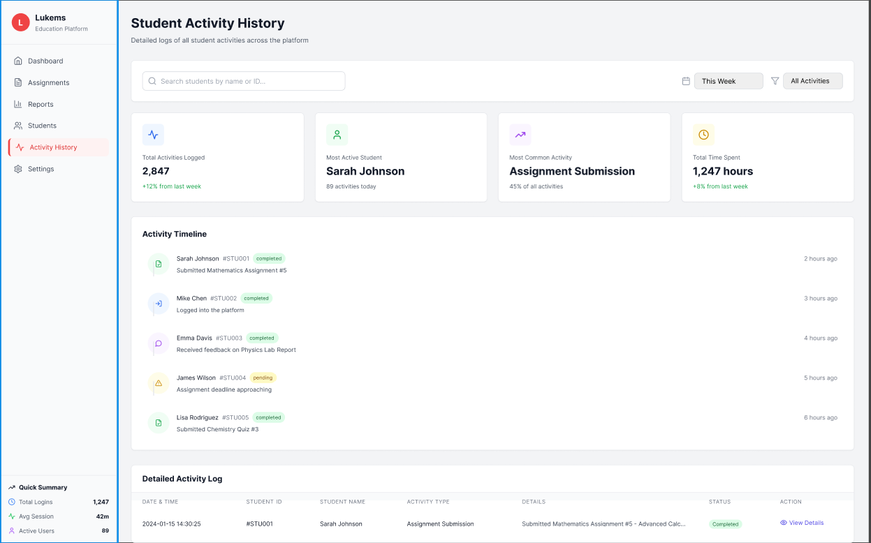

###### *Figure 17 - View activity history all accounts*

| **Screen** | | Menu page, View activity history all accounts | | | | |
| --- | --- | --- | --- | --- | --- | --- |
| **Description** | | Allows coaches to view the activity history of all student accounts in the system | | | | |
| **Screen Access** | | At homepage, click the “Activity History” button in dashboard | | | | |
| **Screen Content** | | | | | | |
| **Item** | | **Type** | **Data** | | **Description** | |
| Total Activities Logged | | Number | Total log entries | | Displays the total number of activities logged | |
| Most Active Student | | Text | Student name | | Shows the student with the highest number of activities | |
| Most Common Activity | | Text | Activity type | | Displays the most frequently performed activity | |
| Total Time Spent | | Number | Hours | | Shows the total time spent across all activities | |
| Activity Timeline | | List | Recent activities | | Displays a timeline of the latest student activities | |
| Detailed Activity Log | | Table | Activity records | | Shows detailed logs with timestamp, student, action, and status | |
| Filter by Date | | Date Range | Start date – End date | | Filters logs within a specific date range | |
| Filter by Activity Type | | Dropdown | Login, Submission, etc. | | Filters logs by type of activity p | |
| Screen Actions | | | | | | |
| **Action Name** | **Description** | | | **Success** | | **Failure** |
| View activity log | Display all activity logs for student accounts | | | Activity log displayed successfully | | Error loading activity log |
| Filter by date | Filter logs based on selected date range | | | Filter applied successfully | | Filter error — retaining current data |
| Filter by activity type | Filter logs based on selected activity type | | | Filter applied successfully | | Filter error — retaining current data |
| Filter by student account | Search for logs of a specific student | | | Filter applied successfully | | Filter error — retaining current data |

### 3.8 UC-07-Grade submissions: daily vlog / check1 / check2 / essay

| **Use Case ID** | **UC-07** | **Use Case Name** | **Grade submissions: daily vlog / check1 / check2 / essay** |
| --- | --- | --- | --- |
| Created By | AnhTT | Date Created | 31 May 2025 |
| Primary Actor | Coach | Secondary Actor | – |
| Description | This use case allows coaches to grade student submissions including daily vlogs, Check1, Check2, and essays. | | |
| Priority | Must have | | |
| Trigger | Coach selects the “Grade Submissions” option from the grading dashboard. | | |
| Pre-conditions | Coach must be logged in and have access to the students’ class. | | |
| Post-conditions | Grades are saved to the system and linked to each corresponding assignment. | | |
| Basic flow | 1. Coach selects the Grade Submissions option  2. System displays available tasks  3. Coach selects task, views submissions  4. Coach enters grade and saves | | |
| Alternative flow | Alternative flow 1: Grade validation error → system shows error messages and prompts correction: MSG02, MSG08  Alternative flow 2: Empty grade submission → system prevents saving and displays validation message  Alternative flow 3: Media playback error → system shows alternative content viewing options | | |
| Exception | Session expired or user not authenticated → System displays: MSG057  Server error during data loading → System displays: MSG055  Failed to load submission content → System displays: MSG065  Network error → System displays: MSG051  Failed to save grade data → System displays: MSG066  Failed to load student submission → System displays: MSG067  Grade validation failed → System displays: MSG068 | | |
| Business rules | BR-01, BR-02, BR-03, BR-05, BR-06, BR-07, BR-08 | | |

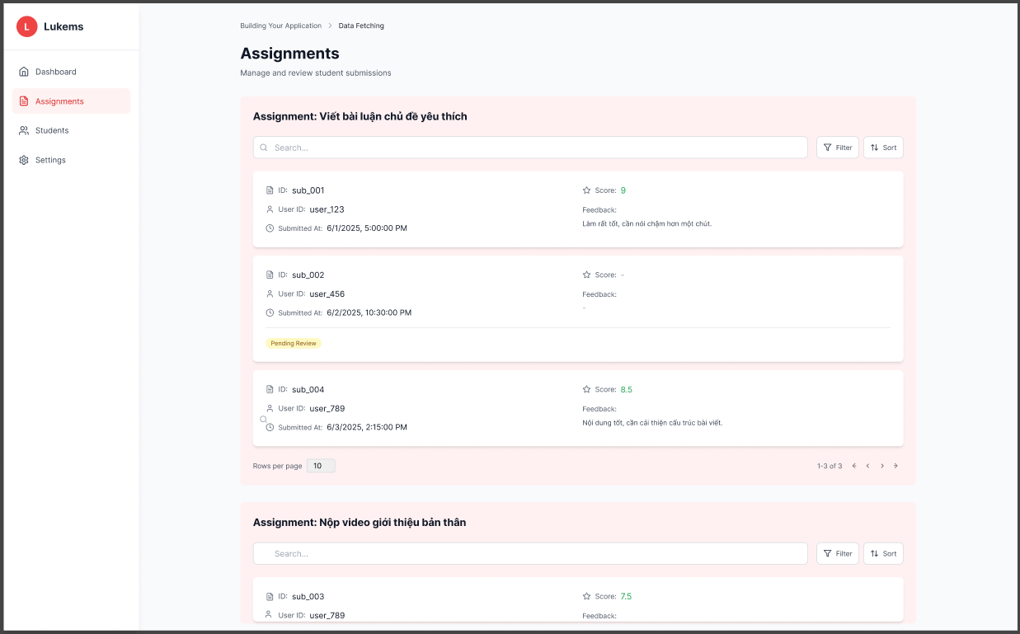

###### *Figure 18 - Grade submissions*

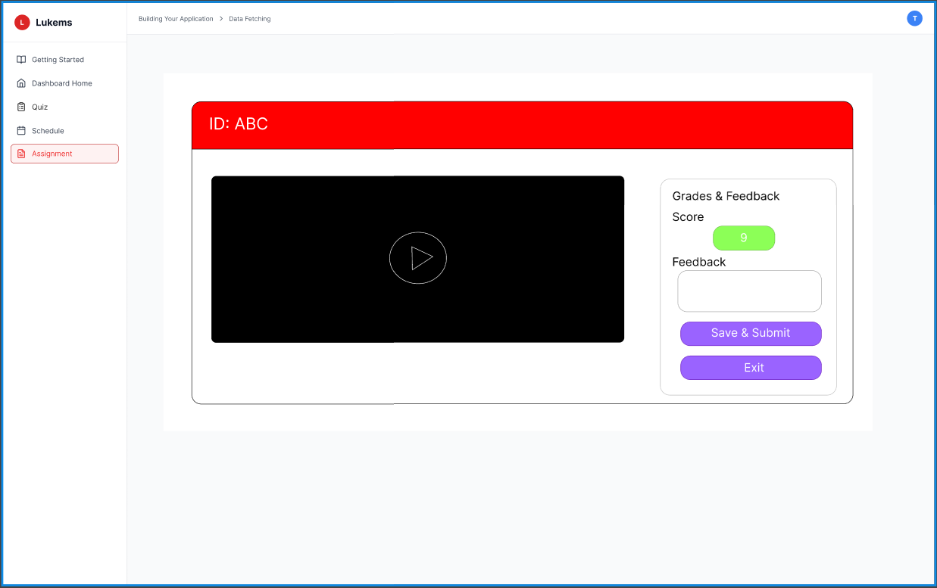

###### *Figure 19 - Grade submissions*

| **Screen** | | Menu page, Grade submissions: daily vlog / check1 / check2 / essay | | | | |
| --- | --- | --- | --- | --- | --- | --- |
| **Description** | | This use case allows coaches to grade student submissions including daily vlogs, Check1, Check2, and essays. | | | | |
| **Screen Access** | | At homepage, click the “Assignment” button in the dashboard | | | | |
| **Screen Content** | | | | | | |
| **Item** | | **Type** | **Data** | | **Description** | |
| Task Identifier | | Text | Submission ID | | Displays the ID of the selected student submission | |
| Submission Preview | | Video/Media | Video playback | | Allows coaches to view the submitted video or media | |
| Score Display/Input | | Number | Score (0–10) | | Field to enter or display the grade | |
| Feedback Field | | Text | Feedback comments | | Optional text input for coach feedback | |
| Save & Submit Button | | Button |  | | Saves the entered grade and feedback | |
| Exit Button | | Button |  | | Exits grading screen and returns to the previous menu | |
| Screen Actions | | | | | | |
| **Action Name** | **Description** | | | **Success** | | **Failure** |
| Select Task | Navigate to grading screen for selected task | | | Task loaded successfully | | Error loading submissions. Please try again or contact admin. |
| View Submission | View media or content of the selected submission | | | Submission loaded successfully | | Unable to load submission content. |
| Enter Grade | Input score for the submission | | | Grade entered successfully | | Invalid grade input. Please enter a valid number. |
| Add Feedback | Input text feedback for the submission | | | Feedback entered successfully | | Feedback could not be saved. |
| Save Grade | Save grade and feedback to the system | | | Grade saved successfully | | Unable to save grade. Please try again; Please enter a grade before saving. |
| Exit Grading | Return to previous screen | | | Exited successfully | | Error exiting grading screen. |

### 

### 3.9 UC-08-Send feedback on grades: vlog / check1 / check2 / essay

| **Use Case ID** | **UC-08** | **Use Case Name** | **Send feedback on grades: vlog / check1 / check2 / essay** |
| --- | --- | --- | --- |
| Created By | AnhTT | Date Created | 2 June 2025 |
| Primary Actor | Coach | Secondary Actor | — |
| Description | This use case allows coaches to provide written feedback for graded student submissions. | | |
| Priority | Must have | | |
| Trigger | Coach selects the “Send Feedback” option after grading. | | |
| Pre-conditions | Coach must be logged in. Feedback can only be submitted after grading is completed. | | |
| Post-conditions | Feedback is saved and linked to the submission; student is notified. | | |
| Basic flow | 1. Coach selects "Send Feedback" after grading. 2. Enters feedback.  3. Sends feedback. | | |
| Alternative flow | Alternative flow 1: Feedback validation error → system shows error messages and prompts correction: MSG02, MSG08  Alternative flow 2: Empty feedback submission → system allows saving but prompts for feedback completion  Alternative flow 3: Previously graded submission → system loads existing grade and feedback for modification | | |
| Exception | Session expired or user not authenticated → System displays: MSG057  Server error during data loading → System displays: MSG055  Failed to load submission content → System displays: MSG069  Network error → System displays: MSG051  Failed to save feedback data → System displays: MSG070  Failed to load existing feedback → System displays: MSG071  Feedback validation failed → System displays: MSG072 | | |
| Business rules | BR-01, BR-02, BR-03, BR-07, BR-08 | | |



###### *Figure 20 - Send Feedback*

| **Screen** | | Menu page, Send feedback on grades:  daily vlog / check1 / check2 / essay | | | | |
| --- | --- | --- | --- | --- | --- | --- |
| **Description** | | This use case allows coaches to provide written feedback for graded student submissions. | | | | |
| **Screen Access** | | At homepage, click to button in dashboard | | | | |
| **Screen Content** | | | | | | |
| **Item** | | **Type** | **Data** | | **Description** | |
| Task Identifier | | Text | Submission ID | | Displays the ID of the selected student submission | |
| Submission Preview | | Video/Media | Video playback | | Allows coaches to view the submitted video or media | |
| Score Display/Input | | Number | Score (0–10) | | Field to enter or display the grade | |
| Feedback Field | | Text | Feedback comments | | Optional text input for coach feedback | |
| Save & Submit Button | | Button |  | | Saves the entered grade and feedback | |
| Exit Button | | Button |  | | Exits grading screen and returns to the previous menu | |
| Screen Actions | | | | | | |
| **Action Name** | **Description** | | | **Success** | | **Failure** |
| Select Task | Navigate to grading screen for selected task | | | Task loaded successfully | | Error loading submissions. Please try again or contact admin. |
| View Submission | View media or content of the selected submission | | | Submission loaded successfully | | Unable to load submission content. |
| Enter Grade | Input score for the submission | | | Grade entered successfully | | Invalid grade input. Please enter a valid number. |
| Add Feedback | Input text feedback for the submission | | | Feedback entered successfully | | Feedback could not be saved. |
| Save Grade | Save grade and feedback to the system | | | Grade saved successfully | | Unable to save grade. Please try again; Please enter a grade before saving. |
| Exit Grading | Return to previous screen | | | Exited successfully | | Error exiting grading screen. |

### 3.10 UC-09-Download student submissions

#### 

| **Use Case ID** | **UC-09** | **Use Case Name** | **Download student submissions** |
| --- | --- | --- | --- |
| Created By | AnhTT | Date Created | 5 June 2025 |
| Primary Actor | Coach | Secondary Actor | — |
| Description | This use case allows coaches to download student submissions for daily vlog, Check1, Check2, and essay assignments. | | |
| Priority | Must have | | |
| Trigger | Coach selects a task type and clicks the “Download” button next to a submission. | | |
| Pre-conditions | Coach must be logged in and assigned to the class. | | |
| Post-conditions | Submission file is downloaded to coach’s device. | | |
| Basic flow | 1. Select “Download Submissions” from menu.  2. Select task type.  3. View submission list.  4. Click download.  5. File is downloaded. | | |
| Alternative flow | Alternative flow 1: No submissions available → system shows empty state with guidance message  Alternative flow 2: Download queue full → system shows wait message and retry option  Alternative flow 3: Large file download → system shows progress indicator and estimated time  Alternative flow 4: Multiple file selection → system allows bulk download as ZIP file | | |
| Exception | Session expired or user not authenticated → System displays: MSG057  Server error during data loading → System displays: MSG055  Failed to load submissions list → System displays: MSG073  Network error → System displays: MSG051  Download failed due to file corruption → System displays: MSG074  Search operation failed → System displays: MSG075  Filter operation failed → System displays: MSG076  Sort operation failed → System displays: MSG077 | | |
| Business rules | BR-09, BR-10, BR-11, BR-12, BR-13 | | |

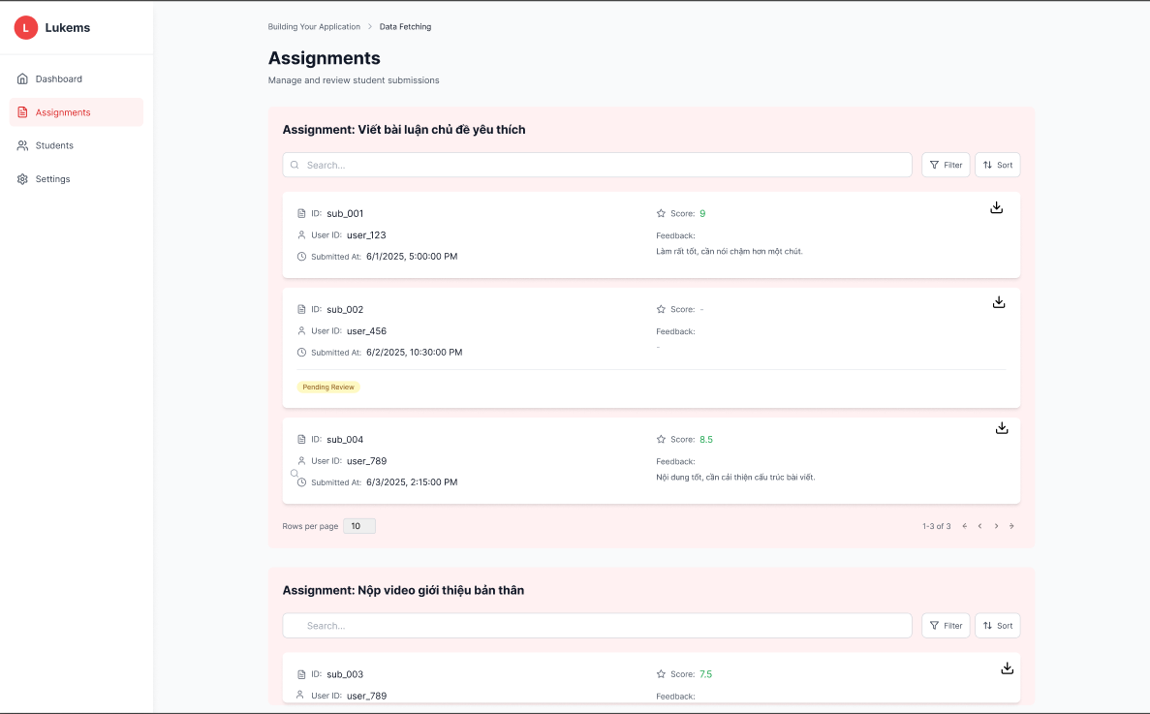

###### *Figure 21 - Download students submissions*

| **Screen** | | Menu page, Download student submissions | | | | |
| --- | --- | --- | --- | --- | --- | --- |
| **Description** | | This use case allows coaches to download student submissions for daily vlog, Check1, Check2, and essay assignments. | | | | |
| **Screen Access** | | At homepage, click the “Assignments” button in the dashboard | | | | |
| **Screen Content** | | | | | | |
| **Item** | | **Type** | **Data** | | **Description** | |
| Task Selector | | Button/List | Daily Vlog, Check1, etc. | | Coach selects the task type to view submissions | |
| Submission List | | Table/List | Submission entries | | Displays submissions per assignment, including ID, User ID, timestamp, and status | |
| Search Field | | Input | Text search | | Allows searching submissions by student or ID | |
| Filter Button | | Button |  | | Opens filter options to narrow down results | |
| Sort Button | | Button |  | | Allows sorting the submission list | |
| Submission Details | | Card/List Item | ID, User ID, Date, Score, Feedback | | Shows individual submission details | |
| Download Button | | Button/Icon | File link/path | | Allows downloading the student’s submission file | |
| Pagination Control | | Control | Page navigation | | Navigate between pages of submissions | |
| Screen Actions | | | | | | |
| **Action Name** | **Description** | | | **Success** | | **Failure** |
| Select Task Type | Choose a task to view all available submissions | | | Submission list is displayed | | No submissions found for this task |
| View Submission List | Display all submissions for the selected task | | | Submission table is shown | | Failed to load submissions |
| Search Submission | Search submissions by student or ID | | | Search results displayed | | No results found |
| Filter Submissions | Filter submissions by status/date | | | Filter applied successfully | | Filter error—retaining current data |
| Sort Submissions | Sort the submissions list | | | Sorting applied successfully | | Sorting failed |
| Download Submission | Download the selected student’s submission file | | | File is downloaded successfully | | Download failed or file invalid |

### 3.11 UC-10-List learning materials

| **Use Case ID** | **UC-10** | **Use Case Name** | **List learning materials** |
| --- | --- | --- | --- |
| Created By | AnhTT | Date Created | 5 June May 2025 |
| Primary Actor | Coach | Secondary Actor | — |
| Description | This use case allows coaches to view a list of all learning materials available to their classes, including PDFs, videos, slides, and reference links categorized by subject or module. | | |
| Priority | Must have | | |
| Trigger | Coach selects the “Learning Materials” option from the main menu. | | |
| Pre-conditions | Coach must be logged in and assigned to at least one class. | | |
| Post-conditions | Learning materials list is displayed. | | |
| Basic flow | 1. Select “Learning Materials” from menu.  2. Display all materials assigned to coach.  3. Render list with title, type, subject.  4. Filter by subject.  5. Open/view selected material. | | |
| Alternative flow | Alternative flow 1: No materials available → system shows empty state with option to upload first material  Alternative flow 2: Search returns no results → system suggests alternative search terms or shows popular materials  Alternative flow 3: Large file preview → system shows loading indicator and file information while processing  Alternative flow 4: Bulk operations → system allows selection of multiple materials for batch actions | | |
| Exception | Session expired or user not authenticated → System displays: MSG057  Server error during data loading → System displays: MSG055  Failed to load materials list → System displays: MSG078  Network error → System displays: MSG051  File preview failed → System displays: MSG079  Download failed due to file corruption → System displays: MSG080  Search operation failed → System displays: MSG081  Filter operation failed → System displays: MSG082 | | |
| Business rules | BR-01, BR-02, BR-03, BR-14, BR-15 | | |

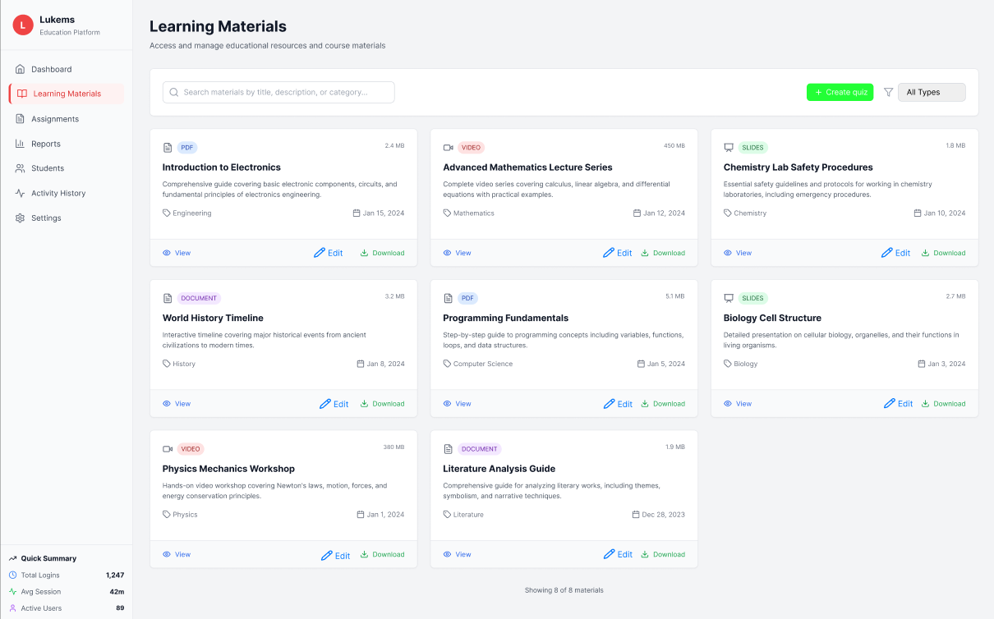

###### *Figure 22 - List learning material*

| **Screen** | | Menu page, List learning materials | | | | |
| --- | --- | --- | --- | --- | --- | --- |
| **Description** | | This use case allows coaches to view a list of all learning materials available to their classes, including PDFs, videos, slides, and reference links categorized by subject or module. | | | | |
| **Screen Access** | | At homepage, click the **Learning Materials** button in the dashboard | | | | |
| **Screen Content** | | | | | | |
| **Item** | | **Type** | **Data** | | **Description** | |
| Material List | | Table/Grid | Title, type, subject, size, date, description | | Lists all learning materials with metadata | |
| Search Field | | Input | Title/description/category | | Allows searching materials by keywords | |
| Filter by Subject | | Dropdown | Subject/module list | | Filters materials by subject/topic | |
| Material Type Icon | | Icon | PDF, Video, Slides, Document | | Visual indicator of each material type | |
| View Button | | Button | View action | | Opens or previews the selected material | |
| Edit Button | | Button | Edit action | | Allows editing material metadata | |
| Download Button | | Button | File link/path | | Downloads the material file | |
| Create Quiz Button | | Button | Action | | Creates a new quiz related to materials | |
| Pagination Control | | Control | Page navigation | | Navigates between pages of materials | |
| Screen Actions | | | | | | |
| **Action Name** | **Description** | | | **Success** | | **Failure** |
| View Learning Materials | Display the list of all available materials | | | Material list displayed | | No materials found |
| Search Materials | Search by title, description, or category | | | Search results displayed | | No matching results |
| Filter by Subject | Filter materials shown by subject/topic | | | List refreshed with filter applied | | Filter error; previous list retained |
| Open/View Material | Preview or open file or link | | | Material opened or previewed | | Unable to open material |
| Download Material | Download selected material | | | File downloaded successfully | | Download failed |
| Edit Material | Update material information | | | Edits saved successfully | | Edit failed |
| Create Quiz | Start quiz creation process | | | Quiz creation page opened | | Unable to start quiz creation |

### 3.12 UC-11-Add Learning Materials

| **Use Case ID** | **UC-11** | **Use Case Name** | **Add Learning Materials** |
| --- | --- | --- | --- |
| Created By | AnhTT | Date Created | ９June 2025 |
| Primary Actor | Coach | Secondary Actor | — |
| Description | This use case allows coaches to upload or link new learning materials to specific subjects, classes, or modules. Materials can include PDFs, videos, slides, or URLs. | | |
| Priority | Must have | | |
| Trigger | The coach clicks “Add Material” from the learning material screen. | | |
| Pre-conditions | Coach must be logged in and have permission to manage materials for assigned classes/modules. | | |
| Post-conditions | The new learning material is saved and visible to assigned students. | | |
| Basic flow | 1. Click “Add Material”.  2. Enter material details.  3. Select subject/type.  4. Upload file or link.  5. Click Save.  6. Material is saved and displayed. | | |
| Alternative flow | Alternative flow 1: User clicks Close without saving → System closes modal and returns to materials list  Alternative flow 2: Invalid URL format → System displays validation error message  Alternative flow 3: Empty title field → System displays required field error message  Alternative flow 4: Duplicate title → System suggests alternative title or warns about duplication | | |
| Exception | Session expired or user not authenticated → System displays: MSG057  Server error during save operation → System displays: MSG055  Network error → System displays: MSG051  URL not accessible → System displays: MSG083  Title already exists → System displays: MSG084  Invalid URL format → System displays: MSG085 | | |
| Business rules | BR-14, BR-15, BR-16, BR-17 | | |

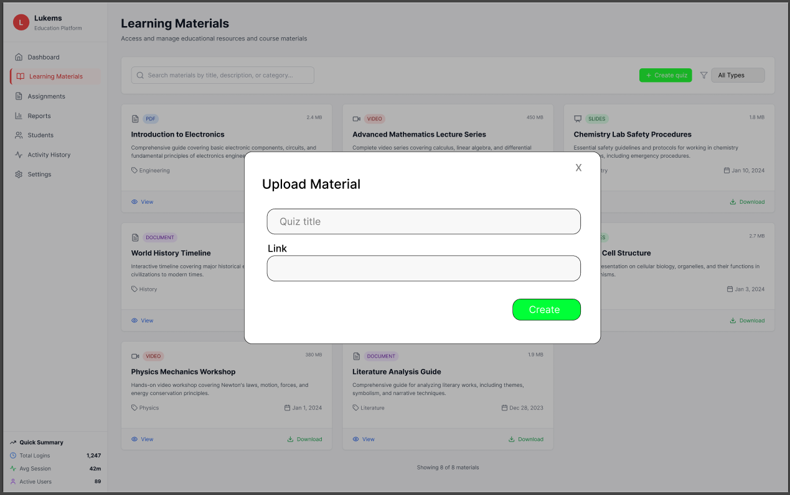

###### *Figure 23- Add learning material*

| **Screen** | | Menu page, Add Learning Materials | | | | |
| --- | --- | --- | --- | --- | --- | --- |
| **Description** | | This use case allows coaches to add a new learning material by providing a title and a link to the resource. Materials can be URLs to online content or repositories. | | | | |
| **Screen Access** | | On the Learning Materials page, click the green **+ Create quiz** button (or equivalent “Add” action). | | | | |
| **Screen Content** | | | | | | |
| **Item** | | **Type** | **Data** | | **Description** | |
| Modal Window | | Container | Upload Material | | Modal overlay to enter new material details | |
| Quiz Title | | Text Input | Title string | | Name/title of the quiz or material | |
| Link | | Text Input | URL string | | Link to the resource | |
| Create Button | | Button | Action | | Submits the form and creates the material | |
| Close Icon | | Icon Button | Action | | Closes the modal without saving | |
| Screen Actions | | | | | | |
| **Action Name** | **Description** | | | **Success** | | **Failure** |
| Fill Upload Form | Coach enters title and URL | | | Form filled | | “Please complete all required fields.” |
| Click Create | Save the material link into the system | | | Material saved and visible in list | | “Failed to save. Please try again later.” |
| Close Modal | Exit without saving | | | Modal closed | | — |

### 

### 3.13 UC-12-Update Learning Materials

| **Use Case ID** | **UC-12** | **Use Case Name** | **Update Learning Materials** |
| --- | --- | --- | --- |
| Created By | AnhTT | Date Created | 12 June 2025 |
| Primary Actor | Coach | Secondary Actor | — |
| Description | This use case allows coaches to update information or replace files of previously uploaded learning materials (title, description, subject assignment, file, or link). | | |
| Priority | Must have | | |
| Trigger | Coach selects an existing material and clicks the “Edit” or “Update” button. | | |
| Pre-conditions | Coach must be logged in and have permission to edit the selected material. | | |
| Post-conditions | Updated learning material is saved and reflected for student access. | | |
| Basic flow | 1. Select material to update.  2. Edit fields.  3. Click Save Changes.  4. Material is updated. | | |
| Alternative flow | Alternative flow 1: User clicks Cancel or Close → System checks for unsaved changes and may show confirmation dialog  Alternative flow 2: Invalid URL format entered → System displays validation error in real-time  Alternative flow 3: Empty title field → System shows required field error message  Alternative flow 4: No changes made → Update button may be disabled or shows "No changes detected"  Alternative flow 5: Material was deleted by another user → System shows error message and refreshes the list | | |
| Exception | Session expired or user not authenticated → System displays: MSG057  Server error during update operation → System displays: MSG055  Network error → System displays: MSG051  Material not found (deleted by another user) → System displays: MSG086  Permission denied (user cannot edit this material) → System displays: MSG087  Concurrent edit conflict → System displays: MSG088  Invalid URL format → System displays: MSG085  Title already exists (duplicate) → System displays: MSG084 | | |
| Business rules | BR-18, BR-19, BR-20, BR-21, BR-22 | | |

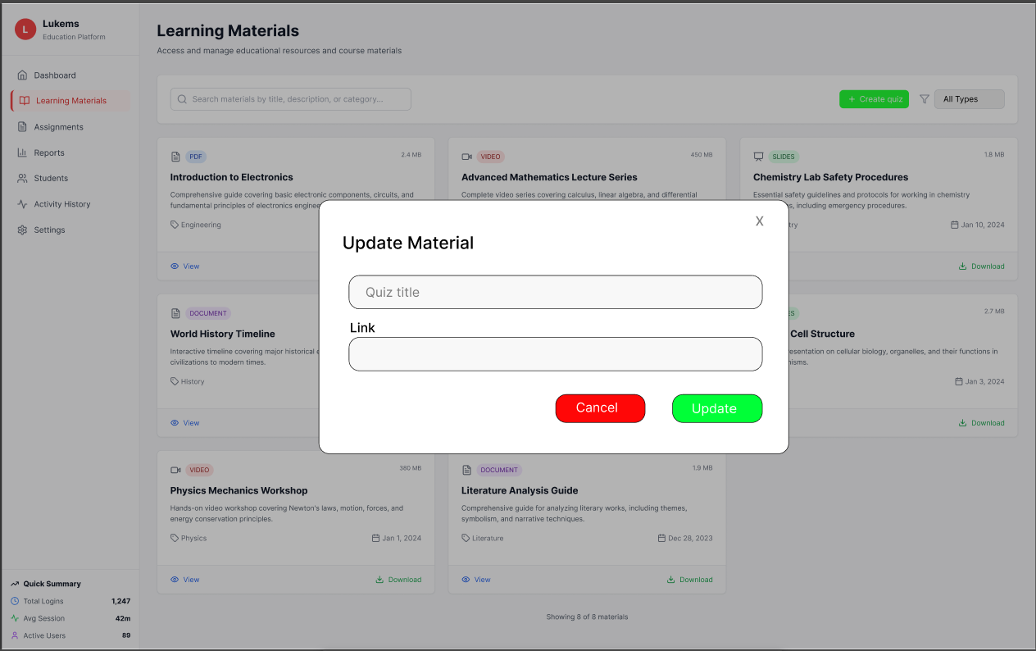

###### *Figure 24 - Update learning material*

| **Screen** | | Menu page: Update Learning Materials | | | | |
| --- | --- | --- | --- | --- | --- | --- |
| **Description** | | This use case allows coaches to update information of previously uploaded learning materials by editing the title or link. In this simplified version of the update form, only the *title* and *link* fields are editable. | | | | |
| **Screen Access** | | On the Learning Materials page, click the **Edit** button next to the material you want to update. | | | | |
| **Screen Content** | | | | | | |
| **Item** | | **Type** | **Data** | | **Description** | |
| Modal Window | | Container | Update Material | | Modal overlay containing editable fields. | |
| Quiz Title | | Text Input | Title string | | Editable title of the learning material. | |
| Link | | Text Input | URL | | Editable URL to the material. | |
| Cancel Button | | Button | — | | Closes the modal without saving changes. | |
| Update Button | | Button | — | | Submits the updated information. | |
| Close Icon | | Icon Button | — | | Closes the modal (top right “X”). | |
| Screen Actions | | | | | | |
| **Action Name** | **Description** | | | **Success** | | **Failure** |
| Select Material to Edit | Opens the update form with current title and link pre-filled. | | | Form displayed showing current data. | | “You do not have permission to edit this material or it no longer exists.” |
| Update Fields | Edit the title or the link. | | | Fields updated. | | “Please complete all required fields.” |
| Save Changes | Submit the updated data. | | | Material updated and visible in the list. | | “Failed to save changes. Please try again later.” |
| Cancel Update | Exit the modal without saving changes. | | | Modal closed, no changes applied. | | — |

### 

### 3.14 UC-13-Delete Learning Materials

#### 

| **Use Case ID** | **UC-13** | **Use Case Name** | **Delete Learning Materials** |
| --- | --- | --- | --- |
| Created By | AnhTT | Date Created | 15 June 2025 |
| Primary Actor | Coach | Secondary Actor | — |
| Description | This use case allows coaches to delete a learning material they have uploaded or have permission to manage. Once deleted, the material is no longer visible to students. | | |
| Priority | Must have | | |
| Trigger | Coach selects a material and clicks the “Delete” button, followed by confirmation. | | |
| Pre-conditions | Coach must be logged in and have delete permission on the material. | | |
| Post-conditions | Material is permanently deleted and removed from student view. | | |
| Basic flow | 1. View learning material list.  2. Click “Delete” on a material.  3. Confirm deletion.  4. Material deleted and list updated. | | |
| Alternative flow | Alternative flow 1: User clicks Cancel or Close → System closes dialog and returns to materials list without changes  Alternative flow 2: Material is being used in active assignments → System shows warning about impact on students  Alternative flow 3: User lacks permission to delete → System shows permission error before displaying confirmation  Alternative flow 4: Material has dependencies (linked quizzes, etc.) → System shows additional warning about cascading effects  Alternative flow 5: Network error during deletion → System retries or shows error message | | |
| Exception | Session expired or user not authenticated → System displays: MSG057  Server error during deletion → System displays: MSG055  Network error → System displays: MSG051  Material not found (already deleted) → System displays: MSG089  Permission denied (user cannot delete this material) → System displays: MSG090  Material in use by active assignments → System displays: MSG091  Database constraint violation → System displays: MSG092  Concurrent deletion conflict → System displays: MSG093 | | |
| Business rules | BR-23, BR-24, BR-25, BR-26 | | |

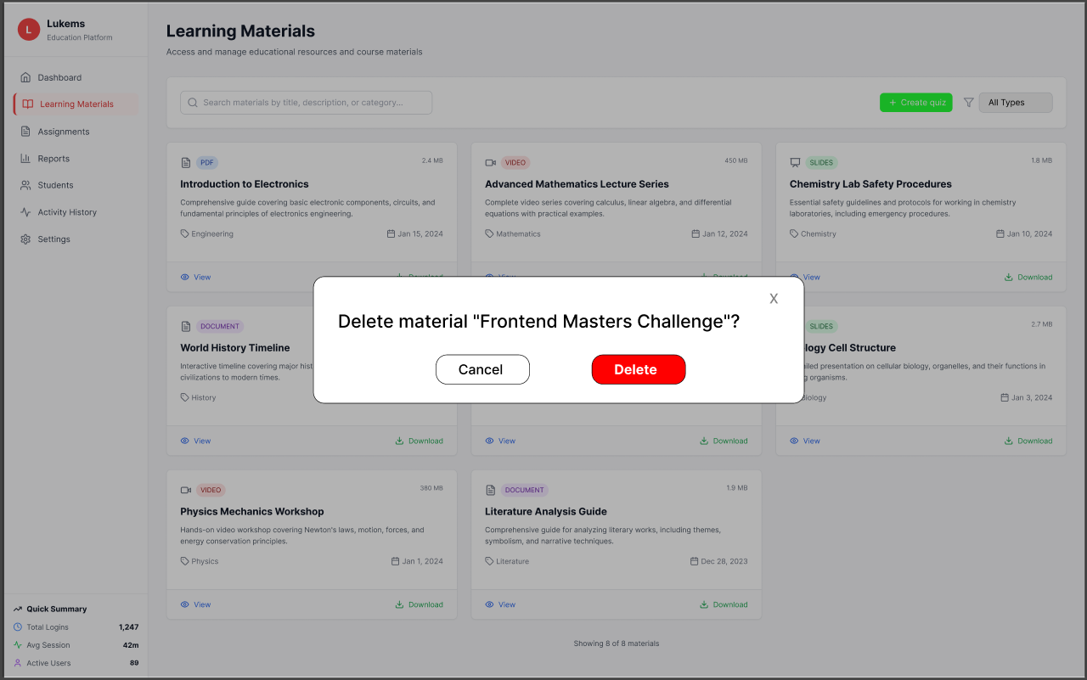

###### *Figure 25 - Delete learning material*

| **Screen** | | Delete Learning Materials | | | | |
| --- | --- | --- | --- | --- | --- | --- |
| **Description** | | This use case allows coaches to **delete a learning material** they have uploaded or have permission to manage. Once deleted, the material is permanently removed and no longer visible to students. | | | | |
| **Screen Access** | | On the **Learning Materials** page, click the **Delete** button associated with a specific material (e.g., “Frontend Masters Challenge”). | | | | |
| **Screen Content** | | | | | | |
| **Item** | | **Type** | **Data** | | **Description** | |
| Material List | | Card/List View | Titles, file/link info | | List of all materials uploaded by the coach. | |
| Delete Button | | Button | — | | Button attached to each material card to initiate deletion. | |
| Confirmation Dialog | | Modal/Popup | Title confirmation | | Modal asks: *Delete quiz "Frontend Masters Challenge"?* | |
| Cancel Button | | Button | — | | Closes the confirmation dialog without deleting. | |
| Delete Button (Confirm) | | Button (Red) | — | | Confirms and proceeds with deletion. | |
| Close Icon | | Icon Button (X) | — | | Closes the confirmation dialog. | |
| Screen Actions | | | | | | |
| **Action Name** | **Description** | | | **Success** | | **Failure** |
| Click Delete Button | Initiates delete request for a specific material. | | | Confirmation dialog is displayed. | | — |
| Confirm Deletion | Confirms the coach wants to delete the material. | | | Material is deleted, success message shown, and the material list updates. | | “You cannot delete this material or it no longer exists.” “Deletion failed. Please try again later.” |
| Cancel Deletion | Cancels the deletion process. | | | Modal closes without deleting anything. | | — |

### 3.15 UC-14-List Quiz

| **Use Case ID** | **UC-14** | **Use Case Name** | **List Quiz** |
| --- | --- | --- | --- |
| Created By | AnhTT | Date Created | 17 June 2025 |
| Primary Actor | Coach | Secondary Actor | — |
| Description | This use case allows coaches to view a list of all quizzes assigned to their classes, including quiz titles, subjects, dates, status (active/closed), and number of questions. | | |
| Priority | Must have | | |
| Trigger | Coach selects a class and accesses the “Quiz List” section from the system menu. | | |
| Pre-conditions | Coach is logged in and assigned to classes with quizzes. | | |
| Post-conditions | N/A | | |
| Basic flow | 1. Coach selects “Quiz List” from menu.  2. System loads quizzes for assigned classes.  3. System displays quiz list with filter option.  4. Coach clicks “View” to see quiz details.  5. System navigates to quiz detail screen. | | |
| Alternative flows | Alternative flow 1: No scheduled activities exist → System displays empty state with "Create your first quiz" call-to-action  Alternative flow 2: User lacks permission to create → Create button is disabled or hidden  Alternative flow 3: Search returns no results → Display "No activities match your search" message  Alternative flow 4: Filter returns no results → Display "No activities match your filters" with clear filters option  Alternative flow 5: Network error → Display retry button and error message | | |
| Exception | Session expired or user not authenticated → System displays: MSG001  Server error during data loading → System displays: MSG002  Network connectivity issues → System displays: MSG003  Insufficient permissions to view schedule → System displays: MSG094  Activity data corruption → System displays: MSG095  Concurrent modification conflict → System displays: MSG096  Database timeout → System displays: MSG097  Invalid date format → System displays: MSG098 | | |
| Business rules | BR-28, BR-28, BR-29 | | |

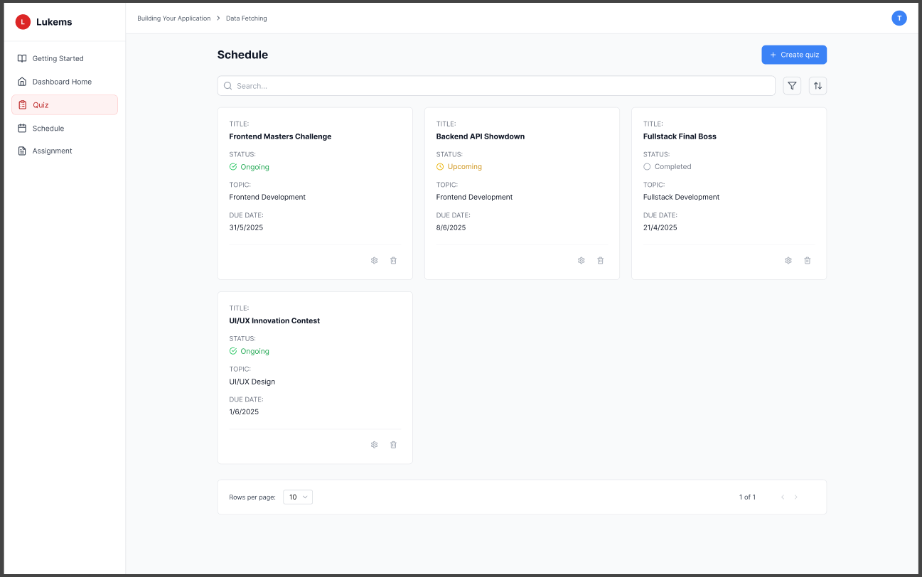

###### *Figure 26 - List Quiz*

| **Screen** | Menu page, List Quiz | | |
| --- | --- | --- | --- |
| **Description** | This use case allows coaches to view a list of all quizzes assigned to their classes, including quiz titles, subjects, dates, status (active/closed), and number of questions. | | |
| **Screen Access** | At homepage, click the button in dashboard | | |
| Screen Content | | | |
| **Item** | **Type** | **Data** | **Description** |
| Quiz Table | Table | Title, subject, date, status, question count | List of all quizzes assigned to coach’s classes |
| View Button | Button | — | Opens detailed view of selected quiz |
| Status Indicator | Icon / Text | Active / Closed | Shows quiz availability status |
| Filter by Subject | Dropdown | Subject/module list | Filters quizzes by selected subject/module |
| Screen Actions | | | |
| **Action Name** | **Description** | **Success** | **Failure** |
| View Quiz List | Display all quizzes assigned to coach | Quiz list displayed with filters | — |
| Filter by Subject | Filter quiz list by subject/module | Quiz list updated with filter | — |
| View Quiz Details | Navigate to detailed quiz view | Quiz detail screen opens | — |

### 

### 3.16 UC-15-Create Quiz

#### 

| **Use Case ID** | **UC-15** | **Use Case Name** | **Create Quiz** |
| --- | --- | --- | --- |
| Created By | AnhTT | Date Created | 19 June 2025 |
| Primary Actor | Coach | Secondary Actor | — |
| Description | This use case allows coaches to create new quizzes for their classes. A quiz may include metadata such as title, subject, time limit, and a list of questions (multiple choice, true/false, or short answer). | | |
| Priority | Must have | | |
| Trigger | Coach selects “Create Quiz” from the quiz management menu. | | |
| Pre-conditions | Coach must be logged in and have quiz creation rights. | | |
| Post-conditions | Quiz is saved and becomes available for assigned classes. | | |
| Basic flow | 1. Select “Create Quiz”.  2. Display blank quiz form.  3. Enter title, subject, time limit.  4. Add questions.  5. Save quiz.  6. Show confirmation. | | |
| Alternative flow | Alternative flow 1: User clicks Cancel or Close (X) → System closes modal and returns to schedule page without creating quiz  Alternative flow 2: User enters invalid dates → System shows validation errors and prevents submission  Alternative flow 3: Quiz title already exists → System shows duplicate title error and suggests alternatives  Alternative flow 4: Network error during creation → System shows retry option with error message  Alternative flow 5: Session expires during creation → System redirects to login with draft save option | | |
| Exception | Session expired or user not authenticated → System displays: MSG001  Server error during quiz creation → System displays: MSG002  Network connectivity issues → System displays: MSG003  Insufficient permissions to create quiz → System displays: MSG099  Duplicate quiz title → System displays: MSG100  Invalid date range → System displays: MSG101  Database constraint violation → System displays: MSG102  Maximum quiz limit reached → System displays: MSG103 | | |
| Business rules | BR-30, BR-31, BR-32, BR-33, BR-34 | | |

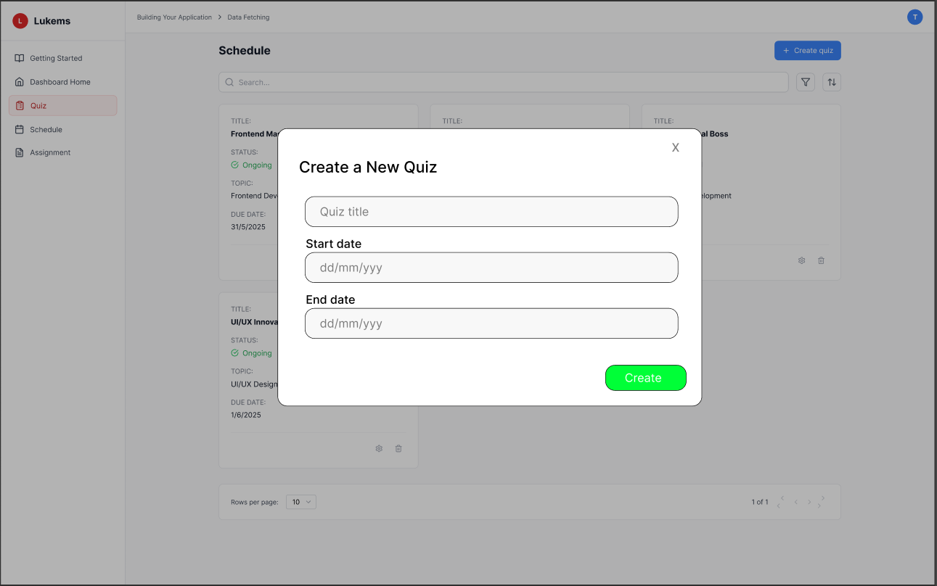

###### *Figure 27 - Create Quiz*

| **Screen** | Menu page, Create Quiz | | |
| --- | --- | --- | --- |
| **Description** | This use case allows coaches to create new quizzes for their classes. A quiz may include metadata such as title, subject, time limit, and a list of questions (multiple choice, true/false, or short answer). | | |
| **Screen Access** | At homepage, click the button in dashboard | | |
| Screen Content | | | |
| **Item** | **Type** | **Data** | **Description** |
| Quiz Title | Text | Title string | Name of the quiz |
| Subject Selector | Dropdown | List of subjects/modules | Assign quiz to a specific subject |
| Time Limit | Number | Minutes | Set time duration for the quiz |
| Question List | Section/Table | List of questions | Add, edit, or remove questions |
| Question Type | Dropdown | MCQ / True-False / Short Answer | Type selector for each question |
| Add Question Button | Button | — | Adds a new question input block |
| Screen Actions | | | |
| **Action Name** | **Description** | **Success** | **Failure** |
| Enter Quiz Details | Fill in title, subject, and time limit | Input accepted | Show error message for missing/invalid data |
| Add Questions | Add questions and answers to the quiz | Questions validated | Show error if question incomplete/invalid |
| Click Save | Submit all entered data and save quiz | Quiz saved, confirmation shown | Show save failure message |

### 

### 3.17 UC-16-Update Quiz

#### 

| **Use Case ID** | **UC-16** | **Use Case Name** | **Update Quiz** |
| --- | --- | --- | --- |
| Created By | AnhTT | Date Created | 21 June 2025 |
| Primary Actor | Coach | Secondary Actor | — |
| Description | This use case allows coaches to update information of an existing quiz, including title, subject, time limit, and questions (edit, add, or remove). | | |
| Priority | Must have | | |
| Trigger | Coach selects an existing quiz and clicks the “Edit” or “Update” button. | | |
| Pre-conditions | Coach must have permission to update the quiz; quiz exists and is editable. | | |
| Post-conditions | Quiz is updated and changes are reflected immediately. | | |
| Basic flow | 1. Select quiz to update.  2. Display form pre-filled with quiz data.  3. Edit fields (title, subject, time, questions).  4. Save changes.  5. Show confirmation and return to quiz list. | | |
| Alternative flow | Alternative flow 1: Quiz has no questions → Show empty state with "Add your first question" prompt  Alternative flow 2: User tries to exit with unsaved changes → Show confirmation dialog asking to save changes  Alternative flow 3: Maximum question limit reached → Disable "Add question" button with tooltip explanation  Alternative flow 4: User lacks edit permissions → Show read-only mode with disabled editing features  Alternative flow 5: Auto-save fails → Show warning and provide manual save option | | |
| Exception | Session expired or user not authenticated → System displays: MSG001  Server error during quiz loading → System displays: MSG002  Network connectivity issues → System displays: MSG003  Insufficient permissions to edit quiz → System displays: MSG104  Quiz not found → System displays: MSG105  Concurrent editing conflict → System displays: MSG106  Question validation failure → System displays: MSG107  Maximum questions limit exceeded → System displays: MSG108  Save operation failed → System displays: MSG109 | | |
| Business rules | BR-35, BR-36, BR-37, BR-38, BR-39 | | |

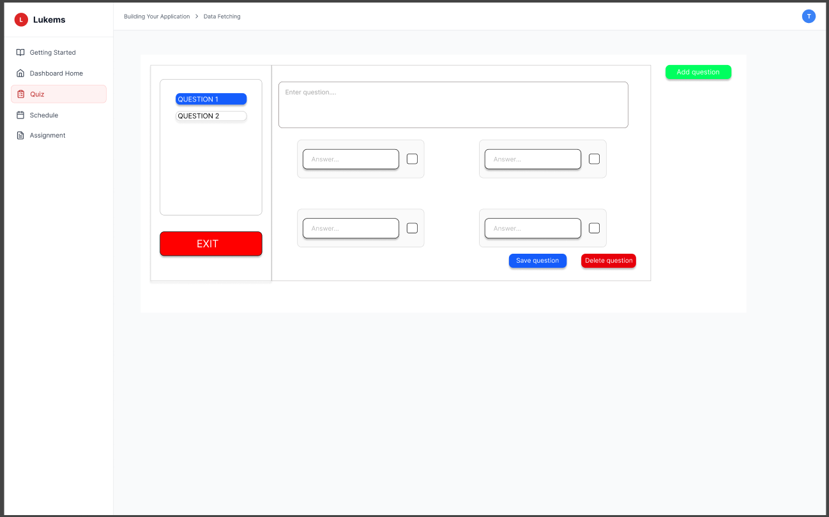

###### *Figure 28 - Update Quiz*

| **Screen** | Menu page, Update Quiz | | |
| --- | --- | --- | --- |
| **Description** | This use case allows coaches to update information of an existing quiz, including title, subject, time limit, and questions (edit, add, or remove). | | |
| **Screen Access** | At homepage, click the button in dashboard | | |
| Screen Content | | | |
| **Item** | **Type** | **Data** | **Description** |
| Quiz Title | Text | Existing title | Editable quiz title |
| Subject Selector | Dropdown | List of subjects/modules | Assign quiz to a subject |
| Time Limit | Number | Minutes | Set/edit time duration |
| Question List | Table/Section | Existing questions | Add, edit, or remove questions |
| Question Type | Dropdown | MCQ / True-False / Short Answer | Change question type |
| Save Changes Button | Button | — | Saves updated quiz data |
| Screen Actions | | | |
| **Action Name** | **Description** | **Success** | **Failure** |
| Open Quiz Editor | Load quiz data into edit form | Form populated | Show error if no permission or quiz not found |
| Edit Fields | Modify quiz details and questions | Input accepted | Show validation error on missing/invalid data |

### 3.18 UC-17-Delete Quiz

| **Use Case ID** | **UC-17** | **Use Case Name** | **Delete Quiz** |
| --- | --- | --- | --- |
| Created By | AnhTT | Date Created | 23 June 2025 |
| Primary Actor | Coach | Secondary Actor | — |
| Description | This use case allows coaches to delete a quiz they created or have permission to manage. Deleted quizzes are no longer available for assignment or viewing. | | |
| Priority | Must have | | |
| Trigger | Coach clicks the “Delete” button next to a quiz and confirms deletion. | | |
| Pre-conditions | Coach must have delete permission for the quiz; quiz exists and is deletable. | | |
| Post-conditions | Quiz is permanently deleted and removed from the quiz list. | | |
| Basic flow | 1. View quiz list.  2. Click “Delete” on a quiz.  3. Confirm deletion in dialog.  4. System deletes quiz.  5. Show success message and refresh list. | | |
| Alternative flow | Alternative flow 1: Quiz has active assignments → Show warning about impact on students before deletion  Alternative flow 2: User lacks delete permissions → Hide delete icon or show disabled state with tooltip  Alternative flow 3: Quiz deletion in progress → Show loading state and disable other actions  Alternative flow 4: Network error during deletion → Show retry option with error message  Alternative flow 5: Quiz has associated data (submissions, grades) → Show additional warning about data loss | | |
| Exception | Session expired during deletion → System displays: MSG001  Server error during deletion → System displays: MSG002  Network connectivity issues → System displays: MSG003  Insufficient permissions to delete → System displays: MSG110  Quiz not found (already deleted) → System displays: MSG111  Quiz has active assignments → System displays: MSG112  Database constraint violation → System displays: MSG113  Concurrent deletion attempt → System displays: MSG114 | | |
| Business rules | BR-40,BR-41,BR-42,BR-43 | | |

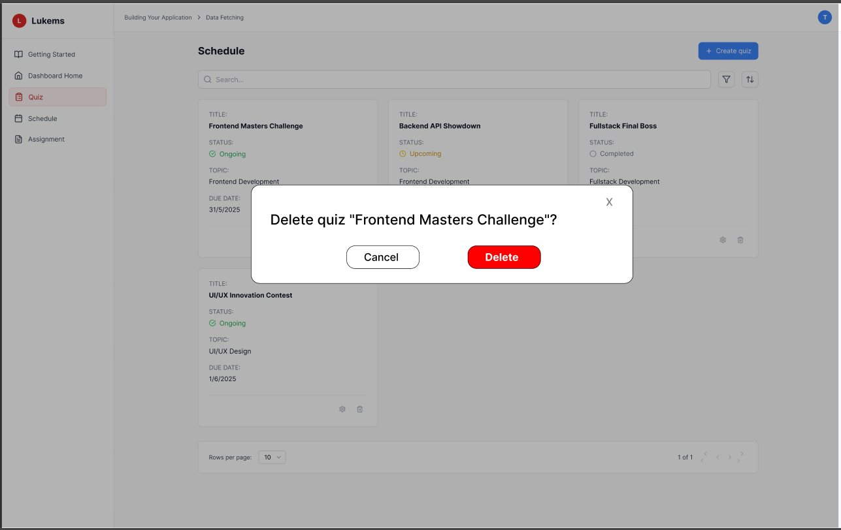

###### *Figure 29 - Delete Quiz*

| **Screen** | | Menu page, Delete Quiz | | | |  |
| --- | --- | --- | --- | --- | --- | --- |
| **Description** | | This use case allows coaches to delete a quiz they created or manage. Once deleted, the quiz will no longer be available for assignment or viewing. | | | | |
| **Screen Access** | | From the **Dashboard Home**, navigate to the **Quiz** page, then click the icon (trash) on a quiz card. | | | | |
| **Screen Content** | | | | | | |
| **Item** | | **Type** | **Data** | | **Description** | |
| Quiz Card List | | Card Grid | Title, Status, Topic, Due Date | | Display list of quizzes with status & topic | |
| Delete Icon | | Icon Button | - | | Shows on each quiz card; triggers confirmation dialog | |
| Confirmation Dialog | | Modal Popup | “Delete quiz ‘[Quiz Title]’?” | | Asks user to confirm deletion with two buttons: Cancel, Delete | |
| Cancel Button | | Button | Cancel | | Dismisses the popup, no action taken | |
| Delete Button | | Button (red) | Delete | | Proceeds with deletion if confirmed | |
| Screen Actions | | | | | | |
| **Action Name** | **Description** | | | **Success** | | **Failure** |
| Click Delete Icon | Coach clicks delete icon on quiz card | | | Show confirmation dialog | | — |
| Confirm Deletion | Coach clicks “Delete” in popup | | | Quiz is removed, success toast shown | | Error toast shown, quiz remains |
| Cancel Deletion | Coach clicks “Cancel” in popup | | | Dialog closes, no change | | — |

### 3.19 UC-18-Personal Schedule for Coach

| **Use Case ID** | **UC-18** | **Use Case Name** | **List personal schedule for coach** |
| --- | --- | --- | --- |
| Actor | Coach | | |
| Description | Allows a coach to view their personal teaching schedule, including upcoming classes, training sessions, meetings, or related events by date and time. | | |
| Trigger | Coach selects “My Schedule” or “Personal Timetable” from main menu. | | |
| Pre-condition | Coach is logged in. | | |
| Post-condition | Schedule is displayed according to selected filters. | | |
| Basic flow | The coach selects “My Schedule” or “Personal Timetable” from the main menu. The coach filters the schedule by week | | |
| Alternative flow | Alternative Flow 1:No scheduled classes in the selected week → Show empty schedule cells (-)  Alternative Flow 2:Invalid or past date selected → Display “No schedule available for this range”  Alternative Flow 3:User not assigned any classes yet → Display message: “No events found for this coach.” | | |
| Exception | Session expired while loading schedule → System displays: MSG115  Server error during schedule retrieval → System displays: MSG116  Network connectivity issues → System displays: MSG117  Insufficient permission to view schedule → System displays: MSG118  No scheduled data found → System displays: MSG119 | | |
| Business rules | BR-44,BR-45,BR-46,BR-47 | | |

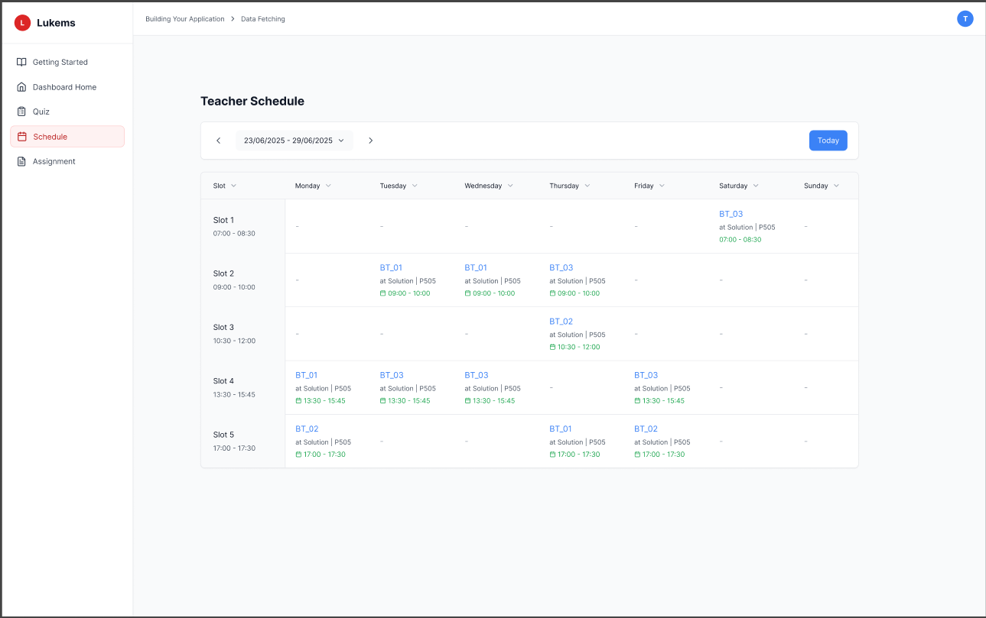

###### *Figure 30 - Personal Schedule for Coach*

| **Menu page** | | Schedule | | | | |
| --- | --- | --- | --- | --- | --- | --- |
| **Description** | | Allows a coach to view their personal teaching schedule, including upcoming classes, training sessions, and meetings for a specific week. | | | | |
| **Screen Access** | | From **Dashboard Home**, click **Schedule** in the sidebar menu. | | | | |
| **Screen Content** | | | | | | |
| **Item** | | **Type** | **Data** | | **Description** | |
| Schedule Table | | Table View | Slot number, time, weekdays (Mon–Sun) | | Displays scheduled activities per slot/day. | |
| Slot Column | | Static Label | Slot 1–5, time range | | Leftmost column listing time ranges per slot | |
| Event Cell | | Cell Item | Title, location, room, time | | Shows the class code, location (e.g., "at Solution | |
| Filter by Date Range | | Date Picker | From - To (weekly) | | Allows navigation between date ranges (weekly) | |
| Today Button | | Button | “Today” | | Quickly navigates back to the current week's schedule | |
| Screen Actions | | | | | | |
| **Action Name** | **Description** | | | **Success** | | **Failure** |
| View Personal Schedule | Automatically loads coach’s schedule for current week | | | Schedule displayed | | — |
| Filter by Date | Select date range to show weekly schedule | | | Schedule updated | | — |
| Click on Schedule Cell | Click to view event info (if interactive/hoverable) | | | Tooltip or popup shown with details | | — |

### 3.20 UC-19-Notify New Content

| **Use Case ID** | **UC-19** | **Use Case Name** | **Notify New Content** |
| --- | --- | --- | --- |
| Created By | AnhTT | Date Created | 24 May 2025 |
| Primary Actor | Coach | Secondary Actor | — |
| Description | System automatically notifies students (or coaches) when new learning materials, assignments, quizzes, or announcements are added. Coaches can also manually trigger notifications. | | |
| Trigger | Automatically triggered when new content is added; manually triggered by coach clicking “Notify Students”. | | |
| Pre-conditions | Content must be assigned to students/classes/modules. | | |
| Post-conditions | Notifications are sent and logged. | | |
| Basic flow | 1. New content created.  2. System detects assignment.  3. (Optional) Coach clicks “Notify”.  4. System generates and sends notification.  5. Notification appears on student dashboard.  6. System logs delivery status. | | |
| Alternative flow | Alternative flow 1: Auto-notification triggered → System detects new content and automatically sends notifications to enrolled students  Alternative flow 2: No active recipients → Show message "No active students to notify" with option to check student enrollment  Alternative flow 3: Scheduled notification → Allow coaches to schedule notifications for future delivery  Alternative flow 4: Custom message → Coach can override auto-generated message with custom text  Alternative flow 5: Partial delivery failure → Show which notifications failed and provide retry option | | |
| Exception | Session expired during notification sending → System displays: MSG001  Server error during notification delivery → System displays: MSG002  Network connectivity issues → System displays: MSG003  No students enrolled in content → System displays: MSG120  Email delivery service unavailable → System displays: MSG121  Message generation failed → System displays: MSG122  Notification quota exceeded → System displays: MSG123  Invalid recipient email addresses → System displays: MSG124  Content not found or deleted → System displays: MSG125 | | |
| Business rules | BR-48,BR-49,BR-50,BR-51,BR-52 | | |

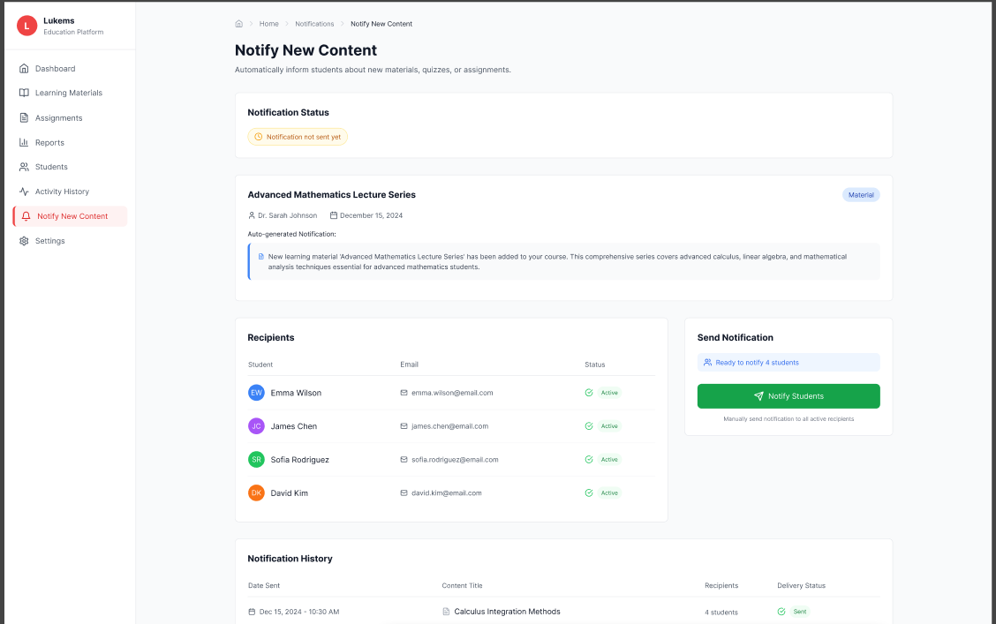

###### *Figure 31 - Notify new content*

| **Screen** | Menu page,Notify New Content | | |
| --- | --- | --- | --- |
| **Description** | System automatically notifies students (or coaches) when new learning materials, assignments, quizzes, or announcements are added. Coaches can also manually trigger notifications. | | |
| **Screen Access** | At homepage, click to button in dashboard | | |
| Screen Content | | | |
| **Item** | **Type** | **Data** | **Description** |
| Notify Button | Button | — | Coach clicks to send notification |
| Recipient List | List | Student accounts (auto-fill) | List of students in the assigned class/group |
| Notification Text | Text | Title + generated message | System generates message based on content type |
| Screen Actions | | | |
| **Action Name** | **Description** | **Success** | **Failure** |
| Auto-send Notification | System auto-sends notification when content is added | Notification sent | — |
| Manual Notify | Coach clicks to manually notify assigned users | Notification sent | Notification send failed (connectivity issue) |

### 3.21 UC-20 View all account student

#### 

| **Use Case ID** | **UC20** | **Use Case Name** | **View all account student** |
| --- | --- | --- | --- |
| Created By | BinhHC | Date Created | 22 May 2025 |
| Primary Actor | Admin | Secondary Actor | – |
| Description | Allows the Admin to view a list of all student accounts in the LUKEMS system. | | |
| Priority | Must have | | |
| Trigger | The Admin selects the "User management" option from the Admin's Dashboard. | | |
| Pre-conditions | The Admin must be logged into the system. | | |
| Post-conditions | The system displays a list of all student accounts. | | |
| Basic flow | 1. The Admin selects the "User management" option from the dashboard.  2. The system displays the user management page.  3. The Admin navigates to the student account list.  4. The system displays a list of all student accounts with basic information | | |
| Alternative flow | Alternative flow 1: No student accounts exist → System displays "No search results." (MSG01)  Alternative flow 2: Search with no results → Admin searches for a student but no matches are found, system displays "No search results." (MSG01)  Alternative flow 3: Filter by status → Admin applies status filter and system shows only students with selected status  Alternative flow 4: Sort student list → Admin selects sorting criteria and system reorders the student list accordingly  Alternative flow 5: Change pagination → Admin selects different rows per page or navigates to different page | | |
| Exception | Session expired during viewing → System displays: MSG57  Server error during data loading → System displays: MSG116  Network connectivity issues → System displays: MSG117  Failed to load student data → System displays: MSG126  Search operation failed → System displays: MSG75  Filter operation failed → System displays: MSG76  Sort operation failed → System displays: MSG77 | | |
| Business rules | BR-53, BR-54, BR-55 | | |

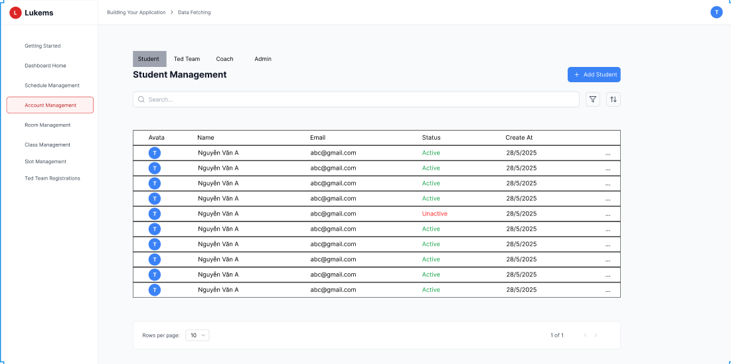

###### *Figure 32 - View all account Student*

| **Screen** | | User management page | | | | |
| --- | --- | --- | --- | --- | --- | --- |
| **Description** | | Allows the Admin to view a list of all student accounts in the system. | | | | |
| **Screen Access** | | From the Admin's homepage, click the "User management" button on the dashboard. | | | | |
| Screen Content | | | | | | |
| **Item** | | **Type** | **Data** | | **Description** | |
| Account list | | Table | Student name, Email, Status | | Displays a list of all student accounts along with relevant information. | |
| View detail button | | Button |  | | Allows viewing detailed information of a selected student account. | |
| Lock/Unlock button | | Button |  | | Allows locking or unlocking a student account. | |
| Add account button | | Button |  | | Navigates to the page for adding a new student account. | |
| Import Excel button | | Button |  | | Allows importing a list of student accounts from an Excel file. | |
| Screen Actions | | | | | | |
| **Action Name** | **Description** | | | **Success** | | **Failure** |
| View Student List | The system automatically loads the list of users when the "Student" filter is applied. | | | The table is populated with the first page of Student accounts. | | An error message is displayed, indicating that the user data could not be loaded. |
| Search User | Admin types a name or email into the search bar and presses Enter or clicks a search icon. | | | The user list is updated to show only the accounts matching the search criteria. | | A "No results found" message is displayed in the table area if no accounts match. |
| Filter by Status | Admin selects a status (e.g., "Locked") from the status filter dropdown. | | | The user list is refreshed to show only Student accounts with the selected status. | | The filter fails to apply, and an error message is shown. The list remains unchanged. |
| Lock/Unlock Account | Admin clicks the "Lock" or "Unlock" button next to a specific Student account. | | | The account's status is successfully changed, and a confirmation message is displayed. The status in the list is updated. | | An error message appears, stating that the account status could not be changed. The status remains the same. |
| Navigate to Add User | Admin clicks the "Add New Student" button. | | | The system redirects to the "Add New Student Account" form (UC-24). | | The button is unresponsive, or an error message appears, preventing navigation. |

### 

### 3.22 UC-21 View all account Ted Team

#### 

| **Use Case ID** | **UC21** | **Use Case Name** | **View all account Ted Team** |
| --- | --- | --- | --- |
| Created By | BinhHC | Date Created | 22 May 2025 |
| Primary Actor | Admin | Secondary Actor | – |
| Description | Allows the Admin to view a list of all Ted Team accounts in the LUKEMS system. | | |
| Priority | Must have | | |
| Trigger | The Admin navigates to the "User Management" section from the main dashboard and selects the "Ted Team" user role to view. | | |
| Pre-conditions | The Admin must be logged into the system with administrative privileges. | | |
| Post-conditions | The system displays a list of all Ted Team accounts, including their details. | | |
| Basic flow | 1. Admin selects the "User Management" option from the system menu.  2. The system displays the user management interface.  3. Admin filters the view to show only "Ted Team" accounts.  4. The system presents a table listing all Ted Team users with key information.  5. Admin can use search and pagination to browse the accounts. | | |
| Alternative flow | Alternative flow 1: No Ted Team accounts exist → System displays "No search results." (MSG01)  Alternative flow 2: Search with no results → Admin searches for a Ted Team member but no matches are found, system displays "No search results." (MSG01)  Alternative flow 3: Filter by status → Admin applies status filter and system shows only Ted Team members with selected status  Alternative flow 4: Sort Ted Team list → Admin selects sorting criteria and system reorders the Ted Team list accordingly  Alternative flow 5: Change pagination → Admin selects different rows per page or navigates to different page | | |
| Exception | Session expired during viewing → System displays: MSG57  Server error during data loading → System displays: MSG116  Network connectivity issues → System displays: MSG117  Failed to load Ted Team data → System displays: MSG127  Search operation failed → System displays: MSG75  Filter operation failed → System displays: MSG76  Sort operation failed → System displays: MSG77 | | |
| Business rules | BR-53, BR-54, BR-55 | | |

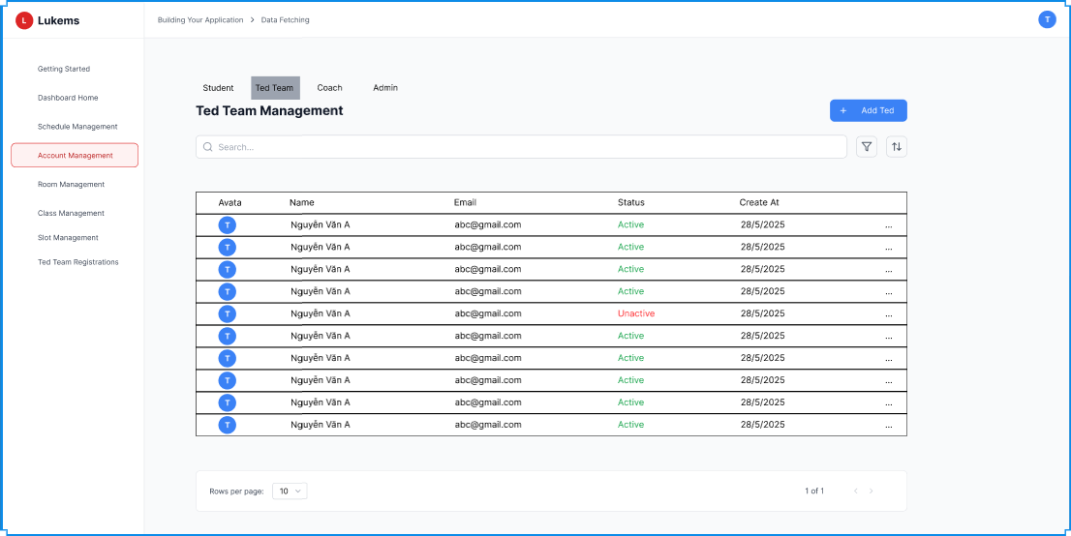

###### *Figure 33 - View all account Ted Team*

| **Screen** | | User management page | | | | |
| --- | --- | --- | --- | --- | --- | --- |
| **Description** | | This screen allows administrators to view and manage all user accounts in the system, with options to filter by role, such as "Ted Team". | | | | |
| **Screen Access** | | From the Admin homepage/dashboard, click on "User Management" in the navigation menu. | | | | |
| Screen Content | | | | | | |
| **Item** | | **Type** | **Data** | | **Description** | |
| Account list | | Table | Ted Team name, Email, Status | | Displays a list of all Ted Team accounts along with relevant information. | |
| View detail button | | Button |  | | Allows viewing detailed information of a selected Ted Team account. | |
| Lock/Unlock button | | Button |  | | Allows locking or unlocking a Ted Team account. | |
| Add account button | | Button |  | | Navigates to the page for adding a new Ted Team account. | |
| Import Excel button | | Button |  | | Allows importing a list of Ted Team accounts from an Excel file. | |
| Screen Actions | | | | | | |
| **Action Name** | **Description** | | | **Success** | | **Failure** |
| View Ted Team List | The system automatically loads the list of users when the "Ted Team" filter is applied. | | | The table is populated with the first page of Ted Team accounts. | | An error message is displayed, indicating that the user data could not be loaded. |
| Search User | Admin types a name or email into the search bar and presses Enter or clicks a search icon. | | | The user list is updated to show only the accounts matching the search criteria. | | A "No results found" message is displayed in the table area if no accounts match. |
| Filter by Status | Admin selects a status (e.g., "Locked") from the status filter dropdown. | | | The user list is refreshed to show only Ted Team accounts with the selected status. | | The filter fails to apply, and an error message is shown. The list remains unchanged. |
| Lock/Unlock Account | Admin clicks the "Lock" or "Unlock" button next to a specific Ted Team account. | | | The account's status is successfully changed, and a confirmation message is displayed. The status in the list is updated. | | An error message appears, stating that the account status could not be changed. The status remains the same. |
| Navigate to Add User | Admin clicks the "Add New Ted Team" button. | | | The system redirects to the "Add New Ted Team Account" form (UC-25). | | The button is unresponsive, or an error message appears, preventing navigation. |

### 3.23 UC-22 View all account Coach

#### 

| **Use Case ID** | **UC22** | **Use Case Name** | **View all account Coach** |
| --- | --- | --- | --- |
| Created By | BinhHC | Date Created | 22 May 2025 |
| Primary Actor | Admin | Secondary Actor | – |
| Description | Allows the Admin to view a list of all Coach accounts in the LUKEMS system. | | |
| Priority | Must have | | |
| Trigger | The Admin navigates to the "User Management" section from the main dashboard and selects the "Coach" user role to view. | | |
| Pre-conditions | The Admin must be logged into the system with administrative privileges. | | |
| Post-conditions | The system displays a list of all Coach accounts, including their details. | | |
| Basic flow | 1. Admin selects the "User Management" option from the system menu.  2. The system displays the user management interface.  3. Admin filters the view to show only "Coach" accounts.  4. The system presents a table listing all Coach users with key information.  5. Admin can use search and pagination to browse the accounts. | | |
| Alternative flow | Alternative flow 1: No Coach accounts exist → System displays "No search results." (MSG01)  Alternative flow 2: Search with no results → Admin searches for a Coach but no matches are found, system displays "No search results." (MSG01)  Alternative flow 3: Filter by status → Admin applies status filter and system shows only Coaches with selected status  Alternative flow 4: Sort Coach list → Admin selects sorting criteria and system reorders the Coach list accordingly  Alternative flow 5: Change pagination → Admin selects different rows per page or navigates to different page | | |
| Exception | Session expired during viewing → System displays: MSG57  Server error during data loading → System displays: MSG116  Network connectivity issues → System displays: MSG117  Failed to load Coach data → System displays: MSG128  Search operation failed → System displays: MSG75  Filter operation failed → System displays: MSG76  Sort operation failed → System displays: MSG77 | | |
| Business rules | BR-53, BR-54, BR-55 | | |

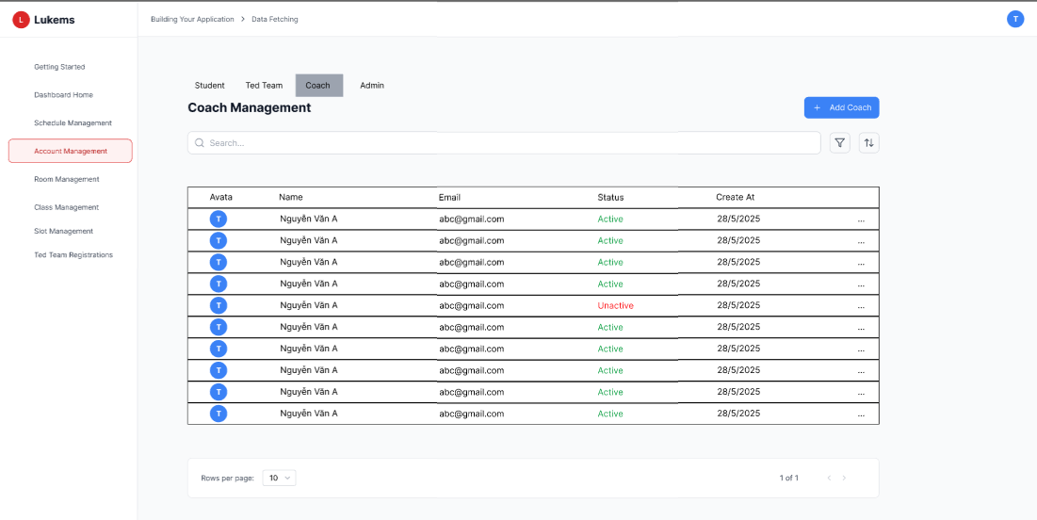

###### *Figure 34 - View all account Coach*

| **Screen** | | User management page | | | | |
| --- | --- | --- | --- | --- | --- | --- |
| **Description** | | This screen allows administrators to view and manage all user accounts in the system, with options to filter by role, such as "Coach". | | | | |
| **Screen Access** | | From the Admin homepage/dashboard, click on "User Management" in the navigation menu. | | | | |
| Screen Content | | | | | | |
| **Item** | | **Type** | **Data** | | **Description** | |
| Account list | | Table | Coach name, Email, Status | | Displays a list of all Coach accounts along with relevant information. | |
| View detail button | | Button |  | | Allows viewing detailed information of a selected Coach account. | |
| Lock/Unlock button | | Button |  | | Allows locking or unlocking a Coach account. | |
| Add account button | | Button |  | | Navigates to the page for adding a new Coach account. | |
| Import Excel button | | Button |  | | Allows importing a list of Coach accounts from an Excel file. | |
| Screen Actions | | | | | | |
| **Action Name** | **Description** | | | **Success** | | **Failure** |
| View Coach List | The system automatically loads the list of users when the "Coach" filter is applied. | | | The table is populated with the first page of Coach accounts. | | An error message is displayed, indicating that the user data could not be loaded. |
| Search User | Admin types a name or email into the search bar and presses Enter or clicks a search icon. | | | The user list is updated to show only the accounts matching the search criteria. | | A "No results found" message is displayed in the table area if no accounts match. |
| Filter by Status | Admin selects a status (e.g., "Locked") from the status filter dropdown. | | | The user list is refreshed to show only Coach accounts with the selected status. | | The filter fails to apply, and an error message is shown. The list remains unchanged. |
| Lock/Unlock Account | Admin clicks the "Lock" or "Unlock" button next to a specific Ted Team account. | | | The account's status is successfully changed, and a confirmation message is displayed. The status in the list is updated. | | An error message appears, stating that the account status could not be changed. The status remains the same. |
| Navigate to Add User | Admin clicks the "Add New Coach" button. | | | The system redirects to the "Add New Coach Account" form (UC-26). | | The button is unresponsive, or an error message appears, preventing navigation. |

### 3.24 UC-23 View all account Admin

#### 

| **Use Case ID** | **UC23** | **Use Case Name** | **View all account Admin** |
| --- | --- | --- | --- |
| Created By | BinhHC | Date Created | 22 May 2025 |
| Primary Actor | Admin | Secondary Actor | — |
| Description | Allows the Admin to view a list of all Admin accounts in the LUKEMS system. | | |
| Priority | Must have | | |
| Trigger | The Admin navigates to the "User Management" section from the main dashboard and selects the "Admin" user role to view. | | |
| Pre-conditions | The Admin must be logged into the system with administrative privileges. | | |
| Post-conditions | The system displays a list of all Admin accounts, including their details. | | |
| Basic flow | 1. Admin selects the "User Management" option from the system menu.  2. The system displays the user management interface.  3. Admin filters the view to show only "Admin" accounts.  4. The system presents a table listing all Admin users with key information.  5. Admin can use search and pagination to browse the accounts. | | |
| Alternative flow | Alternative flow 1: No Admin accounts exist → System displays "No search results." (MSG01)  Alternative flow 2: Search with no results → Admin searches for an Admin but no matches are found, system displays "No search results." (MSG01)  Alternative flow 3: Filter by status → Admin applies status filter and system shows only Admins with selected status  Alternative flow 4: Sort Admin list → Admin selects sorting criteria and system reorders the Admin list accordingly  Alternative flow 5: Change pagination → Admin selects different rows per page or navigates to different page | | |
| Exception | Session expired during viewing → System displays: MSG57  Server error during data loading → System displays: MSG116  Network connectivity issues → System displays: MSG117  Failed to load Admin data → System displays: MSG129  Search operation failed → System displays: MSG75  Filter operation failed → System displays: MSG76  Sort operation failed → System displays: MSG77 | | |
| Business rules | BR-53, BR-54, BR-55 | | |

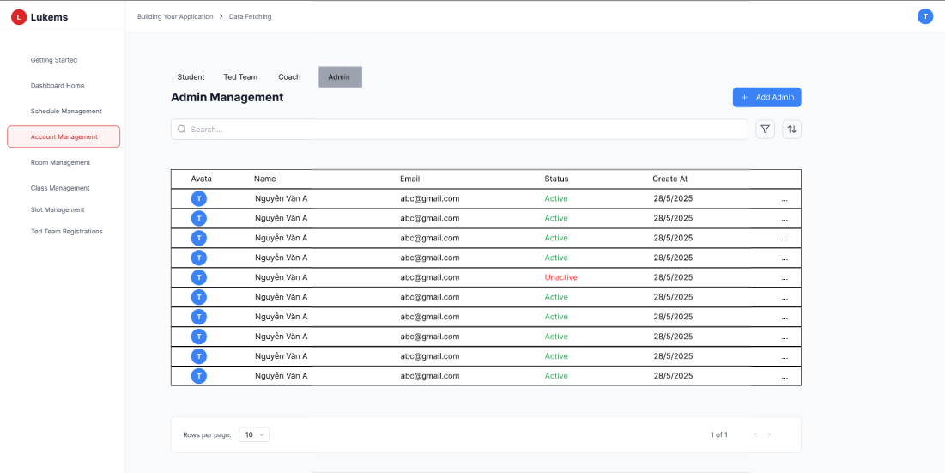

###### *Figure 35 - View all account Admin*

| **Screen** | | User management page | | | | |
| --- | --- | --- | --- | --- | --- | --- |
| **Description** | | This screen allows administrators to view and manage all user accounts in the system, with options to filter by role, such as "Admin". | | | | |
| **Screen Access** | | From the Admin homepage/dashboard, click on "User Management" in the navigation menu. | | | | |
| Screen Content | | | | | | |
| **Item** | | **Type** | **Data** | | **Description** | |
| Account list | | Table | Admin name, Email, Status | | Displays a list of all Admin accounts along with relevant information. | |
| View detail button | | Button |  | | Allows viewing detailed information of a selected Admin account. | |
| Lock/Unlock button | | Button |  | | Allows locking or unlocking a Admin account. | |
| Add account button | | Button |  | | Navigates to the page for adding a new Admin account. | |
| Import Excel button | | Button |  | | Allows importing a list of Admin accounts from an Excel file. | |
| Screen Actions | | | | | | |
| **Action Name** | **Description** | | | **Success** | | **Failure** |
| View Admin List | The system automatically loads the list of users when the "Admin" filter is applied. | | | The table is populated with the first page of Ted Team accounts. | | An error message is displayed, indicating that the user data could not be loaded. |
| Search User | Admin types a name or email into the search bar and presses Enter or clicks a search icon. | | | The user list is updated to show only the accounts matching the search criteria. | | A "No results found" message is displayed in the table area if no accounts match. |
| Filter by Status | Admin selects a status (e.g., "Locked") from the status filter dropdown. | | | The user list is refreshed to show only Admin accounts with the selected status. | | The filter fails to apply, and an error message is shown. The list remains unchanged. |
| Lock/Unlock Account | Admin clicks the "Lock" or "Unlock" button next to a specific Admin account. | | | The account's status is successfully changed, and a confirmation message is displayed. The status in the list is updated. | | An error message appears, stating that the account status could not be changed. The status remains the same. |
| Navigate to Add User | Admin clicks the "Add New Admin" button. | | | The system redirects to the "Add New Admin Account" form (UC-27). | | The button is unresponsive, or an error message appears, preventing navigation. |

### 

### 3.25 UC-24 Add account student

#### 

| **Use Case ID** | **UC24** | **Use Case Name** | **Add account student** |
| --- | --- | --- | --- |
| Created By | BinhHC | Date Created | 22 May 2025 |
| Primary Actor | Admin | Secondary Actor | – |
| Description | Allows the Admin to add a new student account to the LUKEMS system by entering required student information. | | |
| Priority | Must have | | |
| Trigger | The Admin clicks the "Add account" button from the Student User Management screen. | | |
| Pre-conditions | The Admin must be logged into the system with valid credentials and have the 'Admin' role. | | |
| Post-conditions | A new student account is created and added to the system. | | |
| Basic flow | 1. Admin navigates to the "User Management" page.  2. Admin clicks the "Add account" button under the Student section.  3. The system opens the "Add Student Account" form.  4. Admin enters student details: email and sets default status.  5. Admin clicks "Submit".  6. The system validates input and creates a new student account.  7. System redirects to the Student Account List with a confirmation message. | | |
| Alternative flow | Alternative flow 1: Empty email field → Admin clicks Submit without entering email, system displays MSG132: "Email is required."  Alternative flow 2: Invalid email format → Admin enters invalid email format, system displays MSG133: "Please enter a valid email address."  Alternative flow 3: Duplicate email → Admin enters existing email, system displays MSG134: "Email already exists in the system."  Alternative flow 4: Cancel operation → Admin clicks Cancel, system returns to Student Management page without saving | | |
| Exception | Session expired during form submission → System displays: MSG57  Server error during account creation → System displays: MSG116  Network connectivity issues → System displays: MSG117  Failed to create student account → System displays: MSG135  Email validation service unavailable → System displays: MSG136 | | |
| Business rules | BR-53, BR-54, BR-55, BR-56 | | |

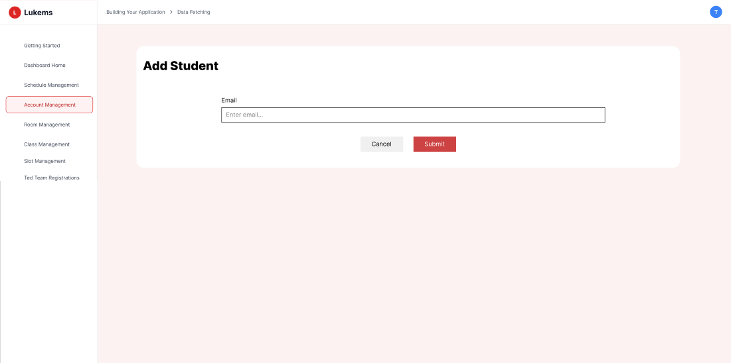

###### *Figure 36 - Add account student*

| **Screen** | | Add New Student Account Page | | | | |
| --- | --- | --- | --- | --- | --- | --- |
| **Description** | | Allows Admin to enter and save a new student account. | | | | |
| **Screen Access** | | From the Admin dashboard, click “User Management”, click “Add account” under the student section. | | | | |
| Screen Content | | | | | | |
| **Item** | | **Type** | **Data** | | **Description** | |
| Email field | | Input | Email address | | Field to enter a unique student email. | |
| Cancel button | | Button |  | | Cancels the action and returns to the student list page. | |
| Submit button | | Button |  | | Validates input and creates a new account. | |
| Screen Actions | | | | | | |
| **Action Name** | **Description** | | | **Success** | | **Failure** |
| Fill student info | Admin enters student email. | | | Fields are filled | | Required fields missing |
| Click Submit | Admin submits the form to create the account | | | Account successfully added to the system. | | Email already exists / System error message shown. |
| Click Cancel | Admin cancels the process | | | Returns to the student list page | | __ |

### 

### 3.26 UC-25 Add account Ted Team

#### 

| **Use Case ID** | **UC25** | **Use Case Name** | **Add account Ted Team** |
| --- | --- | --- | --- |
| Created By | BinhHC | Date Created | 22 May 2025 |
| Primary Actor | Admin | Secondary Actor | – |
| Description | Allows the Admin to add a new Ted account to the LUKEMS system by entering required Ted information. | | |
| Priority | Must have | | |
| Trigger | The Admin clicks the "Add account" button from the Ted TeamUser Management screen. | | |
| Pre-conditions | The Admin must be logged into the system with valid credentials and have the 'Admin' role. | | |
| Post-conditions | A new Ted account is created and added to the system. | | |
| Basic flow | 1. Admin navigates to the "User Management" page.  2. Admin clicks the "Add account" button under the Ted Team section.  3. The system opens the "Add Ted Account" form.  4. Admin enters Ted details: email and sets default status.  5. Admin clicks "Submit".  6. The system validates input and creates a new Ted account.  7. System redirects to the Ted Team Account List with a confirmation message. | | |
| Alternative flow | Alternative flow 1: Empty email field → Admin clicks Submit without entering email, system displays MSG132: "Email is required."  Alternative flow 2: Invalid email format → Admin enters invalid email format, system displays MSG133: "Please enter a valid email address."  Alternative flow 3: Duplicate email → Admin enters existing email, system displays MSG134: "Email already exists in the system."  Alternative flow 4: Cancel operation → Admin clicks Cancel, system returns to Ted Team Management page without saving | | |
| Exception | Session expired during form submission → System displays: MSG057  Server error during account creation → System displays: MSG116  Network connectivity issues → System displays: MSG117  Failed to create Ted account → System displays: MSG138  Email validation service unavailable → System displays: MSG139 | | |
| Business rules | BR-53, BR-54, BR-55, BR-57 | | |

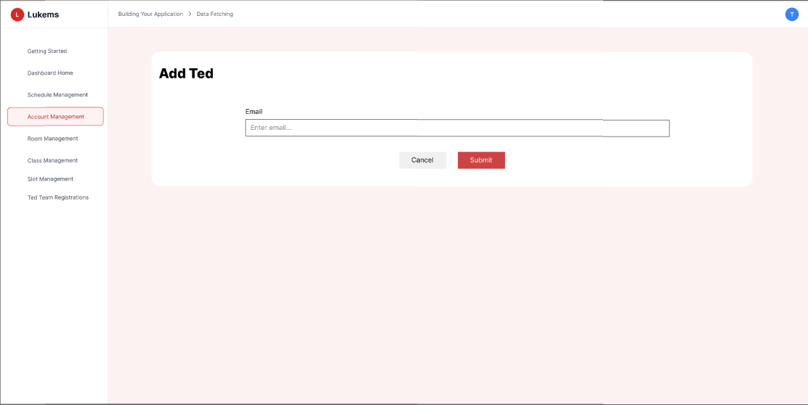

###### *Figure 37 - Add account Ted Team*

| **Screen** | | Add New Ted Team Account Page | | | | |
| --- | --- | --- | --- | --- | --- | --- |
| **Description** | | Allows Admin to enter and save a new Ted account. | | | | |
| **Screen Access** | | From the Admin dashboard, click “User Management”, click “Add account” under the Ted Team section. | | | | |
| Screen Content | | | | | | |
| **Item** | | **Type** | **Data** | | **Description** | |
| Email field | | Input | Email address | | Field to enter a unique Ted email. | |
| Cancel button | | Button |  | | Cancels the action and returns to the Ted Team list page. | |
| Submit button | | Button |  | | Validates input and creates a new account. | |
| Screen Actions | | | | | | |
| **Action Name** | **Description** | | | **Success** | | **Failure** |
| Fill Ted info | Admin enters Ted email. | | | Fields are filled | | Required fields missing |
| Click Submit | Admin submits the form to create the account | | | Account successfully added to the system. | | Email already exists / System error message shown. |
| Click Cancel | Admin cancels the process | | | Returns to the Ted Team list page | | __ |

### 3.27 UC-26 Add account Coach

#### 

| **Use Case ID** | **UC26** | **Use Case Name** | **Add account Coach** |
| --- | --- | --- | --- |
| Created By | BinhHC | Date Created | 22 May 2025 |
| Primary Actor | Admin | Secondary Actor | – |
| Description | Allows the Admin to add a new Coach account to the LUKEMS system by entering required Coach information. | | |
| Priority | Must have | | |
| Trigger | The Admin clicks the "Add account" button from the Coach User Management screen. | | |
| Pre-conditions | The Admin must be logged into the system with valid credentials and have the 'Admin' role. | | |
| Post-conditions | A new Coach account is created and added to the system. | | |
| Basic flow | 1. Admin navigates to the "User Management" page.  2. Admin clicks the "Add account" button under the Coach section.  3. The system opens the "Add Coach Account" form.  4. Admin enters Coach details: email and sets default status.  5. Admin clicks "Submit".  6. The system validates input and creates a new Coach account.  7. System redirects to the Coach Account List with a confirmation message. | | |
| Alternative flow | Alternative flow 1: Empty email field → Admin clicks Submit without entering email, system displays MSG132: "Email is required."  Alternative flow 2: Invalid email format → Admin enters invalid email format, system displays MSG133: "Please enter a valid email address."  Alternative flow 3: Duplicate email → Admin enters existing email, system displays MSG134: "Email already exists in the system."  Alternative flow 4: Cancel operation → Admin clicks Cancel, system returns to Coach Management page without saving | | |
| Exception | Session expired during form submission → System displays: MSG057  Server error during account creation → System displays: MSG116  Network connectivity issues → System displays: MSG117  Failed to create Coach account → System displays: MSG141  Email validation service unavailable → System displays: MSG139 | | |
| Business rules | BR-53, BR-54, BR-55, BR-58 | | |

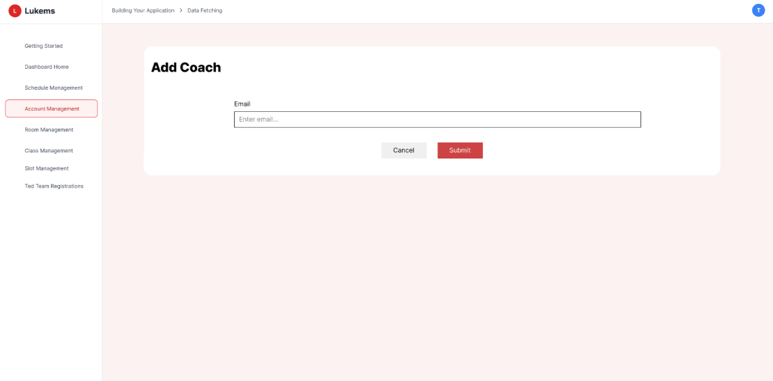

###### *Figure 38 - Add account Coach*

| **Screen** | | Add New Coach Account Page | | | | |
| --- | --- | --- | --- | --- | --- | --- |
| **Description** | | Allows Admin to enter and save a new Coach account. | | | | |
| **Screen Access** | | From the Admin dashboard, click “User Management”, click “Add account” under the Coach section. | | | | |
| Screen Content | | | | | | |
| **Item** | | **Type** | **Data** | | **Description** | |
| Email field | | Input | Email address | | Field to enter a unique Coach email. | |
| Cancel button | | Button |  | | Cancels the action and returns to the Coach list page. | |
| Submit button | | Button |  | | Validates input and creates a new account. | |
| Screen Actions | | | | | | |
| **Action Name** | **Description** | | | **Success** | | **Failure** |
| Fill Coach info | Admin enters Coach email. | | | Fields are filled | | Required fields missing |
| Click Submit | Admin submits the form to create the account | | | Account successfully added to the system. | | Email already exists / System error message shown. |
| Click Cancel | Admin cancels the process | | | Returns to the Coach list page | | __ |

### 3.28 UC-27 Add account Admin

#### 

| **Use Case ID** | **UC27** | **Use Case Name** | **Add account Admin** |
| --- | --- | --- | --- |
| Created By | BinhHC | Date Created | 22 May 2025 |
| Primary Actor | Admin | Secondary Actor | – |
| Description | Allows the Admin to add a new Admin account to the LUKEMS system by entering required Admin information. | | |
| Priority | Must have | | |
| Trigger | The Admin clicks the "Add account" button from the Admin User Management screen. | | |
| Pre-conditions | The Admin must be logged into the system with valid credentials and have the 'Admin' role. | | |
| Post-conditions | A new Admin account is created and added to the system. | | |
| Basic flow | 1. Admin navigates to the "User Management" page.  2. Admin clicks the "Add account" button under the Admin section.  3. The system opens the "Add Admin Account" form.  4. Admin enters Admin details: email and sets default status.  5. Admin clicks "Submit".  6. The system validates input and creates a new Admin account.  7. System redirects to the Admin Account List with a confirmation message. | | |
| Alternative flow | Alternative flow 1: Empty email field → Admin clicks Submit without entering email, system displays MSG132: "Email is required."  Alternative flow 2: Invalid email format → Admin enters invalid email format, system displays MSG133: "Please enter a valid email address."  Alternative flow 3: Duplicate email → Admin enters existing email, system displays MSG134: "Email already exists in the system."  Alternative flow 4: Cancel operation → Admin clicks Cancel, system returns to Admin Management page without saving | | |
| Exception | Session expired during form submission → System displays: MSG057  Server error during account creation → System displays: MSG116  Network connectivity issues → System displays: MSG117  Failed to create Admin account → System displays: MSG143  Email validation service unavailable → System displays: MSG139 | | |
| Business rules | BR-53, BR-54, BR-55, BR-59 | | |

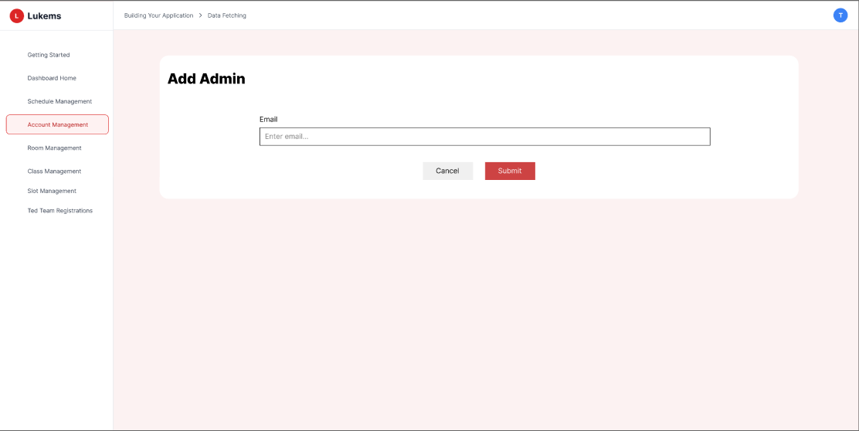

###### *Figure 39 - Add account Admin*

| **Screen** | | Add New Admin Account Page | | | | |
| --- | --- | --- | --- | --- | --- | --- |
| **Description** | | Allows Admin to enter and save a new Admin account. | | | | |
| **Screen Access** | | From the Admin dashboard, click “User Management”, click “Add account” under the Admin section. | | | | |
| Screen Content | | | | | | |
| **Item** | | **Type** | **Data** | | **Description** | |
| Email field | | Input | Email address | | Field to enter a unique Admin email. | |
| Cancel button | | Button |  | | Cancels the action and returns to the Admin list page. | |
| Submit button | | Button |  | | Validates input and creates a new account. | |
| Screen Actions | | | | | | |
| **Action Name** | **Description** | | | **Success** | | **Failure** |
| Fill Admin info | Admin enters Admin email. | | | Fields are filled | | Required fields missing |
| Click Submit | Admin submits the form to create the account | | | Account successfully added to the system. | | Email already exists / System error message shown. |
| Click Cancel | Admin cancels the process | | | Returns to the Admin list page | | __ |

### 

### 3.29 UC-28 Import Excel file for accounts

| **Use Case ID** | **UC-28** | **Use Case Name** | **Import Excel file for accounts** |
| --- | --- | --- | --- |
| Created By | BinhHC | Date Created | 23 May 2025 |
| Primary Actor | Admin | Secondary Actor | – |
| Description | Allows the Admin to import a list of user accounts (Student, Ted Team, Coach) from an Excel file into the system. | | |
| Priority | Must have | | |
| Trigger | The Admin clicks the "Import Excel" button on the user management screen. | | |
| Pre-conditions | PRE-01: The Admin is logged in with appropriate privileges.  PRE-02: A valid Excel file is prepared following the system format. | | |
| Post-conditions | POST-01: Valid user accounts are added to the system and shown in the user list. | | |
| Basic Flow | 1. Admin navigates to the “User Management” screen.  2. Click the “Import Excel” button.  3. Selects the role type (Student, Coach, Ted Team)  .4. Uploads the Excel file.  5. System validates and displays previews.  6. Admin confirms import.  7. System saves valid accounts and shows results. | | |
| Alternative Flow | Alternative flow 1: No file selected → Admin clicks Submit without selecting file, system displays MSG146: "Please select a file to upload."  Alternative flow 2: Invalid file format → Admin selects non-Excel file, system displays MSG145: "Invalid file format. Please upload an Excel file (.xls, .xlsx)."  Alternative flow 3: File too large → Admin selects file exceeding size limit, system displays MSG045: "Attachment too large. Please upload a smaller file."  Alternative flow 4: Duplicate emails in file → System processes file and displays MSG147: "Some accounts were skipped due to duplicate emails."  Alternative flow 5: Cancel operation → Admin clicks Cancel, system returns to User Management page without processing | | |
| Exception | Session expired during file upload → System displays: MSG057  Server error during file processing → System displays: MSG116  Network connectivity issues → System displays: MSG117  Failed to process Excel file → System displays: MSG148  File validation service unavailable → System displays: MSG149 | | |
| Business Rule | BR-53, BR-54, BR-55, BR-60 | | |

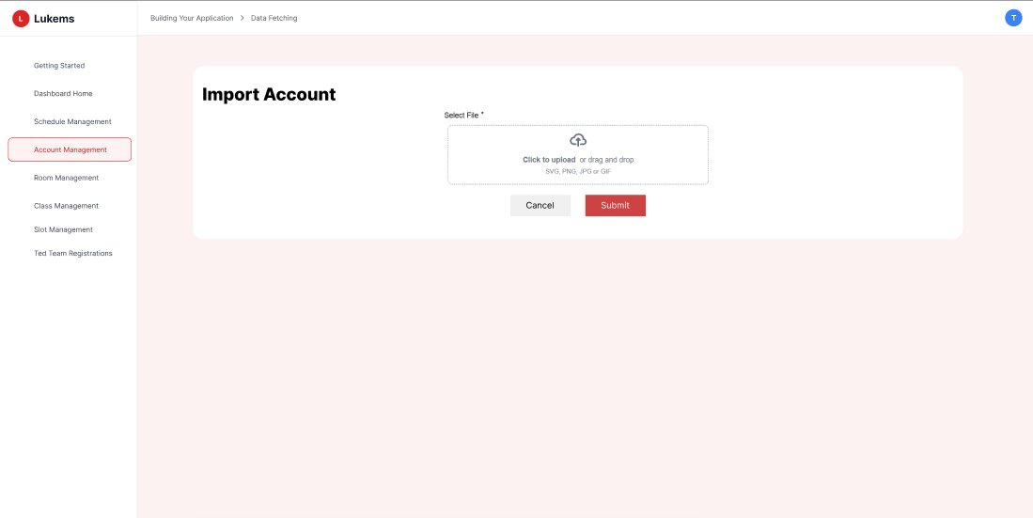

###### *Figure 40 - Import Excel file for accounts*

| **Screen** | | Import Excel | | | | |
| --- | --- | --- | --- | --- | --- | --- |
| **Description** | | Screen allows Admin to import multiple user accounts by uploading an Excel file with required data (name, email, role, status). | | | | |
| **Screen Access** | | From Admin dashboard, Click "User Management", Click "Import Excel" button. | | | | |
| Screen Content | | | | | | |
| **Item** | | **Type** | **Data** | | **Description** | |
| Role selector | | Dropdown | Student / Coach / Ted Team/ Admin | | Select the role for the accounts being imported. | |
| Upload field | | File | .xlsx file | | Upload Excel file containing the user list. | |
| Download template | | Button | — | | Download sample Excel format. | |
| Import button | | Button | — | | Start import process after file is uploaded. | |
| Cancel button | | Button | — | | Return to user list without uploading. | |
| Validation result | | Table | Row preview with status | | Shows preview of data with success/error for each row. | |
| Screen Actions | | | | | | |
| **Action Name** | **Description** | | | **Success** | | **Failure** |
| Upload File | Admin uploads an Excel file | | | File loaded and preview displayed | | File type invalid, system shows format error |
| Click Import | Admin clicks import after checking data preview | | | Accounts created, success message shown | | Duplicate emails, invalid rows skipped, system shows warnings |
| Click Cancel | Admin cancels the process | | | Returns to user list without importing | | — |
| Download Template | Admin downloads sample file | | | Template downloaded successfully | | Error downloading template |

### 3.30 UC-29 Lock or unlock account

| **Use Case ID** | **UC-29** | **Use Case Name** | **Lock or unlock account** |
| --- | --- | --- | --- |
| Created By | BinhHC | Date Created | 07 June 2025 |
| Primary Actor | Admin | Secondary Actor | – |
| Description | Allows the Admin to change the access status of a user account (Student, Ted Team, Coach, or Admin) by locking or unlocking it. | | |
| Priority | Must have | | |
| Trigger | The Admin clicks the "Lock" or "Unlock" button next to a specific user account on the User Management screen. | | |
| Pre-conditions | PRE-01: The Admin is logged in with appropriate privileges.  PRE-02: The target user account exists in the system. | | |
| Post-conditions | POST-01: The selected account is locked or unlocked and its status is updated in the list. | | |
| Basic Flow | 1. Admin navigates to the “User Management” screen.  2. Locates a user account from the list.  3. Click the “Lock” or “Unlock” button.  4. System confirms action.  5. System updates the status and displays the result. | | |
| Alternative Flow | Alternative flow 1: Account already locked → Admin tries to lock already inactive account, system displays MSG150: "Account is already locked."  Alternative flow 2: Account already unlocked → Admin tries to unlock already active account, system displays MSG151: "Account is already unlocked."  Alternative flow 3: Account not found → Selected account no longer exists, system displays MSG152: "Account not found. Please refresh the page."  Alternative flow 4: Insufficient permissions → Admin lacks permission to lock/unlock accounts, system displays MSG153: "You do not have permission to lock/unlock accounts."  Alternative flow 5: Self-lock attempt → Admin tries to lock their own account, system displays MSG154: "You cannot lock your own account." | | |
| Exception | Session expired during operation → System displays: MSG057  Server error during lock/unlock → System displays: MSG155  Network connectivity issues → System displays: MSG117  Database constraint violation → System displays: MSG156  Concurrent modification → System displays: MSG157 | | |
| Business Rule | BR-53, BR-54, BR-55, BR-61 | | |

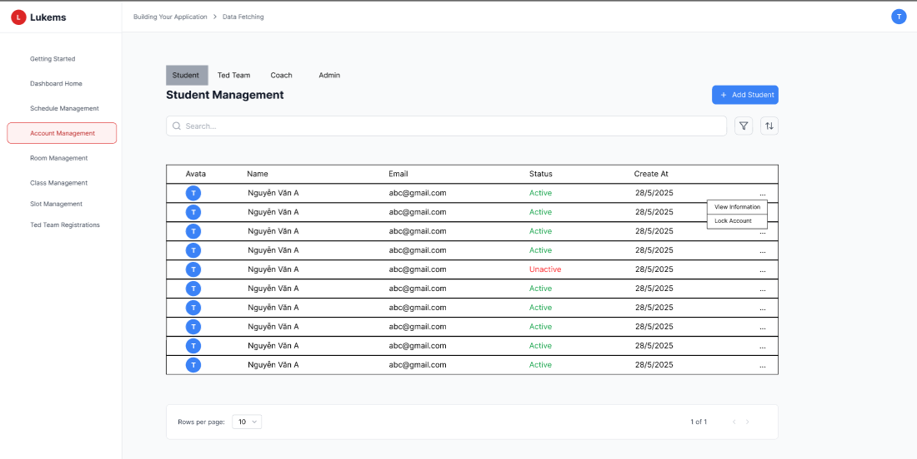

###### *Figure 41 - Lock or unlock account*

| **Screen** | | User Management | | | | |
| --- | --- | --- | --- | --- | --- | --- |
| **Description** | | Screen allows Admin to manage user account access by locking or unlocking accounts directly from the list. | | | | |
| **Screen Access** | | From Admin dashboard, Click "User Management", View user list (Student, Ted Team, Coach, Admin) | | | | |
| Screen Content | | | | | | |
| **Item** | | **Type** | **Data** | | **Description** | |
| Account list | | Table | Name, email, status | | Display all accounts by selected role. | |
| Lock/Unlock button | | Button | Lock / Unlock icon | | Toggle button to lock or unlock a specific user account. | |
| Confirmation popup | | Popup | Yes / No | | Confirms whether Admin wants to proceed with the action. | |
| Status column | | Text/Icon | Active / Locked | | Indicates current status of the account. | |
| Screen Actions | | | | | | |
| **Action Name** | **Description** | | | **Success** | | **Failure** |
| Click Lock button | Admin clicks to lock a user account | | | Account status changes to “Locked”, success message shown | | User not found or system error, system shows error message |
| Click Unlock button | Admin clicks to unlock a user account | | | Account status changes to “Active”, success message shown | | Action fails due to error, status unchanged |
| Confirm Action | Admin confirms in the popup | | | Action executed and reflected in UI | | Admin cancels or system blocks change |

### 3.31 UC-30 View detailed account

| **Use Case ID** | **UC-30** | **Use Case Name** | **View detailed account** |
| --- | --- | --- | --- |
| Created By | BinhHC | Date Created | 23 May 2025 |
| Primary Actor | Admin | Secondary Actor | – |
| Description | Allows the Admin to view detailed information of a specific user account, including name, email, role, status, and creation time. | | |
| Priority | Must have | | |
| Trigger | The Admin clicks the "View detail" button next to a user account on the User Management screen. | | |
| Pre-conditions | PRE-01**:** The Admin is logged into the system.  PRE-02: The selected user account exists. | | |
| Post-conditions | POST-01**:** Detailed information of the selected account is displayed on a new screen or modal. | | |
| Basic Flow | 1. Admin opens the “User Management” screen.  2. Locates the desired user account in the list.  3. Clicks the “View detail” button.  4. System displays detailed information about the account. | | |
| Alternative Flow | Alternative flow 1: Account not found → Selected account no longer exists, system displays MSG163: "Account not found. Please return to the account list."  Alternative flow 2: Insufficient permissions → Admin lacks permission to view account details, system displays MSG164: "You do not have permission to view this account."  Alternative flow 3: Account data incomplete → Some account information is missing, system displays MSG165: "Some account information is unavailable."  Alternative flow 4: Inactive account → Account is locked/inactive, system displays warning MSG166: "This account is currently inactive." | | |
| Exception | Session expired during page load → System displays: MSG057  Server error during data retrieval → System displays: MSG167  Network connectivity issues → System displays: MSG117  Database connection timeout → System displays: MSG168  Account data corruption → System displays: MSG169 | | |
| Business Rule | BR-53, BR-54, BR-55, BR-62 | | |

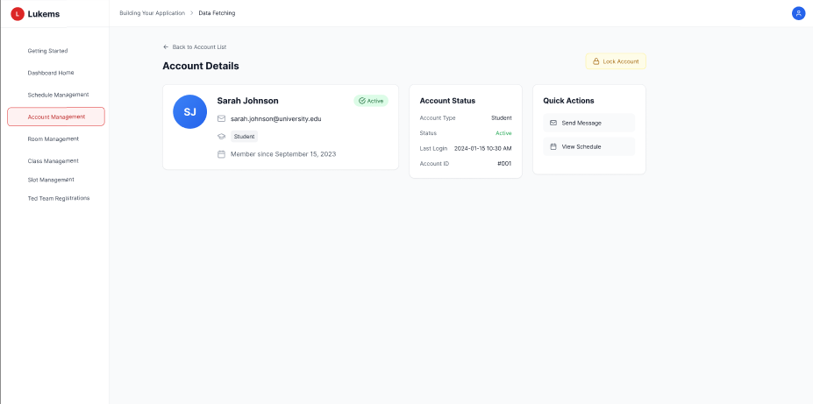

###### *Figure 42 - View detailed account*

| **Screen** | | Account Detail View | | | | |
| --- | --- | --- | --- | --- | --- | --- |
| **Description** | | Screen shows complete details of a selected account including name, email, role, account status, and timestamps. | | | | |
| **Screen Access** | | From Admin dashboard, Click "User Management", Click "View detail" button of a user | | | | |
| Screen Content | | | | | | |
| **Item** | | **Type** | **Data** | | **Description** | |
| Full name | | Text | User's name | | Displays full name of the user | |
| Email | | Text | Email address | | Displays the email of the account | |
| Role | | Text | Student / Coach / Ted Team / Admin | | Displays the assigned role | |
| Status | | Text | Active / Locked | | Current access status of the account | |
| Created date | | Text | Timestamp | | Date and time the account was created | |
| Last login (optional) | | Text | Timestamp | | Last recorded login time (if applicable) | |
| Return button | | Button | — | | Return to User Management list | |
| Screen Actions | | | | | | |
| **Action Name** | **Description** | | | **Success** | | **Failure** |
| Click View Detail | Admin clicks to see full information of a user | | | Detail view screen/modal is shown | | User not found, system shows “Account not found” |
| Return to list | Admin clicks to return | | | User Management screen is shown | | — |
| System auto-load | System fetches account detail data | | | Data displayed properly | | System error, shows “Unable to load account details” |

### 3.32 UC-31 Search class

| **Use Case ID** | **UC-31** | **Use Case Name** | **Search class** |
| --- | --- | --- | --- |
| Created By | BinhHC | Date Created | 23 May 2025 |
| Primary Actor | Admin | Secondary Actor | – |
| Description | Allows the Admin to search for classes based on keywords such as class name or code in the class management screen. | | |
| Priority | Must have | | |
| Trigger | The Admin enters a keyword in the search bar and presses Enter or clicks the search icon in the class list interface. | | |
| Pre-conditions | PRE-01: The Admin is logged in to the system.  PRE-02: At least one class exists in the system. | | |
| Post-conditions | POST-01: The search results are displayed based on the entered keyword. | | |
| Basic Flow | 1. Admin navigates to the “Class Management” screen.  2. Enters a keyword into the search bar.  3. Presses Enter or clicks the search icon.  4. System filters and displays matching class(es). | | |
| Alternative Flow | Alternative flow 1: Empty search query → Admin searches with empty or whitespace-only query, system displays MSG170: "Please enter a search term."  Alternative flow 2: No matching results → Search returns no results, system displays MSG171: "No classes found matching your search criteria."  Alternative flow 3: Search query too short → Admin enters less than 2 characters, system displays MSG172: "Please enter at least 2 characters to search."  Alternative flow 4: Special characters in search → Admin enters invalid characters, system displays MSG173: "Search contains invalid characters. Please use letters and numbers only." | | |
| Exception | Session expired during search → System displays: MSG057  Server error during search → System displays: MSG174  Network connectivity issues → System displays: MSG117  Database timeout during search → System displays: MSG175  Search service unavailable → System displays: MSG176 | | |
| Business Rule | BR-63 | | |

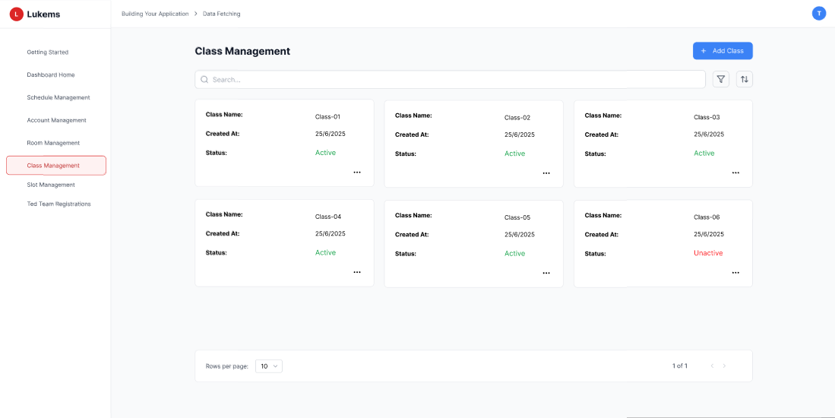

###### *Figure 43 - Search class*

| **Screen** | | Class Management | | | | |
| --- | --- | --- | --- | --- | --- | --- |
| **Description** | | Screen displays a list of classes and allows Admin to search for classes using a keyword. | | | | |
| **Screen Access** | | From Admin dashboard, click "Class Management" in the sidebar menu. | | | | |
| Screen Content | | | | | | |
| **Item** | | **Type** | **Data** | | **Description** | |
| Search bar | | Input | Text | | Allows Admin to enter keyword (class code or name) | |
| Search icon/button | | Button | — | | Executes the search function | |
| Class list | | Table | Class code, name, etc. | | Displays all or filtered classes | |
| Clear button | | Button | — | | Clears search and reloads full list | |
| No result message | | Text | “No class found” | | Shown when no class matches the keyword | |
| Screen Actions | | | | | | |
| **Action Name** | **Description** | | | **Success** | | **Failure** |
| Click View Detail | Admin clicks to see full information of a user | | | Detail view screen/modal is shown | | User not found, system shows “Account not found” |
| Return to list | Admin clicks to return | | | User Management screen is shown | | — |
| System auto-load | System fetches account detail data | | | Data displayed properly | | System error, shows “Unable to load account details” |

### 3.33-UC-32 List Class

| **Use Case ID** | **UC-32** | **Use Case Name** | **List class** |
| --- | --- | --- | --- |
| Created By | BinhHC | Date Created | 23 May 2025 |
| Primary Actor | Admin | Secondary Actor | – |
| Description | Allows the Admin to view a complete list of all classes currently stored in the system. | | |
| Priority | Must have | | |
| Trigger | The Admin accesses the Class Management screen from the main menu. | | |
| Pre-conditions | The Admin is logged into the system.There is at least one class in the database. | | |
| Post-conditions | The Admin views the full class list on screen. | | |
| Basic Flow | 1. Admin clicks “Class Management” from the menu.  2. System retrieves the list of classes from the database.  3. System displays all classes with key information (code, name, status). | | |
| Alternative Flow | Alternative flow 1: No classes exist → System displays MSG01: "No search results." with option to create first class  Alternative flow 2: Class data loading timeout → System displays MSG097: "Unable to load schedule due to server timeout. Please try again later."  Alternative flow 3: Insufficient permissions → System displays MSG164: "You do not have permission to view this account."  Alternative flow 4: Class data corruption → System displays MSG095: "Some schedule data appears to be corrupted. Please contact administrator." | | |
| Exception | Session expired during page load → System displays: MSG057  Server error during class retrieval → System displays: MSG116  Network connectivity issues → System displays: MSG117  Database timeout during class loading → System displays: MSG097  Class data synchronization failure → System displays: MSG043  Insufficient permissions → System displays: MSG164 | | |
| Business Rule | BR-65 | | |



###### *Figure 44 - List class*

| **Screen** | | Class Management | | | | |
| --- | --- | --- | --- | --- | --- | --- |
| **Description** | | Screen displays all classes with key information such as code, name, and status. | | | | |
| **Screen Access** | | From Admin dashboard, click "Class Management" in the sidebar menu. | | | | |
| Screen Content | | | | | | |
| **Item** | | **Type** | **Data** | | **Description** | |
| Class list | | Table | Class code, class name, status | | Displays all classes in tabular format | |
| Search bar | | Input | Text | | (Optional) Search field to filter class list | |
| Add class button | | Button | — | | Redirects to the Add class form | |
| View detail button | | Button | Icon | | View full information of a selected class | |
| Screen Actions | | | | | | |
| **Action Name** | **Description** | | | **Success** | | **Failure** |
| Load class list | System retrieves and displays all classes | | | List shown in table | | System error, system shows error message |
| Click Add class | Admin clicks to add a new class | | | Navigates to Add Class screen | | — |
| Click View detail | Admin clicks to see details of a class | | | Opens class detail screen or modal | | Class not found, error message shown |

### 3.34 UC-33 Add class

| **Use Case ID** | **UC-33** | **Use Case Name** | **Add class** |
| --- | --- | --- | --- |
| Created By | BinhHC | Date Created | 23 May 2025 |
| Primary Actor | Admin | Secondary Actor | – |
| Description | Allows the Admin to create a new class by entering class information such as class code, class name, and status. | | |
| Priority | Must have | | |
| Trigger | The Admin clicks the “Add class” button on the class management screen. | | |
| Pre-conditions | The Admin is logged into the system.The class code must not already exist in the system. | | |
| Post-conditions | A new class is created and added to the class list. | | |
| Basic Flow | 1. Admin navigates to the “Class Management” screen.  2. Clicks the “Add class” button.  3. Fills in required fields: class code, class name, and status.  4. Clicks “Save”.  5. System validates and saves the new class. | | |
| Alternative Flow | Alternative flow 1: Empty class name → Admin submits form with empty class name field, system displays MSG02: "The * field is required."  Alternative flow 2: Class name exceeds maximum length → Admin enters class name longer than allowed limit, system displays MSG08: "Exceed max length of {max_length}."  Alternative flow 3: Empty start date → Admin submits form without selecting start date, system displays MSG02: "The * field is required."  Alternative flow 4: Empty end date → Admin submits form without selecting end date, system displays MSG02: "The * field is required."  Alternative flow 5: Invalid date format → Admin enters invalid date format, system displays MSG098: "Please enter a valid date format (MM/DD/YYYY)."  Alternative flow 6: End date before start date → Admin selects end date that is before start date, system displays MSG101: "End date must be after start date."  Alternative flow 7: Duplicate class name → Admin enters class name that already exists, system displays MSG100: "A quiz with this title already exists. Please choose a different title." | | |
| Exception | Session expired during form submission → System displays: MSG057  Server error during class creation → System displays: MSG135  Network connectivity issues → System displays: MSG117  Database timeout during creation → System displays: MSG097  Form loading failure → System displays: MSG130  Insufficient permissions → System displays: MSG099  Database constraint violation → System displays: MSG102 | | |
| Business Rule | BR-64 | | |

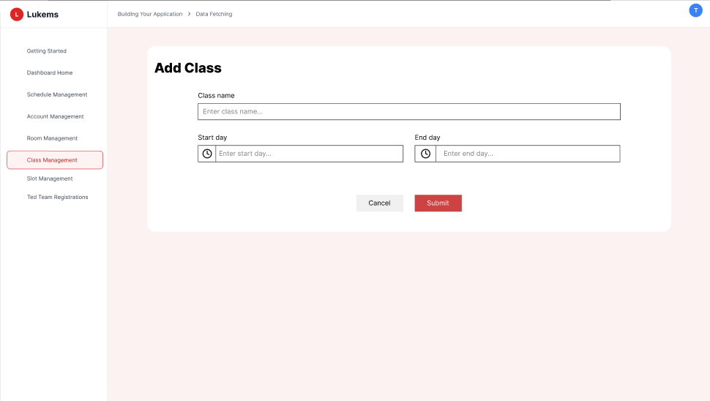

###### *Figure 45 - Add class*

| **Screen** | | Add Class Form | | | | |
| --- | --- | --- | --- | --- | --- | --- |
| **Description** | | Screen allows Admin to input details and create a new class. | | | | |
| **Screen Access** | | From Admin dashboard, click “Class Management”, then click “Add class” button. | | | | |
| Screen Content | | | | | | |
| **Item** | | **Type** | **Data** | | **Description** | |
| Class code field | | Input | Text | | Unique identifier for the class | |
| Class name field | | Input | Text | | Descriptive name of the class | |
| Status dropdown | | Dropdown | Active / Inactive | | Current state of the class | |
| Save button | | Button | — | | Saves the class after validation | |
| Cancel button | | Button | — | | Returns to class list without saving | |
| Screen Actions | | | | | | |
| **Action Name** | **Description** | | | **Success** | | **Failure** |
| Fill information | Admin inputs class code, name, and selects status | | | Fields are filled and ready for submission | | Missing or invalid fields, validation errors shown |
| Click Save | Admin saves the new class | | | Class added to system and confirmation shown | | Duplicate code or system error, class not added |
| Click Cancel | Admin cancels the creation | | | Return to class list screen | | — |

### 3.35 UC-34 Update class

| **Use Case ID** | **UC-34** | **Use Case Name** | **Update class** |
| --- | --- | --- | --- |
| Created By | BinhHC | Date Created | 23 May 2025 |
| Primary Actor | Admin | Secondary Actor | – |
| Description | Allows the Admin to update the information of an existing class, such as its name or status. | | |
| Priority | Must have | | |
| Trigger | The Admin clicks the “Edit” button next to a class in the class list. | | |
| Pre-conditions | The Admin is logged into the system.The selected class exists in the database. | | |
| Post-conditions | The class information is updated and reflected in the class list. | | |
| Basic Flow | 1. Admin opens the “Class Management” screen.  2. Locates the class to be updated.  3. Clicks the “Edit” button.  4. Updates the class name or status.  5. Clicks “Save”.  6. System validates and updates the class. | | |
| Alternative Flow | Alternative flow 1: Empty class name → Admin clears class name field and submits, system displays MSG02: "The * field is required."  Alternative flow 2: Class name exceeds maximum length → Admin enters class name longer than allowed limit, system displays MSG08: "Exceed max length of {max_length}."  Alternative flow 3: Empty start date → Admin clears start date field and submits, system displays MSG02: "The * field is required."  Alternative flow 4: Empty end date → Admin clears end date field and submits, system displays MSG02: "The * field is required."  Alternative flow 5: Invalid date format → Admin enters invalid date format, system displays MSG098: "Please enter a valid date format (MM/DD/YYYY)."  Alternative flow 6: End date before start date → Admin selects end date that is before start date, system displays MSG101: "End date must be after start date."  Alternative flow 7: Duplicate class name → Admin changes class name to one that already exists, system displays MSG100: "A quiz with this title already exists. Please choose a different title."  Alternative flow 8: Class not found → Admin attempts to edit a class that no longer exists, system displays MSG105: "The quiz you are trying to edit no longer exists."  Alternative flow 9: Concurrent editing → Another user is editing the same class, system displays MSG106: "This quiz is being edited by another user. Your changes may conflict." | | |
| Exception | Session expired during form submission → System displays: MSG057  Server error during class update → System displays: MSG109  Network connectivity issues → System displays: MSG117  Database timeout during update → System displays: MSG097  Form loading failure → System displays: MSG130  Insufficient permissions → System displays: MSG104  Database constraint violation → System displays: MSG102  Class not found → System displays: MSG105  Concurrent modification → System displays: MSG106  Validation error → System displays: MSG107 | | |
| Business Rule | BR-66 | | |

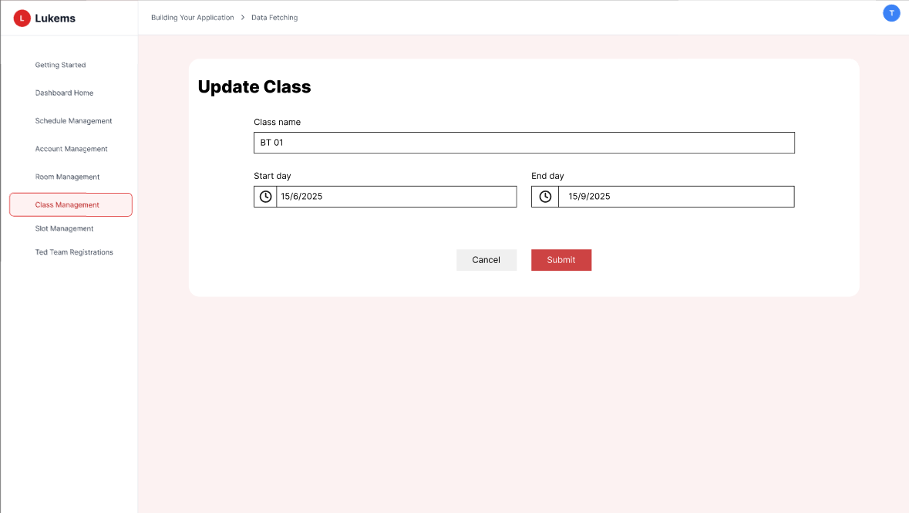

###### *Figure 46 - Update class*

| **Screen** | | Edit Class | | | | |
| --- | --- | --- | --- | --- | --- | --- |
| **Description** | | Screen allows Admin to edit and update information of an existing class. | | | | |
| **Screen Access** | | From “Class Management” screen, click the “Edit” button next to a class. | | | | |
| Screen Content | | | | | | |
| **Item** | | **Type** | **Data** | | **Description** | |
| Class code (readonly) | | Text | Existing code | | Class code shown but not editable | |
| Class name field | | Input | Text | | Editable field for class name | |
| Status dropdown | | Dropdown | Active / Inactive | | Update the status of the class | |
| Save button | | Button | — | | Save the changes made | |
| Cancel button | | Button | — | | Cancel the update and return to list | |
| Screen Actions | | | | | | |
| **Action Name** | **Description** | | | **Success** | | **Failure** |
| Edit class info | Admin modifies class name or status | | | Changes accepted and ready for submission | | Name is empty or invalid, validation message shown |
| Click Save | Admin confirms update | | | System saves and updates class list | | Class not found or system error, class not updated |
| Click Cancel | Admin aborts the update | | | Returns to class list screen without saving | | — |

### 3.36 UC-35 Delete class

| **Use Case ID** | **UC-35** | **Use Case Name** | **Delete class** |
| --- | --- | --- | --- |
| Created By | BinhHC | Date Created | 23 May 2025 |
| Primary Actor | Admin | Secondary Actor | – |
| Description | Allows the Admin to delete an existing class from the system if it is no longer needed. | | |
| Priority | Must have | | |
| Trigger | The Admin clicks the “Delete” button next to a class in the class list. | | |
| Pre-conditions | The Admin is logged into the system.The class to be deleted exists in the database. | | |
| Post-conditions | The selected class is removed from the system and no longer appears in the class list. | | |
| Basic Flow | 1. Admin opens the “Class Management” screen.  2. Locates the class to delete.  3. Clicks the “Delete” button.  4. System shows a confirmation popup.  5. Admin confirms deletion.  6. System deletes the class and shows success message. | | |
| Alternative Flow | Alternative flow 1: Class not found → Admin attempts to delete a class that no longer exists, system displays MSG111: "The quiz you are trying to delete no longer exists."  Alternative flow 2: Insufficient permissions → Admin without delete permissions attempts to delete class, system displays MSG110: "You do not have permission to delete this quiz."  Alternative flow 3: Class has active assignments → Admin attempts to delete class with active assignments, system displays MSG112: "This quiz has active assignments. Deleting will affect student progress."  Alternative flow 4: Concurrent modification → Another user is modifying the same class, system displays MSG114: "This quiz is being modified by another user. Please refresh and try again."  Alternative flow 5: Deletion not confirmed → Admin cancels deletion dialog, system displays MSG39: "Cancellation not confirmed. No changes have been made"  Alternative flow 6: Database constraint violation → System cannot delete due to constraints, system displays MSG113: "Unable to delete quiz due to system constraints. Contact support." | | |
| Exception | Session expired during deletion → System displays: MSG115  Server error during class deletion → System displays: MSG055  Network connectivity issues → System displays: MSG117  Database timeout during deletion → System displays: MSG097  Class not found → System displays: MSG111  Insufficient permissions → System displays: MSG110  Database constraint violation → System displays: MSG113  Concurrent modification → System displays: MSG114 | | |
| Business Rule | BR-67 | | |

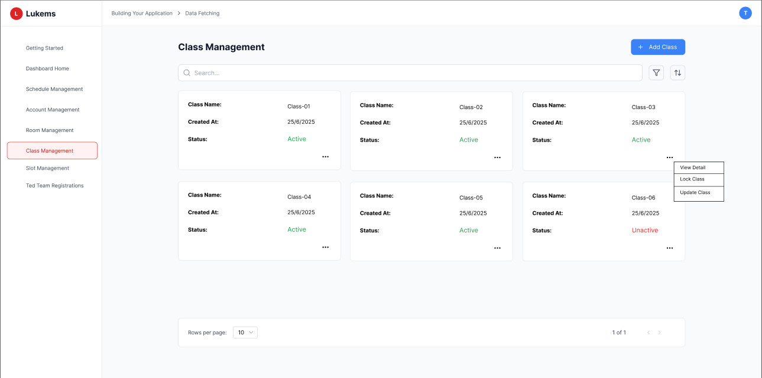

###### *Figure 47 - Delete class*

| **Screen** | | Class Management | | | | |
| --- | --- | --- | --- | --- | --- | --- |
| **Description** | | Screen allows Admin to delete an existing class from the class list. | | | | |
| **Screen Access** | | From “Class Management” screen, Admin clicks the “Delete” button next to a class. | | | | |
| Screen Content | | | | | | |
| **Item** | | **Type** | **Data** | | **Description** | |
| Class list | | Table | Class code, name, status | | Displays available classes | |
| Delete button | | Button | — | | Deletes the selected class after confirmation | |
| Confirmation popup | | Popup | Yes / No | | Asks for confirmation before deletion | |
| Notification toast | | Text | Success or error | | Shows result of the deletion operation | |
| Screen Actions | | | | | | |
| **Action Name** | **Description** | | | **Success** | | **Failure** |
| Click Delete | Admin clicks delete button | | | Confirmation popup appears | | Class not found, error message shown |
| Confirm Delete | Admin confirms deletion in popup | | | Class deleted, success message shown | | Linked data exists, or system error, class not deleted |
| Cancel Delete | Admin cancels confirmation | | | Class remains in list | | — |

### 3.37 UC-36 View detailed class

| **Use Case ID** | **UC-36** | **Use Case Name** | **View detailed class** |
| --- | --- | --- | --- |
| Created By | BinhHC | Date Created | 23 May 2025 |
| Primary Actor | Admin | Secondary Actor | – |
| Description | Allows the Admin to view detailed information of a specific class, including class code, name, status, and timestamps. | | |
| Priority | Must have | | |
| Trigger | The Admin clicks the “View detail” button next to a class in the class list. | | |
| Pre-conditions | The Admin is logged into the system.The selected class exists in the database. | | |
| Post-conditions | The system displays all class details to the Admin. | | |
| Basic Flow | 1. Admin accesses the “Class Management” screen.  2. Locates the desired class.  3. Clicks the “View detail” button.  4. System loads and displays full information of the selected class. | | |
| Alternative Flow | Alternative flow 1: Class not found → Admin attempts to view a class that no longer exists, system displays MSG105: "The quiz you are trying to edit no longer exists."  Alternative flow 2: Insufficient permissions → Admin without view permissions attempts to access class details, system displays MSG118: "You do not have permission to view this schedule."  Alternative flow 3: Data corruption → Class data appears corrupted, system displays MSG095: "Some schedule data appears to be corrupted. Please contact administrator."  Alternative flow 4: Concurrent modification → Another user is modifying the same class, system displays MSG096: "The schedule has been updated by another user. Please refresh to see latest changes."  Alternative flow 5: No students enrolled → Class has no enrolled students, system displays MSG119: "You have no scheduled classes or events for this time range."  Alternative flow 6: Student data loading failed → Unable to load student information, system displays MSG126: "Unable to load student data. Please refresh the page." | | |
| Exception | Session expired during view → System displays: MSG115  Server error during data retrieval → System displays: MSG116  Network connectivity issues → System displays: MSG117  Database timeout during loading → System displays: MSG097  Class not found → System displays: MSG105  Insufficient permissions → System displays: MSG118  Data corruption → System displays: MSG095  Student data loading failed → System displays: MSG126 | | |
| Business Rule | BR-68 | | |

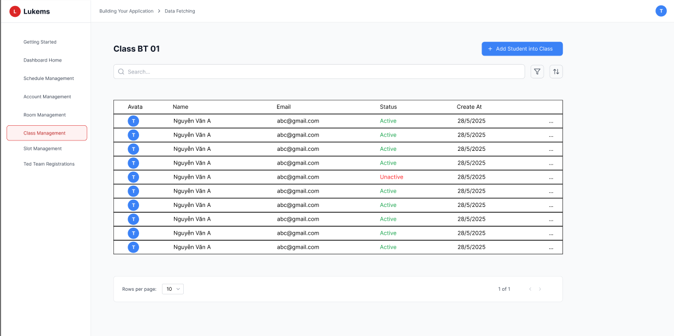

###### *Figure 48 - View detailed class*

| **Screen** | | Class Detail View | | | | |
| --- | --- | --- | --- | --- | --- | --- |
| **Description** | | Displays full details of the selected class including system metadata. | | | | |
| **Screen Access** | | From Class Management screen, Admin clicks the “View detail” button next to a class. | | | | |
| Screen Content | | | | | | |
| **Item** | | **Type** | **Data** | | **Description** | |
| Class code | | Text | CL123, etc. | | Unique identifier of the class | |
| Class name | | Text | Full class name | | Name assigned to the class | |
| Status | | Text | Active / Inactive | | Indicates current status | |
| Created date | | Text | Timestamp | | Date the class was created | |
| Last updated | | Text | Timestamp | | Last modification time | |
| Return button | | Button | — | | Navigates back to class list | |
| Screen Actions | | | | | | |
| **Action Name** | **Description** | | | **Success** | | **Failure** |
| Click View Detail | Admin selects a class to view | | | Class details are displayed | | Class not found, error message shown |
| Return to list | Admin exits the detail screen | | | Returns to class list | | — |
| System auto-load | System fetches class details | | | All fields displayed | | System error, “Unable to load class details” shown |

### 3.38 UC-37 Import student to class by excel file

| **Use Case ID** | **UC-37** | **Use Case Name** | **Import student to class by Excel file** |
| --- | --- | --- | --- |
| Created By | BinhHC | Date Created | 23 May 2025 |
| Primary Actor | Admin | Secondary Actor | – |
| Description | Allows the Admin to import a list of students into a class by uploading an Excel file containing student data. | | |
| Priority | Must have | | |
| Trigger | The Admin clicks the “Import student list” button on the class detail screen. | | |
| Pre-conditions | The Admin is logged into the system.The selected class exists.The Excel file is in correct format. | | |
| Post-conditions | Valid students from the Excel file are added to the selected class. | | |
| Basic Flow | 1. Admin navigates to the “Class Management” screen.  2. Selects a class and clicks “View detail”.  3. Clicks “Import student list” button.  4. Uploads a valid Excel file.  5. System validates data and displays a preview.  6. Admin confirms import.  7. System adds students to class and shows result. | | |
| Alternative Flow | Alternative flow 1: Form loading failed → Admin attempts to access import form but it fails to load, system displays MSG144: "Unable to load the Import Account form. Please try again."  Alternative flow 2: Invalid file format → Admin uploads non-Excel file, system displays MSG145: "Invalid file format. Please upload an Excel file (.xls, .xlsx)."  Alternative flow 3: No file selected → Admin attempts to submit without selecting file, system displays MSG146: "Please select a file to upload."  Alternative flow 4: Duplicate emails detected → Some students already exist in system, system displays MSG147: "Some accounts were skipped due to duplicate emails."  Alternative flow 5: File processing failed → Excel file cannot be processed, system displays MSG148: "Failed to process Excel file. Please check file format and try again."  Alternative flow 6: File validation error → File validation fails, system displays MSG149: "Unable to validate file. Please try again."  Alternative flow 7: Import cancelled → Admin cancels import process, system displays MSG39: "Cancellation not confirmed. No changes have been made" | | |
| Exception | Session expired during import → System displays: MSG115  Server error during file processing → System displays: MSG055  Network connectivity issues → System displays: MSG117  Database timeout during import → System displays: MSG097  Form loading failed → System displays: MSG144  Invalid file format → System displays: MSG145  File required → System displays: MSG146  File processing failed → System displays: MSG148  File validation error → System displays: MSG149 | | |
| Business Rule | BR-69 | | |

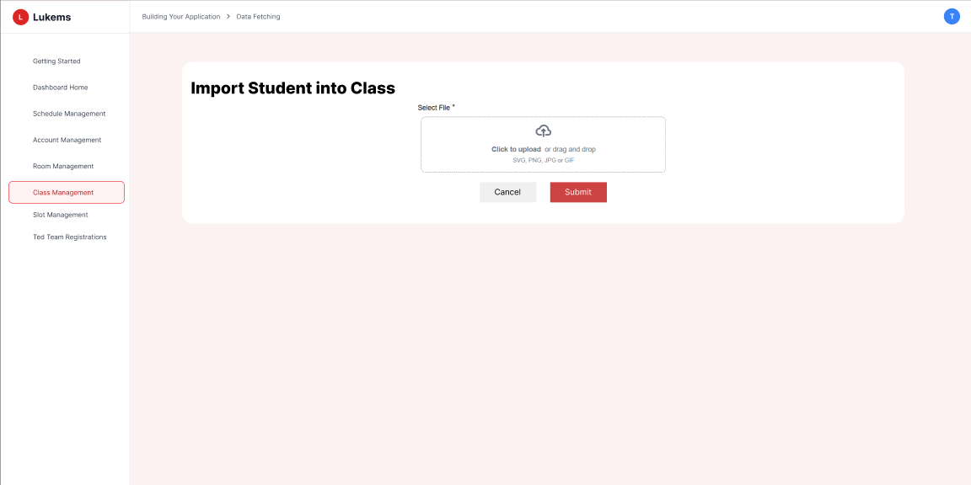

###### *Figure 49 - Import student to class by Excel file*

| **Screen** | | Import Student List | | | | |
| --- | --- | --- | --- | --- | --- | --- |
| **Description** | | Allows Admin to upload an Excel file and import students into a specific class. | | | | |
| **Screen Access** | | From Class Detail screen, click the “Import student list” button. | | | | |
| Screen Content | | | | | | |
| **Item** | | **Type** | **Data** | | **Description** | |
| Upload field | | File | Excel (.xlsx) | | Upload the Excel file containing student emails | |
| Download template | | Button | — | | Allows Admin to download sample template | |
| Role info (optional) | | Text | Fixed: Student | | Indicates role being imported | |
| Import button | | Button | — | | Starts the import process after file upload | |
| Cancel button | | Button | — | | Cancels the operation and returns to class detail | |
| Preview table | | Table | Email, status | | Shows import preview with success/error for each student | |
| Screen Actions | | | | | | |
| **Action Name** | **Description** | | | **Success** | | **Failure** |
| Upload Excel file | Admin selects and uploads Excel file | | | File loaded and preview displayed | | File type invalid, system shows warning message |
| Click Import | Admin confirms to import students | | | Students added to class, success message shown | | Some or all students skipped due to errors, warnings shown |
| Cancel Import | Admin cancels the process | | | Returns to class detail | | — |
| Download template | Admin downloads format example | | | Template downloaded successfully | | Error downloading template |

### 3.39 UC-38 Add student to class

| **Use Case ID** | **UC-38** | **Use Case Name** | **Add student to class** |
| --- | --- | --- | --- |
| Created By | BinhHC | Date Created | 23 May 2025 |
| Primary Actor | Admin | Secondary Actor | – |
| Description | Allows the Admin to manually add a student to an existing class by selecting or entering their email address. | | |
| Priority | Must have | | |
| Trigger | The Admin clicks the “Add student” button in the student list section of a class detail screen. | | |
| Pre-conditions | The Admin is logged into the system.The class exists and is in an editable state.The student exists in the system. | | |
| Post-conditions | The selected student is added to the class if not already in it. | | |
| Basic Flow | 1. Admin navigates to “Class Management”.  2. Clicks “View detail” of a class.  3. Clicks “Add student” button.  4. Enters or selects a student email.  5. Clicks “Add”.  6. System validates and adds the student to the class. | | |
| Alternative Flow | Alternative flow 1: Form loading failed → Admin attempts to access add student form but it fails to load, system displays MSG130: "Unable to load the Add Student form. Please try again."  Alternative flow 2: Email field empty → Admin attempts to submit without entering email, system displays MSG132: "Email is required."  Alternative flow 3: Invalid email format → Admin enters invalid email format, system displays MSG133: "Please enter a valid email address."  Alternative flow 4: Duplicate email → Student email already exists in the class, system displays MSG134: "Email already exists in the system."  Alternative flow 5: Email validation error → Email validation process fails, system displays MSG136: "Unable to validate email. Please try again."  Alternative flow 6: Account creation failed → Student addition process fails, system displays MSG135: "Failed to create student account. Please try again."  Alternative flow 7: Add student cancelled → Admin cancels add student process, system displays MSG39: "Cancellation not confirmed. No changes have been made" | | |
| Exception | Session expired during addition → System displays: MSG115  Server error during student addition → System displays: MSG055  Network connectivity issues → System displays: MSG117  Database timeout during addition → System displays: MSG097  Form loading failed → System displays: MSG130  Email required → System displays: MSG132  Invalid email format → System displays: MSG133  Duplicate email → System displays: MSG134  Account creation failed → System displays: MSG135  Email validation error → System displays: MSG136 | | |
| Business Rule | BR-70 | | |

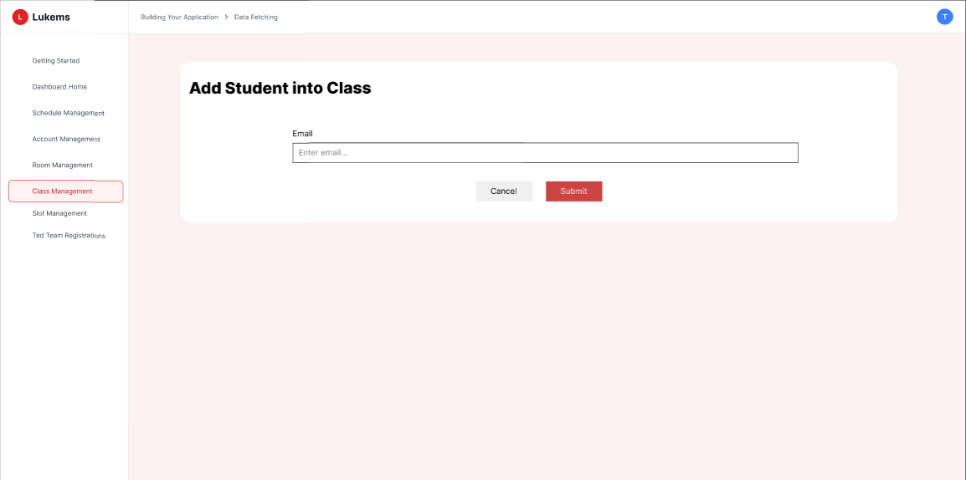

###### *Figure 50 - Add student to class*

| **Screen** | | Add Student to Class | | | | |
| --- | --- | --- | --- | --- | --- | --- |
| **Description** | | Allows Admin to add a student manually to a class via email selection or entry. | | | | |
| **Screen Access** | | From Class Detail screen, click “Add student” button in the Student section. | | | | |
| Screen Content | | | | | | |
| **Item** | | **Type** | **Data** | | **Description** | |
| Student email field | | Input | Email | | Enter or search for the student by email | |
| Add button | | Button | — | | Confirms the addition of the student to the class | |
| Cancel button | | Button | — | | Cancels the action and returns to class detail screen | |
| Validation message | | Text | Success / Error message | | Displays operation result or error | |
| Screen Actions | | | | | | |
| **Action Name** | **Description** | | | **Success** | | **Failure** |
| Enter email | Admin inputs existing student’s email | | | Email field is validated | | Email not found or invalid format, error shown |
| Click Add | Admin submits to add the student | | | Student added to class, success message shown | | Student already in class or system error, warning shown |
| Click Cancel | Admin cancels the action | | | Returns to class detail | | — |

### 3.40 UC-39 Change student in class

| **Use Case ID** | **UC-39** | **Use Case Name** | **Change student in class** |
| --- | --- | --- | --- |
| Created By | BinhHC | Date Created | 23 May 2025 |
| Primary Actor | Admin | Secondary Actor | – |
| Description | Allows the Admin to update the student assigned to a class by replacing the current student with a new one. | | |
| Priority | Must have | | |
| Trigger | The Admin clicks the “Change” icon/button next to a student in the class detail screen. | | |
| Pre-conditions | The Admin is logged into the system.The class exists and contains at least one student.The new student exists and is not already in the class. | | |
| Post-conditions | The old student is removed from the class and the new student is added in their place. | | |
| Basic Flow | 1. Admin opens the “Class Management” screen.  2. Clicks “View detail” of a class.  3. In the student list, clicks “Change” next to the target student.  4. Enters or selects the new student’s email.  5. Clicks “Confirm”.  6. System removes the current student and adds the new one. | | |
| Alternative Flow | Alternative flow 1: Form loading failed → Admin attempts to access change student form but it fails to load, system displays MSG130: "Unable to load the Add Student form. Please try again."  Alternative flow 2: Student not found → Admin attempts to change a student that no longer exists, system displays MSG152: "Account not found. Please refresh the page."  Alternative flow 3: Email field empty → Admin attempts to submit without entering email, system displays MSG132: "Email is required."  Alternative flow 4: Invalid email format → Admin enters invalid email format, system displays MSG133: "Please enter a valid email address."  Alternative flow 5: Duplicate email → New email already exists in the system, system displays MSG134: "Email already exists in the system."  Alternative flow 6: Email validation error → Email validation process fails, system displays MSG136: "Unable to validate email. Please try again."  Alternative flow 7: Update failed → Student information update process fails, system displays MSG135: "Failed to create student account. Please try again."  Alternative flow 8: Insufficient permissions → Admin without edit permissions attempts to change student, system displays MSG153: "You do not have permission to lock/unlock accounts."  Alternative flow 9: Concurrent modification → Another user is modifying the same student, system displays MSG157: "This account has been modified by another user. Please refresh and try again."  Alternative flow 10: Change cancelled → Admin cancels change student process, system displays MSG39: "Cancellation not confirmed. No changes have been made" | | |
| Exception | Session expired during update → System displays: MSG115  Server error during student update → System displays: MSG055  Network connectivity issues → System displays: MSG117  Database timeout during update → System displays: MSG097  Form loading failed → System displays: MSG130  Student not found → System displays: MSG152  Email required → System displays: MSG132  Invalid email format → System displays: MSG133  Duplicate email → System displays: MSG134  Update failed → System displays: MSG135  Email validation error → System displays: MSG136  Insufficient permissions → System displays: MSG153  Concurrent modification → System displays: MSG157 | | |
| Business Rule | BR-71 | | |

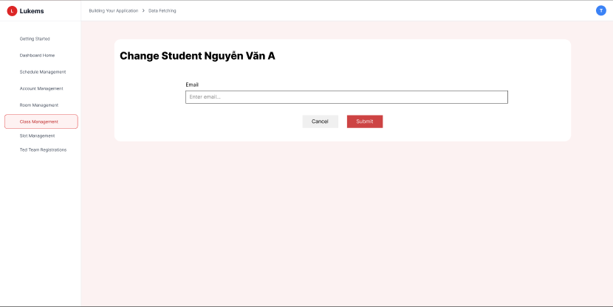

###### *Figure 51 - Change student in class*

| **Screen** | | Change Student Form | | | | |
| --- | --- | --- | --- | --- | --- | --- |
| **Description** | | Allows Admin to replace an existing student in a class with another student. | | | | |
| **Screen Access** | | From Class Detail screen, click “Change” icon/button next to a student in the list. | | | | |
| Screen Content | | | | | | |
| **Item** | | **Type** | **Data** | | **Description** | |
| Current student info | | Text | Name, Email | | Displays the student currently assigned | |
| New student email | | Input | Email | | Input or select new student by email | |
| Confirm button | | Button | — | | Executes the replacement action | |
| Cancel button | | Button | — | | Cancels the operation and returns to class detail | |
| Status message | | Text | Success / Error | | Displays result of the change action | |
| Screen Actions | | | | | | |
| **Action Name** | **Description** | | | **Success** | | **Failure** |
| Input new student | Admin enters new student’s email | | | Field validated, student found | | Email invalid or student not found, error shown |
| Click Confirm | Admin confirms replacement | | | Old student removed, new student added | | New student already in class or system error, change blocked |
| Click Cancel | Admin cancels the change | | | No changes made, returns to class detail | | — |

### 3.41 UC-40 Delete student from class

| **Use Case ID** | **UC-40** | **Use Case Name** | **Delete student from class** |
| --- | --- | --- | --- |
| Created By | BinhHC | Date Created | 23 May 2025 |
| Primary Actor | Admin | Secondary Actor | – |
| Description | Allows the Admin to remove a student from a class if they should no longer be part of it. | | |
| Priority | Must have | | |
| Trigger | The Admin clicks the “Delete” icon/button next to a student in the student list of a class detail screen. | | |
| Pre-conditions | The Admin is logged into the system.The class and student both exist and are linked. | | |
| Post-conditions | The selected student is removed from the class. | | |
| Basic Flow | 1. Admin navigates to the “Class Management” screen.  2. Clicks “View detail” of a class.  3. Clicks the “Delete” button next to the student.  4. System shows confirmation popup.  5. Admin confirms deletion.  6. System removes the student and shows success message. | | |
| Alternative Flow | Alternative flow 1: Student not found → Admin attempts to delete a student that no longer exists, system displays MSG152: "Account not found. Please refresh the page."  Alternative flow 2: Insufficient permissions → Admin without delete permissions attempts to remove student, system displays MSG153: "You do not have permission to lock/unlock accounts."  Alternative flow 3: Student data loading failed → Unable to load student information for deletion, system displays MSG126: "Unable to load student data. Please refresh the page."  Alternative flow 4: Concurrent modification → Another user is modifying the same student, system displays MSG157: "This account has been modified by another user. Please refresh and try again."  Alternative flow 5: Deletion not confirmed → Admin cancels deletion process, system displays MSG39: "Cancellation not confirmed. No changes have been made"  Alternative flow 6: Database constraint violation → System cannot remove student due to constraints, system displays MSG156: "Unable to update account status due to system constraints. Please contact administrator."  Alternative flow 7: Student has active assignments → Student has ongoing assignments in the class, system displays MSG112: "This quiz has active assignments. Deleting will affect student progress." | | |
| Exception | Session expired during deletion → System displays: MSG115  Server error during student removal → System displays: MSG155  Network connectivity issues → System displays: MSG117  Database timeout during deletion → System displays: MSG097  Student not found → System displays: MSG152  Insufficient permissions → System displays: MSG153  Student data loading failed → System displays: MSG126  Concurrent modification → System displays: MSG157  Database constraint violation → System displays: MSG156  Active assignments conflict → System displays: MSG112 | | |
| Business Rule | BR-72 | | |

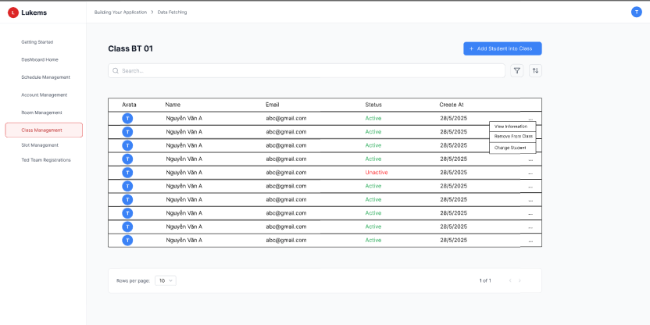

###### *Figure 52 - Delete student from class*

| **Screen** | | Class Detail – Student List | | | | |
| --- | --- | --- | --- | --- | --- | --- |
| **Description** | | Displays all students in the class and allows Admin to remove a student. | | | | |
| **Screen Access** | | From Class Management screen, click “View detail”, then use the “Delete” button in the Student section. | | | | |
| Screen Content | | | | | | |
| **Item** | | **Type** | **Data** | | **Description** | |
| Student list | | Table | Name, Email | | Displays current students in the class | |
| Delete icon/button | | Button | — | | Allows Admin to remove a student | |
| Confirmation popup | | Popup | Yes / No | | Confirms Admin's intention to delete student | |
| Notification toast | | Text | Success or error | | Displays operation result | |
| Screen Actions | | | | | | |
| **Action Name** | **Description** | | | **Success** | | **Failure** |
| Click Delete | Admin initiates student removal | | | Confirmation popup appears | | Student not found or already removed, error message shown |
| Confirm Delete | Admin confirms deletion in popup | | | Student is removed from class, success message displayed | | System error, operation fails |
| Cancel Delete | Admin cancels the deletion | | | No changes made, returns to student list | | — |

### 3.42 UC-41 Search shift

| **Use Case ID** | **UC-41** | **Use Case Name** | **Search shift** |
| --- | --- | --- | --- |
| Created By | BinhHC | Date Created | 23 May 2025 |
| Primary Actor | Admin | Secondary Actor | – |
| Description | Allows the Admin to search for shifts based on keywords or filters such as date, time, or class. | | |
| Priority | Must have | | |
| Trigger | The Admin enters keywords or filter conditions and clicks the search button on the shift management screen. | | |
| Pre-conditions | The Admin is logged into the system.At least one shift exists in the system. | | |
| Post-conditions | Matching shift results are displayed according to the search criteria. | | |
| Basic Flow | 1. Admin navigates to the “Shift Management” screen.  2. Enters keyword or selects filters (e.g., date, class).  3. Clicks the “Search” button.  4. System filters and displays all matching shifts. | | |
| Alternative Flow | Alternative flow 1: Empty search query → User attempts to search without entering search term, system displays MSG170: "Please enter a search term."  Alternative flow 2: No search results → Search returns no matching shifts, system displays MSG171: "No classes found matching your search criteria."  Alternative flow 3: Search query too short → User enters less than 2 characters, system displays MSG172: "Please enter at least 2 characters to search."  Alternative flow 4: Invalid characters → Search contains invalid characters, system displays MSG173: "Search contains invalid characters. Please use letters and numbers only."  Alternative flow 5: Server error during search → Search fails due to server issues, system displays MSG174: "Search failed due to server error. Please try again."  Alternative flow 6: Database timeout → Search times out due to database issues, system displays MSG175: "Search timed out. Please try again later."  Alternative flow 7: Search service unavailable → Search functionality is temporarily down, system displays MSG176: "Search service is temporarily unavailable. Please try again later." | | |
| Exception | Session expired during search → System displays: MSG115  Server error during search → System displays: MSG174  Network connectivity issues → System displays: MSG117  Database timeout during search → System displays: MSG175  Empty search query → System displays: MSG170  No search results → System displays: MSG171  Search query too short → System displays: MSG172  Invalid characters → System displays: MSG173  Search service unavailable → System displays: MSG176 | | |
| Business Rule | BR-73 | | |

| **Screen** | | Shift Management | | | | |
| --- | --- | --- | --- | --- | --- | --- |
| **Description** | | Displays a searchable and filterable list of all shifts. | | | | |
| **Screen Access** | | From Admin dashboard, click “Shift Management” in the menu. | | | | |
| Screen Content | | | | | | |
| **Item** | | **Type** | **Data** | | **Description** | |
| Search bar | | Input | Keyword | | Allows Admin to search by shift name or ID | |
| Date picker | | Input | Date | | Filter by date of shift | |
| Class filter | | Dropdown | Class name | | Filter shifts by assigned class | |
| Search button | | Button | — | | Triggers the search action | |
| Result table | | Table | Shift ID, date, time, class | | Displays filtered or full list of shifts | |
| No result message | | Text | “No shift found” | | Displayed when search returns no result | |
| Screen Actions | | | | | | |
| **Action Name** | **Description** | | | **Success** | | **Failure** |
| Enter search data | Admin inputs keyword or selects filter | | | Input accepted, ready to search | | Invalid input format (e.g., wrong date format), error shown |
| Click Search | Admin performs search | | | Matching shifts displayed in list | | No match found or system error, warning message shown |
| Reset filter | Admin clears search conditions | | | Full shift list is reloaded | | — |

### 3.43 UC-42 List shift

| **Use Case ID** | **UC-41** | **Use Case Name** | **List shift** |
| --- | --- | --- | --- |
| Created By | BinhHC | Date Created | 23 May 2025 |
| Primary Actor | Admin | Secondary Actor | – |
| Description | Allows the Admin to view the full list of all shifts that exist in the system. | | |
| Priority | Must have | | |
| Trigger | The Admin accesses the “Shift Management” screen from the main menu. | | |
| Pre-conditions | The Admin is logged into the system.At least one shift exists in the system. | | |
| Post-conditions | The system displays the list of all available shifts. | | |
| Basic Flow | 1. Admin navigates to the “Shift Management” screen.  2. System loads and displays all shifts with relevant details such as ID, date, time, and class. | | |
| Alternative Flow | Alternative flow 1: Empty search query → User attempts to search without entering search term, system displays MSG170: "Please enter a search term."  Alternative flow 2: No search results → Search returns no matching shifts, system displays MSG171: "No classes found matching your search criteria."  Alternative flow 3: Search query too short → User enters less than 2 characters, system displays MSG172: "Please enter at least 2 characters to search."  Alternative flow 4: Invalid characters → Search contains invalid characters, system displays MSG173: "Search contains invalid characters. Please use letters and numbers only."  Alternative flow 5: Server error during search → Search fails due to server issues, system displays MSG174: "Search failed due to server error. Please try again."  Alternative flow 6: Database timeout → Search times out due to database issues, system displays MSG175: "Search timed out. Please try again later."  Alternative flow 7: Search service unavailable → Search functionality is temporarily down, system displays MSG176: "Search service is temporarily unavailable. Please try again later." | | |
| Exception | Session expired during search → System displays: MSG115  Server error during search → System displays: MSG174  Network connectivity issues → System displays: MSG117  Database timeout during search → System displays: MSG175  Empty search query → System displays: MSG170  No search results → System displays: MSG171  Search query too short → System displays: MSG172  Invalid characters → System displays: MSG173  Search service unavailable → System displays: MSG176 | | |
| Business Rule | BR-74 | | |

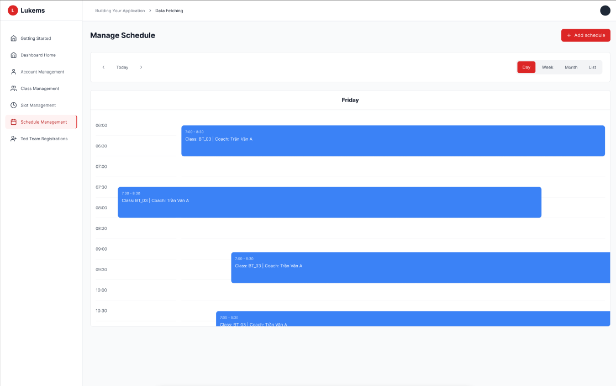

###### *Figure 53.1 - List shift by day*

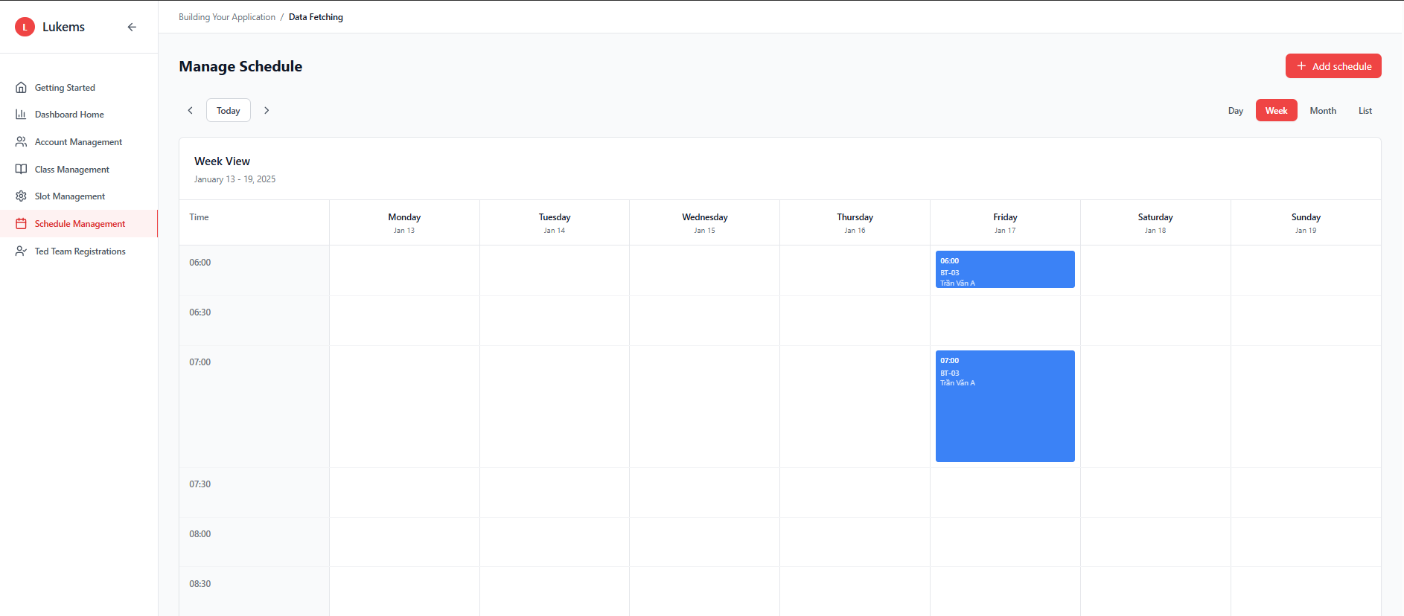

###### *Figure 53.2 - List shift by week*

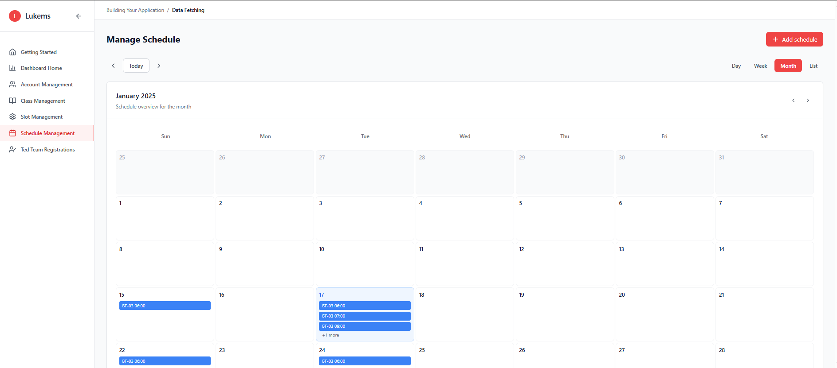

###### *Figure 53.3 - List shift by month*

| **Screen** | | Work Schedule management page | | | | |
| --- | --- | --- | --- | --- | --- | --- |
| **Description** | | Displays the list of all scheduled shifts with basic information for each one. | | | | |
| **Screen Access** | | From Admin dashboard, click “Shift Management”. | | | | |
| Screen Content | | | | | | |
| **Item** | | **Type** | **Data** | | **Description** | |
| Shift table | | Table | ID, Date, Time, Class name | | Displays all shift entries in rows | |
| Search bar | | Input | Keyword | | Allows quick filtering by keyword | |
| Add shift button | | Button | — | | Opens form to create a new shift | |
| View detail button | | Button | Icon | | Opens detailed view of selected shift | |
| Screen Actions | | | | | | |
| **Action Name** | **Description** | | | **Success** | | **Failure** |
| Load shift list | System fetches and displays all shifts | | | Table with shift data shown | | System error, “Unable to load shift list” message displayed |
| Click Add shift | Admin navigates to create a new shift | | | Redirected to Add Shift form | | — |
| Click View detail | Admin opens detailed view of a shift | | | Shift detail displayed | | Shift not found, system shows error message |

### 3.44 UC-43 Add shift

| **Use Case ID** | **UC-43** | **Use Case Name** | **Add shift** |
| --- | --- | --- | --- |
| Created By | BinhHC | Date Created | 23 May 2025 |
| Primary Actor | Admin | Secondary Actor | — |
| Description | Allows the Admin to add a new shift to the system by specifying the class, date, and time. | | |
| Priority | Must have | | |
| Trigger | Admin clicks the “Add shift” button on the Shift Management screen. | | |
| Pre-conditions | The Admin must be logged in and have the necessary permissions. | | |
| Post-conditions | A new shift is saved to the system and becomes visible in the Shift table. | | |
| Basic Flow | 1. Admin navigates to “Shift Management” screen from the Admin Dashboard.  2. Admin clicks on the “Add shift” button.  3. System opens the “Add Shift” form.  4. Admin enters shift information (Class, Date, Time, ID).  5. Admin clicks the Save button.  6. System validates the information and saves the shift. | | |
| Alternative Flow | Alternative flow 1: Required fields empty → User attempts to submit without filling mandatory fields, system displays MSG02: "The * field is required."  Alternative flow 2: Invalid email format → User enters invalid coach email format, system displays MSG133: "Please enter a valid email address."  Alternative flow 3: Invalid date format → User enters invalid date format, system displays MSG98: "Please enter a valid date format (MM/DD/YYYY)."  Alternative flow 4: Duplicate schedule → Schedule with same details already exists, system displays MSG100: "A quiz with this title already exists. Please choose a different title." (adapted for schedule context)  Alternative flow 5: Email validation error → System cannot validate coach email, system displays MSG136: "Unable to validate email. Please try again."  Alternative flow 6: Exceed max length → User enters text exceeding maximum allowed length, system displays MSG08: "Exceed max length of {max_length}."  Alternative flow 7: Form load failed → Unable to load the add schedule form, system displays MSG130: "Unable to load the Add Student form. Please try again." (adapted for schedule context)  Alternative flow 8: Schedule creation successful → Schedule added successfully, system displays MSG177: "Schedule created successfully." | | |
| Exception | Session expired during creation → System displays: MSG115  Server error during creation → System displays: MSG116  Network connectivity issues → System displays: MSG117  Database constraint violation → System displays: MSG102  Permission denied → System displays: MSG099  Schedule creation failed → System displays: MSG178  Form validation error → System displays: MSG107  Invalid selection → System displays: MSG179  Conflict detected → System displays: MSG180 | | |
| Business Rules | BR-75, BR-76, BR-77 | | |

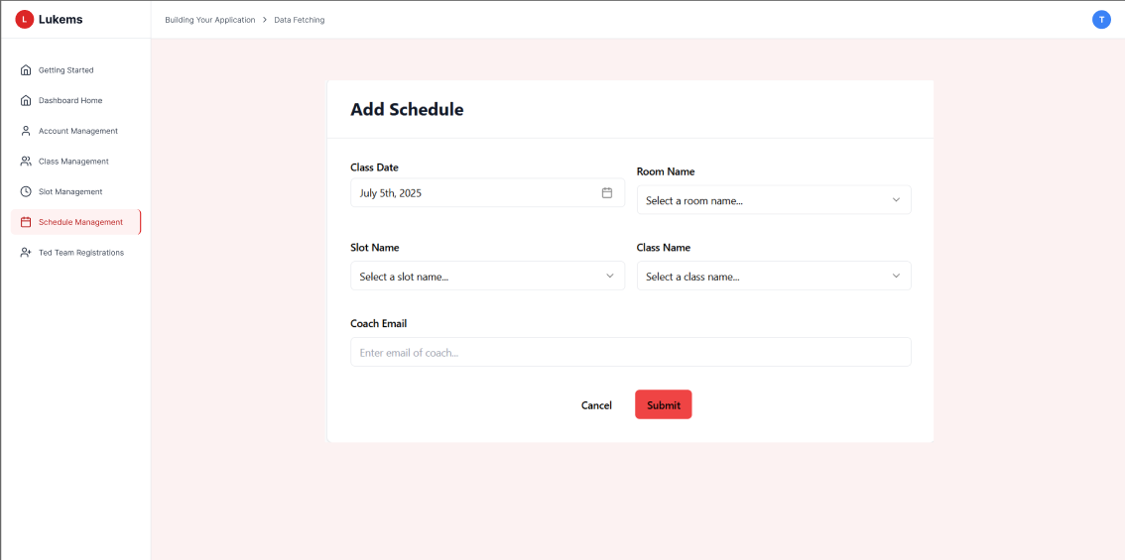

###### *Figure 54 - Add shift*

| **Screen** | | Work Schedule management page | | | | |
| --- | --- | --- | --- | --- | --- | --- |
| **Description** | | Displays the list of all scheduled shifts with basic information for each one. | | | | |
| **Screen Access** | | From Admin dashboard, click “Shift Management”. | | | | |
| Screen Content | | | | | | |
| **Item** | | **Type** | **Data** | | **Description** | |
| Shift table | | Table | ID, Date, Time, Class name | | Displays all shift entries in rows | |
| Search bar | | Input | Keyword | | Allows quick filtering by keyword | |
| Add shift button | | Button | — | | Opens form to create a new shift | |
| View detail button | | Button | Icon | | Opens detailed view of selected shift | |
| Screen Actions | | | | | | |
| **Action Name** | **Description** | | | **Success** | | **Failure** |
| Load shift list | System fetches and displays all shifts | | | Table with shift data shown | | System error, “Unable to load shift list” message displayed |
| Click Add shift | Admin navigates to create a new shift | | | Redirected to Add Shift form | | — |
| Click View detail | Admin opens detailed view of a shift | | | Shift detail displayed | | Shift not found, system shows error message |

### 3.45 UC-44 Shift approval

| **Use Case ID** | **UC-44** | **Use Case Name** | **Shift approval** |
| --- | --- | --- | --- |
| Created By | BinhHC | Date Created | 23 May 2025 |
| Primary Actor | Admin | Secondary Actor | — |
| Description | Allows the Admin to approve newly created or pending shifts before they become active in the system. | | |
| Priority | Must have | | |
| Trigger | Admin clicks the “Approve” button next to a pending shift on the Shift Management screen. | | |
| Pre-conditions | The Admin is logged in and has permission to manage shifts. | | |
| Post-conditions | The selected shift is marked as approved and becomes active in the system. | | |
| Basic Flow | 1. Admin navigates to the “Shift Management” screen.  2. Admin views list of unapproved/pending shifts.  3. Admin clicks “Approve” for a selected shift.  4. System validates the request.  5. Shift is marked as approved and reflected in the table. | | |
| Alternative Flow | Alternative flow 1: Empty search query → User attempts to search without entering search term, system displays MSG170: "Please enter a search term."  Alternative flow 2: No search results → Search returns no matching requests, system displays MSG171: "No classes found matching your search criteria."  Alternative flow 3: Search query too short → User enters less than 2 characters, system displays MSG172: "Please enter at least 2 characters to search."  Alternative flow 4: Invalid characters → Search contains invalid characters, system displays MSG173: "Search contains invalid characters. Please use letters and numbers only."  Alternative flow 5: Approval successful → Request approved successfully, system displays MSG181: "Registration request approved successfully."  Alternative flow 6: Rejection successful → Request rejected successfully, system displays MSG182: "Registration request rejected successfully."  Alternative flow 7: Request already processed → Attempting to process an already handled request, system displays MSG183: "This request has already been processed."  Alternative flow 8: Invalid date → Registration request has invalid date information, system displays MSG184: "Invalid registration date. Please contact administrator." | | |
| Exception | Session expired during approval → System displays: MSG115  Server error during approval → System displays: MSG116  Network connectivity issues → System displays: MSG117  Database timeout during approval → System displays: MSG175  Permission denied → System displays: MSG118  Request not found → System displays: MSG185  Approval failed → System displays: MSG186  Filter operation failed → System displays: MSG187  Failed to load registration data → System displays: MSG188 | | |
| Business Rules | BR-78, BR-79, BR-80 | | |

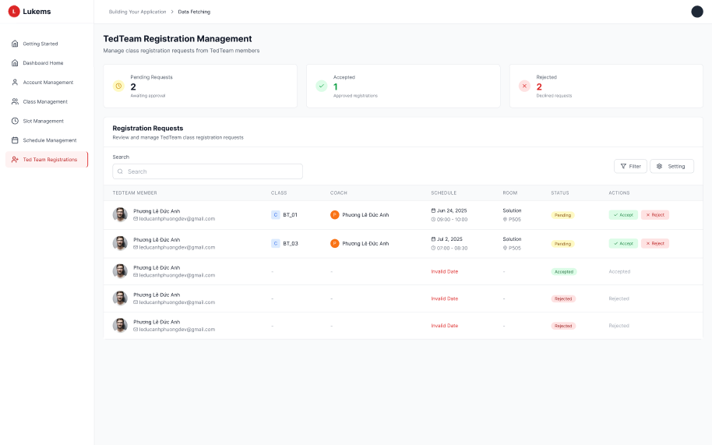

###### *Figure 55 - Shift approval*

| **Screen** | | Shift Management | | | | |
| --- | --- | --- | --- | --- | --- | --- |
| **Description** | | Displays a list of scheduled shifts and allows approval of pending ones. | | | | |
| **Screen Access** | | From Admin dashboard, click on “Shift Management”. | | | | |
| Screen Content | | | | | | |
| **Item** | | **Type** | **Data** | | **Description** | |
| Shift table | | Table | ID, Date, Time, Class, Status | | Shows all shifts with their approval state | |
| Search bar | | Input | Keyword | | Allows filtering shift list | |
| Approve button | | Button | — | | Appears only for shifts with "Pending" status | |
| View detail button | | Button | Icon | | Opens a shift detail popup or page | |
| Screen Actions | | | | | | |
| **Action Name** | **Description** | | | **Success** | | **Failure** |
| Load shift list | System displays shifts from database | | | Table with shift data shown | | “Unable to load shift list” error |
| Approve shift | Admin approves a pending shift | | | Shift status changes to Approved | | Error: shift not found, already approved, or system failure |
| Click View detail | Admin views full shift info | | | Shift details shown | | System error loading shift details |

### 3.46 UC-45 Update timetable

| **Use Case ID** | **UC-45** | **Use Case Name** | **Update timetable** |
| --- | --- | --- | --- |
| Created By | BinhHC | Date Created | 23 May 2025 |
| Primary Actor | Admin | Secondary Actor | — |
| Description | Allows the Admin to update the timetable of a class or student by modifying the time, date, or class-related fields. | | |
| Priority | Must have | | |
| Trigger | The Admin selects a timetable entry from the Time Table Management page and clicks the "Edit" button. | | |
| Pre-conditions | The Admin must be logged into the system with valid credentials and have access to Time Table Management. | | |
| Post-conditions | The selected timetable is updated and changes are saved to the system. | | |
| Basic flow | 1. The Admin navigates to the "Time Table Management" page from the Admin dashboard.  2. The Admin views the list of timetable entries.  3. The Admin clicks the "Edit" button next to a timetable entry.  4. The system opens an update form pre-filled with current information.  5. The Admin modifies fields such as class name, date, time, or coach.  6. The Admin clicks “Save” to confirm changes.  7. The system validates the input and updates the timetable record. | | |
| Alternative flow | Alternative flow 1: Required fields empty → User attempts to submit without filling mandatory fields, system displays MSG02: "The * field is required."  Alternative flow 2: Invalid email format → User enters invalid coach email format, system displays MSG133: "Please enter a valid email address."  Alternative flow 3: Invalid date format → User enters invalid date format, system displays MSG98: "Please enter a valid date format (MM/DD/YYYY)."  Alternative flow 4: Email validation error → System cannot validate coach email, system displays MSG136: "Unable to validate email. Please try again."  Alternative flow 5: Exceed max length → User enters text exceeding maximum allowed length, system displays MSG08: "Exceed max length of {max_length}."  Alternative flow 6: Schedule update successful → Schedule updated successfully, system displays MSG03: "Update asset(s) successfully."  Alternative flow 7: Concurrent modification → Schedule modified by another user, system displays MSG96: "The schedule has been updated by another user. Please refresh to see latest changes."  Alternative flow 8: Invalid date range → End date before start date, system displays MSG101: "End date must be after start date." | | |
| Exception | Session expired during update → System displays: MSG115  Server error during update → System displays: MSG116  Network connectivity issues → System displays: MSG117  Database timeout during update → System displays: MSG97  Permission denied → System displays: MSG104  Schedule not found → System displays: MSG105  Concurrent editing conflict → System displays: MSG106  Form validation error → System displays: MSG107  Update failed → System displays: MSG109  Data corruption → System displays: MSG95  Database constraint violation → System displays: MSG88  Invalid selection → System displays: MSG179  Conflict detected → System displays: MSG189 | | |
| Business Rules | BR-81, BR-82, BR-83 | | |

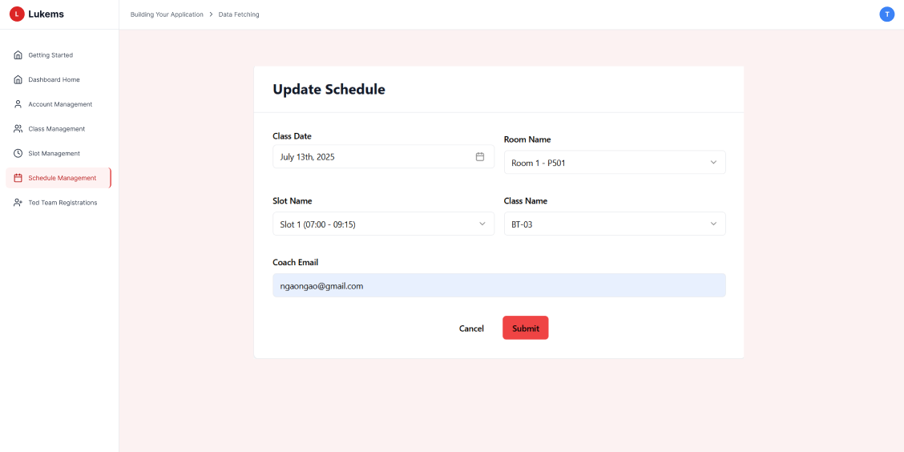

###### *Figure 56 - Update timetable*

| **Screen** | | Work Schedule management page | | | | |
| --- | --- | --- | --- | --- | --- | --- |
| **Description** | | Allows the Admin to view, manage, and update class or student timetable entries. | | | | |
| **Screen Access** | | From Admin dashboard, click on “Time Table Management”. | | | | |
| Screen Content | | | | | | |
| **Item** | | **Type** | **Data** | | **Description** | |
| Timetable List | | Table | ID, Class, Date, Time, Coach | | Shows list of scheduled timetables | |
| Search bar | | Input | Keyword | | Allows filtering by class name or coach | |
| Edit button | | Button | — | | Opens form for updating selected timetable | |
| Save button | | Button | — | | Saves the modified data | |
| Cancel button | | Button | — | | Cancels the update process | |
| Screen Actions | | | | | | |
| **Action Name** | **Description** | | | **Success** | | **Failure** |
| Click Edit | Admin opens the update form | | | Form loads with existing data | | Entry not found |
| Update timetable | Admin updates time/date/class | | | Timetable updated and confirmed | | Validation error or conflict |
| Click Cancel | Admin cancels the action | | | Return to timetable list | | — |

### 3.47 UC-46 Delete timetable

| **Use Case ID** | **UC-46** | **Use Case Name** | **Delete timetable** |
| --- | --- | --- | --- |
| Created By | BinhHC | Date Created | 23 May 2025 |
| Primary Actor | Admin | Secondary Actor | — |
| Description | Allows the Admin to delete a timetable entry that is no longer valid, removing it from the system permanently. | | |
| Priority | Must have | | |
| Trigger | Admin clicks the "Delete" button next to a timetable entry on the Time Table Management page. | | |
| Pre-conditions | Admin is logged in and has permission to access Time Table Management. | | |
| Post-conditions | The selected timetable entry is permanently deleted from the system. | | |
| Basic flow | 1. Admin navigates to the “Time Table Management” page.  2. Admin locates the timetable entry to delete.  3. Admin clicks the “Delete” button.  4. System shows a confirmation dialog.  5. Admin confirms deletion.  6. System deletes the entry and refreshes the list. | | |
| Alternative flow | Alternative flow 1: Deletion successful → Schedule deleted successfully, system displays MSG07: "Delete asset(s) successfully."  Alternative flow 2: Cancellation not confirmed → User cancels deletion process, system displays MSG39: "Cancellation not confirmed. No changes have been made"  Alternative flow 3: Schedule not found → Schedule to be deleted no longer exists, system displays MSG89: "The material you are trying to delete no longer exists."  Alternative flow 4: Permission denied → User lacks permission to delete schedule, system displays MSG90: "You do not have permission to delete this material."  Alternative flow 5: Schedule in use → Schedule is being used in active assignments, system displays MSG91: "This material is currently being used in active assignments and cannot be deleted."  Alternative flow 6: Database constraint violation → System constraints prevent deletion, system displays MSG92: "This material cannot be deleted due to system constraints. Please contact administrator."  Alternative flow 7: Concurrent deletion conflict → Schedule modified by another user, system displays MSG93: "This material has been modified by another user. Please refresh and try again." | | |
| Exception | Session expired during deletion → System displays: MSG115  Server error during deletion → System displays: MSG116  Network connectivity issues → System displays: MSG117  Database timeout during deletion → System displays: MSG97  Permission denied → System displays: MSG110  Schedule not found → System displays: MSG111  Active assignments warning → System displays: MSG112  Database error → System displays: MSG113  Concurrent action conflict → System displays: MSG114  Delete dialog failed → System displays: MSG193  Deletion failed → System displays: MSG194 | | |
| Business Rules | BR-84, BR-85 | | |

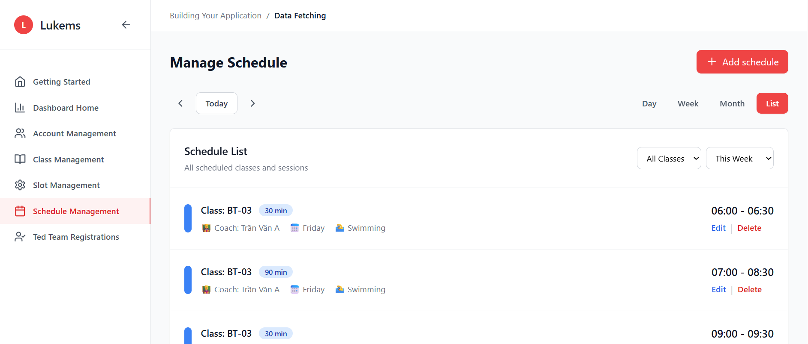

###### *Figure 57 - Delete timetable*

| **Screen** | | Work Schedule management page | | | | |
| --- | --- | --- | --- | --- | --- | --- |
| **Description** | | Allows the Admin to manage, update, and delete timetable entries for classes and students. | | | | |
| **Screen Access** | | From Admin dashboard, click on “Time Table Management”. | | | | |
| Screen Content | | | | | | |
| **Item** | | **Type** | **Data** | | **Description** | |
| Timetable List | | Table | ID, Class, Date, Time, Coach | | Displays existing timetable records | |
| Search bar | | Input | Keyword | | Filters timetable list | |
| Delete button | | Button | — | | Triggers confirmation for deleting a timetable entry | |
| Confirmation dialog | | Dialog | Yes / No | | Asks Admin to confirm or cancel deletion | |
| Screen Actions | | | | | | |
| **Action Name** | **Description** | | | **Success** | | **Failure** |
| Click Delete | Admin starts deletion process | | | Confirmation dialog shown | | Entry not found |
| Confirm Delete | Admin confirms deletion | | | Timetable entry deleted, list updated | | System error during delete |
| Cancel Delete | Admin cancels at dialog | | | No changes made | | — |

### 3.48 UC-47 Create form email

| **Use Case ID** | **UC-47** | **Use Case Name** | **Create form email** |
| --- | --- | --- | --- |
| Created By | BinhHC | Date Created | 23 May 2025 |
| Primary Actor | Admin | Secondary Actor | — |
| Description | Allows the Admin to create and save a new email form/template to be used for automatic notifications such as shift assignment, approval results, or timetable changes. | | |
| Priority | Must have | | |
| Trigger | Admin clicks “Create” or “Add new” button on the Email Template Management screen. | | |
| Pre-conditions | Admin is logged in and has permission to manage email templates. | | |
| Post-conditions | A new email form/template is saved in the system and available for use. | | |
| Basic flow | 1. Admin navigates to the “Email Template Management” screen.  2. Admin clicks the “Create” or “Add new” button.  3. System displays a blank form for template creation.  4. Admin inputs template name, subject, content, and placeholders (if applicable).  5. Admin clicks “Save”.  6. System validates and saves the new template. | | |
| Alternative flow | Alternative flow 1: Email creation successful → Form email created and sent successfully, system displays MSG04: "Add asset successfully."  Alternative flow 2: Class selection required → No class selected for email distribution, system displays MSG02: "The * field is required."  Alternative flow 3: Subject field empty → Subject line not provided, system displays MSG02: "The * field is required."  Alternative flow 4: Email content empty → Email content field left blank, system displays MSG02: "The * field is required."  Alternative flow 5: Subject exceeds maximum length → Subject line too long, system displays MSG08: "Exceed max length of {max_length}."  Alternative flow 6: Email content exceeds maximum length → Email content too long, system displays MSG08: "Exceed max length of {max_length}."  Alternative flow 7: No recipients found → No active students in selected class, system displays MSG120: "No active students found for this content. Please check enrollment."  Alternative flow 8: Invalid recipients → Some email addresses are invalid, system displays MSG124: "Some email addresses are invalid. Please verify recipient information." | | |
| Exception | Session expired during creation → System displays: MSG115  Server error during email creation → System displays: MSG116  Network connectivity issues → System displays: MSG117  Permission denied → System displays: MSG118  Email delivery service error → System displays: MSG121  Message generation failed → System displays: MSG122  Daily quota exceeded → System displays: MSG123  Content not found → System displays: MSG125  Form loading failed → System displays: MSG197  Email validation failed → System displays: MSG198  Recipient validation failed → System displays: MSG199  Email sending failed → System displays: MSG200 | | |
| Business Rules | BR-86, BR-87, BR-88 | | |

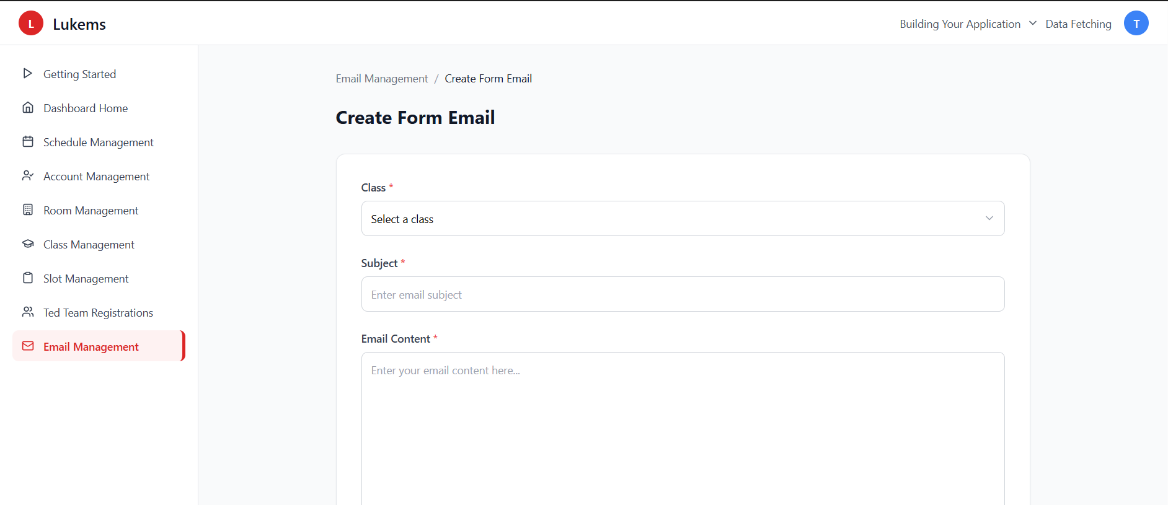

###### *Figure 58 - Create form email*

| **Screen** | | Email Management | | | | |
| --- | --- | --- | --- | --- | --- | --- |
| **Description** | | Allows Admin to create, update, delete, and manage email form templates. | | | | |
| **Screen Access** | | From Admin dashboard, click “Email Template Management”. | | | | |
| Screen Content | | | | | | |
| **Item** | | **Type** | **Data** | | **Description** | |
| Template list | | Table | Name, Subject, Last Updated | | Lists existing templates | |
| Create button | | Button | — | | Opens form to create new email template | |
| Template form | | Form | Name, Subject, Content, Placeholders | | Inputs for new template data | |
| Save button | | Button | — | | Submits and saves the new email template | |
| Cancel button | | Button | — | | Cancels template creation | |
| Screen Actions | | | | | | |
| **Action Name** | **Description** | | | **Success** | | **Failure** |
| Click Create | Open blank email form | | | Form loaded successfully | | System error loading form |
| Submit Template | Save new template | | | Template saved and listed | | Validation error or duplicate name |
| Cancel Template | Abort creation | | | Return to template list | | — |

### 3.49 UC-48 Send Email Notify

| **Use Case ID** | **UC-48** | **Use Case Name** | **Send Email Notify** |
| --- | --- | --- | --- |
| Created By | BinhHC | Date Created | 23 May 2025 |
| Primary Actor | Admin | Secondary Actor | — |
| Description | Allows the Admin to send email notifications to selected users by using a predefined email template or by composing custom content. | | |
| Priority | Must have | | |
| Trigger | Admin clicks the “Send email notify” button on the Send Email Notify Page. | | |
| Pre-conditions | Admin is logged in and has permission to manage email notifications. | | |
| Post-conditions | Email(s) are sent to the chosen recipients and logged in the system. | | |
| Basic flow | 1. Admin navigates to the Send Email Notify Page.  2. Admin selects an existing template or chooses to write a custom email.  3. Admin selects recipients (by role, class, or specific users).  4. Admin optionally previews the email.  5. Admin clicks Send.  6. System queues and dispatches the email, then shows a success message. | | |
| Alternative flow | Alternative flow 1: Notification sent successfully → Email notification delivered successfully, system displays MSG05: "A confirmation email has been sent to {email_address}."  Alternative flow 2: Recipient selection required → No recipients selected for notification, system displays MSG02: "The * field is required."  Alternative flow 3: Message content empty → Notification message content not provided, system displays MSG02: "The * field is required."  Alternative flow 4: Subject line required → Subject field left empty, system displays MSG02: "The * field is required."  Alternative flow 5: Message content exceeds limit → Notification content too long, system displays MSG08: "Exceed max length of {max_length}."  Alternative flow 6: No recipients found → No active users found for notification, system displays MSG120: "No active students found for this content. Please check enrollment."  Alternative flow 7: Invalid email addresses → Some recipient addresses are invalid, system displays MSG124: "Some email addresses are invalid. Please verify recipient information."  Alternative flow 8: Daily quota exceeded → Notification limit reached, system displays MSG123: "Daily notification limit reached. Please try again tomorrow." | | |
| Exception | Session expired during sending → System displays: MSG115  Server error during notification → System displays: MSG116  Network connectivity issues → System displays: MSG117  Permission denied → System displays: MSG118  Email delivery service unavailable → System displays: MSG121  Message generation failed → System displays: MSG122  Content not found → System displays: MSG125  Notification service unavailable → System displays: MSG042  Form loading failed → System displays: MSG201  Recipient loading failed → System displays: MSG202  Template loading failed → System displays: MSG203  Notification sending failed → System displays: MSG204 | | |
| Business Rules | BR-89, BR-90, BR-91 | | |

| **Screen** | | Send Email Notify Page | | | | |
| --- | --- | --- | --- | --- | --- | --- |
| **Description** | | Enables the Admin to compose or select templates and send email notifications to users. | | | | |
| **Screen Access** | | From Admin dashboard, click **“**Send Email Notify**”** under Notification Management**.** | | | | |
| Screen Content | | | | | | |
| **Item** | | **Type** | **Data** | | **Description** | |
| Template selector | | Dropdown | Template names | | Choose an existing email template (optional) | |
| Subject field | | Input | Text | | Email subject (auto-filled from template, editable) | |
| Content editor | | Rich-text | HTML / Markdown | | Email body (supports placeholders) | |
| Recipient selector | | Multi-select | Role, Class, User list | | Define target audience | |
| Attachment upload | | File | •pdf, •docx, •xlsx | | (Optional) attach files | |
| Preview button | | Button | — | | Show formatted preview of email | |
| Send button | | Button | — | | Dispatch email notification | |
| Cancel button | | Button | — | | Abort and return to list | |
| Screen Actions | | | | | | |
| **Action Name** | **Description** | | | **Success** | | **Failure** |
| Load template | Populate subject/body from selected template | | | Fields filled with template data | | Template not found |
| Preview email | Render email with placeholders resolved | | | Preview dialog shown | | Rendering error |
| Send email | Validate & dispatch email | | | Confirmation “Email sent” | | Validation error, SMTP error |
| Cancel | Abort sending | | | Return to previous page | | — |

### 3.50 UC-49 View statistics for all accounts

| **Use Case ID** | **UC-49** | **Use Case Name** | **View statistics for all accounts** |
| --- | --- | --- | --- |
| Created By | BinhHC | Date Created | 23 May 2025 |
| Primary Actor | Admin | Secondary Actor | — |
| Description | Allows the Admin to view summarized statistics related to all system accounts, including activity level, registration status, shift assignments, and learning progress. | | |
| Priority | Must have | | |
| Trigger | Admin clicks on "Account Statistics" from the Admin dashboard. | | |
| Pre-conditions | Admin is logged in and has permission to access account statistics. | | |
| Post-conditions | Account statistics are displayed for viewing and can optionally be exported. | | |
| Basic flow | 1. Admin navigates to the View Account Statistics Page.  2. System loads all user accounts and their statistical data.  3. Admin can filter or search for specific accounts.  4. Admin views detailed statistics per user (shifts joined, attendance rate, feedback received, etc.).  5. Admin may choose to export the data. | | |
| Alternative flow | Alternative flow 1: Statistics loaded successfully → All account statistics displayed with charts and data tables showing current metrics and trends.  Alternative flow 2: Filter applied successfully → Statistics filtered by selected criteria (role, date range), displaying filtered results with updated charts and metrics.  Alternative flow 3: No accounts found → No accounts match the selected filter criteria, system displays MSG01: "No search results."  Alternative flow 4: Date range applied → Statistics filtered by selected date range, showing account creation trends for the specified period.  Alternative flow 5: Role filter applied → Statistics filtered by user role (Student, Teacher, Admin), displaying role-specific metrics and counts.  Alternative flow 6: Search performed → Account details filtered by search query, showing matching user accounts in the details table.  Alternative flow 7: Export data requested → Statistics data exported successfully for external analysis or reporting purposes. | | |
| Exception | Session expired during data loading → System displays: MSG115  Server error during statistics loading → System displays: MSG116  Network connectivity issues → System displays: MSG117  Permission denied → System displays: MSG94  Data corruption detected → System displays: MSG95  Database timeout → System displays: MSG97  Failed to load statistics data → System displays: MSG205  Chart rendering failed → System displays: MSG206  Filter operation failed → System displays: MSG076  Search operation failed → System displays: MSG075  Export operation failed → System displays: MSG207  Account details loading failed → System displays: MSG126 | | |
| Business Rules | BR-92, BR-93 | | |

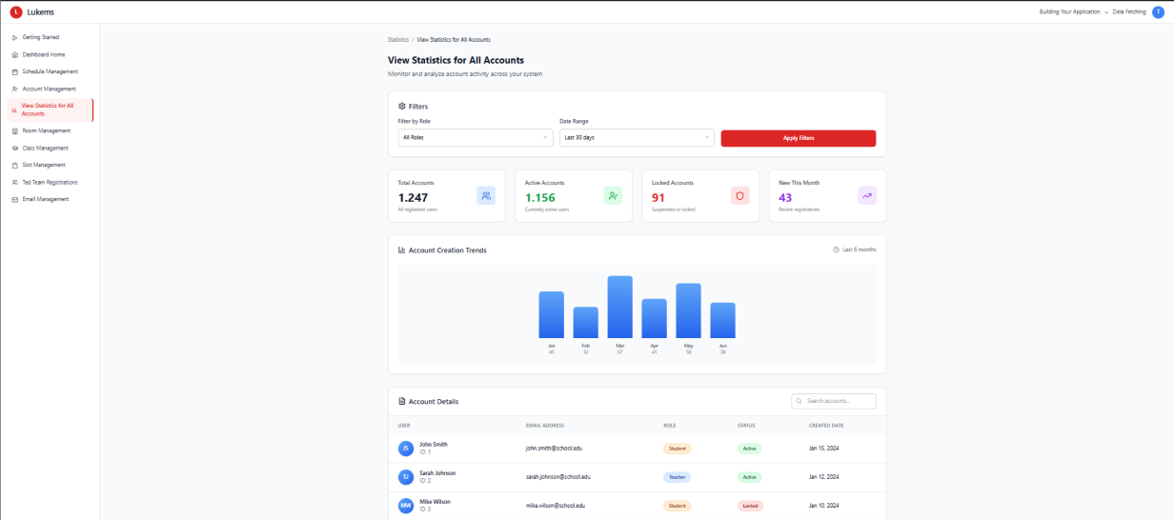

###### *Figure 59 - View statistics for all accounts*

| **Screen** | | View Account Statistics Page | | | | |
| --- | --- | --- | --- | --- | --- | --- |
| **Description** | | Provides Admin a dashboard view of system account activity and engagement metrics. | | | | |
| **Screen Access** | | From Admin dashboard, click **"**AccountStatistics**"**. | | | | |
| Screen Content | | | | | | |
| **Item** | | **Type** | **Data** | | **Description** | |
| Statistics table | | Table | User ID, Name, Role, Join date, Total shifts, Attendance rate, Feedback score | | Displays user stats | |
| Role filter | | Dropdown | Coach / Student / Admin | | Filters results by role | |
| Date range picker | | Input | Start – End | | Filters based on activity date | |
| Export button | | Button | CSV / Excel | | Exports statistics table | |
| Search bar | | Input | Name or ID | | Search for specific users | |
| Screen Actions | | | | | | |
| **Action Name** | **Description** | | | **Success** | | **Failure** |
| Load statistics | Display all user data and metrics | | | Table populated with stats | | Data not loaded, error shown |
| Apply filters | Filter stats by role/date | | | Filtered results shown | | Filter error |
| Export statistics | Export visible data | | | File downloaded | | Export error |
|  |  |  |  |  |  |  |

### 3.51 UC-50 View scores for all accounts

| **Use Case ID** | **UC-50** | **Use Case Name** | **View scores for all accounts** |
| --- | --- | --- | --- |
| Created By | BinhHC | Date Created | 23 May 2025 |
| Primary Actor | Admin | Secondary Actor | — |
| Description | Allows the Admin to view detailed learning scores or performance metrics of all user accounts, including test results, evaluation scores, and feedback ratings. | | |
| Priority | Must have | | |
| Trigger | Admin clicks on "Scores" or navigates to the View Score Page from the Admin dashboard. | | |
| Pre-conditions | Admin is logged in and has permission to access learning or evaluation scores. | | |
| Post-conditions | The score information is displayed and may be filtered or exported. | | |
| Basic flow | 1. Admin opens the View Score Page.  2. System loads all users with their respective scores.  3. Admin may filter by role, class, or date.  4. Admin views detailed scoring data such as test results, quiz scores, evaluation summaries.  5. Admin may export the result as a report. | | |
| Alternative flow | Alternative flow 1: Scores loaded successfully → All student scores displayed with detailed performance data including subject scores, class information, and performance status.  Alternative flow 2: Filter applied successfully → Scores filtered by selected criteria (class, subject, role), displaying filtered results with updated performance metrics.  Alternative flow 3: No scores found → No scores match the selected filter criteria, system displays MSG01: "No search results."  Alternative flow 4: Class filter applied → Scores filtered by selected class, showing performance data for students in the specific class.  Alternative flow 5: Subject filter applied → Scores filtered by selected subject, displaying subject-specific performance across all students.  Alternative flow 6: Role filter applied → Scores filtered by user role, showing performance data for the selected user category.  Alternative flow 7: Search performed → Student scores filtered by search query, showing matching student performance records.  Alternative flow 8: Export scores requested → Score data exported successfully for external analysis or reporting purposes. | | |
| Exception | Session expired during data loading → System displays: MSG115  Server error during scores loading → System displays: MSG116  Network connectivity issues → System displays: MSG117  Permission denied → System displays: MSG94  Data corruption detected → System displays: MSG95  Database timeout → System displays: MSG97  Failed to load scores data → System displays: MSG208  Failed to load student data → System displays: MSG126  Filter operation failed → System displays: MSG076  Search operation failed → System displays: MSG075  Export operation failed → System displays: MSG207  Score calculation failed → System displays: MSG209  Performance data unavailable → System displays: MSG210 | | |
| Business Rules | BR-94, BR-95 | | |

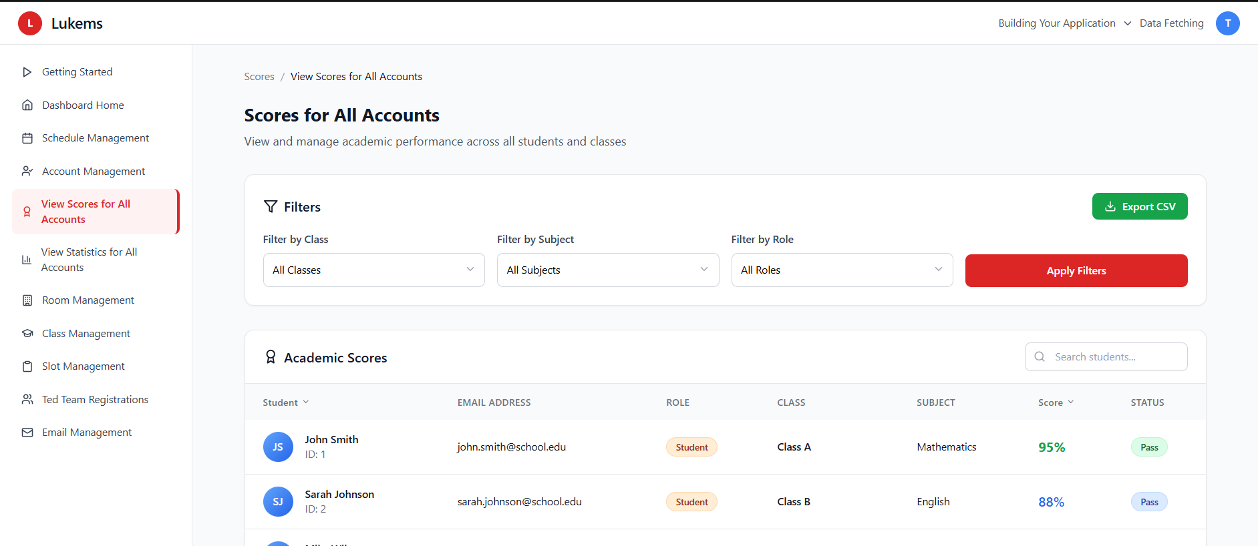

###### *Figure 60 - View scores for all accounts*

| **Screen** | | View Score Page | | | | |
| --- | --- | --- | --- | --- | --- | --- |
| **Description** | | Allows Admin to view and manage score information of users for assessment and monitoring purposes. | | | | |
| **Screen Access** | | From Admin dashboard, click “Scores” or “View Scores”. | | | | |
| Screen Content | | | | | | |
| **Item** | | **Type** | **Data** | | **Description** | |
| Score table | | Table | User ID, Name, Class, Role, Test Score, Quiz Score, Evaluation, Feedback | | Displays score records | |
| Role/class filter | | Dropdown | Role / Class | | Filters users by criteria | |
| Search bar | | Input | Name / ID | | Locates user directly | |
| Export button | | Button | CSV / Excel | | Downloads score data | |
| Score detail button | | Button | Icon | | Opens detailed view per user | |
| Screen Actions | | | | | | |
| **Action Name** | **Description** | | | **Success** | | **Failure** |
| Load scores | Show score table for all users | | | Score table displayed | | Data load error |
| Apply filters | Filter users by class or role | | | Filtered results shown | | No data found |
| View details | Open individual user’s full score | | | Full score breakdown displayed | | Error retrieving data |
| Export scores | Download the visible data | | | File downloaded | | Export error |

### 3.52 UC-51 View progress for all accounts

| **Use Case ID** | **UC-51** | **Use Case Name** | **View progress for all accounts** |
| --- | --- | --- | --- |
| Created By | BinhHC | Date Created | 23 May 2025 |
| Primary Actor | Admin | Secondary Actor | — |
| Description | Allows the Admin to monitor and view the progress of all user accounts across various activities such as shift participation, task completion, learning milestones, and attendance. | | |
| Priority | Must have | | |
| Trigger | Admin clicks on "Progress" or navigates to the View Progress Page from the Admin dashboard. | | |
| Pre-conditions | Admin is logged in and has permission to access progress statistics. | | |
| Post-conditions | The system displays progress data of users, and Admin can view or export the data. | | |
| Basic flow | 1. Admin opens the View Progress Page.  2. System loads a list of all users with their current progress status.  3. Admin filters results by role, class, or time range.  4. Admin views progress indicators (e.g. % completed, milestones reached, number of shifts joined).  5. Admin may export data for reports or further analysis. | | |
| Alternative flow | Alternative flow 1: Progress loaded successfully → All student progress displayed with detailed learning advancement data including completion status, progress percentages, and course information.  Alternative flow 2: Filter applied successfully → Progress filtered by selected criteria (class, subject, role), displaying filtered results with updated progress metrics.  Alternative flow 3: No progress data found → No progress records match the selected filter criteria, system displays MSG01: "No search results."  Alternative flow 4: Class filter applied → Progress filtered by selected class, showing learning advancement for students in the specific class.  Alternative flow 5: Subject filter applied → Progress filtered by selected subject, displaying subject-specific learning progress across all students.  Alternative flow 6: Role filter applied → Progress filtered by user role, showing advancement data for the selected user category.  Alternative flow 7: Search performed → Student progress filtered by search query, showing matching student learning records.  Alternative flow 8: Export progress requested → Progress data exported successfully for external analysis or reporting purposes. | | |
| Exception | Session expired during data loading → System displays: MSG115  Server error during progress loading → System displays: MSG116  Network connectivity issues → System displays: MSG117  Permission denied → System displays: MSG94  Data corruption detected → System displays: MSG95  Database timeout → System displays: MSG97  Failed to load progress data → System displays: MSG211  Failed to load student data → System displays: MSG126  Filter operation failed → System displays: MSG076  Search operation failed → System displays: MSG075  Export operation failed → System displays: MSG207  Progress calculation failed → System displays: MSG212  Learning data unavailable → System displays: MSG213  Failed to retrieve assignment progress → System displays: MSG041 | | |
| Business Rules | BR-96, BR-97 | | |

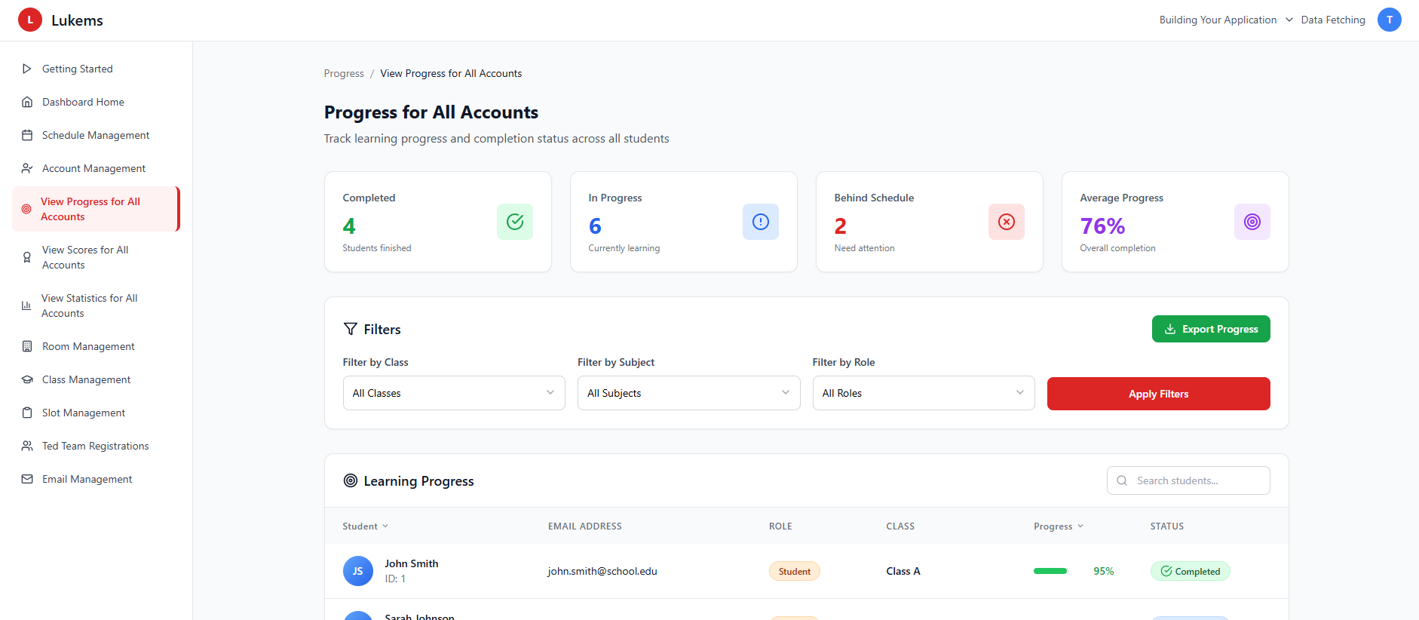

###### *Figure 61 - View progress for all accounts*

| **Screen** | | View Progress Page | | | | |
| --- | --- | --- | --- | --- | --- | --- |
| **Description** | | Allows Admin to track and analyze user progress across activities and learning goals. | | | | |
| **Screen Access** | | From Admin dashboard, click **“**Progress**”**. | | | | |
| Screen Content | | | | | | |
| **Item** | | **Type** | **Data** | | **Description** | |
| Progress table | | Table | User ID, Name, Class, Role, Progress %, Completed Tasks, Attendance, Milestones | | Displays progress details | |
| Filter options | | Dropdown | Role / Class / Time period | | Filters by user category | |
| Search bar | | Input | Name / ID | | Search specific user | |
| Export button | | Button | CSV / Excel | | Export current progress view | |
| Progress detail button | | Button | Icon | | View detailed tracking for selected user | |
| Screen Actions | | | | | | |
| **Action Name** | **Description** | | | **Success** | | **Failure** |
| Load progress | Display progress data for users | | | Table populated | | Load error shown |
| Apply filters | Narrow down users | | | Filtered view displayed | | Filter error or empty result |
| View detail | Admin opens full progress record | | | Detailed progress shown | | Error fetching data |
| Export progress | Export filtered progress table | | | File downloaded | | Export failure |

### 3.53 UC-52 View performance for all account

| **Use Case ID** | **UC-52** | **Use Case Name** | **View performance for all accounts** |
| --- | --- | --- | --- |
| Created By | BinhHC | Date Created | 23 May 2025 |
| Primary Actor | Admin | Secondary Actor | — |
| Description | Allows the Admin to view a consolidated performance overview of all accounts, including attendance consistency, evaluation outcomes, task efficiency, and general engagement metrics. | | |
| Priority | Must have | | |
| Trigger | Admin clicks “Performance” or navigates to the View Performance Page from the Admin dashboard. | | |
| Pre-conditions | Admin is logged in and has access to performance tracking functionality. | | |
| Post-conditions | Performance statistics of all users are displayed and can be analyzed or exported. | | |
| Basic flow | 1. Admin opens the View Performance Page.  2. System loads users’ performance data based on predefined metrics.  3. Admin filters by role, class, or time range if needed.  4. Admin views metrics such as attendance rate, evaluation score, task completion rate, and consistency.  5. Admin may export results for reporting or decision-making. | | |
| Alternative flow | Alternative flow 1: Performance data loaded successfully → All account performance displayed with comprehensive metrics including average scores, attendance rates, completion rates, and performance trends.  Alternative flow 2: Filter applied successfully → Performance filtered by selected criteria (class, role, date range), displaying filtered results with updated performance analytics.  Alternative flow 3: No performance data found → No performance records match the selected filter criteria, system displays MSG01: "No search results."  Alternative flow 4: Date range filter applied → Performance filtered by selected time period, showing performance trends for the specified duration.  Alternative flow 5: Role filter applied → Performance filtered by user role (Student, Teacher, Coach, Admin), displaying role-specific performance metrics.  Alternative flow 6: Class filter applied → Performance filtered by selected class, showing performance data for students in the specific class.  Alternative flow 7: Search performed → Account performance filtered by search query, showing matching user performance records.  Alternative flow 8: Export performance data requested → Performance data exported successfully for external analysis or reporting purposes. | | |
| Exception | Session expired during data loading → System displays: MSG115  Server error during performance loading → System displays: MSG116  Network connectivity issues → System displays: MSG117  Permission denied → System displays: MSG94  Data corruption detected → System displays: MSG95  Database timeout → System displays: MSG97  Failed to load performance data → System displays: MSG214  Failed to load account data → System displays: MSG126  Filter operation failed → System displays: MSG076  Search operation failed → System displays: MSG075  Export operation failed → System displays: MSG207  Performance calculation failed → System displays: MSG215  Chart rendering failed → System displays: MSG206  Analytics data unavailable → System displays: MSG216  Failed to load performance trends → System displays: MSG217 | | |
| Business Rules | BR-98, BR-99 | | |

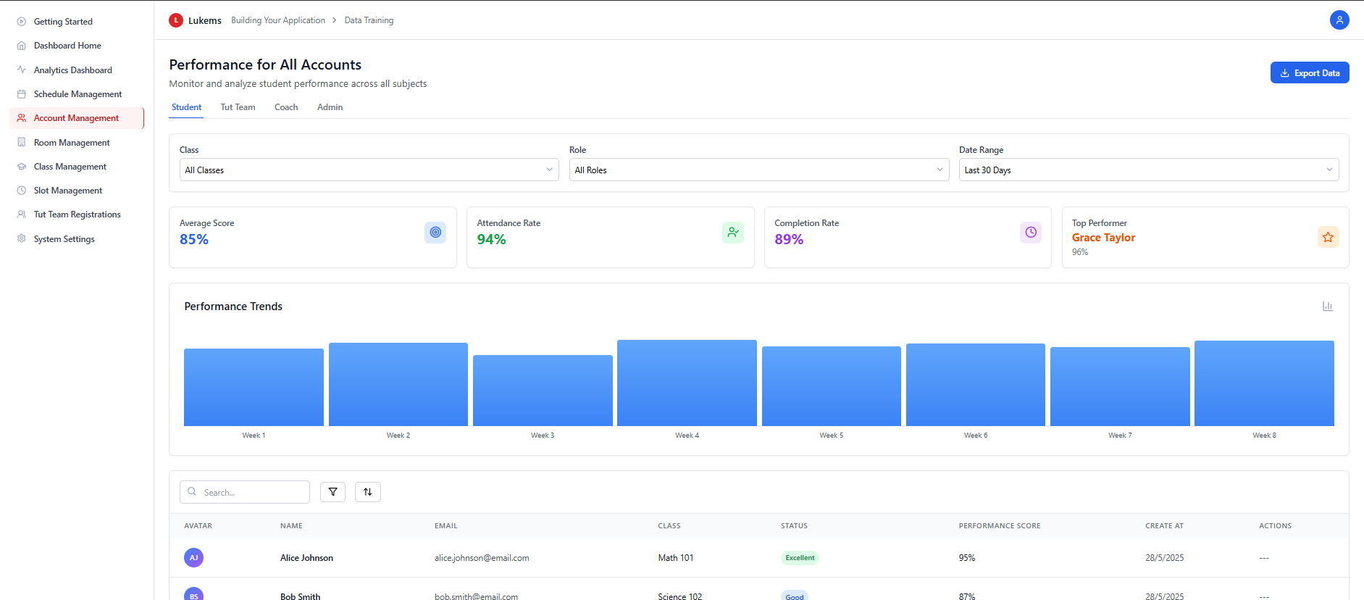

###### *Figure 62 - View performance for all accounts*

| **Screen** | | View Performance Page | | | | |
| --- | --- | --- | --- | --- | --- | --- |
| **Description** | | Displays aggregated performance indicators for each account to assist Admin in monitoring overall productivity and effectiveness. | | | | |
| **Screen Access** | | From Admin dashboard, click **“**Performance**”**. | | | | |
| Screen Content | | | | | | |
| **Item** | | **Type** | **Data** | | **Description** | |
| Performance table | | Table | User ID, Name, Role, Class, Attendance %, Evaluation Score, Task Completion %, Average Score | | Core performance indicators | |
| Role/class filter | | Dropdown | Role / Class | | Limit dataset by category | |
| Time filter | | Input | Date range | | Focus on specific period | |
| Export button | | Button | CSV / Excel | | Download performance data | |
| Detail view button | | Button | Icon | | Show full performance history | |
| Screen Actions | | | | | | |
| **Action Name** | **Description** | | | **Success** | | **Failure** |
| Load performance data | System loads user metrics | | | Table with full data | | Error: “Unable to load data” |
| Apply filters | Focus on selected group | | | Filtered results shown | | Filter failed or empty |
| Export performance | Export currently visible data | | | File downloaded | | Export error |
| View detailed performance | Admin opens full record | | | Performance breakdown shown | | Fetch error |

### 3.54 UC-53 View activity history for all accounts

| **Use Case ID** | **UC-53** | **Use Case Name** | **View activity history for all accounts** |
| --- | --- | --- | --- |
| Created By | BinhHC | Date Created | 23 May 2025 |
| Primary Actor | Admin | Secondary Actor | — |
| Description | Allows the Admin to view and monitor the activity history of all user accounts, including login/logout times, shift participation, email actions, and other interactions with the system. | | |
| Priority | Must have | | |
| Trigger | Admin accesses the View Activity History Page from the Admin dashboard. | | |
| Pre-conditions | Admin is logged in and has permission to track system activity logs. | | |
| Post-conditions | A list of user activity logs is displayed, and Admin may filter, search, or export the data. | | |
| Basic flow | 1. Admin opens the View Activity History Page.  2. System displays a list of all user activity records.  3. Admin filters by user, activity type, or date.  4. Admin views logs such as login/logout times, actions taken, timestamps.  5. Admin may export the filtered logs as a report. | | |
| Alternative flow | Alternative flow 1: Activity history loaded successfully → All account activities displayed with comprehensive logs including user actions, timestamps, activity types, and system interactions.  Alternative flow 2: Filter applied successfully → Activity history filtered by selected criteria (role, class, activity type, date range), displaying filtered results with updated activity logs.  Alternative flow 3: No activity records found → No activity records match the selected filter criteria, system displays MSG01: "No search results."  Alternative flow 4: Date range filter applied → Activity history filtered by selected time period, showing activities for the specified duration.  Alternative flow 5: Role filter applied → Activity history filtered by user role (Student, Teacher, Admin), displaying role-specific activity logs.  Alternative flow 6: Class filter applied → Activity history filtered by selected class, showing activities for users in the specific class.  Alternative flow 7: Activity type filter applied → Activity history filtered by activity type (Login, Assignment, Quiz, etc.), showing specific action logs.  Alternative flow 8: Search performed → Activity history filtered by search query, showing matching user activity records.  Alternative flow 9: Export activity data requested → Activity data exported successfully for external analysis or auditing purposes. | | |
| Exception | Session expired during data loading → System displays: MSG115  Server error during activity loading → System displays: MSG116  Network connectivity issues → System displays: MSG117  Permission denied → System displays: MSG94  Data corruption detected → System displays: MSG95  Database timeout → System displays: MSG97  Failed to load activity log data → System displays: MSG062  Failed to load activity timeline → System displays: MSG063  Activity filter operation failed → System displays: MSG064  Filter operation failed → System displays: MSG076  Search operation failed → System displays: MSG075  Export operation failed → System displays: MSG207  Activity data unavailable → System displays: MSG218  Log synchronization failed → System displays: MSG219 | | |
| Business Rules | BR-100, BR-101 | | |

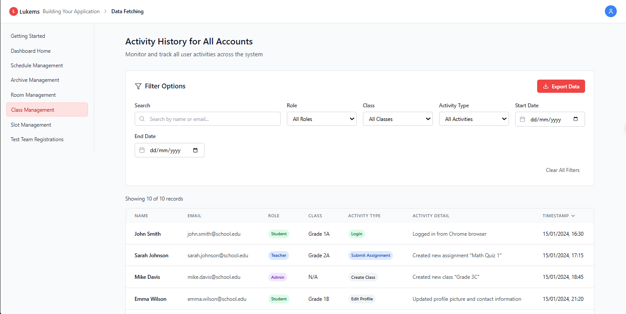

###### *Figure 63 - View activity history for all accounts*

| **Screen** | | View Activity History Page | | | | |
| --- | --- | --- | --- | --- | --- | --- |
| **Description** | | Displays the full activity history of user accounts for auditing and monitoring purposes. | | | | |
| **Screen Access** | | From Admin dashboard, click **“**Activity History**”** or **“**Logs**”**. | | | | |
| Screen Content | | | | | | |
| **Item** | | **Type** | **Data** | | **Description** | |
| Activity log table | | Table | User ID, Name, Role, Activity Type, Timestamp, IP Address | | Core audit data | |
| Activity filter | | Dropdown | Login, Logout, Update, Email, Delete, etc. | | Filters specific action types | |
| User filter | | Input | Name / ID | | Filter by specific account | |
| Date range picker | | Input | From - To | | Limits logs to a time range | |
| Export button | | Button | CSV / Excel | | Download filtered logs | |
| Screen Actions | | | | | | |
| **Action Name** | **Description** | | | **Success** | | **Failure** |
| Load activity history | Load all activity logs | | | Activity log table shown | | Error retrieving logs |
| Apply filters | Narrow results by user/date/type | | | Filtered logs displayed | | Invalid filter / empty results |
| Export logs | Export filtered list | | | File downloaded | | Export error |

### 3.55 UC-54 View learning calendar

#### 

| **Use Case ID** | **UC54** | **Use Case Name** | **View learning calendar** |
| --- | --- | --- | --- |
| Created By | NhiBTT | Date Created | 22 May 2025 |
| Primary Actor | Student | Secondary Actor | – |
| Description | This use case allows students to view their class schedule for a selected week. It provides details such as course name, instructor, time, location, and slot number.. | | |
| Priority | Must have | | |
| Trigger | Student navigates to the **Student Schedule** screen and selects a week. | | |
| Pre-conditions | The Student must be logged into the system. | | |
| Post-conditions | Weekly schedule is displayed based on selected date range. | | |
| Basic flow | 1. Student logs in and opens the **Student Schedule** page. 2. Student selects a week from the date picker. 3. The system fetches and displays the corresponding schedule in a table format by day and slot. 4. Schedule items are shown with course, instructor, time, and room. | | |
| Alternative flow | **AF1:** No classes scheduled for the selected week → System displays: “–” in all slots. **AF2:** Schedule is partially filled (some days have classes, others don’t) → Only relevant slots are populated. **AF3:** Schedule includes overlapping or rescheduled sessions → Display with correct timing and labels (e.g., “Next up”). | | |
| Exception | If the system fails to retrieve the data, an error message **MSG010** or **MSG011** is shown. | | |
| Business rules | BR-136, BR-137, BR-166, BR-167 | | |

###### 

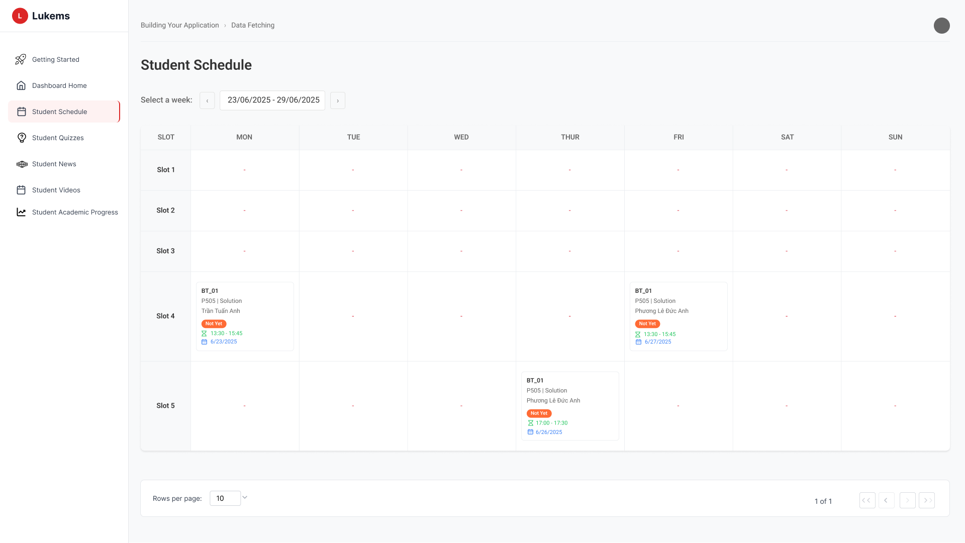

###### *Figure 64 -* View learning calendar

| **Screen** | | View learning calendar screen | | | | |
| --- | --- | --- | --- | --- | --- | --- |
| **Description** | | Shows weekly student class schedule including slot, day, instructor, course, time, and room. | | | | |
| **Screen Access** | | Navigate to “Student Schedule” from sidebar → Select a week from the top. | | | | |
| Screen Content | | | | | | |
| **Item** | | **Type** | **Data** | | **Description** | |
| Date Selector | | Dropdown / Date Picker | Week range (e.g. 23/06/2025 - 29/06/2025) | | Select schedule week | |
| Schedule Table | | Table Grid | Slots (1–5), Days (Mon–Sun) | | Grid with schedule per time slot/day | |
| Class Card | | Card View | Course, teacher, time, room, date | | Appears inside schedule cell if class exists | |
| Pagination | | Page buttons | 1, 2, 3... | | Navigate weekly views (if available) | |
| Rows per page | | Dropdown | 5, 10, 15 | | Adjust number of rows displayed | |
| Screen Actions | | | | | | |
| **Action Name** | **Description** | | | **Success** | | **Failure** |
| Select Week | Choose week from date picker | | | Schedule updates | | "No schedule found for selected week" |
| View Class Info | View course details in a slot | | | Class info displays | | — |
| Adjust Rows | Change number of rows | | | Table updates | | — |

### 

### 3.56 UC-55 View quizzes

#### 

| **Use Case ID** | **UC55** | **Use Case Name** | **View quizzes** |
| --- | --- | --- | --- |
| Created By | NhiBTT | Date Created | 22 May 2025 |
| Primary Actor | Student | Secondary Actor | – |
| Description | This use case allows students to view a list of assigned quizzes along with their status (e.g., Not Started, Can Not Be Started, Done). | | |
| Priority | Must have | | |
| Trigger | The Student navigates to the relevant section from the main menu. | | |
| Pre-conditions | The Student must be logged into the system. | | |
| Post-conditions | List of quizzes is displayed with current status of each quiz. | | |
| Basic flow | 1. Student logs into the system. 2. Student navigates to the **Student Quizzes** page. 3. The system displays a list of quizzes in card format. 4. Each quiz shows the title, assigned date, and current status (e.g., Not Started, Done). | | |
| Alternative flow | **AF1:** No quizzes assigned → System displays: *“No quizzes available.”* **AF2:** Some quizzes are locked → Shown with red label *“Can not be started”*, cannot be clicked. **AF3:** Quizzes are filtered or searched by keyword → System updates displayed list accordingly. | | |
| Exception | If the system fails to retrieve the data, an error message **MSG012** or **MSG013** is shown. For filter failures, **MSG014** is displayed. | | |
| Business rules | BR-138, BR-168, BR-169 | | |

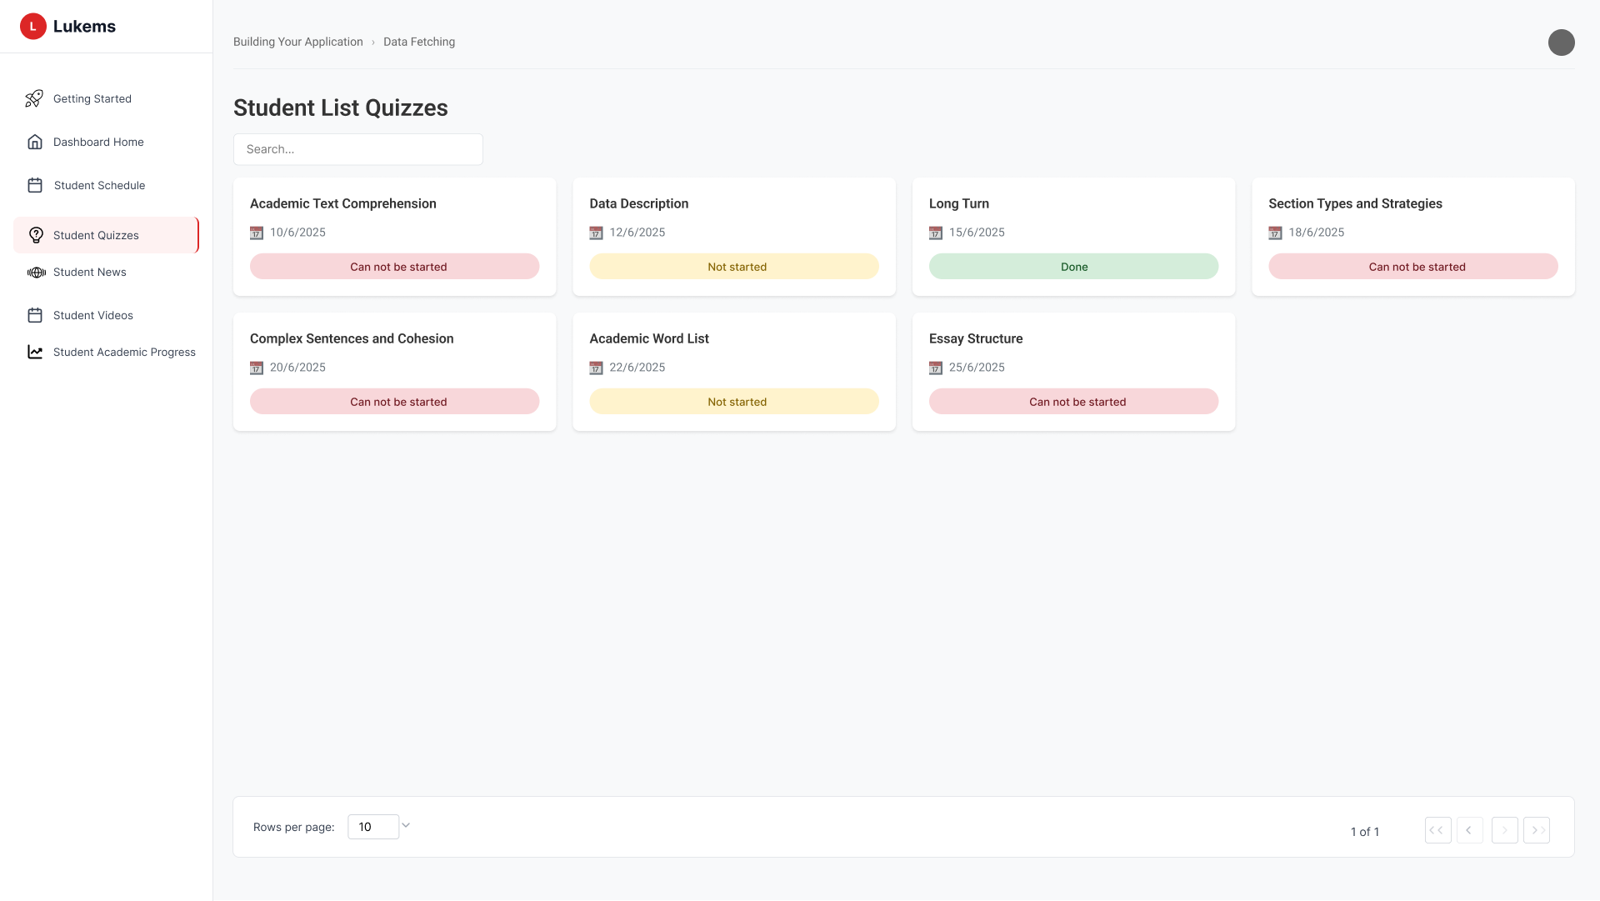

###### *Figure 65 -* View quizzes

| **Screen** | | View quizzes screen | | | | |
| --- | --- | --- | --- | --- | --- | --- |
| **Description** | | Displays all assigned quizzes for the student including status and date. | | | | |
| **Screen Access** | | Navigate to “Student Quizzes” from the sidebar. | | | | |
| Screen Content | | | | | | |
| **Item** | | **Type** | **Data** | | **Description** | |
| Search Box | | Text Input | Keyword | | Search quizzes by name | |
| Quiz Card | | Card View | Quiz title, date, status | | Displays each quiz with status label | |
| Status Label | | Text Badge | Can Not Be Started / Not Started / Done | | Indicates current quiz state | |
| Filter Button | | Icon Button | Filter options | | Allows filtering by quiz status | |
| Pagination | | Page Buttons | 1, 2, 3... | | Navigate through pages of quiz list | |
| Screen Actions | | | | | | |
| **Action Name** | **Description** | | | **Success** | | **Failure** |
| Search Quiz | Enter keyword to search quiz titles | | | Filtered quizzes shown | | No results found |
| Click Filter | Apply quiz status filter | | | List updates by status | | No matching quizzes |
| View Quiz Status | See status of each quiz | | | Status shown correctly | | — |

### 

## 

### 

### 3.57 UC-56 View News

#### 

| **Use Case ID** | **UC56** | **Use Case Name** | **View News** |
| --- | --- | --- | --- |
| Created By | NhiBTT | Date Created | 22 May 2025 |
| Primary Actor | Student | Secondary Actor | – |
| Description | This use case allows students to view a list of news articles relevant to their academic life, including title, summary, and date. | | |
| Priority | Must have | | |
| Trigger | The Student navigates to the relevant section from the main menu. | | |
| Pre-conditions | The Student must be logged into the system. | | |
| Post-conditions | A list of news articles is displayed with titles, summaries, and publish dates. | | |
| Basic flow | 1. Students log into the system. 2. Students click **Student News** from the sidebar. 3. The system loads a list of news articles sorted by latest date. 4. Each row displays title, short content, and published date. | | |
| Alternative flow | **AF1:** No news articles available → System displays message: *“No news found.”* **AF2:** Student uses search box → System filters news list by keyword. **AF3:** Student uses filter/sort tools → System reorders or filters news accordingly. | | |
| Exception | If the system fails to retrieve the data, an error message **MSG015** or **MSG016** is shown. For search failures, **MSG017** is displayed | | |
| Business rules | BR-139, BR-173, BR-174 | | |

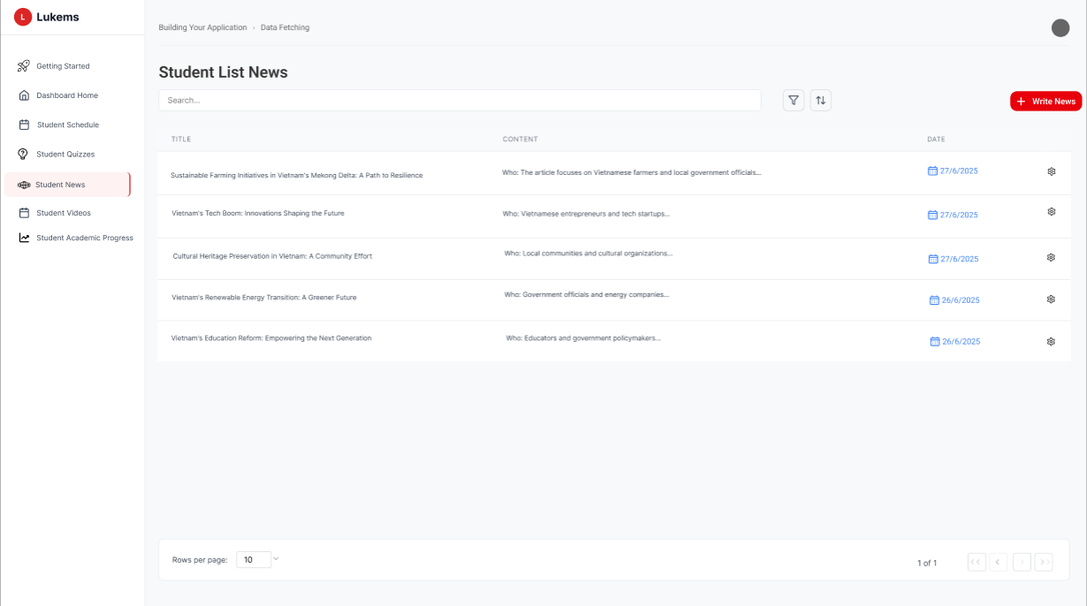

###### *Figure 66 -* View News

| **Screen** | | View News screen | | | | |
| --- | --- | --- | --- | --- | --- | --- |
| **Description** | | Shows a list of student-related news articles, including title, content summary, and date. | | | | |
| **Screen Access** | | Navigate to Student News from the sidebar. | | | | |
| Screen Content | | | | | | |
| **Item** | | **Type** | **Data** | | **Description** | |
| Search Box | | Text Input | Keyword | | Search news by title or content | |
| News Row | | Table Row | Title, summary, date | | One row per article | |
| Filter Button | | Icon Button | Sorting/filter options | | Filter by date or topic | |
| Write News Button | | Action Button | “Write News” | | Create new article (admin only) | |
| Pagination | | Page Controls | 1, 2, 3... | | Navigate between news pages | |
| Screen Actions | | | | | | |
| **Action Name** | **Description** | | | **Success** | | **Failure** |
| View News | Enter keyword to search articles | | | Matching news displayed | | No results found |
| Click Write News | Student adds a new article | | | Redirects to form page | | Permission denied |
| View News Summary | See truncated content in row | | | Summary shown | | — |

### 3.58 UC-57 View videos

#### 

| **Use Case ID** | **UC57** | **Use Case Name** | **View videos** |
| --- | --- | --- | --- |
| Created By | NhiBTT | Date Created | 22 May 2025 |
| Primary Actor | Student | Secondary Actor | – |
| Description | This use case allows students to view and submit daily, midterm, and final videos. They can see video titles, status, action buttons, and submission dates. | | |
| Priority | Must have | | |
| Trigger | The Student navigates to the relevant section from the main menu. | | |
| Pre-conditions | The Student must be logged into the system. | | |
| Post-conditions | Video list is displayed. Students may submit or re-submit videos depending on status. | | |
| Basic flow | 1. Student logs into the system. 2. Student clicks on **Student Videos** from the sidebar. 3. The system displays tabs for *Daily Videos*, *Midterm Videos*, *Final Videos*. 4. Student selects a tab to view related videos. 5. The list displays video title, status (None, Missing, Submitted), submission date, and an action button. 6. Student clicks **Submit** or **Re-submit** to upload a video. | | |
| Alternative flow | **AF1:** Student has not yet submitted → Action button shows **Submit**, status is *None*.  **AF2:** Video already submitted → Action button shows **Re-submit**, status is *Submitted*.  **AF3:** Student missed submission → Action shows **NULL**, status is *Missing*.  **AF4:** Student uses search box or filter → System filters video list accordingly. | | |
| Exception | If the system fails to retrieve the data, an error message **MSG018** or **MSG019** is shown. For playback failures, **MSG020** is displayed. | | |
| Business rules | BR-140, BR-175, BR-176, BR-177 | | |

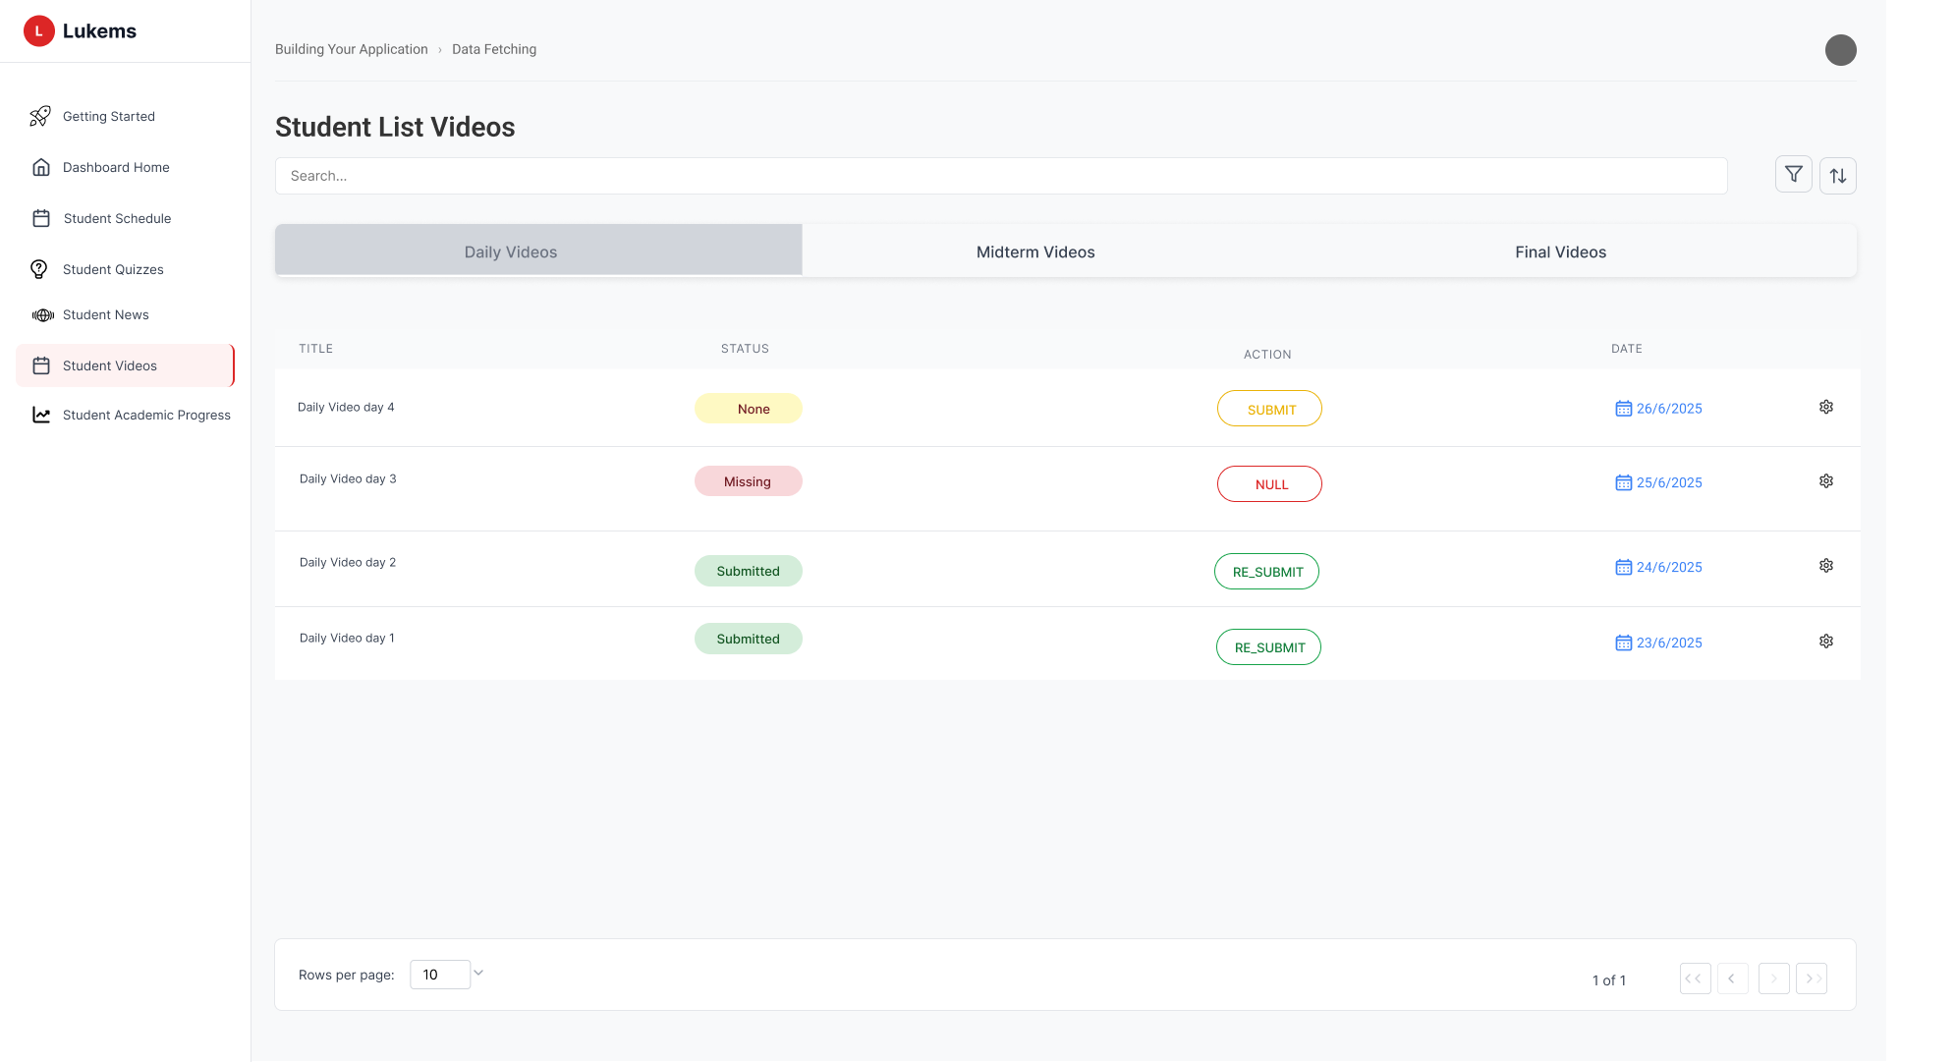

###### *Figure 67 -* View videos

| **Screen** | | View videos screen | | | | |
| --- | --- | --- | --- | --- | --- | --- |
| **Description** | | Displays all required videos for students across 3 tabs (Daily, Midterm, Final), with options to submit or resubmit. | | | | |
| **Screen Access** | | Navigate to Student Videos from sidebar. | | | | |
| Screen Content | | | | | | |
| **Item** | | **Type** | **Data** | | **Description** | |
| Tabs | | Tab Navigation | Daily, Midterm, Final | | Categorizes videos by type | |
| Search Box | | Text Input | Keyword | | Filter video list by title | |
| Video Row | | Table Row | Title, status, action, date | | Each row shows one video task | |
| Status Badge | | Label | None / Missing / Submitted | | Visual status indicator | |
| Action Button | | Button | Submit / Re-submit / NULL | | Submit or re-upload video | |
| Submission Date | | Icon + Text | e.g., 25/6/2025 | | Submission deadline or recorded date | |
| Settings Icon | | Icon Button |  | | (Future) Edit or manage per video (admin) | |
| Screen Actions | | | | | | |
| **Action Name** | **Description** | | | **Success** | | **Failure** |
| Submit Video | Upload a video for a task | | | Video uploaded & status updated | | Upload failed (MSG051) |
| Re-submit Video | Replace previously submitted video | | | New video replaces the old one | | Deadline passed (MSG094) |
| View Status | Check current submission state | | | Status badge shown correctly | | — |

### 3.59 UC-58 Do quiz

#### 

| **Use Case ID** | **UC58** | **Use Case Name** | **Do quiz** |
| --- | --- | --- | --- |
| Created By | NhiBTT | Date Created | 22 May 2025 |
| Primary Actor | Student | Secondary Actor | – |
| Description | This use case allows a student to resume an in-progress quiz. A confirmation popup appears to ensure the student intentionally wants to continue the test. | | |
| Priority | Must have | | |
| Trigger | The Student navigates to the relevant section from the main menu. | | |
| Pre-conditions | Student is logged in, and the selected quiz is in a resumable state (e.g. *Not Finished*). | | |
| Post-conditions | Student is redirected to the quiz interface to continue the attempt. | | |
| Basic flow | 1. Student logs in and navigates to the **Student Quizzes** page. 2. System displays a list of quizzes with their status (e.g., *Can not be started*, *Done*). 3. Student clicks on a quiz that is allowed to be continued. 4. System opens a modal dialog asking:  *“Are you sure you want to continue doing this test?”* 5. Student clicks **Continue**. 6. System redirects to the quiz interface for continuation. | | |
| Alternative flow | **AF1:** Student clicks **Cancel** in the confirmation modal → Modal closes, remains on the list view. **AF2:** Student refreshes page during modal → Modal dismissed, state reset. **AF3:** Quiz is no longer available when student clicks Continue → System displays error and returns to list view. | | |
| Exception | If the system fails to retrieve the data, an error message **MSG021** is shown. For submission failures, **MSG022** is displayed | | |
| Business rules | BR-141, BR-178, BR-179 | | |

###### *Figure 68.1 -* Do quiz

###### *Figure 68.2 -* Do quiz

| **Screen** | | Do quiz screen | | | | |
| --- | --- | --- | --- | --- | --- | --- |
| **Description** | | Displays all available quizzes with their title, date, and status. When student attempts to resume a quiz, a confirmation dialog is shown. | | | | |
| **Screen Access** | | Navigate to Student Quizzes from sidebar. | | | | |
| Screen Content | | | | | | |
| **Item** | | **Type** | **Data** | | **Description** | |
| Quiz Card | | Card View | Title, date, status | | One card per quiz | |
| Status Label | | Badge | ​​Done / Not started / Cannot be started | | Indicates availability | |
| Confirmation Modal | | Modal/Dialog | Message text | | Confirm before resuming quiz | |
| Continue Button | | Button (Red) | Continue | | Proceed to quiz interface | |
| Cancel Button | | Button (White) | Cancel | | Close dialog without action | |
| Screen Actions | | | | | | |
| **Action Name** | **Description** | | | **Success** | | **Failure** |
| Click Quiz Card | Student selects a quiz to resume | | | Confirmation dialog appears | | Quiz not eligible → MSG089 |
| Confirm Continue | Student confirms to continue quiz | | | Redirect to quiz screen | | Session expired → MSG057 |
| Cancel Continue | Student cancels from modal | | | Modal closes | | — |

### 3.60 UC-59 Write News

#### 

| **Use Case ID** | **UC59** | **Use Case Name** | **Write News** |
| --- | --- | --- | --- |
| Created By | NhiBTT | Date Created | 22 May 2025 |
| Primary Actor | Student | Secondary Actor | – |
| Description | Allows the Student to write a news article. | |  |
| Priority | Must have | |  |
| Trigger | User clicks "Write News" button from the Student News page | |  |
| Pre-conditions | The Student must be logged into the system. | |  |
| Post-conditions | New news article is created and saved to the system, user is redirected to updated news list | |  |
| Basic flow | 1. User navigates to Student News page 2. User clicks "Write News" button in the top navigation 3. System displays Write News modal dialog 4. User enters required news title in the News Title field 5. User selects publication date using date picker 6. User optionally enters news source information 7. User creates and formats content using rich text editor 8. User clicks Submit button 9. System validates form data 10. System saves news article to database 11. Modal closes and user returns to Student News page with updated list | |  |
| Alternative flow | **AF1**: User clicks Cancel button → Modal closes without saving, returns to news list  **AF2**: Form validation fails → System displays error messages, user corrects issues  **AF3**: User attempts to close modal with unsaved changes → System prompts for confirmation before discarding changes  **AF4**: Rich text editor fails to load → System displays plain text editor as fallback | |  |
| Exception | If the system fails to retrieve the data, an error message **MSG023** is shown. For submission failures, **MSG024** is displayed. | |  |
| Business rules | BR-142, BR-180, BR-181, BR-182 | |  |

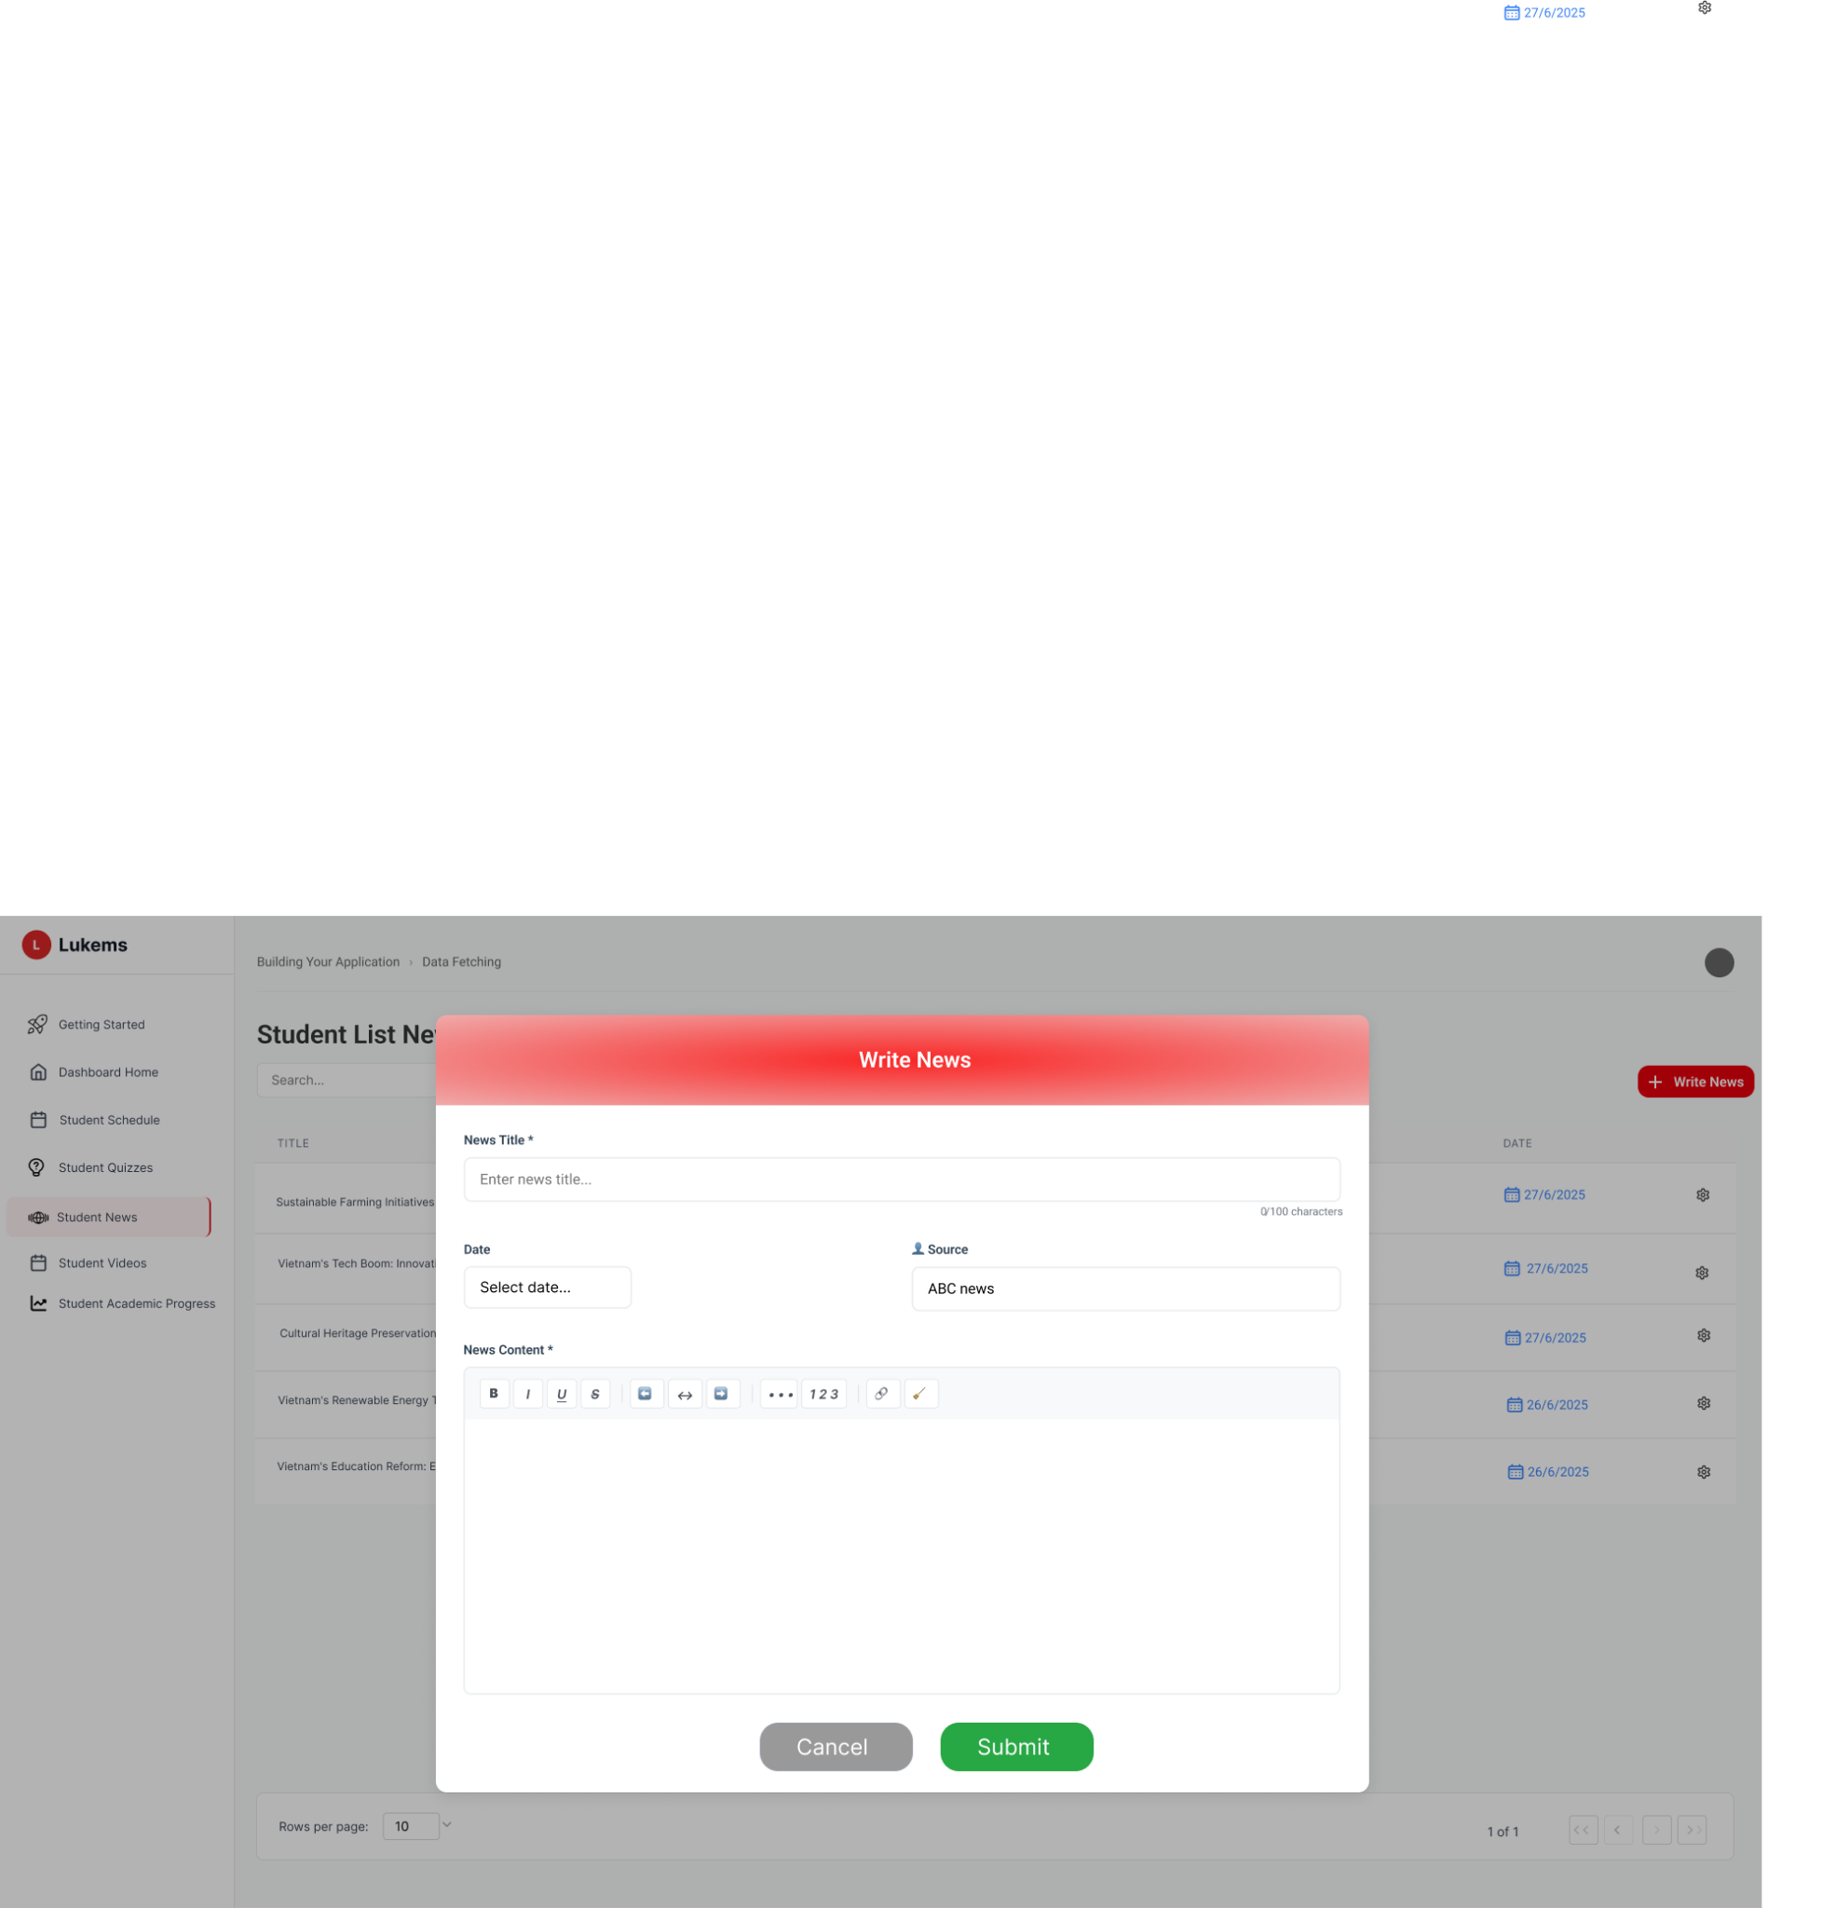

###### *Figure 69 -* Write News

| **Screen** | | Write News screen | | | | |
| --- | --- | --- | --- | --- | --- | --- |
| **Description** | | Modal dialog for creating new student news articles. Provides form fields for title, date, source, and rich text content with formatting options. | | | | |
| **Screen Access** | | Access from Student News page via "Write News" button in top navigation. | | | | |
| Screen Content | | | | | | |
| **Item** | | **Type** | **Data** | |  | |
| Modal Header | | Header | "Write News" | | Title bar of the modal dialog | |
| News Title Field | | Text Input | User input text | | Required field for news article title with character counter | |
| Date Field | | Date Picker | Selected date | | Date selection for news publication | |
| Source Field | | Text Input | User input text | | Optional field for news source (e.g., "ABC news") | |
| Content Editor | | Rich Text Editor | Formatted content | | WYSIWYG editor with formatting toolbar (bold, italic, underline, lists, links, etc.) | |
| Submit Button | | Button | "Submit" | | Primary action button to save news article | |
| Cancel Button | | Button | "Cancel" | | Secondary action button to close modal without saving | |
| Screen Actions | | | | | | |
| **Action Name** | **Description** | | | **Success** | | **Failure** |
| Enter News Title | User enters title in the News Title field | | | Title is saved in form | | Validation error if empty or exceeds character limit |
| Select Date | User selects a date from date picker | | | Date is populated in Date field | | Invalid date format error |
| Enter Source | User enters news source information | | | Source is saved in form | | — |
| Format Content | User uses rich text editor to format news content | | | Content formatting is applied | | Editor fails to load formatting |
| Submit News | User clicks Submit button to save news | | | News is saved and modal closes, redirects to news list | | Form validation errors displayed |
| Cancel Creation | User clicks Cancel button | | | Modal closes, changes are discarded | | — |

### 3.61 UC-60 Submit Video/Vlog

#### 

| **Use Case ID** | **UC60** | **Use Case Name** | **Submit Video/Vlog** |
| --- | --- | --- | --- |
| Created By | NhiBTT | Date Created | 22 May 2025 |
| Primary Actor | Student | Secondary Actor | – |
| Description | This use case allows students to submit video assignments either by uploading files or providing video URLs. The system tracks due dates and validates submissions. | | |
| Priority | Must have | | |
| Trigger | Student clicks submit action for a video assignment | | |
| Pre-conditions | Student is logged in and has an assigned video task with submission permissions | | |
| Post-conditions | Video submission is recorded in the system, student receives confirmation, and assignment status is updated | | |
| Basic flow | 1. Student navigates to Student Videos page 2. Student clicks submit action for a specific video assignment 3. System displays Submit Video modal dialog 4. Student enters video title in the Video Title field 5. Student selects due date using date picker 6. Student chooses submission method (Upload File or Submit Link)   **If Upload File selected:**   * Student drags video file into upload area or clicks to browse * System validates file format and size * File is prepared for upload   **If Submit Link selected:**   * Link input field becomes active * Student enters video URL * System validates URL format  1. Student clicks Submit button 2. System validates all form data 3. System saves video submission to database 4. Modal closes and student returns to videos page with updated status | | |
| Alternative flow | **AF1**: Student clicks Cancel button → Modal closes without saving, returns to videos list  **AF2**: File validation fails → System displays error message about unsupported format or size limit  **AF3**: URL validation fails → System shows error message for invalid URL format  **AF4**: Due date is in the past → System shows warning about late submission  **AF5**: Upload fails due to network issues → System displays retry option and preserves form data | | |
| Exception | If the system fails to retrieve the data, an error message **MSG025** is shown. For submission failures, **MSG026** is displayed. | | |
| Business rules | BR-143, BR-183, BR-184, BR-185, BR-186, BR-187 | | |

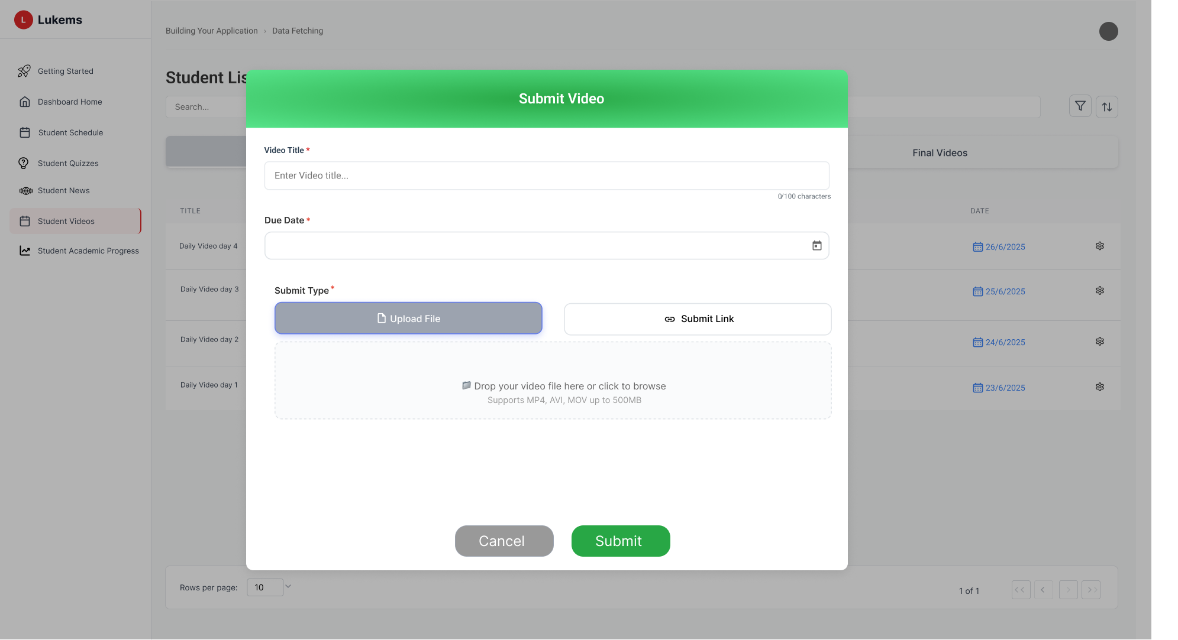

###### *Figure 70.1 -* Submit video

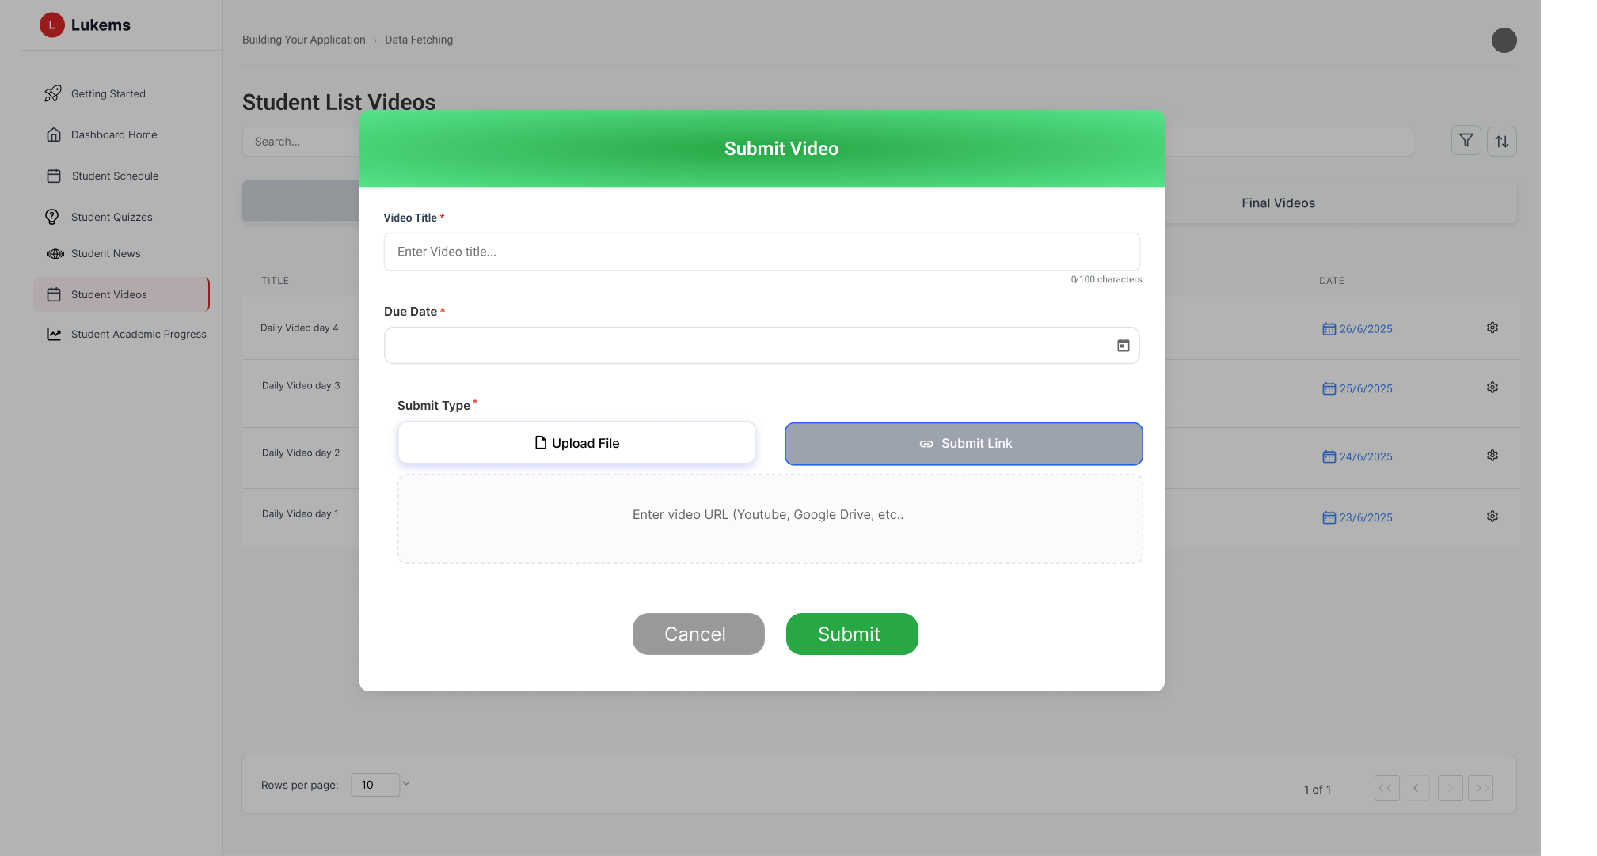

###### *Figure 70.2 -* Submit video

| **Screen** | | Submit Video/Vlog screen | | | | |
| --- | --- | --- | --- | --- | --- | --- |
| **Description** | | Modal dialog for students to submit video assignments. Supports both file upload and URL submission with due date tracking. | | | | |
| **Screen Access** | | Access from Student Videos page via submission action or direct link from assignment. | | | | |
| Screen Content | | | | | | |
| **Item** | | **Type** | **Data** | | **Description** | |
| Modal Header | | Header | "Submit Video" | | Title bar of the modal dialog | |
| Video Title Field | | Text Input | User input text | | Required field for video title with 100 character limit counter | |
| Due Date Field | | Date Picker | Selected date | | Required field for video submission deadline | |
| Submit Type Toggle | | Button Group | "Upload File" / "Submit Link" | | Toggle between file upload and URL submission methods | |
| File Upload Area | | Drop Zone | File data | | Drag & drop area for video files with browse option | |
| File Format Info | | Text Label | "Supports MP4, AVI, MOV up to 500MB" | | Information about supported file formats and size limits | |
| Link Input Field | | Text Input | URL string | | Input field for video URL (visible when Submit Link is selected) | |
| Submit Button | | Button | "Submit" | | Primary action button to save video submission | |
| Cancel Button | | Button | "Cancel" | | Secondary action button to close modal without saving | |
| Screen Actions | | | | | | |
| **Action Name** | **Description** | | | **Success** | | **Failure** |
| Enter Video Title | User enters title in the Video Title field | | | Title is saved in form | | Validation error if empty or exceeds 100 characters |
| Select Due Date | User selects a due date from date picker | | | Date is populated in Due Date field | | Invalid date format or past date error |
| Choose Upload File | User clicks Upload File button to select video file | | | File upload dialog opens | | File browser fails to open |
| Drag & Drop File | User drags video file into upload area | | | File is loaded and validated | | File format not supported or size exceeds limit |
| Submit Link | User clicks Submit Link button to provide video URL | | | Link input field becomes active | | Invalid URL format error |
| Submit Video | User clicks Submit button to save video submission | | | Video is saved and modal closes | | Form validation errors or upload failure |
| Cancel Submission | User clicks Cancel button | | | Modal closes, changes are discarded | | — |
|  |  | | |  | |  |

### 3.62 UC-61 Academic progress

#### 

| **Use Case ID** | **UC58** | **Use Case Name** | **Academic progress** |
| --- | --- | --- | --- |
| Created By | NhiBTT | Date Created | 22 May 2025 |
| Primary Actor | Student | Secondary Actor | – |
| Description | This use case allows students to view their comprehensive academic progress statistics including scores, rankings, skill development, and performance trends. All data is read-only for student viewing purposes. | | |
| Priority | Must have | | |
| Trigger | Student navigates to Student Academic Progress page from sidebar | | |
| Pre-conditions | Student is logged in and has academic data available in the system | | |
| Post-conditions | Student views their current academic progress and performance metrics | | |
| Basic flow | 1. Student clicks on "Student Academic Progress" in the sidebar navigation 2. System loads and displays Academic Progress dashboard by default 3. Student views overall statistics in the top cards (Overall Score, Completed Tasks, Best Category, Class Rank) 4. Student reviews English Skills Progress section showing individual skill percentages 5. Student examines Monthly Performance Trend chart to track progress over time 6. Student can switch between different tabs (Quiz Result, Exercises History, Average Score, Leaderboard) to view specific metrics 7. System displays corresponding statistics for each selected tab | | |
| Alternative flow | **AF1**: Student clicks Quiz Result tab → System displays quiz-specific performance data  **AF2**: Student clicks Exercises History tab → System shows exercise completion and performance history  **AF3**: Student clicks Average Score tab → System displays average scores across different subjects/categories  **AF4**: Student clicks Leaderboard tab → System shows class ranking and peer comparison  **AF5**: Data is not available for any section → System displays "No data available" message | | |
| Exception | If the system fails to retrieve the data, an error message **MSG027** is shown. | | |
| Business rules | BR-144, BR-188, BR-189, BR-190, BR-191 | | |

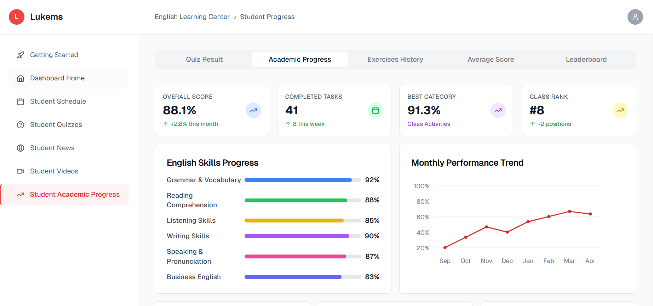

###### *Figure 71 -* View academic progress

| **Screen** | | Academic progress screen | | | | |
| --- | --- | --- | --- | --- | --- | --- |
| **Description** | | Read-only dashboard displaying comprehensive academic progress statistics for students. Shows performance metrics, skill development, and comparative rankings without any editing capabilities. | | | | |
| **Screen Access** | | Navigate to Student Academic Progress from main sidebar navigation. | | | | |
| Screen Content | | | | | | |
| **Item** | | **Type** | **Data** | | **Description** | |
| Navigation Tabs | | Tab Group | Quiz Result, Academic Progress, Exercises History, Average Score, Leaderboard | | Tab navigation for different progress views | |
| Overall Score Card | | Statistics Card | Percentage value with trend | | Shows overall academic performance (88.1%) with monthly change indicator | |
| Completed Tasks Card | | Statistics Card | Number with trend | | Displays total completed tasks (41) with weekly progress | |
| Best Category Card | | Statistics Card | Percentage with category name | | Shows highest performing subject area (91.3% Class Activities) | |
| Class Rank Card | | Statistics Card | Rank number with trend | | Displays current class ranking (#8) with position change | |
| English Skills Progress | | Progress Bar Chart | Skill names and percentages | | Visual representation of progress in different English skills | |
| Monthly Performance Trend | | Line Chart | Performance data over time | | Shows performance trends across months (Sep-Apr) | |
| Skill Progress Bars | | Progress Indicators | Percentage values | | Individual progress bars for Grammar, Reading, Listening, Writing, Speaking, Business English | |
| Screen Actions | | | | | | |
| **Action Name** | **Description** | | | **Success** | | **Failure** |
| View Quiz Result | Student clicks on Quiz Result tab | | | Quiz Result statistics are displayed | | System displays error message and retry option when academic data cannot be loaded |
| View Academic Progress | Student clicks on Academic Progress tab | | | Academic Progress statistics are displayed | | System shows fallback text-based statistics when charts fail to render |
| View Exercises History | Student clicks on Exercises History tab | | | Exercises History statistics are displayed | | System displays cached data if available, otherwise shows connection error |
| View Average Score | Student clicks on Average Score tab | | | Average Score statistics are displayed | | System shows "No data available" for time periods without records |
| View Leaderboard | Student clicks on Leaderboard tab | | | Leaderboard statistics are displayed | | System shows "No data available" for time periods without records |
| Hover on Progress Bar | Student hovers over skill progress bars | | | Tooltip shows detailed progress information | | — |
| View Performance Trend | Student views monthly performance chart | | | Chart displays performance data over time | | Chart rendering error |

### 3.63 UC-61.1 View exercises history

#### 

| **Use Case ID** | **UC 61.1** | **Use Case Name** | **View exercises history** |
| --- | --- | --- | --- |
| Created By | NhiBTT | Date Created | 22 May 2025 |
| Primary Actor | Student | Secondary Actor | – |
| Description | This use case allows students to view their exercise completion history | | |
| Priority | Must have | | |
| Trigger | Student clicks Exercises History tab from Student Academic Progress page | | |
| Pre-conditions | Student is logged in and has exercise completion data available in the system | | |
| Post-conditions | Student views their exercise history and completion performance metrics | | |
| Basic flow | 1. Student navigates to Student Academic Progress page 2. Student clicks on "Exercises History" tab 3. System displays exercise history statistics in summary cards: 4. System displays Recent Submissions list with individual exercise details 5. Student can view each exercise item showing: 6. Student can hover over exercise items for visual feedback 7. Student can click on exercise items to view detailed information (read-only) | | |
| Alternative flow | **AF1**: Student clicks other tabs → System navigates to corresponding tab view  **AF2**: No recent exercises available → System displays "No recent exercises" message  **AF3**: Exercise details not available → System shows "Details not available" message  **AF4**: Student clicks on pending exercise → System shows exercise details with due date information | | |
| Exception | If the system fails to retrieve the data, an error message **MSG028** is shown. | | |
| Business rules | BR-145 | | |

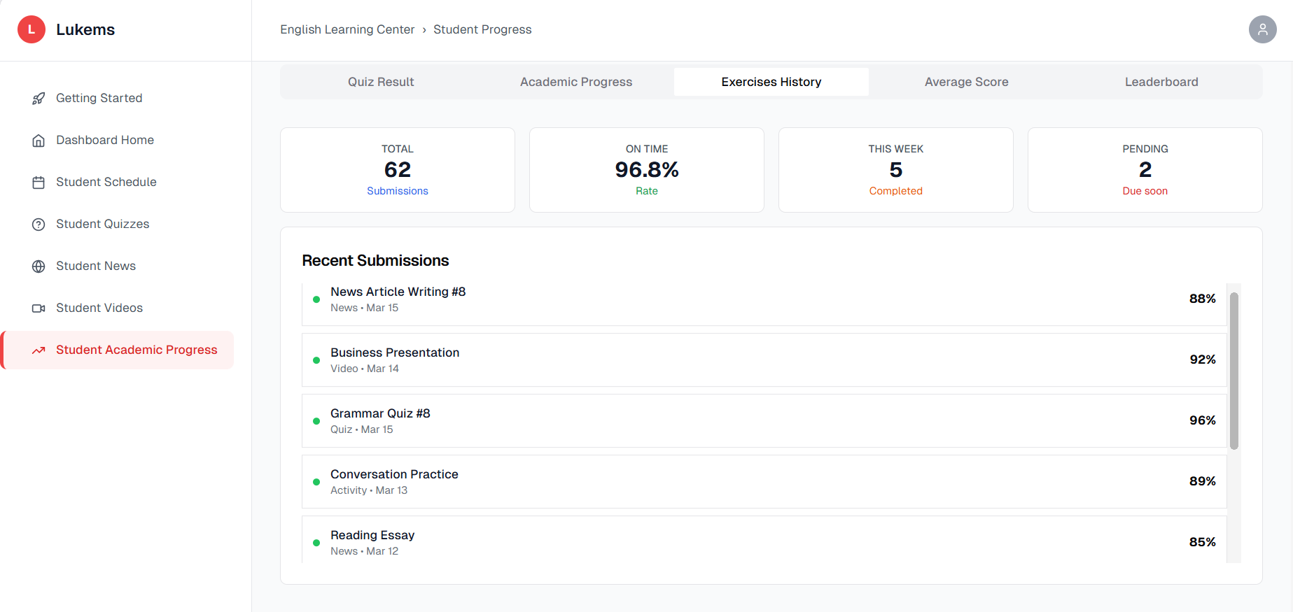

###### *Figure 72 -* View exercises history

| **Screen** | | View exercises history | | | | |
| --- | --- | --- | --- | --- | --- | --- |
| **Description** | | Read-only tab displaying exercise and assignment completion history with performance statistics. Shows completion rates, recent submissions, and individual exercise scores. | | | | |
| **Screen Access** | | Access from Student Academic Progress page by clicking Exercises History tab. | | | | |
| Screen Content | | | | | | |
| **Item** | | **Type** | **Data** | | **Description** | |
| Tab Navigation | | Tab Group | Quiz Result, Academic Progress, Exercises History, Average Score, Leaderboard | | Navigation tabs for different progress views (current: Exercises History) | |
| Total Exercises Card | | Button | Number (62) | | Total number of exercises completed with "Submissions" label | |
| On Time Rate Card | | Statistics Card | Percentage (96.8%) | | Percentage of exercises completed on time with "Rate" label | |
| This Week Card | | Statistics Card | Number (5) | | Number of exercises completed this week with "Completed" label | |
| Pending Card | | Statistics Card | Number (2) | | Number of pending exercises with "Due soon" label | |
| Recent Submissions Header | | Section Header | "Recent Submissions" | | Title for the exercise submissions list section | |
| Exercise List Items | | List Items | Exercise details with scores | | Individual exercise entries showing name, type, date, and score percentage | |
| News Article Writing #6 | | List Item | News • Mar 16 | | Recent news writing assignment with 98% score | |
| Business Presentation | | List Item | Video • Mar 14 | | Video presentation assignment with 92% score | |
| Grammar Quiz #8 | | List Item | Quiz • Mar 15 | | Grammar quiz assignment with 96% score | |
| Conversation Practice | | List Item | Activity • Mar 13 | | Conversation practice activity with 89% score | |
| Reading Essay | | List Item | News • Mar 12 | | Reading essay assignment with 95% score | |
| Screen Actions | | | | | | |
| **Action Name** | **Description** | | | **Success** | | **Failure** |

| View Quiz Result | Student clicks on Quiz Result tab | | | Quiz Result statistics are displayed | | System displays error message and retry option when academic data cannot be loaded |
| --- | --- | --- | --- | --- | --- | --- |
| View Academic Progress | Student clicks on Academic Progress tab | | | Academic Progress statistics are displayed | | System shows fallback text-based statistics when charts fail to render |
| View Exercises History | Student clicks on Exercises History tab | | | Exercises History statistics are displayed | | System displays cached data if available, otherwise shows connection error |
| View Average Score | Student clicks on Average Score tab | | | Average Score statistics are displayed | | System shows "No data available" for time periods without records |
| View Leaderboard | Student clicks on Leaderboard tab | | | Leaderboard statistics are displayed | | System shows "No data available" for time periods without records |
| Hover on Submission Item | Student hovers over recent submission items | | | Hover effect is displayed | | — |
| View Submission Details | Student clicks on submission item | | | Detailed view of submission (read-only) | | Submission details not available |

### 

### 3.64 UC-61.1.1 View result each quiz screen.

#### 

| **Use Case ID** | **UC 61.1.1** | **Use Case Name** | **View result each quiz screen** |
| --- | --- | --- | --- |
| Created By | NhiBTT | Date Created | 22 May 2025 |
| Primary Actor | Student | Secondary Actor | – |
| Description | This use case allows a student to view detailed results of a completed quiz | | |
| Priority | Must have | | |
| Trigger | Student navigates to Academic Progress section and selects Quiz Result tab | | |
| Pre-conditions | Student is logged in, has completed at least one quiz, and quiz results are available in the system | | |
| Post-conditions | Student views detailed quiz performance and understands areas for improvement | | |
| Basic flow | 1. Students select 'View result' from the View exercise history screen. 2. System retrieves and displays the result in this quiz. 3. Students can interact with the data if applicable. | | |
| Alternative flow | **AF1:** Student clicks on Academic Progress tab → System shows progress statistics and quiz history  **AF2:** Student clicks "View Answers" → System displays detailed answer explanations and learning tips  **AF3:** Quiz data unavailable → System shows error message MSG001, offers retry option  **AF4:** Student navigates to different progress tab → System loads corresponding progress data (Exercises History, Average Score, Leaderboard)  **AF5:** Session expires during viewing → System redirects to login with session timeout message | | |
| Exception | If the system fails to retrieve the data, an error message **MSG029** is shown. | | |
| Business rules | BR-146 | | |

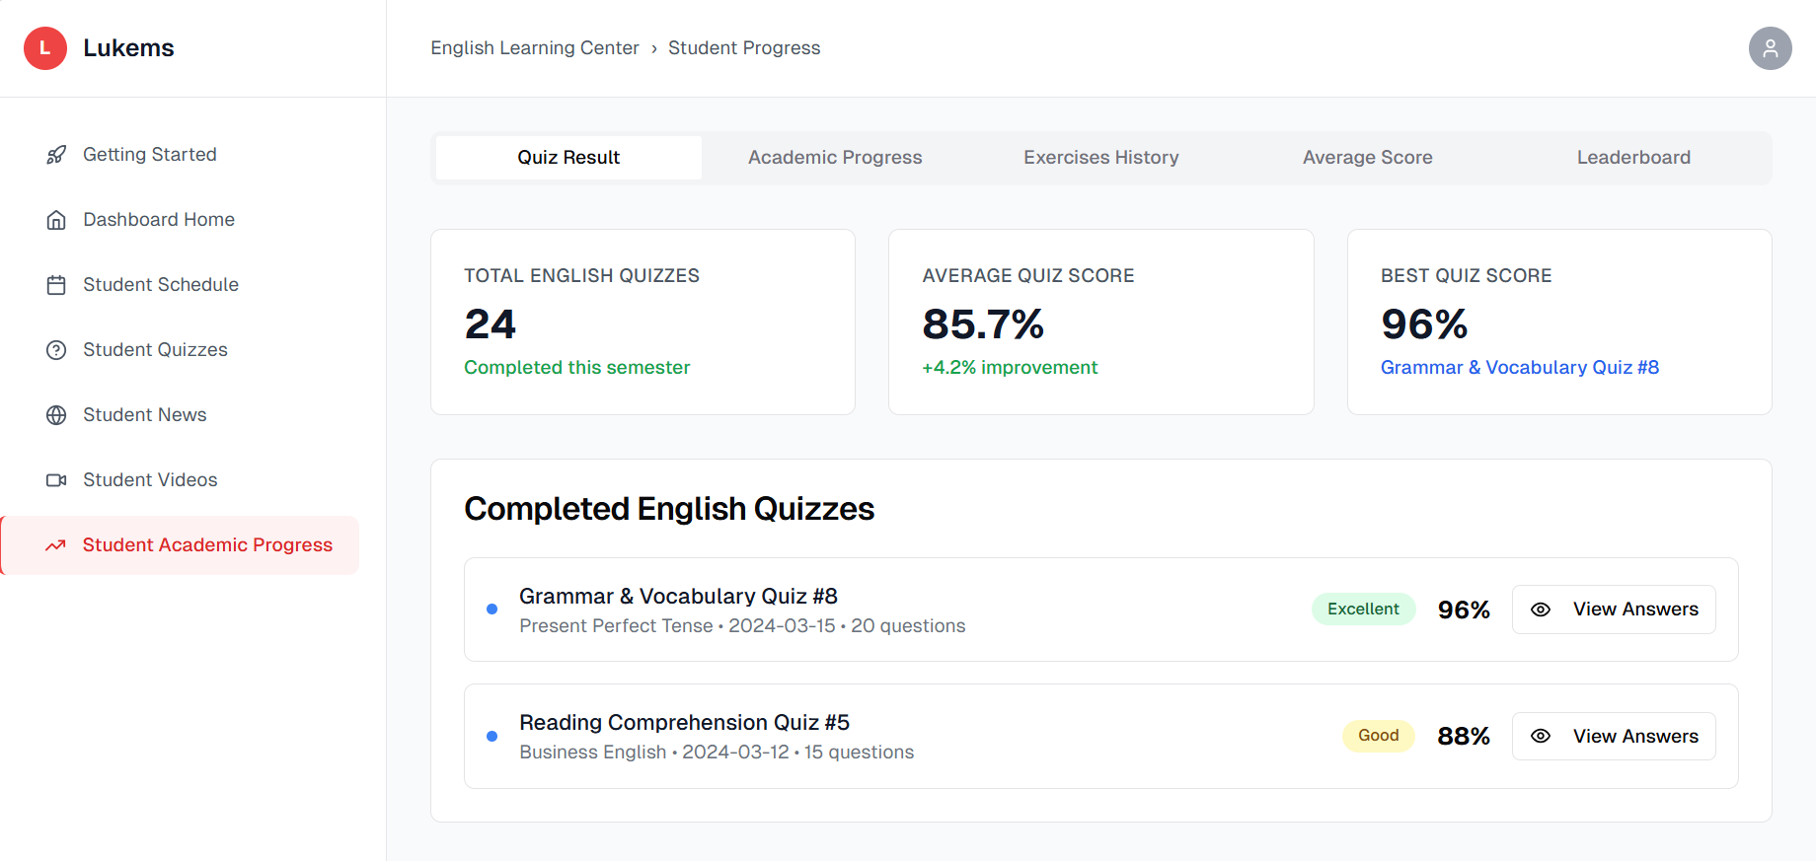

###### *Figure 73.1 -* View result each quiz

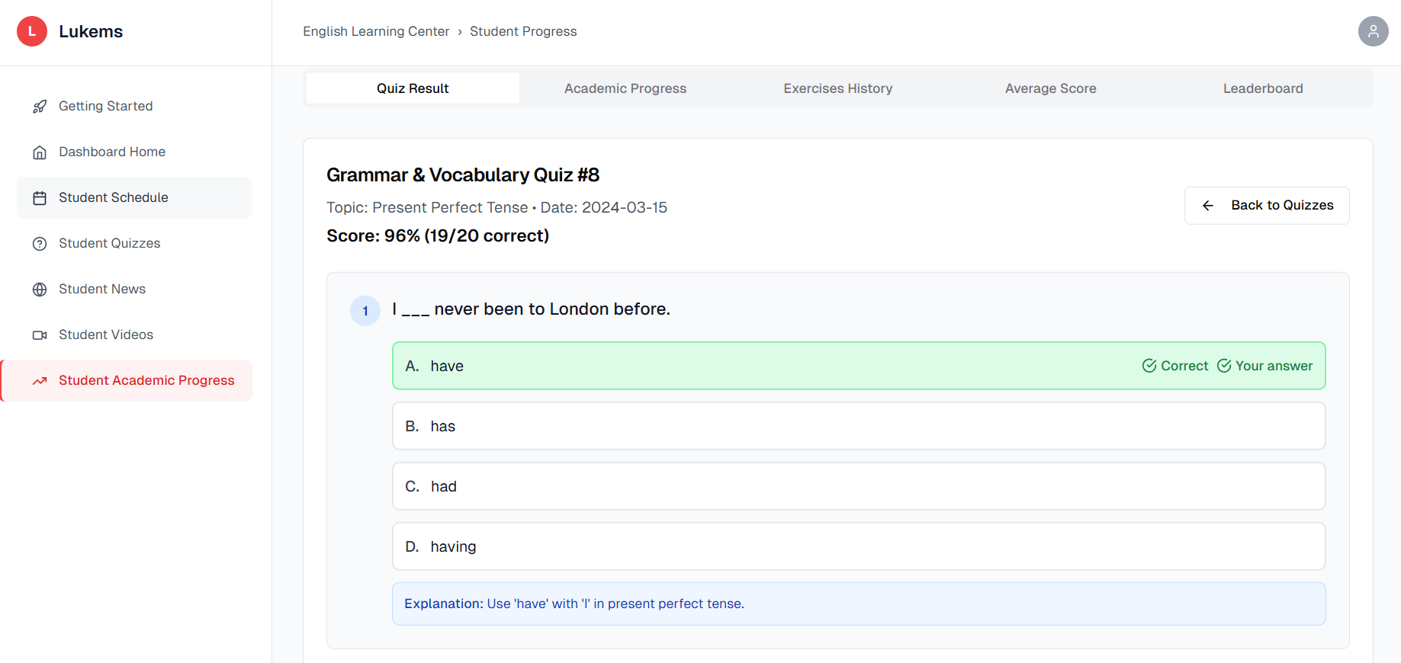

###### *Figure 73.2 -* View result each quiz

| **Screen** | | View result each quiz screen | | | | |
| --- | --- | --- | --- | --- | --- | --- |
| **Description** | | This use case allows a student to view detailed results of a completed quiz and track their academic progress across all quizzes. Students can see question-by-question breakdown, correct answers, explanations, and overall performance metrics. | | | | |
| **Screen Access** | | From the Student dashboard, click on 'View result each quiz' in the navigation menu. | | | | |
| Screen Content | | | | | | |
| **Item** | | **Type** | **Data** | | **Description** | |
| Quiz Title | | Text Label | Grammar & Vocabulary Quiz #8 | | Main quiz identifier | |
| Topic Info | | Text Label | Present Perfect Tense | | Subject matter covered | |
| Date | | Text Label | 2024-03-15 | | Quiz completion date | |
| Score | | Text Label | 96% (19/20 correct) | | Overall performance score | |
| Question Card | | Card View | Question text, options, status | | Individual question with answer choices | |
| Answer Option | | Radio Button/Card | A, B, C, D options | | Multiple choice answers | |
| Correct Indicator | | Badge/Icon | Green checkmark | | Shows correct answer | |
| Your Answer | | Badge/Icon | Green checkmark | | Shows student's selection | |
| Explanation | | Text Block | Grammar explanation | | Educational feedback | |
| Back Button | | Button | "Back to Quizzes" | | Navigation control | |
| Progress Stats | | Card View | Total quizzes, average score, best score | | Academic metrics | |
| Quiz List | | List View | Completed quiz entries | | Historical performance | |
| View Answers Button | | Button | "View Answers" | | Detailed results access | |
| Performance Badge | | Badge | Excellent/Good/Poor | | Score categorization | |
| Screen Actions | | | | | | |
| **Action Name** | **Description** | | | **Success** | | **Failure** |
| View Quiz Detail | Student clicks on a quiz to view detailed results | | | Displays quiz questions, answers, and explanations | | If quiz data cannot be loaded, display "Quiz results are temporarily unavailable. Please try again later." |
| View Answers | Student clicks "View Answers" button | | | Shows detailed question-by-question breakdown | | If session expires during viewing, redirect to login with message "Session expired. Please log in again." |
| Back to Quizzes | Student clicks "Back to Quizzes" button | | | Returns to main quiz list | | If navigation fails, display "Unable to navigate. Please refresh the page." |
| Navigate Tab | Student clicks on Academic Progress tab | | | Switches to academic progress view | | If academic progress data fails to load, display "Progress data unavailable. Contact support if issue persists." |
| Navigate Sidebar | Student clicks on sidebar menu items | | | Navigates to selected section | | If academic progress data fails to load, display "Progress data unavailable. Contact support if issue persists." |

### 3.65 UC-61.2 View average score

#### 

| **Use Case ID** | **UC 61.2** | **Use Case Name** | **View average score** |
| --- | --- | --- | --- |
| Created By | NhiBTT | Date Created | 22 May 2025 |
| Primary Actor | Student | Secondary Actor | – |
| Description | Allows the Student to view average scores across quizzes, news, videos. | | |
| Priority | Must have | | |
| Trigger | The Student navigates to the relevant section from the main menu. | | |
| Pre-conditions | The Student must be logged into the system. | | |
| Post-conditions | The system displays the requested learning or activity content. | | |
| Basic flow | 1. Students select 'View average score' from the View Academic progress screen. 2. System retrieves and displays the average score of students. 3. Students can interact with the data if applicable. | | |
| Alternative flow | If there is no content available, the system displays a message indicating this. | | |
| Exception | **AF1:** Student clicks on specific category card → System shows detailed average score data for that category  **AF2:** Student hovers over charts → System displays tooltips with specific average score data points  **AF3:** Score data unavailable → System shows error message MSG101, offers retry option  **AF4:** Student clicks on other tabs (Quiz Result, Academic Progress, etc.) → System loads corresponding tab content  **AF5:** Charts fail to load → System shows error message MSG103, displays data in alternative format **AF6:** Student refreshes page → System reloads all average score data and updates metrics | | |
| Business rules | BR-147 | | |

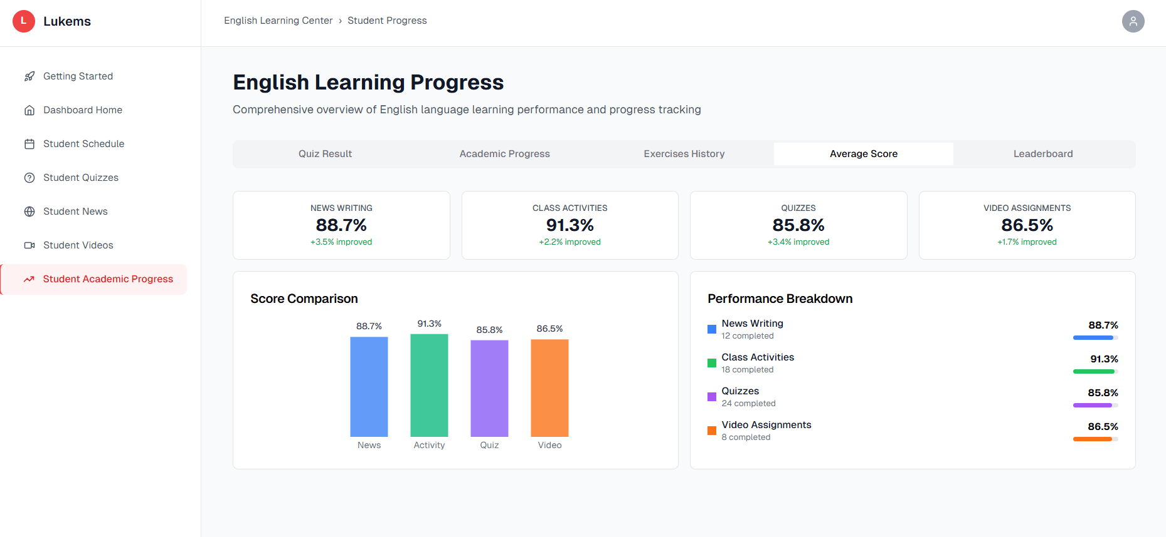

###### *Figure 74 -* View average score

| **Screen** | | View average score screen | | | | |
| --- | --- | --- | --- | --- | --- | --- |
| **Description** | | This use case allows a student to view their average scores across all English learning categories including News Writing, Class Activities, Quizzes, and Video Assignments. Students can track score improvements, compare performance across categories, and monitor their overall academic progress through average score metrics. | | | | |
| **Screen Access** | | From the Student dashboard, click on 'View average score' in the navigation menu. | | | | |
| Screen Content | | | | | | |
| **Item** | | **Type** | **Data** | | **Description** | |
| Page Header | | Text Label | "English Learning Progress" | | Main page title | |
| Page Description | | Text Label | "Comprehensive overview of English language learning performance and progress tracking" | | Page purpose description | |
| Tab Navigation | | Tab Bar | Quiz Result, Academic Progress, Exercises History, Average Score, Leaderboard | | Main navigation tabs | |
| Score Cards | | Card Grid | 4 category cards with average scores and improvement indicators | | Main score metrics | |
| News Writing Card | | Score Card | 88.7% (+5.5% improved) | | Average score for news writing activities | |
| Class Activities Card | | Score Card | 91.3% (+2.3% improved) | | Average score for class activities | |
| Quizzes Card | | Score Card | 85.8% (+4.6% improved) | | Average score for quizzes | |
| Video Assignments Card | | Score Card | 86.5% (+1.7% improved) | | Average score for video assignments | |
| Score Comparison Chart | | Bar Chart | Comparative average scores across categories | | Visual score comparison | |
| Performance Breakdown | | Horizontal Bar Chart | Detailed average score breakdown with completion counts | | Category-wise score analysis | |
| Improvement Indicators | | Badge/Icon | Green arrows with percentage | | Score improvement indicators | |
| Completion Status | | Text Label | "15 completed", "24 completed", etc. | | Activity completion counts | |
| Screen Actions | | | | | | |
| **Action Name** | **Description** | | | **Success** | | **Failure** |
| View Tab Details | Student clicks on progress tabs (Quiz Result, Academic Progress, etc.) | | | Displays specific tab content | | If tab data cannot be loaded, display "Average score data is temporarily unavailable. Please try again later." |
| View Category Detail | Student clicks on performance category cards | | | Shows detailed breakdown for selected category | | If category details fail to load, display "Category score information unavailable. Please refresh the page." |
| Navigate Chart | Student interacts with comparison charts | | | Displays data points and values | | If charts fail to render, display "Score charts are loading. Please wait or refresh if the issue persists." |
| Access Sidebar Menu | Student clicks on sidebar navigation items | | | Navigates to selected section | | If navigation is restricted, display "You don't have permission to access this section." |
| Refresh Scores | Student refreshes or reloads score data | | | Updates all average score metrics | | If server connection fails, display "Unable to update score data. Check your internet connection." |

### 3.66 UC-62 View leaderboard

#### 

| **Use Case ID** | **UC58** | **Use Case Name** | **Do quiz** |
| --- | --- | --- | --- |
| Created By | NhiBTT | Date Created | 22 May 2025 |
| Primary Actor | Student | Secondary Actor | – |
| Description | Allows the Student to view the leaderboard standings. | | |
| Priority | Must have | | |
| Trigger | The Student navigates to the relevant section from the main menu. | | |
| Pre-conditions | The Student must be logged into the system. | | |
| Post-conditions | The system displays the requested learning or activity content. | | |
| Basic flow | 1. Student selects the menu item.  2. System retrieves and shows the data.  3. Student interacts with the content. | | |
| Alternative flow | **AF1:** Student clicks on student name → System shows student profile or performance details  **AF2:** Student views trophy icons → System displays achievement level explanations  **AF3:** Leaderboard data unavailable → System shows error message MSG201, offers retry option  **AF4:** Student clicks on other tabs → System loads corresponding tab content  **AF5:** Rankings fail to load → System shows error message MSG203, displays cached data if available  **AF6:** Student refreshes page → System reloads all ranking data and updates positions | | |
| Exception | If the system fails to retrieve the data, an error message **MSG031** is shown. | | |
| Business rules | BR-148 | | |

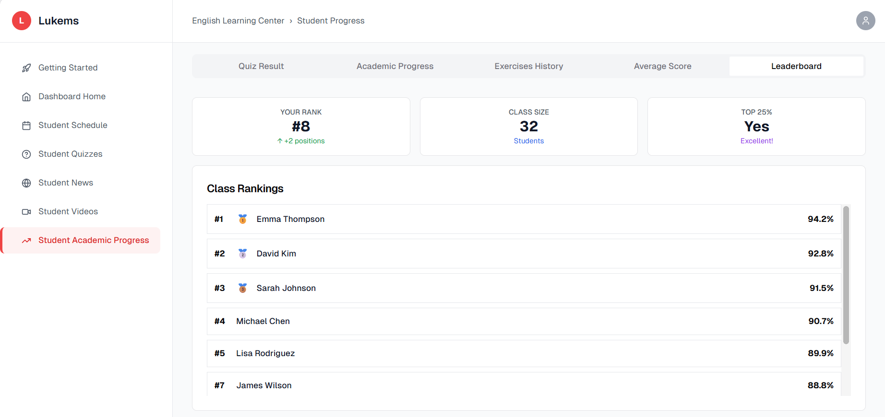

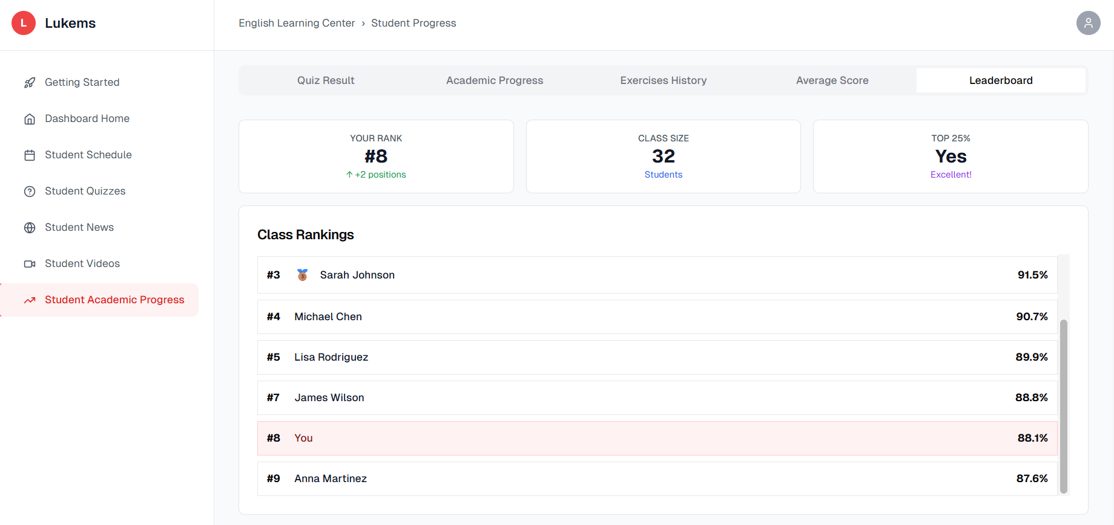

###### *Figure 75 -* View Leader board

| **Screen** | | View leaderboard screen | | | | |
| --- | --- | --- | --- | --- | --- | --- |
| **Description** | | This screen allows students to view the leaderboard standings. | | | | |
| **Screen Access** | | From the Student dashboard, click on 'View leaderboard' in the navigation menu. | | | | |
| Screen Content | | | | | | |
| **Item** | | **Type** | **Data** | | **Description** | |
| Tab Navigation | | Tab Bar | Quiz Result, Academic Progress, Exercises History, Average Score, Leaderboard | | Main navigation tabs | |
| Your Rank Card | | Stats Card | #8 with +2 positions improvement | | Current student ranking | |
| Class Size Card | | Stats Card | 32 Students | | Total number of students in class | |
| Top 25% Card | | Stats Card | Yes - Excellent! | | Top percentile achievement status | |
| Rank Position | | Number Display | #8 | | Current ranking position | |
| Position Change | | Badge/Icon | +2 positions (green arrow) | | Ranking improvement indicator | |
| Class Size | | Number Display | 32 | | Total students count | |
| Students Label | | Text Label | Students | | Class size descriptor | |
| Top 25% Status | | Text Label | "Yes" | | Top percentile indicator | |
| Performance Badge | | Badge | "Excellent!" | | Achievement level indicator | |
| Class Rankings Header | | Text Label | "Class Rankings" | | Rankings section title | |
| Ranking List | | List View | Student entries with rank, name, and score | | Detailed class rankings | |
| Rank Number | | Number Badge | #1, #2, #3, etc. | | Position indicators | |
| Student Name | | Text Label | Emma Thompson, David Kim, etc. | | Student names | |
| Trophy Icons | | Icon | Gold, Silver, Bronze trophies | | Achievement indicators for top 3 | |
| Score Display | | Percentage | 94.2%, 92.8%, 91.5%, etc. | | Student performance scores |  |
| Screen Actions | | | | | | |
| **Action Name** | **Description** | | | **Success** | | **Failure** |
| View Tab Details | Student clicks on progress tabs (Quiz Result, Academic Progress, etc.) | | | Displays specific tab content | | If leaderboard data cannot be loaded, display "Leaderboard is temporarily unavailable. Please try again later." |
| View Student Profile | Student clicks on student name in rankings | | | Shows detailed student profile | | If student profile details fail to load, display "Student profile information unavailable. Please refresh the page." |
| Refresh Rankings | Student refreshes or reloads leaderboard data | | | Updates all ranking metrics | | If server connection fails, display "Unable to update rankings. Check your internet connection." |
| Access Sidebar Menu | Student clicks on sidebar navigation items | | | Navigates to selected section | | If navigation is restricted, display "You don't have permission to access this section." |
| Sort Rankings | Student interacts with ranking list | | | Displays sorted ranking data | | If sorting fails, display "Unable to sort rankings. Please refresh the page." |

### 3.67 UC-63 View notifications

#### 

| **Use Case ID** | **UC63** | **Use Case Name** | **View notifications** |
| --- | --- | --- | --- |
| Created By | NhiBTT | Date Created | 22 May 2025 |
| Primary Actor | Student | Secondary Actor | – |
| Description | Allows the Student to view system notifications. | | |
| Priority | Must have | | |
| Trigger | The Student navigates to the relevant section from the main menu. | | |
| Pre-conditions | The Student must be logged into the system. | | |
| Post-conditions | The system displays the requested learning or activity content. | | |
| Basic flow | 1. Students select 'Notification' from the main menu. 2. System retrieves and displays notification from system. 3. Students can interact with the data if applicable. | | |
| Alternative flow | If there is no content available, the system displays a message indicating this. | | |
| Exception | If the system fails to retrieve the data, an error message **MSG032** or **MSG033** is shown. | | |
| Business rules | BR-149 | | |

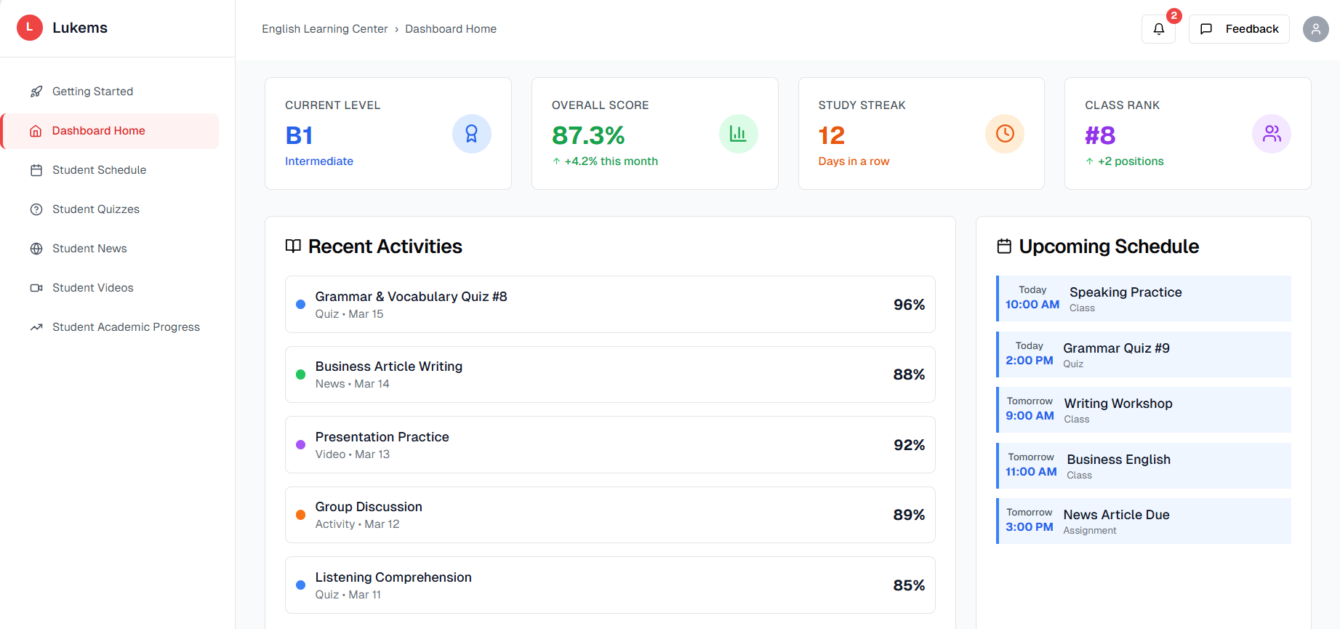

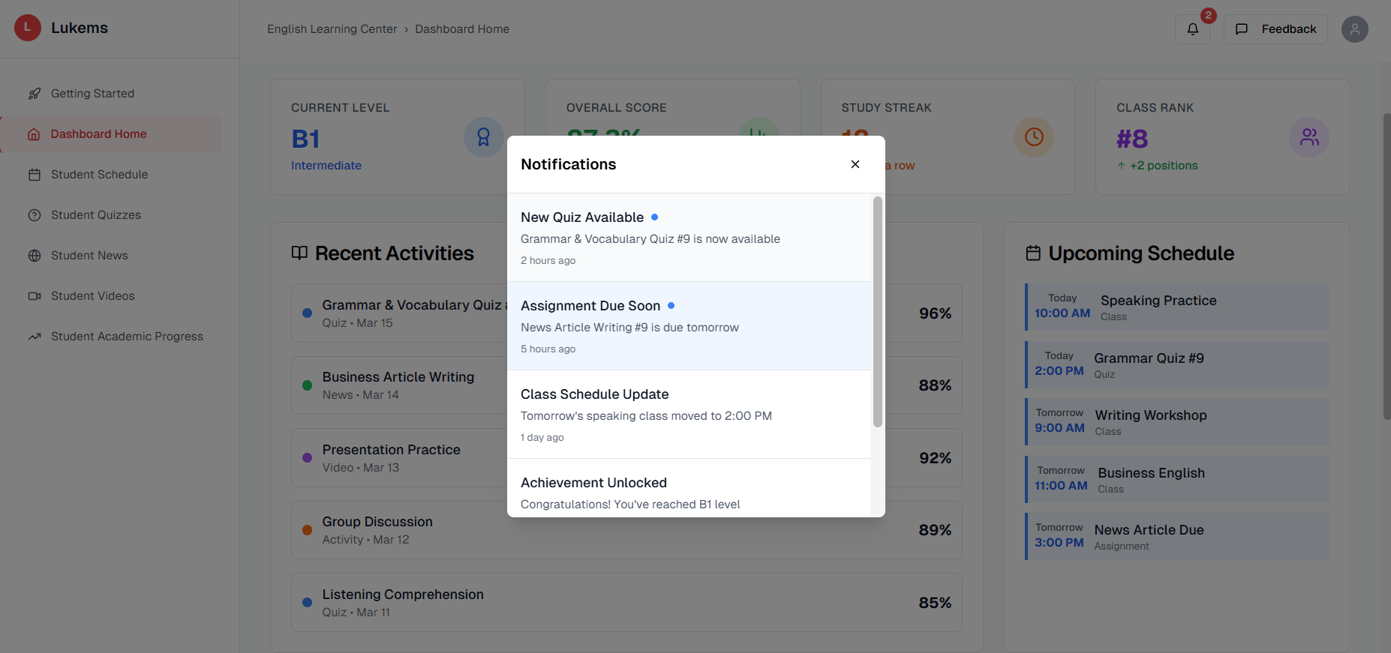

###### *Figure 76 -* View notifications

| Screen | | View notifications screen | | | | |
| --- | --- | --- | --- | --- | --- | --- |
| Description | | This screen allows students to view system notifications. | | | | |
| Screen Access | | From the Student dashboard, click on 'View notifications' in the navigation menu. | | | | |
| Screen Content | | | | | | |
| Item | | Type | Data | | Description | |
| Notification list | | Table | Message, Date | | Displays all notifications. | |
| Screen Actions | | | | | | |
| **Action Name** | **Description** | | | **Success** | | **Failure** |
| View Notifications | Displays all system notifications. | | | Notifications are listed. | | Error fetching notifications. |

### 3.68 UC-64 View course feedback

#### 

| **Use Case ID** | **UC64** | **Use Case Name** | **View course feedback** |
| --- | --- | --- | --- |
| Created By | NhiBTT | Date Created | 22 May 2025 |
| Primary Actor | Student | Secondary Actor | – |
| Description | Allows the Student to view feedback received for the course/coach/ted team. | | |
| Priority | Must have | | |
| Trigger | The Student navigates to the relevant section from the main menu. | | |
| Pre-conditions | The Student must be logged into the system. | | |
| Post-conditions | The system displays the requested learning or activity content. | | |
| Basic flow | 1. Students select 'Course feedback' from the main menu. 2. System retrieves and displays all feedback. 3. Students can interact with the data if applicable. | | |
| Alternative flow | If there is no content available, the system displays a message indicating this. | | |
| Exception | If the system fails to retrieve the data, an error message **MSG034** is shown. | | |
| Business rules | BR-150 | | |

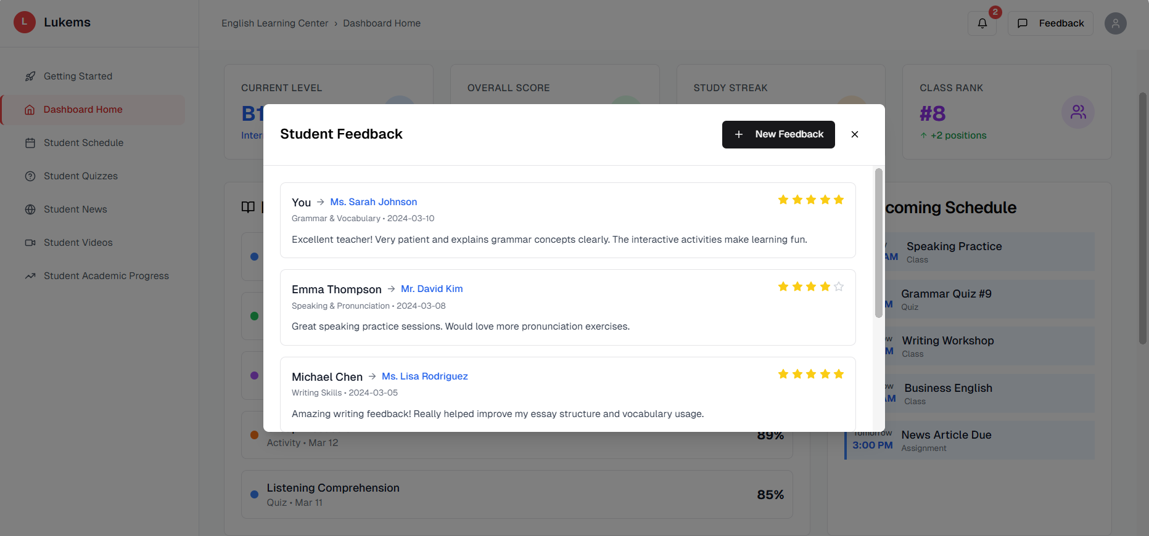

###### *Figure 77 -* View feedback

| **Screen** | | View course feedback screen | | | | |
| --- | --- | --- | --- | --- | --- | --- |
| **Description** | | This screen allows students to view feedback received for the course/coach/ted team. | | | | |
| **Screen Access** | | From the Student dashboard, click on 'View course feedback' in the navigation menu. | | | | |
| Screen Content | | | | | | |
| **Item** | | **Type** | **Data** | | **Description** | |
| Feedback list | | Table | name, content, date | | Displays all feedback. | |
| Screen Actions | | | | | | |
| **Action Name** | **Description** | | | **Success** | | **Failure** |
| View feedback | Display all feedback. | | | Displayed successfully. | | Error retrieving question. |

### 3.68 UC-65 Do feedback

#### 

| **Use Case ID** | **UC65** | **Use Case Name** | **Do feedback** |
| --- | --- | --- | --- |
| Created By | NhiBTT | Date Created | 22 May 2025 |
| Primary Actor | Student | Secondary Actor | – |
| Description | Allows the Student to give a feedback on the course/coach/ted team. | | |
| Priority | Must have | | |
| Trigger | The Student navigates to the relevant section from the main menu. | | |
| Pre-conditions | The Student must be logged into the system. | | |
| Post-conditions | The system displays the requested learning or activity content. | | |
| Basic flow | 1. Students select 'Do feedback' from the View course feedback.  2. System retrieves and displays a form.  3. Students can interact with the data if applicable. | | |
| Alternative flow | If there is no content available, the system displays a message indicating this. | | |
| Exception | If the system fails to retrieve the data, an error message **MSG035** is shown. For submission failures, **MSG036** is displayed | | |
| Business rules | BR-151 | | |

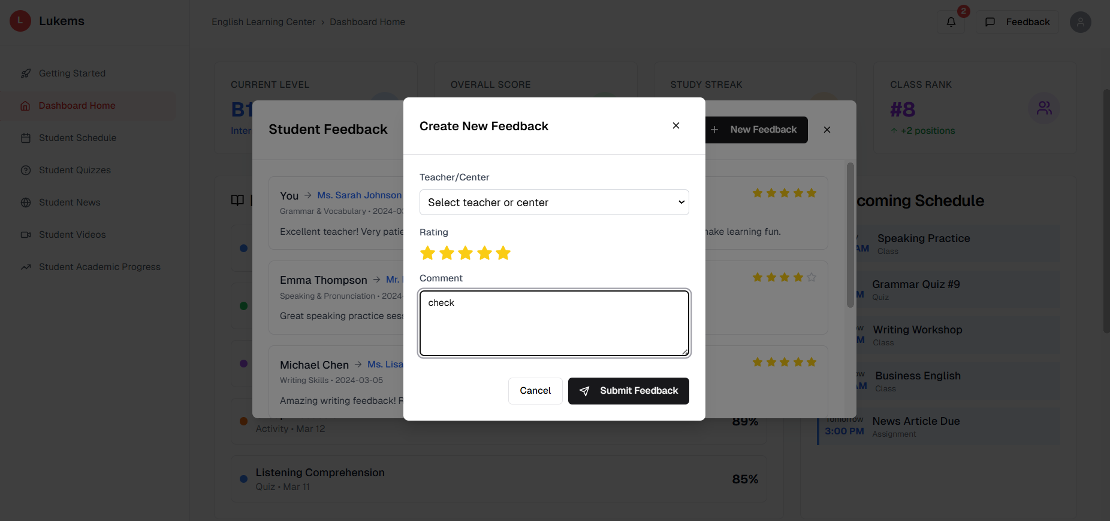

###### *Figure 78 -* Do feedback

| **Screen** | | View course feedback | | | | |
| --- | --- | --- | --- | --- | --- | --- |
| **Description** | | This screen allows students to give feedback on the course/coach/ted team. | | | | |
| **Screen Access** | | From the Student dashboard, click on 'Do feedback' in the navigation menu. | | | | |
| Screen Content | | | | | | |
| **Item** | | **Type** | **Data** | | **Description** | |
| Feedback form | | Form | Rating, Text Input | | Form to collect student feedback. | |
| Submit button | | Button |  | | Submits the feedback to the system. | |
| Rating stars | | Rating stars | 1-5 | | Allows students to rate the course/coach. | |
| Comment box | | Text Area | Text Area | | Students provide detailed feedback. | |
| Screen Actions | | | | | | |
| **Action Name** | **Description** | | | **Success** | | **Failure** |
| Fill Feedback | Student opens feedback form. | | | Form loads with questions. | | Form fails to open. |
| Submit Feedback | Submit a filled feedback form. | | | Feedback is saved. | | Submission fails. |

### 3.69 UC-66 View learning materials

#### 

| **Use Case ID** | **UC66** | **Use Case Name** | **View Learning Materials** |
| --- | --- | --- | --- |
| Created By | PhuongLDA | Date Created | 22 May 2025 |
| Primary Actor | Student | Secondary Actor | – Coach |
| Description | Allows users (Students and Coaches) to view available learning materials such as PDFs, DOCs, and other file types along with related information. | | |
| Priority | Must have | | |
| Trigger | The user selects the "Learning Materials" section from the main menu. | | |
| Pre-conditions | The user must be logged into the system with the appropriate role (Student or Coach). | | |
| Post-conditions | The system displays a list of learning materials with actions and metadata (title, description, category, etc.). | | |
| Basic flow | 1. The user logs into the system successfully.  2. The user navigates to the Learning Materials section from the main menu.  3. The system displays a list of materials in a card/grid layout.  4. Each card contains:  File type (e.g., PDF, DOC)  Title, Description  Category  Date, Size  5. Actions: View, Download (and Edit if Coach)  6. The user may use the search bar or filters (e.g., by subject or category) to refine the list. | | |
| Alternative flow | If the list exceeds the page length, pagination or infinite scroll will allow the user to navigate to additional materials.  If the user is a Coach, they will also see Edit options for each material item. | | |
| Exception | If the system fails to retrieve materials, error message **MSG078** is displayed: "Unable to load materials. Please try again later."  If the user is not authenticated, they will be redirected to the login screen with message **MSG052**. | | |
| Business rules | BR-170, BR-171, BR-172 | | |

|  | View Learning Materials | | |
| --- | --- | --- | --- |
| **Description** | This screen allows students and coaches to view available learning materials such as PDFs, DOCs, videos, and other educational resources. | | |
| **Screen Access** | From the dashboard, click on **"Learning Materials"** in the navigation menu. | | |
| Screen Content | | | |
| **Item** | **Type** | **Data** | **Description** |
| Materials List | Title, Description, File Type, Date, Size | Displays available learning materials in a grid or list layout. | Title, Description, File Type, Date, Size |
| File Type Icon | PDF, DOC, MP4, etc. | Indicates the type of each file. | PDF, DOC, MP4, etc. |
| Search Bar | Text | Allows user to search materials by keyword. | Text |
| Filter | Dropdown | Subject, Category | Dropdown |
| View Button | Button | - | Button |
| Download Button | Button | - | Button |
| Screen Actions | | | |
| **Action Name** | **Description** | | **Failure** |
| Load Materials List | User navigates to Learning Materials section | List of materials is displayed in UI | Error loading list / no materials shown |
| Search Materials | User types keyword in search bar | Filtered materials displayed | No results found or search not responding |
| Filter Materials | User selects category or subject filter | Filtered list by selected criteria | Filter fails to apply or returns nothing |
| View Material | User clicks on "View" button | Material opens in new tab | Material fails to open / access denied |
| Download Material | User clicks on "Download" button | File downloaded successfully | Download fails or file missing |

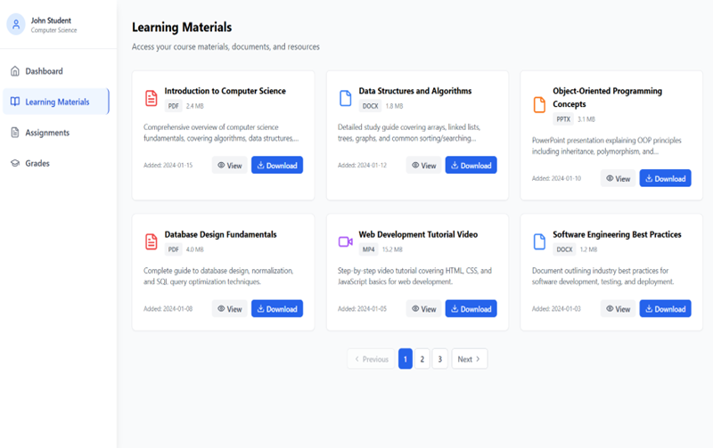

###### *Figure 15 - View Learning Materials*

### 3.70 UC-67 View personal schedule

#### 

| **Use Case ID** | **UC67** | **Use Case Name** | **View personal schedule** |
| --- | --- | --- | --- |
| Created By | AnhLTK | Date Created | 22 May 2025 |
| Primary Actor | Ted Team | Secondary Actor | – |
| Description | Allows the Ted Team to view their personal schedule in the LUKEMS system. | | |
| Priority | Must have | | |
| Trigger | The Ted Team selects the "View personal schedule" option from the main menu | | |
| Pre-conditions | The Ted Team must be logged into the system. | | |
| Post-conditions | The system displays the Ted Team's personal schedule | | |
| Basic flow | 1. The Ted Team selects "View personal schedule" from the main menu  2. The system displays the Ted Team's personal teaching schedule with class details | | |
| Alternative flow | If there is no schedule data, the system will display a message indicating no schedule is available | | |
| Exception | If the system fails to retrieve the schedule data, error message **MSG037** is displayed. For download-related issues, **MSG038** is shown. | | |
| Business rules | BR-102, BR-103, BR-104 | | |

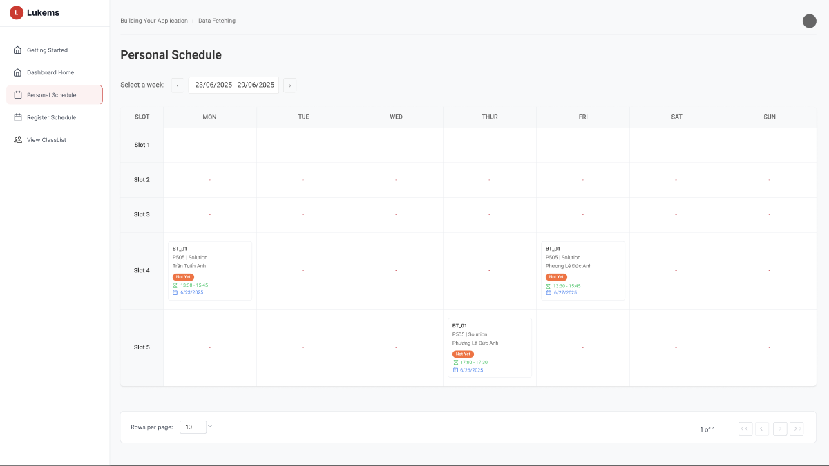

###### *Figure 80 -* View personal schedule

| **Screen** | | User personal schedule page | | | | |
| --- | --- | --- | --- | --- | --- | --- |
| **Description** | | Allows the Ted Team to view their personal teaching schedule. | | | | |
| **Screen Access** | | From the Ted Team's homepage, click the "View personal schedule" button on the main menu. | | | | |
| Screen Content | | | | | | |
| **Item** | | **Type** | **Data** | | **Description** | |
| Schedule list | | Table | Class Date, Time, Class Code, Room, Status | | Displays a list of all scheduled classes with relevant information including BT-01, BT-J1 classes with dates, times, and room assignments | |
| Week selector | | Dropdown | Date range | | Allows selecting specific week to view schedule | |
| Time slots | | Labels | Slot 1-5 | | Shows different time periods throughout the day | |
| Day columns | | Headers | MON, TUE, WED, THUR, FRI, SAT, SUN | | Displays days of the week for schedule layout | |
| Class blocks | | Elements | BT-01, BT-J1 with room and time info | | Individual class entries showing in schedule grid | |
| Screen Actions | | | | | | |
| **Action Name** | **Description** | | | **Success** | | **Failure** |
| View Schedule List | The system automatically loads the list of classes when the page is opened | | | The table is populated with schedule data showing classes like BT-01, BT-J1 with times and locations | | An error message is displayed, indicating that the schedule data could not be loaded |
| Filter by Date Range | Allows Ted Team to filter schedule by specific date range using week selector | | | The schedule is updated to show only classes within the selected date range | | A "No results found" message is shown if no classes match the filter |

### 

### 3.71 UC-68 Register work schedule

#### 

| **Use Case ID** | **UC68** | **Use Case Name** | **Register work schedule** |
| --- | --- | --- | --- |
| Created By | AnhLTK | Date Created | 22 May 2025 |
| Primary Actor | Ted Team | Secondary Actor | – |
| Description | Allows Ted Team members to register their availability and preferred work schedule in the LUKEMS system for scheduling purposes. | | |
| Priority | Must have | | |
| Trigger | The Ted Team member selects the 'Register work schedule' option from the dashboard. | | |
| Pre-conditions | The Ted Team member must be logged into the system and have appropriate permissions to modify schedule preferences. | | |
| Post-conditions | The system saves the work schedule preferences and updates the member's availability profile. | | |
| Basic flow | 1. Ted Team member selects the 'Register work schedule' option from the dashboard.  2. The system displays a schedule registration form with time slots and availability options.  3. Ted Team member fills in their preferred working hours, days, and any constraints.  4. The system validates the input and saves the schedule preferences.  5. Confirmation message is displayed with the registered schedule summary. | | |
| Alternative flow | If there are scheduling conflicts or validation errors, the system will highlight the issues and allow the user to make corrections before saving. | | |
| Exception | If the database connection is lost during submission, the system displays error message **MSG038** to notify the user. | | |
| Business rules | BR-105, BR-106, BR-107 | | |

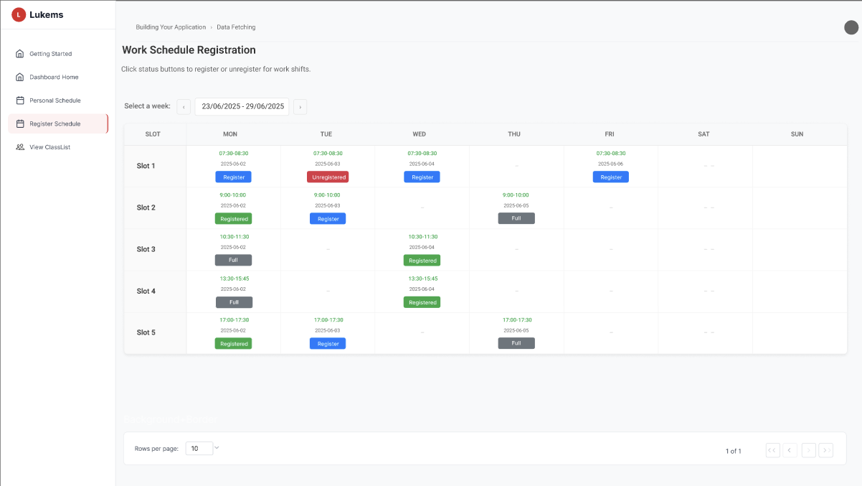

###### *Figure 81 -* Register work schedule

| **Screen** | | Work schedule registration page | | | | |
| --- | --- | --- | --- | --- | --- | --- |
| **Description** | | Allows the Ted Team to register their available work schedule | | | | |
| **Screen Access** | | From the Ted Team's homepage, click the "Register work schedule" button on the main menu | | | | |
| Screen Content | | | | | | |
| **Item** | | **Type** | **Data** | | **Description** | |
| Schedule grid | | Table | Time slots, Days, Status buttons | | Displays weekly schedule with time slots (Slot 1-5) and days (MON-SUN) for work shift registration | |
| Week selector | | Dropdown | Date range | | Allows selecting specific week to register work shifts | |
| Time slots | | Labels | MON, TUE, WED, THU, FRI, SAT, SUN | | Displays days of the week for schedule layout | |
| Status buttons | | Buttons | Register, Unregister, Registered, Full | | Interactive buttons for registering/unregistering shifts with different states | |
| Time labels | | Text | Various time ranges (07:30-08:30, 08:00-10:00, etc.) | | Shows specific time periods for each slot | |
| Screen Actions | | | | | | |
| **Action Name** | **Description** | | | **Success** | | **Failure** |
| Register for Shift | Allows staff to click "Register" button to sign up for available work shifts | | | Button changes to "Registered" status and shift is booked for the user | | Error message appears indicating registration failed |
| Unregister from Shift | Allows staff to click "Unregister" button to remove themselves from registered shifts | | | Button changes back to "Register" status and shift becomes available | | Error message appears indicating unregistration failed |
| View Schedule Grid | System loads the weekly schedule grid showing all available shifts and their status | | | Grid displays with current registration status for all time slots | | Error message displays indicating schedule data cannot be loaded |
| Change Week | Allows user to select different week using dropdown selector | | | Schedule updates to show selected week's shift availability | | Error message if selected week data cannot be retrieved |

### 

### 3.72 UC-69 Cancel register work schedule

#### 

| **Use Case ID** | **UC69** | **Use Case Name** | **Cancel register work schedule** |
| --- | --- | --- | --- |
| Created By | AnhLTK | Date Created | 22 May 2025 |
| Primary Actor | Ted Team | Secondary Actor | – |
| Description | Allows the Ted Team to cancel their previously registered work schedule in the LUKEMS system | | |
| Priority | Should have | | |
| Trigger | The Ted Team selects the "Cancel register work schedule" option from the register work schedule page. | | |
| Pre-conditions | The Ted Team must be logged into the system and have a registered work schedule | | |
| Post-conditions | The system removes the Ted Team's work schedule registration. | | |
| Basic flow | 1. The Ted Team accesses their registered work schedule  2. The Ted Team selects " Unregister" | | |
| Alternative flow | If the Ted Team chooses not to confirm, the cancellation is aborted and the schedule remains. | | |
| Exception | If the user does not confirm the cancellation, error message **MSG039** is shown and no changes are applied. | | |
| Business rules | BR-108, BR-109, BR-110 | | |

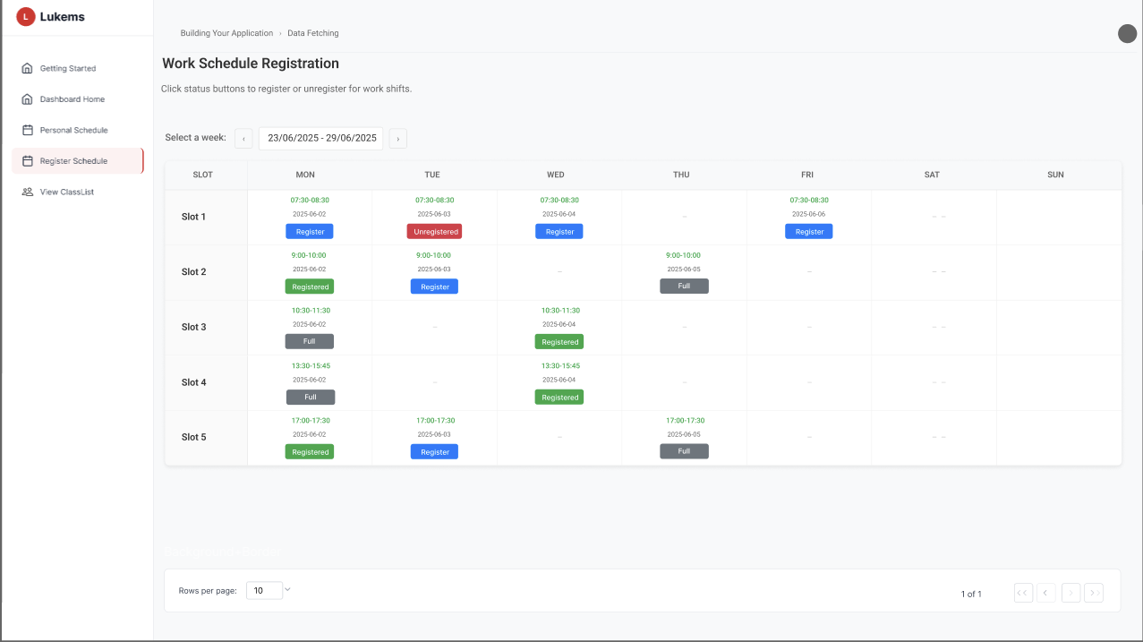

###### *Figure 82 - Cancel* register work schedule

| **Screen** | | Cancel work schedule page | | | | |
| --- | --- | --- | --- | --- | --- | --- |
| **Description** | | Allows the Ted Team to cancel their registered work schedule | | | | |
| **Screen Access** | | Confirmation interface showing current schedule and cancellation options | | | | |
| Screen Content | | | | | | |
| **Item** | | **Type** | **Data** | | **Description** | |
| Current Schedule Display | | Table | Existing registered schedule details | | Shows the currently registered work schedule with all time slots, preferences, and constraints clearly displayed for review | |
| Confirmation dialog | | Modal | Confirmation message | | Asks for confirmation before cancelling a registered slot | |
| Cancel button | | Button |  | | Cancels the selected work schedule and changes the status back to **Register (blue)** | |
| Keep schedule button | | Button |  | | Aborts cancellation and keeps the current registered status | |
| Screen Actions | | | | | | |
| **Action Name** | **Description** | | | **Success** | | **Failure** |
| View Current Schedule | The system displays the registered work schedule | | | The schedule is shown with all registered time slots | | An error message is displayed indicating the schedule cannot be loaded |
| Confirm Cancellation | The Ted Team confirms cancellation by clicking the red button | | | The slot is cancelled and reverts to **Register (blue button)** status | | An error message is shown and the slot remains registered |
| Abort Cancellation | The Ted Team chooses to keep the current schedule | | | The dialog closes and no changes are made | | The dialog remains open, and an error is shown if abort fails |

### 

### 3.73 UC-70 Checkin self

#### 

| **Use Case ID** | **UC70** | **Use Case Name** | **Checkin self** |
| --- | --- | --- | --- |
| Created By | AnhLTK | Date Created | 23 May 2025 |
| Primary Actor | Ted Team | Secondary Actor | – |
| Description | Automatically records Ted Team's attendance when they start their registered work shift in the LUKEMS system | | |
| Priority | Must have | | |
| Trigger | Ted Team logs into the system during their registered work shift time | | |
| Pre-conditions | Ted Team must have registered work shifts and logs into the system during shift time | | |
| Post-conditions | The system records Ted Team's work shift attendance with timestamp | | |
| Basic flow | 1. Ted Team logs into the LUKEMS system  2. System checks Ted Team's registered work shift schedule  3. System verifies current time is within Ted Team's work shift period  4. System automatically records Ted Team's attendance with timestamp  5. System confirms work shift check-in is completed and displays confirmation | | |
| Alternative flow | If Ted Team has no registered work shift at current time, the system displays an appropriate message | | |
| Exception | If there is a system time error during check-in, the system displays error message **MSG040** to prevent invalid records. | | |
| Business rules | BR-111, BR-112, BR-113 | | |

### 

### 3.74 UC-71 View assignment progress of students

#### 

| **Use Case ID** | **UC71** | **Use Case Name** | **View assignment progress of students** |
| --- | --- | --- | --- |
| Created By | AnhLTK | Date Created | 23 May 2025 |
| Primary Actor | Ted Team | Secondary Actor | – |
| Description | Allows the Ted Team to view the assignment progress of students in their classes within the LUKEMS system | | |
| Priority | Must have | | |
| Trigger | The Ted Team selects the "View assignment progress of students" option from the view classlist | | |
| Pre-conditions | The Ted Team must be logged into the system and have assigned classes with students | | |
| Post-conditions | The system displays the assignment progress of students | | |
| Basic flow | 1. The Ted Team selects "view classlist" from the main menu  2. The system displays a list of classes  3. The Ted Team selects a specific class  4. The system shows assignment progress for students in that class | | |
| Alternative flow | If there are no assignments or students, the system displays an appropriate message | | |
| Exception | If assignment data cannot be retrieved due to integration error, error message **MSG041** is shown to the user. | | |
| Business rules | BR-114, BR-115, BR-116 | | |

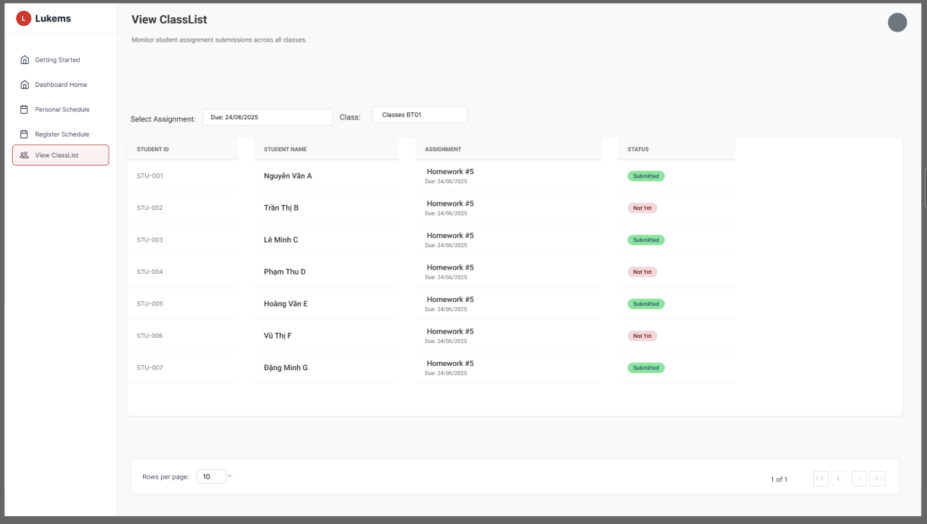

###### *Figure 83 -* View assignment progress of students

| **Screen** | | Student assignment progress page | | | | |
| --- | --- | --- | --- | --- | --- | --- |
| **Description** | | Allows Ted Team to view assignment submission progress and status of students in their classes | | | | |
| **Screen Access** | | From the Ted Team's homepage, click "View ClassList" menu, then select a class, then click on assignment to view student progress | | | | |
| Screen Content | | | | | | |
| **Item** | | **Type** | **Data** | | **Description** | |
| Class selector | | Tab | Class list | | Allows selection of specific class to view (accessed from ClassList menu) | |
| Assignment selector | | Dropdown/Button | Assignment name, Due date | | Allows selection of specific assignment to monitor progress | |
| Student progress table | | Table | Student ID, Student name, Assignment status, Due date | | Displays detailed progress information for each student in the selected assignment | |
| Filter options | | Button | All, Completed, Pending, Overdue | | Filters assignments by completion status | |
| Screen Actions | | | | | | |
| **Action Name** | **Description** | | | **Success** | | **Failure** |
| Select Class | Ted Team selects a class from the ClassList, then chooses an assignment | | | The student list and assignment progress are loaded for the selected class and assignment | | An error message is displayed stating assignment data cannot be loaded |
| Filter Progress | Ted Team applies filters by specific assignment completion status | | | The table is updated to show only assignments matching the filter criteria | | A "No results found" message is shown if no assignments match the filter |

### 

### 3.75 UC-72 Send reminder

#### 

| **Use Case ID** | **UC72** | **Use Case Name** | **Send reminder** |
| --- | --- | --- | --- |
| Created By | AnhLTK | Date Created | 23 May 2025 |
| Primary Actor | Ted Team | Secondary Actor | – |
| Description | Allows the Ted Team to send reminders to students about assignments, classes, or other important information through the LUKEMS system directly from the ClassList view | | |
| Priority | Should have | | |
| Trigger | The Ted Team selects students and clicks the "Send reminder" button from the ClassList assignment view | | |
| Pre-conditions | The Ted Team must be logged into the system and have students in their classes with assignments | | |
| Post-conditions | The system sends reminder notifications to selected students | | |
| Basic flow | 1. The Ted Team accesses the ClassList view from the navigation menu  2. The Ted Team selects an assignment from the dropdown filter  3. The system displays the list of students with their assignment submission status  4. The Ted Team selects recipient students using individual checkboxes or "Select All"  5. The Ted Team clicks "Send Reminder" button (individual or bulk)  6. The system sends the reminder to selected students | | |
| Alternative flow | If no students are selected for bulk reminder, the system disables the bulk send button and shows "0 students selected" | | |
| Exception | If the email or notification service is unavailable, the system displays error message **MSG042** to inform failure. | | |
| Business rules | BR-117, BR-118, BR-119 | | |

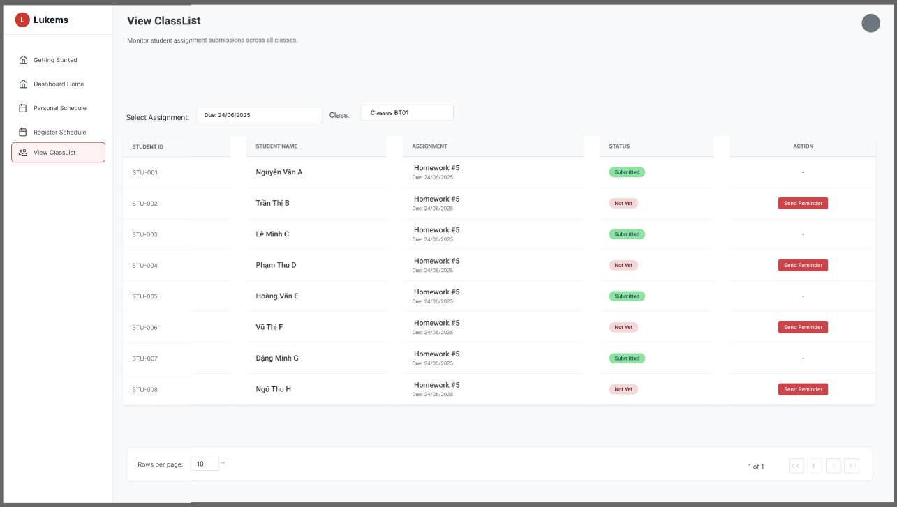

###### *Figure 84 - Send reminder*

| **Screen** | | Send reminder page | | | | |
| --- | --- | --- | --- | --- | --- | --- |
| **Description** | | Allows the Ted Team to send reminders to students | | | | |
| **Screen Access** | | From the assignment progress page, click the "Send reminder" button | | | | |
| Screen Content | | | | | | |
| **Item** | | **Type** | **Data** | | **Description** | |
| Assignment filter | | Dropdown | Assignment names | | Allows selection of assignments to view student submission status | |
| Student list | | Table | Student data with status | | Shows student ID, name, assignment info, and submission status | |
| Individual reminder | | Button |  | | Sends reminder to specific student (only visible for "Not Yet" status) | |
| Bulk selection | | Checkbox | Student IDs | | Allows selection of multiple students for bulk reminder | |
| Bulk reminder | | Button |  | | Sends reminder to all selected students | |
| Select All | | Checkbox |  | | Selects/deselects all students in the list | |
| Status indicator | | Badge | Submission status | | Shows "Submitted" or "Not Yet" status for each student | |
| Screen Actions | | | | | | |
| **Action Name** | **Description** | | | **Success** | | **Failure** |
| Select Assignment | The Ted Team selects an assignment from dropdown | | | The student list updates to show submission status for selected assignment | | Error message if assignment data cannot be loaded |
| Select Students | The Ted Team selects students using checkboxes | | | The selected students are highlighted and bulk action counter is updated | | Checkbox selection fails to register |
| Send Individual Reminder | The Ted Team clicks "Send Reminder" for a specific student | | | The reminder is sent, button shows "Sent" status with green color | | Error message shows that the reminder could not be sent |
| Send Bulk Reminder | The Ted Team clicks "Send Reminder to Selected Students" | | | Reminders are sent to all selected students, success notification is displayed | | Error message shows that bulk reminder failed |
| Select All | The Ted Team clicks "Select All" checkbox | | | All students are selected and bulk actions are enabled | | Selection fails or partial selection occurs |

### 

### 3.76 UC-73 View class list

#### 

| **Use Case ID** | **UC73** | **Use Case Name** | **View class list** |
| --- | --- | --- | --- |
| Created By | AnhLTK | Date Created | 23 May 2025 |
| Primary Actor | Ted Team | Secondary Actor | – |
| Description | Allows the Ted Team to view a list of all classes they are assigned to teach in the LUKEMS system | | |
| Priority | Must have | | |
| Trigger | The Ted Team selects "View ClassList" from the sidebar navigation menu | | |
| Pre-conditions | The Ted Team must be logged into the LUKEMS system | | |
| Post-conditions | The system displays the list of classes assigned to the Ted Team with comprehensive class information | | |
| Basic flow | 1. The Ted Team selects "View ClassList" from the main navigation menu  2. The system displays all classes assigned to the Ted Team in a grid layout  3. The Ted Team can view class details including name, date, and status  4. The Ted Team can access additional functions like "View Quiz" and "View Assignment"  5.The Ted Team can search for specific classes using the search field | | |
| Alternative flow | If no classes are assigned to the Ted Team, the system displays a message indicating no classes are available | | |
| Exception | If class data synchronization fails, the system displays error message **MSG043** and no class list is shown | | |
| Business rules | BR-120, BR-121, BR-122 | | |

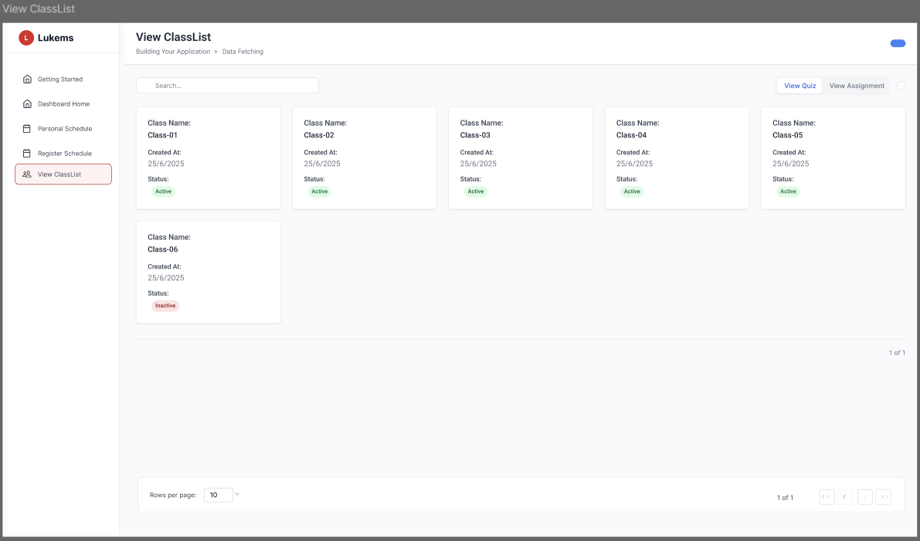

###### *Figure 85 -* View classlist

| **Screen** | | Class list page | | | | |
| --- | --- | --- | --- | --- | --- | --- |
| **Description** | | Allows the Ted Team to view all their assigned classes with comprehensive class information | | | | |
| **Screen Access** | | From the sidebar navigation, click "View ClassList" option | | | | |
| Screen Content | | | | | | |
| **Item** | | **Type** | **Data** | | **Description** | |
| Class Grid | | Card Layout | Class code, Class name, Schedule, Number of students | | Displays comprehensive information about each class | |
| Class Status | | Badge | Active, Inactive | | Visual indicator of class availability | |
| Creation Date | | Date Field | 25/6/2025 format | | Shows when each class was established | |
| Action Buttons | | Button Group | View Quiz, View Assignment | | Provides quick access to class-related functions | |
| Screen Actions | | | | | | |
| **Action Name** | **Description** | | | **Success** | | **Failure** |
| Load Class List | The system automatically loads all assigned classes when page opens | | | The class grid is populated with current class assignments showing Class-01 through Class-06 | | An error message is displayed indicating classes cannot be loaded |
| Search Classes | The Ted Team searches for specific classes using the search field | | | The grid is filtered to show only classes matching the search criteria | | A "No results found" message appears if no classes match the search |
| View Class Details | The Ted Team clicks on a class card to view detailed information | | | The detailed class information page opens successfully | | An error message shows that class details cannot be accessed |
| Access Quiz Function | The Ted Team clicks "View Quiz" button | | | Quiz management interface opens for the selected classes | | Error message indicates quiz function is not available |
| Access Assignment Function | The Ted Team clicks "View Assignment" button | | | Assignment management interface opens for the selected classes | | Error message indicates assignment function is not available |
| Navigate Pages | The Ted Team uses pagination controls to navigate through multiple class pages | | | Page navigation works smoothly showing different sets of classes | | Navigation fails and current page remains unchanged |

### 

### 3.77 UC-74 Check student

#### 

| **Use Case ID** | **UC74** | **Use Case Name** | **Check student** |
| --- | --- | --- | --- |
| Created By | AnhLTK | Date Created | 23 May 2025 |
| Primary Actor | Ted Team | Secondary Actor | – |
| Description | Allows the Ted Team to take attendance and monitor student presence for today's classes through the LUKEMS system | | |
| Priority | Must have | | |
| Trigger | The Ted Team selects "View ClassList" from the navigation menu and accesses the attendance check feature | | |
| Pre-conditions | The Ted Team must be logged into the LUKEMS system  A class must be selected (e.g., Classes B101)  The session date and time must be set (e.g., 06/29/2025, Morning 06:00-12:00) | | |
| Post-conditions | The system displays comprehensive student attendance information  Attendance status can be updated and saved  Student presence is monitored and recorded | | |
| Basic flow | 1. The Ted Team accesses the "View ClassList" option from the sidebar  2. The system displays the Attendance Check interface  3. The Ted Team selects class, date, and session  4. The system loads and displays the student list with current attendance status  5. The Ted Team can view individual student details and update attendance  6. The system saves attendance data when "Save Attendance" is clicked | | |
| Alternative flow | If no students are enrolled in the selected class, the system displays a message "No students found for this class and session" | | |
| Exception | If attendance data cannot be processed correctly, error message **MSG044** is displayed. | | |
| Business rules | BR-123, BR-124, BR-125 | | |

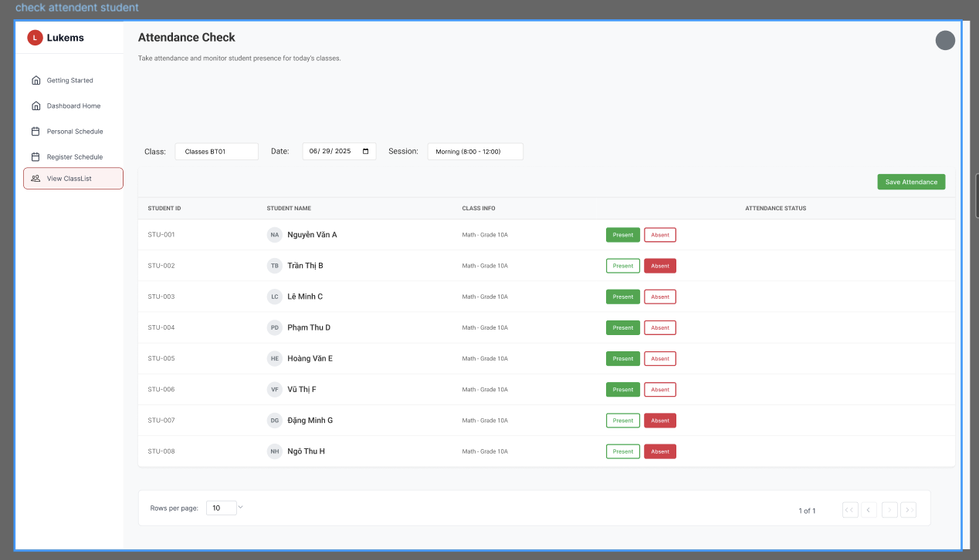

###### *Figure 86 -* Check attendance students

| **Screen** | | Student check page | | | | |
| --- | --- | --- | --- | --- | --- | --- |
| **Description** | | Allows the Ted Team to take attendance and monitor student presence for today's classes | | | | |
| **Screen Access** | | From the main navigation, select "View ClassList" to access attendance check functionality | | | | |
| Screen Content | | | | | | |
| **Item** | | **Type** | **Data** | | **Description** | |
| Class Filter | | Dropdown | Classes B101, B102, etc. | | Allows selection of specific class | |
| Date Picker | | Date Field | 06/29/2025 | | Sets the attendance date | |
| Session Filter | | Dropdown | Morning 06:00-12:00, Afternoon 13:00-18:00 | | Filters by session time | |
| Student List | | Table | Student ID, Student Name, Class Info, Attendance Status | | Displays comprehensive student enrollment and attendance information | |
| Attendance Status | | Toggle Buttons | Present (Green), Absent (Red) | | Shows and allows updating of attendance status | |
| Save Attendance | | Button |  | | Saves all attendance changes | |
| Screen Actions | | | | | | |
| **Action Name** | **Description** | | | **Success** | | **Failure** |
| Load Class Data | The system loads all students enrolled in the selected class and session | | | Student table is populated with current enrollment and attendance data | | Error message appears stating student data cannot be loaded |
| Update Attendance | Ted Team clicks Present/Absent buttons to update student attendance status | | | The attendance status is updated and highlighted (Green for Present, Red for Absent) | | Status change is not saved and reverts to previous state |
| Save Attendance | Ted Team clicks "Save Attendance" to persist all changes | | | All attendance updates are saved to the database | | Error message MSG044 appears indicating save operation failed |
| Filter Students | Ted Team uses class, date, or session filters | | | The list updates to show only students matching the selected criteria | | "No students found" message appears if no matches |

### 

### 3.78 UC-75 Update class note

#### 

| **Use Case ID** | **UC75** | **Use Case Name** | **Update class note** |
| --- | --- | --- | --- |
| Created By | AnhLTK | Date Created | 23 May 2025 |
| Primary Actor | Ted Team | Secondary Actor | – |
| Description | Allows the Ted Team to update and manage student notes during attendance check sessions in the LUKEMS system | | |
| Priority | Should have | | |
| Trigger | The Ted Team clicks on a student's name or selects "Update Note" option from the attendance check interface | | |
| Pre-conditions | The Ted Team must be logged into the system  Must be in an active attendance session  A specific student must be selected (e.g., Nguyễn Văn A, STU-001) | | |
| Post-conditions | The system saves the updated student note and returns to the attendance check interface | | |
| Basic flow | 1. The Ted Team is on the Attendance Check page  2. The Ted Team clicks on a student's name (e.g., Nguyễn Văn A)  3. The "Update Note" modal dialog opens displaying student information  4. The Ted Team adds or edits notes in the text area with placeholder "Add a note about this student"  5. The Ted Team clicks "Save Note" button to confirm changes  6. The system saves the note and closes the modal  7. The system returns to the attendance check interface | | |
| Alternative flow | If the Ted Team clicks "Cancel" button, the system discards any changes and closes the modal without saving | | |
| Exception | If the note content exceeds character limits or contains invalid characters, the system shows error message **MSG045** and prevents the update | | |
| Business rules | BR-126, BR-127, BR-128 | | |

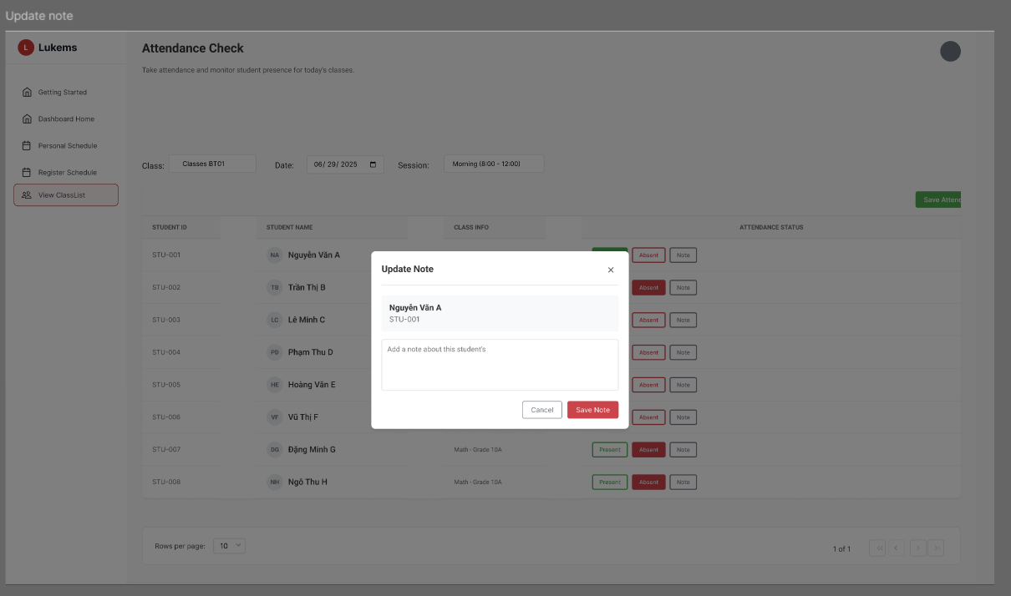

###### *Figure 87 -* Update class note

| **Screen** | | Class note update page | | | | |
| --- | --- | --- | --- | --- | --- | --- |
| **Description** | | Allows the Ted Team to add or edit notes for individual students during attendance sessions | | | | |
| **Screen Access** | | From the Attendance Check page, click on any student's name to open the note editor | | | | |
| Screen Content | | | | | | |
| **Item** | | **Type** | **Data** | | **Description** | |
| Student Identifier | | Text Display | Nguyễn Văn A, STU-001 | | Shows which student the note is for | |
| Note Editor | | Text Area | Free-form text content | | Rich text editor for composing and editing class notes | |
| Action Buttons | | Button Group | Cancel, Save Note | | Provides options to save or discard changes | |
| Session Context | | Background Info | Classes B101, 06/29/2025, Morning 08:00-12:00 | | Shows current attendance session details | |
| Screen Actions | | | | | | |
| **Action Name** | **Description** | | | **Success** | | **Failure** |
| **Open Note Editor** | The system opens the note modal when Ted Team clicks on a student's name | | | The Update Note modal appears with student information (Nguyễn Văn A, STU-001) and empty text area | | An error message appears stating the note editor cannot be opened |
| **Load Existing Notes** | The system loads any existing notes for the selected student | | | The note editor is populated with existing note content for the student | | An error message appears if notes cannot be loaded |
| **Edit Note Content** | The Ted Team modifies the note content using the rich text editor | | | The content is updated in real-time as the Ted Team types | | The editor fails to respond and content changes are not registered |
| **Save Updated Note** | The Ted Team clicks "Save Note" to persist the changes | | | The note is successfully saved, modal closes, and system returns to attendance check | | An error message shows that the note could not be saved |
| **Cancel Note Edit** | The Ted Team clicks "Cancel" to discard changes | | | The modal closes without saving and returns to attendance check | | Modal fails to close properly |
| **Close Modal** | The Ted Team clicks the × button to close the dialog | | | The modal closes and returns to the attendance interface | | Modal remains open and cannot be closed |

### 

### 3.79 UC-76 View quiz status

#### 

| **Use Case ID** | **UC76** | **Use Case Name** | **View quiz status** |
| --- | --- | --- | --- |
| Created By | AnhLTK | Date Created | 23 May 2025 |
| Primary Actor | Ted Team | Secondary Actor | – |
| Description | Allows the Ted Team to view the status of quizzes assigned to students in their classes through the LUKEMS system | | |
| Priority | Must have | | |
| Trigger | The Ted Team selects the "View Quiz Status" option from the main menu or clicks "View Quiz" button from the View ClassList page | | |
| Pre-conditions | The Ted Team must be logged into the system  The Ted Team must have created quizzes for their classes  The Ted Team must be assigned to teach classes | | |
| Post-conditions | The system displays the status of all quizzes including completion rates and scores | | |
| Basic flow | 1. The Ted Team is on the View ClassList page  2. The Ted Team clicks "View Quiz" button  3. The system displays the Quiz Status page  4. The Ted Team selects a quiz from the dropdown (e.g., "Quiz #3 - Reading")  5. The Ted Team selects a class from the dropdown (e.g., "Classes ST01")  6. The system displays all students and their quiz completion status  7. The Ted Team can view detailed status for each quiz including:   * Student ID and Name * Quiz details (Quiz #3 - Reading • 20 questions) * Status (Completed, In Progress, Not Started) * Score (e.g., 18/20, 14/20, 16/20, 10/20, 19/20) | | |
| Alternative flow | If no quizzes have been created, the system displays a message indicating no quizzes are available  The Ted Team can filter quiz list by submission status using the status filter dropdown | | |
| Exception | If quiz data is invalid or incomplete, the system displays error message **MSG046** and prevents data loading | | |
| Business rules | BR-129, BR-130, BR-131, BR-132 | | |

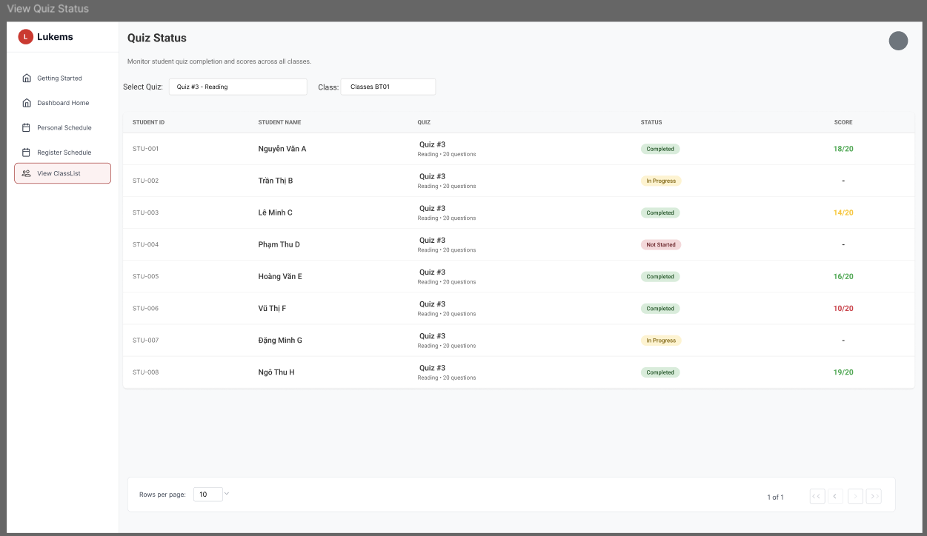

###### *Figure 88 -* View quiz

| **Screen** | | Quiz status page | | | | |
| --- | --- | --- | --- | --- | --- | --- |
| **Description** | | Allows the Ted Team to view comprehensive quiz status and student performance | | | | |
| **Screen Access** | | From the View ClassList page, click "View Quiz" button to access the quiz status interface | | | | |
| Screen Content | | | | | | |
| **Item** | | **Type** | **Data** | | **Description** | |
| Page Header | | Text Label | "Quiz Status" | | Shows the page title | |
| Page Description | | Text | "Monitor student quiz completion and scores across all classes" | | Describes the page functionality | |
| Quiz Selector | | Dropdown | "Quiz #3 - Reading" | | Dropdown to select specific quiz to view | |
| Class Selector | | Dropdown | "Classes ST01" | | Dropdown to select specific class | |
| Student Data Table | | Table | Student information and quiz results | | Main table displaying all student quiz data | |
| Student ID Column | | Table Column | STU-001, STU-002, etc. | | Shows unique student identifiers | |
| Student Name Column | | Table Column | Nguyễn Văn A, Trần Thị B, etc. | | Shows student full names | |
| Quiz Details Column | | Table Column | Quiz #3  Reading • 20 questions | | Shows quiz name, type, and question count | |
| Status Column | | Table Column | Completed, In Progress, Not Started | | Shows current completion status with color coding | |
| Score Column | | Table Column | 18/20, 14/20, 16/20, etc. | | Shows achieved scores out of total possible | |
| Status Filter | | Dropdown | All, Completed, In Progress, Not Started | | Filters quiz list based on student submission status | |
| Export Button | | Button | Export results | | Exports quiz submission status to Excel/PDF format | |
| Pagination | | Controls | Rows per page: 10, Page 1 of 1 | | Navigation controls for large datasets | |
| Screen Actions | | | | | | |
| **Action Name** | **Description** | | | **Success** | | **Failure** |
| Load Quiz Status | The system loads all quizzes and their basic submission info when page is accessed | | | The quiz status page is displayed with complete student data and submission statuses | | An error message MSG046 appears indicating quiz data cannot be loaded |
| Select Quiz | The Ted Team selects a specific quiz from the dropdown to view detailed results | | | The page updates to show detailed results for the selected quiz with all student data | | An error message appears if quiz data cannot be retrieved |
| Select Class | The Ted Team selects a specific class to filter quiz results | | | The student list updates to show only students from the selected class | | A "No students found" message appears if class data is unavailable |
| Filter Submission Status | The Ted Team filters quiz list by submission status (All, Completed, In Progress, Not Started) | | | The list updates to reflect the selected status filter showing relevant students | | A "No matching quizzes found" message appears if no quizzes match the filter |
| Export Results | The Ted Team clicks export button to download quiz results | | | The system generates and downloads a report file containing all quiz submission data | | An error message shows that the export failed and file cannot be generated |
| View Student Performance | The Ted Team reviews individual student quiz performance and scores | | | The system displays detailed performance metrics for each student including completion status and scores | | An error message shows that student performance data cannot be retrieved |

### 

### 3.80 UC-77 Submit report

#### 

| **Use Case ID** | **UC77** | **Use Case Name** | **Submit report** |
| --- | --- | --- | --- |
| Created By | AnhLTK | Date Created | 23 May 2025 |
| Primary Actor | Ted Team | Secondary Actor | – |
| Description | Allows the Ted Team to submit various reports related to their teaching activities and student progress to the administration through the LUKEMS system | | |
| Priority | Must have | | |
| Trigger | The Ted Team selects the "Submit Report" option from the main menu in the LUKEMS system | | |
| Pre-conditions | The Ted Team must be logged into the system  Must have appropriate permissions to submit reports  Data must be available for reporting | | |
| Post-conditions | The system submits the report to the administration and displays confirmation message | | |
| Basic flow | 1. The Ted Team is on the Repository Report List page  2. The Ted Team clicks "Submit Report" button  3. The "Submit Report" modal dialog opens  4. The Ted Team fills in the Repo Title field (e.g., "Enter repo title...")  5. The Ted Team selects the Date using the date picker (mm/dd/yyyy format)  6. The Ted Team selects source from the dropdown ("Select source")  7. The Ted Team enters report content in the rich text editor ("Enter your repository content here...")  8. The Ted Team clicks "Submit" button to confirm submission  9. The system saves the report and closes the modal  10. The system returns to the Repository Report List with the new report added | | |
| Alternative flow | If the Ted Team clicks "Cancel" button, the system discards any changes and closes the modal without saving | | |
| Exception | If required fields are empty or invalid, the system shows error message **MSG050** and prevents submission  If the report content exceeds character limits, the system shows error message **MSG051** and prevents submission | | |
| Business rules | BR-133, BR-134, BR-135 | | |

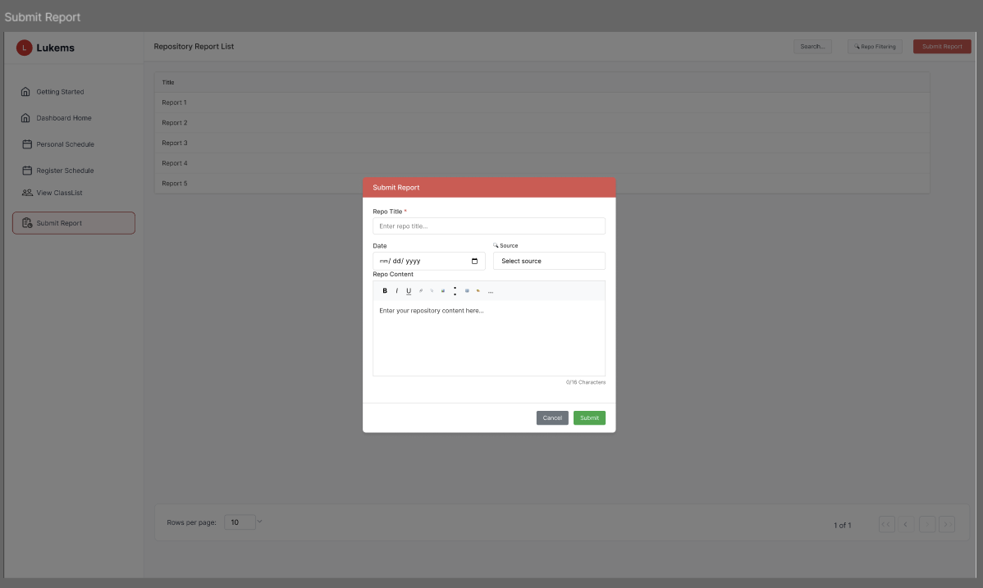

###### *Figure 89 - Submit report*

| **Screen** | | Report submission page | | | | |
| --- | --- | --- | --- | --- | --- | --- |
| **Description** | | Allows the Ted Team to create and submit various types of reports to the administration | | | | |
| **Screen Access** | | From the Repository Report List page, click "Submit Report" button to open the modal | | | | |
| Screen Content | | | | | | |
| **Item** | | **Type** | **Data** | | **Description** | |
| Modal Header | | Text Label | "Submit Report" | | Shows the dialog title | |
| Repo Title | | Text Input Field | "Enter repo title..." | | Required field for entering the report title | |
| Date | | Date Picker | mm/dd/yyyy format | | Date selection field for the report | |
| Source | | Dropdown | "Select source" | | Dropdown menu for selecting the data source | |
| Repo Content | | Rich Text Editor | "Enter your repository content here..." | | Large text area with formatting toolbar (Bold, Italic, Underline, etc.) for composing report content | |
| Character Counter | | Display | "0/16 Characters" | | Shows current character count and limit | |
| Cancel Button | | Button | "Cancel" | | Closes modal without saving changes | |
| Submit Button | | Button | "Submit" | | Submits the completed report to administration | |
| Close Button | | Icon Button | × | | Alternative way to close modal | |
| Background Context | | Overlay | Repository Report List | | Shows the underlying report list page | |
| Screen Actions | | | | | | |
| **Action Name** | **Description** | | | **Success** | | **Failure** |
| Open Submit Dialog | The system opens the submit report modal when Ted Team clicks "Submit Report" button | | | The Submit Report modal appears with empty form fields ready for input | | An error message appears stating the dialog cannot be opened |
| Fill Report Form | The Ted Team completes all required fields in the report form | | | All form data is validated and accepted, form shows no validation errors | | Validation errors appear for incomplete or invalid fields with specific error messages |
| Submit Report | The Ted Team clicks "Submit" button to send the completed report to administration | | | The report is successfully submitted, modal closes, and confirmation message is displayed | | An error message shows that the report submission failed, form remains open with data preserved |
| Cancel Report | The Ted Team clicks "Cancel" to discard changes | | | The modal closes without saving and returns to Repository Report List | | Modal fails to close properly |
| Close Modal | The Ted Team clicks the × button to close the dialog | | | The modal closes and returns to the report list interface | | Modal remains open and cannot be closed |

### 

### 

## 4. Non-Functional Requirements

### 4.1 External Interfaces

| Interface | Description |
| --- | --- |
| Google OAuth 2.0 | Used for user authentication (Sign In with Google). |
| Email Server (SMTP) | Sends system notifications and announcements. |
| File Storage (Local / Cloud S3) | Stores and retrieves files like vlogs, materials, and submissions. |
| Excel File Integration | Imports/exports user, class, and grade data. |
| Web Browsers | Supports Chrome, Firefox, Safari on desktop and mobile. |
| Mobile Platform | React Native app version for students, Coaches, and TedTeam. |

### 4.2 Quality Attributes

| **Attribute** | **Description** |
| --- | --- |
| Usability | - UI follows Material Design  - Students become productive in ≤ 30 mins  - Power users become productive in ≤ 2 hours of training  - Mobile & desktop responsive |
| Availability | System is operational 99.5% of the time annually, excluding scheduled maintenance. |
| MTBF | Mean Time Between Failures is at least 1,000 hours. |
| MTTR | Mean Time to Repair is ≤ 2 hours for critical failures. |
| Accuracy | - Grading, scheduling, and leaderboard data accurate within ±1%  - System must prevent inconsistent or incorrect data entries. |
| Bug Rate | - ≤ 3 bugs/KLOC  - Critical: ≤ 0.5/KLOC  - Critical bug = data loss or blocked functionality  - Major: logic errors  - Minor: UI/typo issues |
| Response Time | - Normal action (view profile, schedule): ≤ 1 sec avg, ≤ 2 sec max  - Reports/statistics (≤1000 users): ≤ 3 sec |
| Throughput | - Supports 100 concurrent users without performance degradation. |
| Capacity | - Up to 10,000 students, 500 staff, 1 million records stored (quizzes, grades, reports, etc.) |
| Resource Usage | - RAM usage ≤ 70%, CPU ≤ 75% during peak load  - File uploads ≤ 500MB with real-time progress tracking. |

## 5. Requirement Appendix

### 5.1 Business Rules

| **ID** | **Rule Definition** | **Related Use Cases** |
| --- | --- | --- |
| BR-01 | Only users with the “Coach” role can access the report. | UC-04, UC-06, UC-07, UC-08, UC-10 |
| BR-02 | Data is queried live from the database. | UC-04, UC-05, UC-06, UC-07, UC-08, UC-10 |
| BR-03 | Viewing only; no editing allowed. | UC-04, UC-05, UC-06, UC-07, UC-08, UC-10 |
| BR-04 | Only teachers who have successfully logged in can access the learning outcomes report feature. | UC-05, UC-06 |
| BR-05 | Only users with the Coach role can grade student submissions. | UC-07 |
| BR-06 | Coaches can only grade students within the classes they are assigned to. | UC-07 |
| BR-07 | Once a grade is submitted, it is stored immediately and cannot be modified unless explicitly allowed by the system. | UC-08 |
| BR-08 | Grading must follow the point scale defined for each task (e.g., 0–10 or pass/fail). | UC-08 |
| BR-09 | Coaches can only download submissions from classes they are assigned to. | UC-09 |
| BR-10 | Only valid file types (e.g., PDF, DOCX, MP4) are supported for download. | UC-09 |
| BR-11 | Downloading submissions does not allow editing or deleting them. | UC-09 |
| BR-12 | All download actions are logged for auditing and tracking purposes. | UC-09 |
| BR-13 | Each task has its own submission view and download interface. | UC-09 |
| BR-14 | Materials must be categorized by subject, topic, or module. | UC-10, UC-11 |
| BR-15 | Material types may include PDFs, videos, slides, or external links. | UC-10, UC-11 |
| BR-16 | System logs all uploads with timestamp and coach ID. | UC-11 |
| BR-17 | Materials become visible to students after upload. | UC-11 |
| BR-18 | Only the uploader or users with edit permissions can update materials. | UC-12 |
| BR-19 | All updates must retain required fields (title, subject, type). | UC-12 |
| BR-20 | File or link replacement is optional but must follow format and size rules. | UC-12 |
| BR-21 | All updates are logged with timestamp and editor ID. | UC-12 |
| BR-22 | Updated materials are instantly reflected for student access. | UC-12 |
| BR-23 | Only the uploader or users with delete rights can delete materials. | UC-13 |
| BR-24 | Deleted materials are permanently removed and cannot be recovered via the user interface. | UC-13 |
| BR-25 | Deletion requires explicit confirmation from the user. | UC-13 |
| BR-26 | All delete actions must be logged with timestamp and user ID for auditing purposes. | UC-13 |
| BR-27 | Quizzes must show real-time status (Active/Closed). | UC-13 |
| BR-28 | Quiz list must be filterable by subject/module. | UC-14 |
| BR-29 | Quizzes are read-only on the list screen (no edit or delete allowed). | UC-14 |
| BR-30 | Only coaches with quiz creation rights can create new quizzes. | UC-15 |
| BR-31 | Each quiz must contain at least one question. | UC-15 |
| BR-32 | Supported question types are Multiple Choice (MCQ), True/False, and Short Answer only. | UC-15 |
| BR-33 | Quiz titles must be unique within each subject. | UC-15 |
| BR-34 | All quiz creation activities must be logged with timestamp and user ID for auditing purposes. | UC-15 |
| BR-35 | Only the quiz creator or authorized coach may update quiz content. | UC-16 |
| BR-36 | A quiz must contain at least one valid question at all times. | UC-16 |
| BR-37 | All updates must be logged with timestamps and editor (coach) IDs. | UC-16 |
| BR-38 | Quizzes already assigned to students or attempted may be locked from editing, depending on system rules. | UC-16 |
| BR-39 | Updates must retain required fields: quiz title, subject, question formats. | UC-16 |
| BR-40 | Only quiz creator or authorized coach may delete quiz. | UC-17 |
| BR-41 | Quizzes assigned or attempted may not be deletable. | UC-17 |
| BR-42 | Deletion requires explicit confirmation. | UC-17 |
| BR-43 | All deletions logged with timestamp and user ID. | UC-17 |
| BR-44 | Coaches can only view their own schedules. | UC-18 |
| BR-45 | Schedule entries are aggregated from class assignments, meetings, and related events. | UC-18 |
| BR-46 | All times are displayed in the coach’s local time zone. | UC-18 |
| BR-47 | Events that are cancelled or completed must be clearly marked in the schedule. | UC-18 |
| BR-48 | Notifications are automatically sent when new content is assigned. | UC-19 |
| BR-49 | Coaches can manually trigger notifications by clicking the “Notify” button. | UC-19 |
| BR-50 | Notifications must include content title, type, and assigned class/module. | UC-19 |
| BR-51 | All notification activities are logged with timestamp and sender info. | UC-19 |
| BR-52 | The system prevents duplicate notifications on repeated content edits. | UC-19 |
| BR-53 | Only users with the 'Admin' role can access the User Management module to view, add, or manage user accounts. | UC-20, UC-21, UC-22, UC-23, UC-24, UC-25, UC-26, UC-27, UC-28, UC-29, UC-30 |
| BR-54 | The user list must display essential information for quick identification, including Full Name, Email, and Account Status (e.g., Active/Locked). | UC-20, UC-21, UC-22, UC-23, UC-24, UC-25, UC-26, UC-27, UC-28, UC-29, UC-30 |
| BR-55 | All administrative actions performed within the User Management module, including viewing user lists, must be logged for security and auditing purposes. | UC-20, UC-21, UC-22, UC-23, UC-24, UC-25, UC-26, UC-27, UC-28, UC-29, UC-30 |
| BR-56 | Student account email must be unique in the system. | UC-24 |
| BR-57 | Ted Team account email must be unique in the system. | UC-25 |
| BR-58 | Coach account email must be unique in the system. | UC-26 |
| BR-59 | Admin account email must be unique in the system. | UC-27 |
| BR-60 | Imported emails must be unique across system | UC-28 |
| BR-61 | Locked accounts cannot log in to the system. | UC-29 |
| BR-62 | Only Admins can view full detail of user accounts including system metadata. | UC-30 |
| BR-63 | Search is case-insensitive and supports partial matches on class code or name. | UC-31 |
| BR-64 | Class code must be unique in the system. | UC-33 |
| BR-65 | Class list must include class code, name, and status. | UC-32 |
| BR-66 | Class names must not be empty. | UC-34 |
| BR-67 | Cannot delete class that is linked to active sessions or students. | UC-35 |
| BR-68 | Only Admins can view full detail of classes including system metadata | UC-36 |
| BR-69 | Student emails must be valid and unique within the class when importing. | UC-37 |
| BR-70 | Students cannot be added to the same class more than once. | UC-38 |
| BR-71 | New students must not already be assigned to the same class. | UC-39 |
| BR-72 | Removing a student from a class must also remove their associated schedules or data if applicable. | UC-40 |
| BR-73 | Search must support partial match and be case-insensitive on keywords. | UC-41 |
| BR-74 | Shift list must include shift ID, date, time, and associated class. | UC-42 |
| BR-75 | A shift must be associated with a valid class ID. | UC-43 |
| BR-76 | A shift must not overlap with an existing shift for the same class and time. | UC-43 |
| BR-77 | All required fields (Class, Date, Time) must be filled before submission. | UC-43 |
| BR-78 | Only Admins are allowed to approve pending shifts. | UC-44 |
| BR-79 | A shift can only be approved once; repeat actions are blocked. | UC-44 |
| BR-80 | Approved shifts will be visible in system calendars and other modules as active. | UC-44 |
| BR-81 | Only Admins can modify existing timetable entries. | UC-45 |
| BR-82 | Timetable updates must not overlap with existing shifts for the same class. | UC-45 |
| BR-83 | Class, date, time, and coach fields are mandatory when updating a timetable. | UC-45 |
| BR-84 | Only Admins are allowed to delete timetable entries. | UC-46 |
| BR-85 | Once deleted, timetable entries are permanently removed and cannot be recovered. | UC-46 |
| BR-86 | Only Admins can create email templates. | UC-47 |
| BR-87 | Email templates must have a unique name and a non-empty subject and content. | UC-47 |
| BR-88 | Templates may use predefined placeholders (e.g., [StudentName], [ShiftTime]) for dynamic content substitution. | UC-47 |
| BR-89 | Only Admins are permitted to send bulk email notifications. | UC-48 |
| BR-90 | An email must have a non-empty subject, content, and at least one recipient before it can be sent. | UC-48 |
| BR-91 | Placeholders in templates must be resolved by the system before dispatch; unresolved placeholders block sending. | UC-48 |
| BR-92 | Only Admins can access the account statistics dashboard. | UC-49 |
| BR-93 | Exported data must reflect all applied filters and respect data access permissions. | UC-49 |
| BR-94 | Only Admins can access and view scores of all accounts. | UC-50 |
| BR-95 | Exported score data must respect applied filters and include full score breakdowns per user. | UC-50 |
| BR-96 | Only Admins can view progress data of all user accounts. | UC-51 |
| BR-97 | Progress must be calculated based on defined metrics (e.g., attendance %, completed tasks, milestones achieved). | UC-51 |
| BR-98 | Only Admins can view performance data for all user accounts. | UC-52 |
| BR-99 | Performance is computed based on weighted metrics including attendance, evaluation, and task completion. | UC-52 |
| BR-100 | Only Admins are authorized to view full activity logs of all users. | UC-53 |
| BR-101 | Activity logs must include timestamp, user ID, action type, and metadata (e.g. IP, device) for each event. | UC-53 |
| BR-102 | Only authenticated Ted Team can view their own personal schedule | UC-67 |
| BR-103 | All schedule data must be synchronized with the central academic system | UC-67 |
| BR-104 | Schedule must display in Ted Team preferred timezone | UC-67 |
| BR-105 | Ted Team can only register availability for future dates (minimum 24 hours ahead) | UC-68 |
| BR-106 | Overlapping time slots with existing commitments are not allowed | UC-68 |
| BR-107 | Emergency changes require administrator override | UC-69 |
| BR-108 | Once the schedule has been approved and classes have been assigned, cancellation is not allowed | UC-69 |
| BR-109 | If there are no assigned classes, the schedule can be cancelled immediately with no impact on students | UC-69 |
| BR-110 | All cancellation actions must be logged with timestamp, performer identity, and reason (if provided) | UC-69 |
| BR-111 | Ted Team attendance is only auto-recorded when they have registered work shifts | UC-70 |
| BR-112 | Auto check-in occurs automatically upon system login during work shift hours | UC-70 |
| BR-113 | Ted Team attendance timestamp records the actual login time within work shift period | UC-70 |
| BR-114 | Ted Team can only view progress of students in their assigned classes | UC-71 |
| BR-115 | Overdue assignments must be clearly marked and highlighted | UC-71 |
| BR-116 | Progress reports must include completion dates and scores | UC-71 |
| BR-117 | Only students with "Not Yet" submission status can receive individual reminders | UC-72 |
| BR-118 | Bulk reminders can be sent to multiple students simultaneously, but only to those who haven't submitted | UC-72 |
| BR-119 | The system must provide real-time feedback for reminder sending status (sending, sent, failed) | UC-72 |
| BR-120 | Only assigned classes are visible to each Ted Team member | UC-73 |
| BR-121 | Class status must be either "Active" or "Inactive" | UC-73 |
| BR-122 | Class creation date must be in valid format (DD/MM/YYYY) | UC-73 |
| BR-123 | Only authorized Ted Team members can access attendance functions | UC-74 |
| BR-124 | Attendance can only be taken for current or past dates | UC-74 |
| BR-125 | Each student can only have one attendance status per session | UC-74 |
| BR-126 | Notes can only be added/edited during active attendance sessions | UC-75 |
| BR-127 | Each student can have multiple notes with timestamps | UC-75 |
| BR-128 | Note content must not exceed 500 characters | UC-75 |
| BR-129 | Only quizzes created by the Ted Team for their assigned classes are visible | UC-76 |
| BR-130 | Quiz results and scores are only displayed after students have submitted their completed quiz | UC-76 |
| BR-131 | Quiz status is updated in real-time as students complete quizzes | UC-76 |
| BR-132 | Ted Team can view comprehensive statistics and student performance data | UC-76 |
| BR-133 | Reports can only be submitted by authenticated Ted Team members | UC-77 |
| BR-134 | All required fields (Title, Date, Source, Content) must be completed before submission | UC-77 |
| BR-135 | Report content must not exceed maximum character limit | UC-77 |
| BR-136 | Schedule must reflect the most updated information from academic timetable. | UC-54 |
| BR-137 | Time is displayed in 24-hour format. | UC-54 |
| BR-138 | Only quizzes assigned to the logged-in student are shown. | UC-55 |
| BR-139 | Students can only view published news. | UC-56 |
| BR-140 | Students can submit videos only before the deadline. | UC-57 |
| BR-141 | Students can only resume a quiz if it is in-progress and not expired.. | UC-58 |
| BR-142 | News title is required and must be between 1-200 characters | UC-59 |
| BR-143 | Submitted videos must comply with size and format restrictions. | UC-60 |
| BR-144 | Academic progress is updated only after verified activities. | UC-61 |
| BR-145 | Students can only view their own completed exercises. | UC-61.1 |
| BR-146 | Quiz results are shown only after submission is graded. | UC-61.1.1 |
| BR-147 | Average score includes only completed and graded items. | UC-61.2 |
| BR-148 | Leaderboard must only display students from the same cohort. | UC-62 |
| BR-149 | Notifications must be sorted by timestamp and category. | UC-63 |
| BR-150 | Course feedback must remain anonymous unless opted out. | UC-64 |
| BR-151 | Feedback can be submitted once per course by each student. | UC-65 |
| BR-152 | Materials are visible only after the official release date. | UC-66 |
| BR-153 | Only materials assigned to the student’s course are accessible. | UC-66 |
| BR-154 | Only valid Google accounts allowed. | UC-01 |
| BR-155 | Session created after login. | UC-01 |
| BR-156 | Login failure retries limited to 3 attempts. | UC-01 |
| BR-157 | User data synced from Google profile. | UC-01 |
| BR-158 | Session must be securely terminated. | UC-01 |
| BR-159 | Cookies and tokens cleared. | UC-02 |
| BR-160 | User cannot access protected pages after logout. | UC-02 |
| BR-161 | Logout action is logged. | UC-02 |
| BR-162 | Only authenticated users can edit profiles. | UC-03 |
| BR-163 | Fields must comply with format rules (e.g., date format). | UC-03 |
| BR-164 | Changes logged for audit. | UC-03 |
| BR-165 | Sensitive info encrypted in storage. | UC-03 |
| BR-166 | Slot is defined by institution standard (e.g., Slot 4 = 13:30 - 15:45). | UC-54 |
| BR-167 | Students can only view their own schedule. | UC-54 |
| BR-168 | Quiz status must reflect real-time access and completion. | UC-55 |
| BR-169 | Students cannot start quizzes marked *“Can not be started”*. | UC-55 |
| BR-170 | Only authenticated users can access Learning Materials. | UC-66 |
| BR-171 | Students may only view and download materials; Coaches may edit and upload materials. | UC-66 |
| BR-172 | All material data (title, file type, category) must be stored in the database and searchable. | UC-66 |
| BR-173 | News is shown in reverse chronological order (latest first). | UC-56 |
| BR-174 | News content is truncated in list view, full text shown only in detail view. | UC-56 |
| BR-175 | Resubmission overwrites previous uploads. | UC-57 |
| BR-176 | Action buttons change based on submission status. | UC-57 |
| BR-177 | Student can configure which videos are required and their deadlines. | UC-57 |
| BR-178 | Confirmation is mandatory before redirecting to quiz interface. | UC-58 |
| BR-179 | Completed or locked quizzes must not allow continuation. | UC-58 |
| BR-180 | Date cannot be in the future beyond current date | UC-59 |
| BR-181 | Content must not exceed 10,000 characters | UC-59 |
| BR-182 | Only users with "news_writer" permission can create news articles | UC-59 |
| BR-183 | Video title is required and must be between 1-100 characters | UC-60 |
| BR-184 | Due date cannot be more than 1 year in the future | UC-60 |
| BR-185 | Supported file formats: MP4, AVI, MOV only | UC-60 |
| BR-186 | Maximum file size is 500MB | UC-60 |
| BR-187 | URL submissions must be from approved video platforms (YouTube, Vimeo, etc.) | UC-60 |
| BR-188 | All statistics are read-only - no editing or modification capabilities | UC-61 |
| BR-188 | Progress data is updated in real-time when new assessments are completed | UC-61 |
| BR-190 | Class ranking is calculated based on overall academic performance | UC-61 |
| BR-191 | Skill progress is calculated from completed activities in each category | UC-61 |

### 5.2 Common Requirements

### 5.3 Application Messages List

| **Message code** | **Message Type** | **Context** | **Content** |
| --- | --- | --- | --- |
| MSG01 | In line | There is not any search result | *No search results.* |
| MSG02 | In red, under the text box | Input-required fields are empty | *The * field is required.* |
| MSG03 | Toast message | Updating asset(s) information successfully | *Update asset(s) successfully.* |
| MSG04 | Toast message | Adding new asset successfully | *Add asset successfully.* |
| MSG05 | Toast message | Confirming email of asset hand-over is sent successfully | *A confirmation email has been sent to {email_address}.* |
| MSG06 | Toast message | Resetting asset information successfully | *Return asset(s) successfully.* |
| MSG07 | Toast message | Deleting asset information successfully | *Delete asset(s) successfully.* |
| MSG08 | In red, under the text box | Input value length > max length | *Exceed max length of {max_length}.* |
| MSG09 | In line | Username or password is not correct when clicking sign-in | *Incorrrect user name or password. Please check again.* |
| MSG010 | In red, under the text box | Failed to load learning calendar data | *Unable to load calendar data. Please try again.* |
| MSG011 | In red, under the text box | No learning calendar content available | *No calendar events found.* |
| MSG012 | In red, under the text box | Failed to load quizzes list | *Unable to load quizzes. Please refresh the page.* |
| MSG013 | In red, under the text box | No quizzes available | *No quizzes found for your account.* |
| MSG014 | In red, under the text box | Quiz filter operation failed | *Filter could not be applied. Please try again.* |
| MSG015 | In red, under the text box | Failed to load news data | *Unable to load news. Please try again later.* |
| MSG016 | In red, under the text box | No news content available | *No news articles found.* |
| MSG017 | In red, under the text box | News search operation failed | *Search could not be completed. Please try again.* |
| MSG018 | In red, under the text box | Failed to load videos | *Unable to load videos. Please refresh the page.* |
| MSG019 | In red, under the text box | No videos available | *No videos found in your library.* |
| MSG020 | In red, under the text box | Video playback initialization failed | *Cannot play video. Please try again.* |
| MSG021 | In red, under the text box | Failed to load quiz questions | *Unable to load quiz questions. Please try again.* |
| MSG022 | In red, under the text box | Quiz submission failed | *Your answers could not be submitted. Please try again.* |
| MSG023 | In red, under the text box | Failed to load news form | *Cannot load news form. Please refresh the page.* |
| MSG024 | In red, under the text box | News submission failed | *Your news article could not be submitted. Please try again.* |
| MSG025 | In red, under the text box | Video upload form failed to load | *Cannot load upload form. Please try again.* |
| MSG026 | In red, under the text box | Video submission failed | *Your video could not be uploaded. Please try again.* |
| MSG027 | In red, under the text box | Failed to load academic progress data | *Unable to load progress data. Please refresh the page.* |
| MSG028 | In red, under the text box | Failed to load exercise history | *Cannot load exercise history. Please try again.* |
| MSG029 | In red, under the text box | Failed to load quiz results | *Unable to load quiz results. Please refresh the page.* |
| MSG030 | In red, under the text box | Failed to load average score data | *Cannot load score data. Please try again.* |
| MSG031 | In red, under the text box | Failed to load leaderboard data | *Unable to load rankings. Please refresh the page.* |
| MSG032 | In red, under the text box | Failed to load notifications | *Cannot load notifications. Please try again.* |
| MSG033 | In red, under the text box | No notifications available | *No notifications found.* |
| MSG034 | In red, under the text box | Failed to load course feedback | *Unable to load feedback. Please refresh the page.* |
| MSG035 | In red, under the text box | Failed to load feedback form | *Cannot load feedback form. Please try again.* |
| MSG036 | In red, under the text box | Feedback submission failed | *Your feedback could not be submitted. Please try again.* |
| MSG037 | In red, under the text box | Failed to load personal schedule | *Unable to load personal schedule.* |
| MSG038 | In red, under the text box | Failed to register work schedule due to database connection loss | *Unable to save work schedule.* |
| MSG039 | In line | Cancellation was not confirmed | *Cancellation not confirmed. No changes have been made* |
| MSG040 | In red, under the text box | Check-in failed due to time synchronization error | *Check-in failed due to system time error. Please contact admin.* |
| MSG041 | In red, under the text box | Failed to retrieve assignment progress | *Unable to retrieve assignment progress. Please try again later.* |
| MSG042 | In red, under the text box | Notification service is unavailable | *Failed to send reminder. Notification service is currently unavailable* |
| MSG043 | In red, under the text box | Failed to synchronize class data | *Unable to load class list. Please refresh or try again later.* |
| MSG044 | In red, under the text box | Failed to calculate attendance data | *Failed to load attendance data. Please try again later* |
| MSG045 | In red, under the text box | File attachment too large | *Attachment too large. Please upload a smaller file.* |
| MSG046 | In red, under the text box | Failed to calculate quiz status | *Failed to calculate quiz status. Please check again later* |
| MSG047 | In red, under the text box | Report submission deadline has passed | *Report submission failed. Deadline has already passed.* |
| MSG048 | In red, top of login box | Google service unavailable | *Google services are currently unreachable. Please try again later.* |
| MSG049 | In red, top of login box | OAuth config error | *Authentication configuration error. Please contact support.* |
| MSG050 | In red, top of login box | Google account suspended | *Your Google account is suspended or disabled. Please try another account.* |
| MSG051 | In red, top of login box | Network error | *Network error occurred. Please check your connection and try again.* |
| MSG052 | In red, top of login box | Token verification failed | *Authentication failed. Please sign in again.* |
| MSG053 | In red, top of login box | Server error | *An unexpected error occurred. Please try again later.* |
| MSG054 | In red, top of screen | Network error | *Network error occurred while signing out. Please check your connection.* |
| MSG055 | In red, top of screen | Server error | *An unexpected error occurred. Please try again.* |
| MSG056 | In red, top of screen | Session expired | *Session is already expired. Please log in again.* |
| MSG057 | In red, top of profile | Session expired | *Your session has expired. Please log in again to continue.* |
| MSG058 | In red, top of profile | Server error | *An unexpected error occurred while updating your profile. Please try again.* |
| MSG059 | In red, top of profile | Update failed | *Failed to save your profile changes due to a system issue. Please try later.* |
| MSG060 | In red, under the text box | Failed to load score distribution chart | *Unable to load score distribution. Please refresh the page.* |
| MSG061 | In red, under the text box | Failed to load assignment completion status chart | *Unable to load assignment status. Please refresh the page.* |
| MSG062 | In red, under the text box | Failed to load activity log data | *Unable to load activity history. Please refresh the page.* |
| MSG063 | In red, under the text box | Failed to load activity timeline | *Unable to load activity timeline. Please try again.* |
| MSG064 | In red, under the text box | Activity filter operation failed | *Filter could not be applied to activity logs. Please try again.* |
| MSG065 | In red, under the video player | Failed to load submission content | *Unable to load student submission. Please refresh the page.* |
| MSG066 | In red, under the save button | Failed to save grade data | *Unable to save grade. Please check your connection and try again.* |
| MSG067 | In red, under the task identifier | Failed to load student submission | *Student submission could not be loaded. Please try again.* |
| MSG068 | In red, under the score input | Grade validation failed | *Please enter a valid grade between 0 and 10.* |
| MSG069 | In red, under the video player | Failed to load submission content | *Unable to load student submission for feedback. Please refresh the page.* |
| MSG070 | In red, under the save button | Failed to save feedback data | *Unable to save feedback. Please check your connection and try again.* |
| MSG071 | In red, under the feedback field | Failed to load existing feedback | *Existing feedback could not be loaded. Please try again.* |
| MSG072 | In red, under the feedback field | Feedback validation failed | *Feedback contains invalid characters or exceeds character limit.* |
| MSG073 | In red, under the submission list | Failed to load submissions list | *Unable to load student submissions. Please refresh the page.* |
| MSG074 | In red, under the download button | Download failed due to file corruption | *File could not be downloaded. Please contact admin or try again later.* |
| MSG075 | In red, under the search field | Search operation failed | *Search could not be completed. Please try again.* |
| MSG076 | In red, under the filter button | Filter operation failed | *Filter could not be applied. Please try again.* |
| MSG077 | In red, under the sort button | Sort operation failed | *Sorting could not be applied. Please try again.* |
| MSG078 | In red, under the materials list | Failed to load materials list | *Unable to load learning materials. Please refresh the page.* |
| MSG079 | In red, under the material card | File preview failed | *Unable to preview this material. Please try downloading instead.* |
| MSG080 | In red, under the download button | Download failed due to file corruption | *File could not be downloaded. Please contact admin.* |
| MSG081 | In red, under the search field | Search operation failed | *Search could not be completed. Please try again.* |
| MSG082 | In red, under the filter controls | Filter operation failed | *Filter could not be applied. Please try again.* |
| MSG083 | In red, under Link field | URL not accessible | *The provided URL is not accessible. Please check the link.* |
| MSG084 | In red, under Quiz title field | Title already exists | *A material with this title already exists. Please choose a different title.* |
| MSG085 | In red, under Link field | Invalid URL format | *Please enter a valid URL format (e.g., https://example.com).* |
| MSG086 | In red, center of modal | Material not found | *The material you are trying to edit no longer exists. Please refresh the page.* |
| MSG087 | In red, center of modal | Permission denied | *You do not have permission to edit this material.* |
| MSG088 | In red, center of modal | Concurrent edit conflict | *This material has been modified by another user. Please refresh and try again.* |
| MSG089 | In red, center of dialog | Material not found | *The material you are trying to delete no longer exists.* |
| MSG090 | In red, center of dialog | Permission denied | *You do not have permission to delete this material.* |
| MSG091 | In red, center of dialog | Material in use | *This material is currently being used in active assignments and cannot be deleted.* |
| MSG092 | In red, center of dialog | Database constraint violation | *This material cannot be deleted due to system constraints. Please contact administrator.* |
| MSG093 | In red, center of dialog | Concurrent deletion conflict | *This material has been modified by another user. Please refresh and try again.* |
| MSG094 | In red, center of page | Insufficient permissions | *You do not have permission to view the schedule.* |
| MSG095 | In red, center of page | Data corruption | *Some schedule data appears to be corrupted. Please contact administrator.* |
| MSG096 | In yellow, top of page | Concurrent modification | *The schedule has been updated by another user. Please refresh to see latest changes.* |
| MSG097 | In red, center of page | Database timeout | *Unable to load schedule due to server timeout. Please try again later.* |
| MSG098 | In red, inline | Invalid date format | *Please enter a valid date format (MM/DD/YYYY).* |
| MSG099 | In red, center of modal | Insufficient permissions | *You do not have permission to create quizzes.* |
| MSG100 | In red, below title field | Duplicate title | *A quiz with this title already exists. Please choose a different title.* |
| MSG101 | In red, below date fields | Invalid date range | *End date must be after start date.* |
| MSG102 | In red, center of modal | Database constraint | *Unable to create quiz due to system constraints. Please try again.* |
| MSG103 | In red, center of modal | Limit exceeded | *You have reached the maximum number of quizzes allowed. Please delete unused quizzes.* |
| MSG104 | In red, center of screen | Insufficient permissions | *You do not have permission to edit this quiz.* |
| MSG105 | In red, center of screen | Quiz not found | *The quiz you are trying to edit no longer exists.* |
| MSG106 | In yellow, top of screen | Concurrent editing | *This quiz is being edited by another user. Your changes may conflict.* |
| MSG107 | In red, below field | Validation error | *Please correct the highlighted fields before saving.* |
| MSG108 | In red, top of screen | Limit exceeded | *Maximum number of questions (50) reached. Remove questions to add new ones.* |
| MSG109 | In red, top of screen | Save failed | *Failed to save changes. Please try again or check your connection.* |
| MSG110 | In red, center of screen | Permission denied | *You do not have permission to delete this quiz.* |
| MSG111 | In red, center of screen | Quiz not found | *The quiz you are trying to delete no longer exists.* |
| MSG112 | In yellow, dialog content | Active assignments | *This quiz has active assignments. Deleting will affect student progress.* |
| MSG113 | In red, top of screen | Database error | *Unable to delete quiz due to system constraints. Contact support.* |
| MSG114 | In yellow, top of screen | Concurrent action | *This quiz is being modified by another user. Please refresh and try again.* |
| MSG115 | In red, top of screen | Session expired | *Your session has expired. Please log in again.* |
| MSG116 | In red, top of screen | Server error | *Failed to retrieve schedule due to server error. Please try again.* |
| MSG117 | In red, top of screen | Network error | *A network issue occurred. Please check your internet connection.* |
| MSG118 | In red, center of screen | Permission denied | *You do not have permission to view this schedule.* |
| MSG119 | In yellow, center screen | No schedule found | *You have no scheduled classes or events for this time range.* |
| MSG120 | In yellow, center of screen | No recipients | *No active students found for this content. Please check enrollment.* |
| MSG121 | In red, top of screen | Delivery service error | *Email delivery service is temporarily unavailable. Please try again later.* |
| MSG122 | In red, center of screen | Message generation failed | *Unable to generate notification message. Please try manual message.* |
| MSG123 | In yellow, top of screen | Quota exceeded | *Daily notification limit reached. Please try again tomorrow.* |
| MSG124 | In red, below table | Invalid recipients | *Some email addresses are invalid. Please verify recipient information.* |
| MSG125 | In red, center of screen | Content not found | *The content you are trying to notify about no longer exists.* |
| MSG126 | In red, under the text box | Failed to load student data | *Unable to load student data. Please refresh the page.* |
| MSG127 | In red, under the text box | Failed to load Ted Team data | *Unable to load Ted Team data. Please refresh the page.* |
| MSG128 | In red, under the text box | Failed to load Coach data | *Unable to load Coach data. Please refresh the page.* |
| MSG129 | In red, under the text box | Failed to load Admin data | *Unable to load Admin data. Please refresh the page.* |
| MSG130 | In red, center of form | Failed to load form | *Unable to load the Add Student form. Please try again.* |
| MSG131 | In green, top of page | Success message | *Student account created successfully.* |
| MSG132 | In red, under email field | Email required | *Email is required.* |
| MSG133 | In red, under email field | Invalid email format | *Please enter a valid email address.* |
| MSG134 | In red, under email field | Duplicate email | *Email already exists in the system.* |
| MSG135 | In red, center of form | Account creation failed | *Failed to create student account. Please try again.* |
| MSG136 | In red, under email field | Email validation error | *Unable to validate email. Please try again.* |
| MSG137 | In red, center of form | Failed to load form | *Unable to load the Add Ted form. Please try again.* |
| MSG138 | In red, center of form | Account creation failed | *Failed to create Ted account. Please try again.* |
| MSG139 | In red, under email field | Email validation error | *Unable to validate email. Please try again.* |
| MSG140 | In red, center of form | Failed to load form | *Unable to load the Add Coach form. Please try again.* |
| MSG141 | In red, center of form | Account creation failed | *Failed to create Coach account. Please try again.* |
| MSG142 | In red, center of form | Failed to load form | *Unable to load the Add Admin form. Please try again.* |
| MSG143 | In red, center of form | Account creation failed | *Failed to create Admin account. Please try again.* |
| MSG144 | In red, center of form | Failed to load form | *Unable to load the Import Account form. Please try again.* |
| MSG145 | In red, under file upload area | Invalid file format | *Invalid file format. Please upload an Excel file (.xls, .xlsx).* |
| MSG146 | In red, under file upload area | File required | *Please select a file to upload.* |
| MSG147 | In yellow, top of page | Duplicate warning | *Some accounts were skipped due to duplicate emails.* |
| MSG148 | In red, center of form | File processing failed | *Failed to process Excel file. Please check file format and try again.* |
| MSG149 | In red, under file upload area | File validation error | *Unable to validate file. Please try again.* |
| MSG150 | In yellow, center of dialog | Account already locked | *Account is already locked.* |
| MSG151 | In yellow, center of dialog | Account already unlocked | *Account is already unlocked.* |
| MSG152 | In red, center of dialog | Account not found | *Account not found. Please refresh the page.* |
| MSG153 | In red, center of dialog | Permission denied | *You do not have permission to lock/unlock accounts.* |
| MSG154 | In red, center of dialog | Self-lock prevention | *You cannot lock your own account.* |
| MSG155 | In red, center of dialog | Server error | *Failed to update account status due to server error. Please try again.* |
| MSG156 | In red, center of dialog | Database constraint | *Unable to update account status due to system constraints. Please contact administrator.* |
| MSG157 | In yellow, center of dialog | Concurrent modification | *This account has been modified by another user. Please refresh and try again.* |
| MSG158 | In red, center of page | Failed to load account details | *Unable to load account details. Please try again.* |
| MSG159 | In red, top of page | Navigation failed | *Unable to navigate back. Please try again.* |
| MSG160 | In red, center of dialog | Lock dialog failed | *Unable to load lock account dialog. Please try again.* |
| MSG161 | In red, center of page | Message feature unavailable | *Messaging feature is currently unavailable. Please try again later.* |
| MSG162 | In red, center of page | Schedule load failed | *Unable to load user schedule. Please try again.* |
| MSG163 | In red, center of page | Account not found | *Account not found. Please return to the account list.* |
| MSG164 | In red, center of page | Permission denied | *You do not have permission to view this account.* |
| MSG165 | In yellow, top of page | Data incomplete | *Some account information is unavailable.* |
| MSG166 | In yellow, under account status | Account inactive warning | *This account is currently inactive.* |
| MSG167 | In red, center of page | Server error | *Failed to retrieve account data due to server error. Please try again.* |
| MSG168 | In red, center of page | Database timeout | *Unable to load account data due to server timeout. Please try again later.* |
| MSG169 | In red, center of page | Data corruption | *Account data appears to be corrupted. Please contact administrator.* |
| MSG170 | In red, under search box | Empty search query | *Please enter a search term.* |
| MSG171 | In line | No search results | *No classes found matching your search criteria.* |
| MSG172 | In red, under search box | Search query too short | *Please enter at least 2 characters to search.* |
| MSG173 | In red, under search box | Invalid characters | *Search contains invalid characters. Please use letters and numbers only.* |
| MSG174 | In red, center of page | Server error | *Search failed due to server error. Please try again.* |
| MSG175 | In red, center of page | Database timeout | *Search timed out. Please try again later.* |
| MSG176 | In red, under search box | Search service unavailable | *Search service is temporarily unavailable. Please try again later.* |
| MSG206 | In red, under chart area | Chart rendering failed | *Unable to display statistics chart. Please try again.* |
| MSG207 | In red, under export button | Export operation failed | *Failed to export statistics data. Please try again.* |
| MSG208 | In red, center of page | Failed to load scores data | *Unable to load student scores. Please refresh the page.* |
| MSG209 | In red, under score column | Score calculation failed | *Unable to calculate performance scores. Please try again.* |
| MSG210 | In red, center of table | Performance data unavailable | *Student performance data is currently unavailable. Please try again later.* |
| MSG211 | In red, center of page | Failed to load progress data | *Unable to load student progress. Please refresh the page.* |
| MSG212 | In red, under progress column | Progress calculation failed | *Unable to calculate learning progress. Please try again.* |
| MSG213 | In red, center of table | Learning data unavailable | *Student learning data is currently unavailable. Please try again later.* |
| MSG214 | In red, center of page | Failed to load performance data | *Unable to load account performance data. Please refresh the page.* |
| MSG215 | In red, under performance metrics | Performance calculation failed | *Unable to calculate performance metrics. Please try again.* |
| MSG216 | In red, center of dashboard | Analytics data unavailable | *Performance analytics data is currently unavailable. Please try again later.* |
| MSG217 | In red, under chart area | Failed to load performance trends | *Unable to load performance trend data. Please refresh the page.* |
| MSG218 | In red, center of page | Activity data unavailable | *Activity history data is currently unavailable. Please try again later.* |
| MSG219 | In red, under activity table | Log synchronization failed | *Unable to synchronize activity logs. Please refresh the page.* |

### 5.4 Other Requirements…